Case pvgsNBWpfXfgOZf10064 Details

**Demographics**

* 22-year-old white female; student

**Chief complaint**

* blurred vision and diplopia

**History of present illness**

* Character/signs/symptoms:blurry and double vision
* Location:OS
* Severity:severe
* Nature of onset:acute
* Duration:4 days
* Frequency:constant
* Exacerbations/remissions:blur and diplopia is worse when she covers her right eye; goes away when she covers her left eye
* Relationship to activity or function:none
* Accompanying signs/symptoms:none

**Secondary complaints/symptoms**

* none

**Patient ocular history**

* last eye exam 8 months ago; mostly wears monthly disposable soft contact lenses; reports compliance with cleaning regimen and discarding lenses monthly; does not sleep in her lenses

**Family ocular history**

* paternal uncle: also had acute diplopia in one eye and then affected the other

**Patient medical history**

* scoliosis, hypertension

**Medications taken by patient**

* lisinopril

**Patient allergy history**

* fluoroquinolones

**Family medical history**

* father: prostate cancer

**Review of systems**

* Constitutional/general health:denies
* Ear/nose/throat:denies
* Cardiovascular:denies
* Pulmonary:denies
* Dermatological:denies
* Gastrointestinal:denies
* Genitourinary:denies
* Musculoskeletal:denies
* Neuropsychiatric:denies
* Endocrine:denies
* Hematologic:denies
* Immunologic:denies

**Mental status**

* Orientation:oriented to time, place, and person
* Mood:appropriate
* Affect:appropriate

**Clinical findings**

**Habitual spectacle Rx**

* OD:-10.00 -0.75 x 080; distance VA: 20/25
* OS:-9.50 -1.00 x 075; distance VA: 20/40 (PH 20/25)

**Pupils:**

* PERRL, negative APD

**EOMs:**

* full, no restrictions OU

**Cover test:**

* distance: 10 exophoria, near: 12 exophoria

**Confrontation fields:**

* full to finger counting OD, OS

**Keratometry**

* OD:45.00 @ 175 / 44.00 @ 085; no distortion of mires
* OS:45.50 @ 165 / 43.75 @ 075; no distortion of mires

**Slit lamp**

* lids/lashes/adnexa:unremarkable OD, OS
* conjunctiva:normal OD, OS
* cornea:clear OD, OS
* anterior chamber:deep and quiet OD, OS
* iris:normal OD, OS
* lens:clear OD, see image 1 OS
* vitreous:clear OD, OS

**IOPs:**

* OD: 15 mmHg, OS: 14 mmHg @ 12:00 pm by Goldmann applanation tonometry

**Fundus OD**

* C/D:0.30 H/0.35 V
* macula:normal
* posterior pole:normal
* periphery:unremarkable

**Fundus OS**

* C/D:0.30 H/0.30 V
* macula:normal
* posterior pole:normal
* periphery:superior lattice degeneration

**Blood pressure:**

* 120/79 mmHg, right arm, sitting

**Pulse:**

* 74 bpm, regular

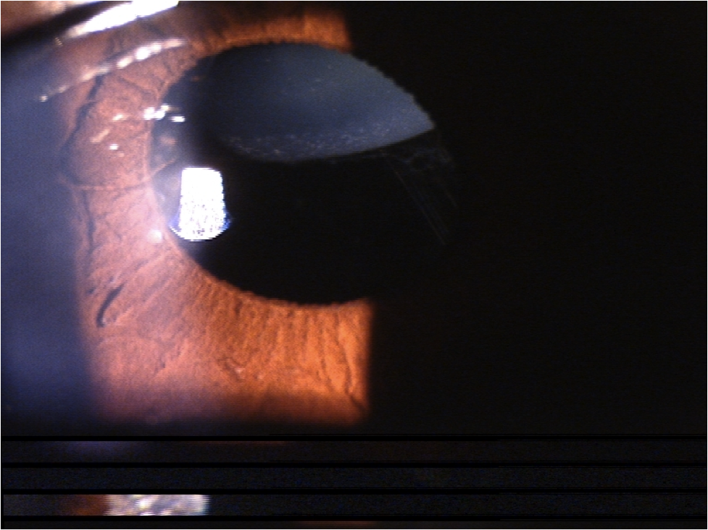

## Question 1 / 5

Given the patient’s chief complaint and clinical findings, which of the following systemic conditions is she MOST likely suffering from?

a) Multiple sclerosis

b) Acromegaly

c) Osteogenesis imperfecta

d) Marfan syndrome

e) Homocystinuria

## Question 2 / 5

Which of the following complications is frequently associated with this patient’s suspected systemic condition?

a) Paralysis

b) Aortic aneurysm

c) Trisomy 21

d) Pituitary tumor

e) Bone fractures

f) Nerve demyelination

## Question 3 / 5

Which of the following results would you MOST likely expect if this patient's color vision was to be tested?

a) Deuteranopia

b) Tritanopia

c) Anomalous trichromacy

d) Protanopia

e) Anomalous dichromacy

f) Normal color vision

## Question 4 / 5

You are asked to serve as a subject matter expert and give a testimonial during a trial involving vision loss due to a mismanaged corneal ulcer. Which of the following describes the MOST appropriate scenario?

a) As an optometrist providing an expert testimony, you are entitled to accept a fee

b) A fee may only be accepted if the judge rules in favor of the plaintiff

c) By law, practicing optometrists cannot give expert testimonies

d) As a clinician, you cannot accept a fee when asked to give an expert testimony

## Question 5 / 5

The patient's mother is seen at your office and you fit her with monovision contact lenses. At her follow-up appointment she is belligerent and rude to your staff members. Which of the following is the MOST appropriate scenario?

a) Dismiss the patient from your office via a letter and also include an offer to see her for 30 days for emergency care only

b) Refuse to see the patient on the grounds that she is in violation of your personal right to refuse service to any patient

c) File a police report against the patient so that you can refuse service to her in the future

d) Politely ask the patient to leave and tell her she is no longer welcome at your office