Case qXCORFMouXfCEGjGjA98 Details

**Demographics**

* 38-year-old Asian male; computer engineer

**Chief complaint**

* troubles with new glasses

**History of present illness**

* Character/signs/symptoms:sees colored fringes around lights with new glasses
* Location:OD, OS
* Severity:moderate
* Nature of onset:noticed when he picked up his new glasses
* Duration:2 weeks
* Frequency:constant
* Exacerbations/remissions:worse at night; symptoms are not apparent with his old glasses
* Relationship to activity or function:none
* Accompanying signs/symptoms:none

**Secondary complaints/symptoms**

* none

**Patient ocular history**

* last eye exam 1 month ago; wears single vision distance glasses

**Family ocular history**

* mother: LASIK surgery

**Patient medical history**

* unremarkable

**Medications taken by patient**

* none

**Patient allergy history**

* NKDA

**Family medical history**

* mother: hypothyroidism

**Review of systems**

* Constitutional/general health:denies
* Ear/nose/throat:denies
* Cardiovascular:denies
* Pulmonary:denies
* Dermatological:denies
* Gastrointestinal:denies
* Genitourinary:denies
* Musculoskeletal:denies
* Neuropsychiatric:denies
* Endocrine:denies
* Hematologic:denies
* Immunologic:denies

**Mental status**

* Orientation:oriented to time, place, and person
* Mood:appropriate
* Affect:appropriate

**Clinical findings**

**Habitual spectacle Rx**

* material: crown glass; A measurement: 52 mm; DBL: 14 mm
* OD:-4.75 DS; VA distance: 20/20
* OS:-4.75 -0.25 x 178; VA distance: 20/20

**New spectacle Rx**

* material: polycarbonate; see image 1 (frame is noted to be properly aligned and adjusted)
* OD:-5.00 DS; VA distance: 20/20
* OS:-5.00 -0.25 x 178; VA distance: 20/20

**Subjective refraction**

* OD:-5.00 DS; VA distance: 20/20
* OS:-5.00 -0.25 x 180; VA distance: 20/20

**Slit lamp**

* lids/lashes/adnexa:unremarkable OD, OS
* conjunctiva:normal OD, OS
* cornea:clear OD, OS
* anterior chamber:deep and quiet OD, OS
* iris:normal OD, OS
* lens:clear OD, OS
* vitreous:clear OD, OS

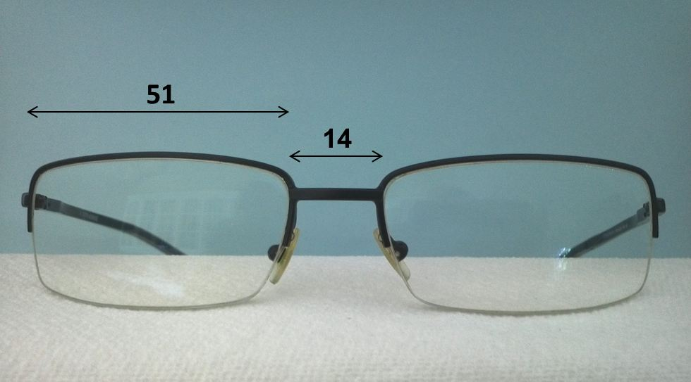

## Question 1 / 5

Which of the following is the MOST likely cause of the “colored fringes” reported by the patient?

a) A change in the material used to make his new lenses

b) The patient is not looking through the optical centers of the lenses

c) The patient has not yet adapted to the new prescription

d) The new glasses are causing unwanted prism due to misalignment

## Question 2 / 5

The patient states that he requires high-impact safety glasses for work. According to the American National Standards Institute (ANSI), what is the minimum center thickness allowable for high-impact prescription safety lenses made from polycarbonate?

a) 4.0 mm

b) 1.0 mm

c) 2.0 mm

d) 3.0 mm

e) There is no minimum thickness

## Question 3 / 5

The patient brings in a frame and asks you if it may be used for his prescription safety glasses. According to the American National Standards Institute (ANSI), what marking must be placed on the frame in order to identify that it has met the high-velocity impact safety standards?

a) Z87.1

b) Z87-2

c) Z87+

d) Z87-2+

e) Z87.1+

f) Z87

## Question 4 / 5

According to the Food and Drug Administration (FDA), all DRESS lenses must be able to pass the drop-ball test in order to evaluate impact resistance. What are the requirements of this test?

a) A 1 inch steel ball weighing 1 oz dropped from a distance of 40 inches

b) A 0.5 inch steel ball weighing 0.1 oz dropped from a distance of 15 inches

c) A 5/8 inch steel ball weighing 0.56 oz dropped from a distance of 50 inches

d) A 3/8 inch steel ball weighing 0.8 oz dropped from a distance of 60 inches

## Question 5 / 5

The patient also states that he occasionally requires side shields for his glasses during performance of his work duties. Which of the following maintains compliance with ANSI?

a) Attachment of high-velocity-compliant side shields to any basic frame

b) The side shields are able to withstand an impact of 150 feet per second at three points

c) The side shields of the safety frame must be permanent

d) The side shields are to be made of metal to ensure durability

e) The side shields are able to withstand a 3/8 inch steel ball weighing 0.8 oz dropped from a distance of 60 inches

f) The side shields have a minimum thickness of 3.0 mm