Case rJRHhhZfsFyVNJTQ6421 Details

**Demographics**

* 10-year-old black male; student

**Chief complaint**

* blurry vision

**History of present illness**

* Character/signs/symptoms:parents report that the patient has been complaining of blurred vision at near
* Location:OD, OS
* Severity:moderate
* Nature of onset:gradual (since he began 5th grade)
* Duration:6 months
* Frequency:intermittent
* Exacerbations/remissions:worse at the end of the day or after prolonged near work; better on weekends
* Relationship to activity or function:playing video games, doing homework, reading
* Accompanying signs/symptoms:occasional headaches above and around the eyes

**Secondary complaints/symptoms**

* parents also report his eyelids are often swollen and he complains of itchy eyes

**Patient ocular history**

* 1st eye exam

**Family ocular history**

* mother: glaucoma suspect

**Patient medical history**

* unremarkable

**Medications taken by patient**

* childrens multivitamin, Singulair®

**Patient allergy history**

* seasonal allergies; NKDA

**Family medical history**

* father: hypertension

**Review of systems**

* Constitutional/general health:denies
* Ear/nose/throat:runny nose
* Cardiovascular:denies
* Pulmonary:denies
* Dermatological:eczema
* Gastrointestinal:denies
* Genitourinary:denies
* Musculoskeletal:denies
* Neuropsychiatric:denies
* Endocrine:denies
* Hematologic:denies
* Immunologic:denies

**Mental status**

* Orientation:age appropriate orientation to time, place, and person
* Mood:appropriate
* Affect:appropriate

**Clinical findings**

**Uncorrected visual acuity**

* OD:distance: 20/20, near: 20/25 @ 40 cm
* OS:distance: 20/20, near: 20/25 @ 40 cm

**Pupils:**

* PERRL, negative APD

**EOMs:**

* full, no restrictions OU

**Cover test:**

* distance: orthophoria, near: orthophoria

**Confrontation fields:**

* full to finger counting OD, OS

**Stereo test:**

* 200 (via Lang II)

**Color test:**

* 12/12 OD, OS (Ishihara color plates)

**Subjective refraction**

* OD:plano -0.25 x 180; VA distance: 20/20; VA near: 20/25 @ 40 cm
* OS:plano DS; VA distance: 20/20, VA near: 20/25 @ 40 cm

**Accommodative system**

* NRA/PRA:+2.75 / -0.75
* Monocular estimation method (MEM):+1.25 OD, OS

**Wet refraction:**

* OD:+1.25 DS; VA distance: 20/20
* OS:+1.25 DS; VA distance: 20/20

**Slit lamp**

* lids/lashes/adnexa:unremarkable OD, OS
* conjunctiva:trace conjunctival injection, 2+ papillae OD, OS
* cornea:clear OD, OS
* anterior chamber:deep and quiet OD, OS
* iris:normal OD, OS
* lens:clear OD, OS
* vitreous:clear OD, OS

**IOPs:**

* OD: 17 mmHg, OS: 17 mmHg @ 2:30 pm by Tonopen

**Fundus OD**

* C/D:see image 1
* macula:normal
* posterior pole:normal
* periphery:unremarkable

**Fundus OS**

* C/D:see image 2
* macula:normal
* posterior pole:normal
* periphery:unremarkable

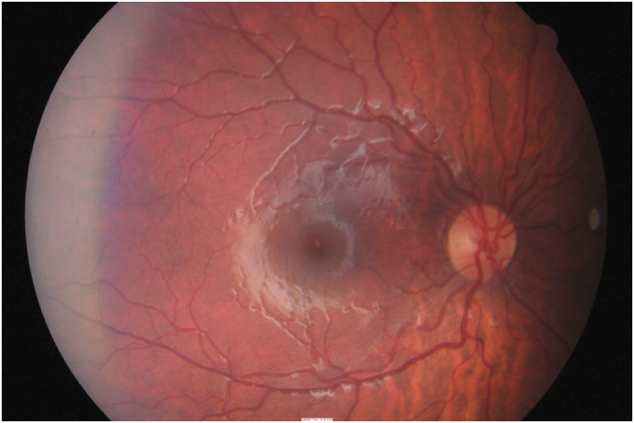

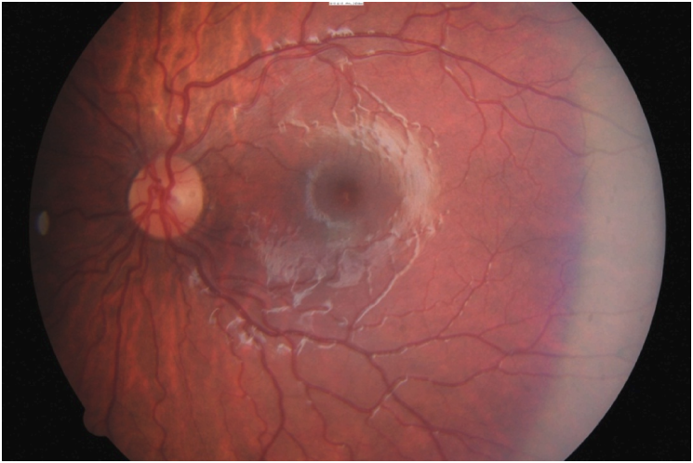

## Question 1 / 6

Which of the following prescriptions would be the MOST appropriate to prescribe for this patient?

a) OD: +0.50 DS; OS: +0.50 DS; for near activities only

b) OD: +1.25 DS; OS: +1.25 DS; for full time wear

c) OD: +1.00 DS; OS: +1.00 DS; for near activities only

d) No spectacles are required for distance or near at this time

e) OD: +0.50 DS; OS: +0.50 DS; for full-time wear

f) OD: +1.75 DS; OS: +1.75 DS; for full time wear

g) OD: +1.75 DS; OS: +1.75 DS; for near activities only

h) OD: plano -0.25 x 180; OS: plano DS; for full-time wear

## Question 2 / 6

After reviewing the patient’s anterior segment findings, which of the following treatment options would be MOST appropriate in order to address his secondary complaint of itchy eyes?

a) Pataday® q.d.

b) Zirgan® q.5h

c) Pred Forte® t.i.d.

d) Moxeza® t.i.d.

e) AzaSite® b.i.d.

## Question 3 / 6

Which of the following is NOT a common finding associated with vernal keratoconjunctivitis?

a) Preauricular lymphadenopathy

b) Horner-Trantas dots

c) Cobblestone papillae

d) Corneal "shield ulcer"

## Question 4 / 6

Which of the following topical ocular medications represents the MOST appropriate first line of treatment for the acute signs and symptoms associated with vernal keratoconjunctivitis?

a) Timolol® b.i.d.

b) Vigamox® t.i.d.

c) Alrex® q.i.d.

d) Pataday® q.d.

e) Preservative-free artificial tears q.2h

## Question 5 / 6

After initiating treatment, what is the MOST appropriate follow-up plan for this patient?

a) Return for follow-up in 1 year for a annual eye examination

b) Return for follow-up in 1 week to check patient symptoms and slit-lamp findings

c) Return for follow-up in 1 week to check patients symptoms and IOP

d) Return for follow-up in 6 weeks for a dilated fundus examination

e) Return for follow-up in 1 month for repeat cycloplegic refraction

## Question 6 / 6

If you were to perform a scraping of the conjunctival secretions in a patient suspected of having allergic conjunctivitis, the presence of which type of cell would confirm your diagnosis?

a) Monocytes

b) Lymphocytes

c) Basophils

d) Eosinophils

e) Neutrophils