Case rTApOugDBDiiTgcZ4020 Details

**Demographics**

* 47-year-old white female; secretary

**Chief complaint**

* interested in blepharoplasty

**History of present illness**

* Character/signs/symptoms:eyelid is droopy; she is bothered by cosmesis
* Location:OS upper eyelid
* Severity:mild
* Nature of onset:gradual
* Duration:2 months
* Frequency:constant
* Exacerbations/remissions:none
* Relationship to activity or function:none
* Accompanying signs/symptoms:none; no recent history of trauma, no otherneurological symptoms

**Secondary complaints/symptoms**

* occasional ocular allergies, uses Pataday® PRN

**Patient ocular history**

* last eye exam 2 years ago; wears PALs full time

**Family ocular history**

* father: macular degeneration

**Patient medical history**

* hypertension, smoker (30 years)

**Medications taken by patient**

* Lopressor®, Nicoderm®, Pataday®

**Patient allergy history**

* codeine, seasonal allergies

**Family medical history**

* father: hypertension

**Review of systems**

* Constitutional/general health:denies
* Ear/nose/throat:denies
* Cardiovascular:denies
* Pulmonary:shortness of breath when running
* Dermatological:denies
* Gastrointestinal:denies
* Genitourinary:denies
* Musculoskeletal:denies
* Neuropsychiatric:denies
* Endocrine:denies
* Hematologic:denies
* Immunologic:denies

**Mental status**

* Orientation:oriented to time, place, and person
* Mood:appropriate
* Affect:appropriate

**Clinical findings**

**Habitual spectacle Rx**

* OD:-2.00 -0.25 x 010 add: +1.50; VA distance: 20/20, VA near: 20/20 @ 40 cm
* OS:-2.25 DS add: +1.50; VA distance: 20/20, VA near: 20/20 @ 40 cm

**Pupils:**

* OD: 8 mm in dim illumination, 5 mm in bright illumination, 4+ reaction to light; OS: 5 mm in dim illumination, 3 mm in bright illumination, 4+ reaction to light; (-) APD

**EOMs:**

* full, no restrictions OU

**Cover test:**

* distance: 4 exophoria, near: 4 exophoria

**Confrontation fields:**

* full to finger counting OD, OS

**Slit lamp**

* lids/lashes/adnexa:see image 1 OD, OS
* conjunctiva:nasal pinguecula OD, OS
* cornea:clear OD, OS
* anterior chamber:deep and quiet OD, OS
* iris:normal OD, OS
* lens:clear OD, OS
* vitreous:clear OD, OS

**IOPs:**

* OD: 17 mmHg, OS: 15 mmHg @ 2:25 pm by Goldmann applanation tonometry

**Fundus OD**

* C/D:see image 1
* macula:see image 1
* posterior pole:see image 1
* periphery:unremarkable

**Fundus OS**

* C/D:see image 2
* macula:see image 2
* posterior pole:see image 2
* periphery:unremarkable

**Blood pressure:**

* 121/78 mmHg, right arm, sitting

**Pulse:**

* 76 bpm, regular

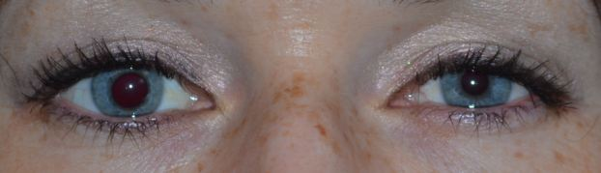

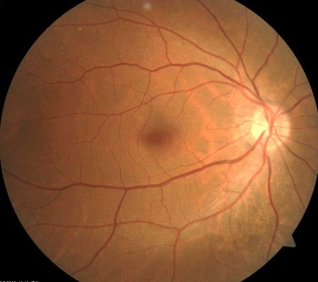

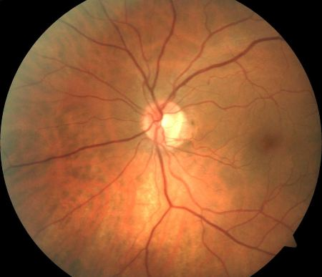

## Question 1

Which of the following represents the MOST likely diagnosis of this patient's eyelid and pupil findings?

a) Pupil-involved third nerve palsy

b) Physiological anisocoria

**c) Horner syndrome - Correct Answer**

d) Argyll Robertson pupil

e) Adie tonic pupil

Explanation:

Horner syndrome results from a disruption in the sympathetic innervation of the eye due to a lesion or mass located either post-ganglionically or pre-ganglionically. The classic triad of signs observed in a patient suffering from Horner syndrome is pupil miosis, a small ptosis (due to a disruption of sympathetic stimulation of Muller's muscle), and anhidrosis (lack of sweat) on one side of the head or body (depending on the location of the lesion).When evaluating these patients, be sure to test pupil size in both dim illumination and bright illumination, as the pupil miosis is usually more evident in dim lighting conditions. Pupil testing will also reveal unaffected light and near pupillary reactions. Patients may also present with a mild reverse ptosis of the lower lid on the affected side. Clinically, some patients report an improvement in near vision due to a decrease in pupil size. The affected eye may also demonstrate a lower intraocular pressure.Horner syndrome may also be congenital. A patient with a congenital Horner syndrome will display iris heterochromia. The affected eye will have a lighter appearing iris (this may also occur in a longstanding case of Horner syndrome).An Argyll Robertson pupil is a highly specific sign of late-stage syphilis. Patients with this condition will exhibit irregularly shaped pupils that are poorly responsive to light (if at all). However, the pupils will respond well to a near stimulus; therefore, light-near dissociation occurs with this condition. Earlier in the disease process, the pupils will appear miotic. Typically, both pupils are involved but they may be asymmetrically affected. In the later stages of syphilis, iris atrophy may occur. Even with the treatment of syphilis, the pupils will not return to normal.A patient with physiological anisocoria will display anisocoria that is equal under both dim and bright lighting conditions (or it may be somewhat greater in dim light). The patient will not display a ptosis, and the direct and consensual responses to light should be the same. If all of the results are normal, and physiological anisocoria is suspected, it is best to confirm the stability of the anisocoria by referring to previous photos of the patient.A patient presenting with a third nerve palsy and pupil involvement is usually suffering from an aneurysm. The patient will typically report a very bad headache and will likely suffer from diplopia due to extraocular muscle involvement. The eye will appear down and out with a dilated pupil, which may not be visible initially due to the presence of a large ptosis. Patients that present with a third nerve palsy and a blown pupil, with no history of vascular disease, must be sent to the emergency room immediately.A patient with an Adie tonic pupil (that is not long standing) will present with a pupil that is dilated and irregular; it will react poorly to light but will slowly constrict in response to near stimuli or convergence. A longstanding Adie pupil will slowly begin to constrict with time and will eventually appear smaller than the normal pupil.