Case rTApOugDBDiiTgcZ4020 Details

**Demographics**

* 47-year-old white female; secretary

**Chief complaint**

* interested in blepharoplasty

**History of present illness**

* Character/signs/symptoms:eyelid is droopy; she is bothered by cosmesis
* Location:OS upper eyelid
* Severity:mild
* Nature of onset:gradual
* Duration:2 months
* Frequency:constant
* Exacerbations/remissions:none
* Relationship to activity or function:none
* Accompanying signs/symptoms:none; no recent history of trauma, no otherneurological symptoms

**Secondary complaints/symptoms**

* occasional ocular allergies, uses Pataday® PRN

**Patient ocular history**

* last eye exam 2 years ago; wears PALs full time

**Family ocular history**

* father: macular degeneration

**Patient medical history**

* hypertension, smoker (30 years)

**Medications taken by patient**

* Lopressor®, Nicoderm®, Pataday®

**Patient allergy history**

* codeine, seasonal allergies

**Family medical history**

* father: hypertension

**Review of systems**

* Constitutional/general health:denies
* Ear/nose/throat:denies
* Cardiovascular:denies
* Pulmonary:shortness of breath when running
* Dermatological:denies
* Gastrointestinal:denies
* Genitourinary:denies
* Musculoskeletal:denies
* Neuropsychiatric:denies
* Endocrine:denies
* Hematologic:denies
* Immunologic:denies

**Mental status**

* Orientation:oriented to time, place, and person
* Mood:appropriate
* Affect:appropriate

**Clinical findings**

**Habitual spectacle Rx**

* OD:-2.00 -0.25 x 010 add: +1.50; VA distance: 20/20, VA near: 20/20 @ 40 cm
* OS:-2.25 DS add: +1.50; VA distance: 20/20, VA near: 20/20 @ 40 cm

**Pupils:**

* OD: 8 mm in dim illumination, 5 mm in bright illumination, 4+ reaction to light; OS: 5 mm in dim illumination, 3 mm in bright illumination, 4+ reaction to light; (-) APD

**EOMs:**

* full, no restrictions OU

**Cover test:**

* distance: 4 exophoria, near: 4 exophoria

**Confrontation fields:**

* full to finger counting OD, OS

**Slit lamp**

* lids/lashes/adnexa:see image 1 OD, OS
* conjunctiva:nasal pinguecula OD, OS
* cornea:clear OD, OS
* anterior chamber:deep and quiet OD, OS
* iris:normal OD, OS
* lens:clear OD, OS
* vitreous:clear OD, OS

**IOPs:**

* OD: 17 mmHg, OS: 15 mmHg @ 2:25 pm by Goldmann applanation tonometry

**Fundus OD**

* C/D:see image 1
* macula:see image 1
* posterior pole:see image 1
* periphery:unremarkable

**Fundus OS**

* C/D:see image 2
* macula:see image 2
* posterior pole:see image 2
* periphery:unremarkable

**Blood pressure:**

* 121/78 mmHg, right arm, sitting

**Pulse:**

* 76 bpm, regular

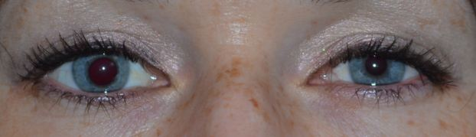

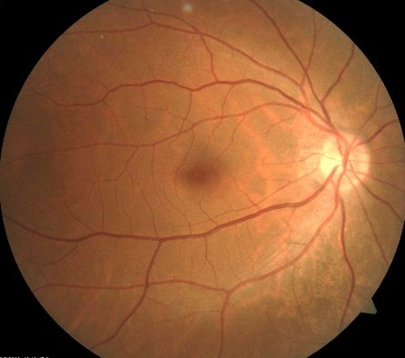

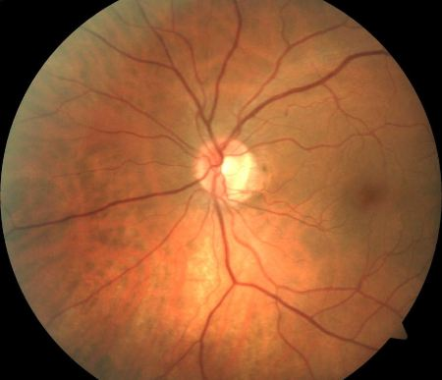

## Question 1

Which of the following represents the MOST likely diagnosis of this patient's eyelid and pupil findings?

a) Pupil-involved third nerve palsy

b) Physiological anisocoria

c) Horner syndrome

d) Argyll Robertson pupil

e) Adie tonic pupil