Case rjcclHAbPUlbIhHf3206 Details

**Demographics**

* 22-year-old Asian male; veterinary student

**Chief complaint**

* blurry vision

**History of present illness**

* Character/signs/symptoms:difficulty with distance vision with current glasses
* Location:OD, OS
* Severity:moderate
* Nature of onset:gradual
* Duration:3 months
* Frequency:constant
* Exacerbations/remissions:worse at night; better with squinting
* Relationship to activity or function:none
* Accompanying signs/symptoms:none

**Secondary complaints/symptoms**

* none

**Patient ocular history**

* last eye exam 1 year ago; wears glasses full time

**Family ocular history**

* mother: LASIK

**Patient medical history**

* congenital heart murmur

**Medications taken by patient**

* none

**Patient allergy history**

* NKDA

**Family medical history**

* father: cardiovascular disease

**Review of systems**

* Constitutional/general health:denies
* Ear/nose/throat:denies
* Cardiovascular:denies
* Pulmonary:denies
* Dermatological:denies
* Gastrointestinal:denies
* Genitourinary:denies
* Musculoskeletal:denies
* Neuropsychiatric:denies
* Endocrine:denies
* Hematologic:denies
* Immunologic:denies

**Mental status**

* Orientation:oriented to time, place, and person
* Mood:appropriate
* Affect:appropriate

**Clinical findings**

**Habitual spectacle Rx**

* OD:-6.50 -0.75 x 180; VA distance: 20/30 -2
* OS:-6.25 -0.50 x 176; VA distance: 20/30 +1

**Pupils:**

* PERRL, negative APD

**EOMs:**

* full, no restrictions OU

**Cover test:**

* distance: orthophoria, near: 6 exophoria

**Confrontation fields:**

* full to finger counting OD, OS

**Subjective refraction**

* OD:-7.00 -1.25 x 175; VA distance: 20/20, VA near: 20/20 @ 40 cm
* OS:-6.75 -1.00 x 173; VA distance: 20/20, VA near: 20/20 @ 40 cm

**Slit lamp**

* lids/lashes/adnexa:unremarkable OD, OS
* conjunctiva:normal OD, OS
* cornea:clear OD, OS
* anterior chamber:deep and quiet OD, OS
* iris:normal OD, OS
* lens:clear OD, OS
* vitreous:clear OD, OS

**IOPs:**

* OD: 15 mmHg, OS: 16 mmHg @ 1:25 pm by Goldmann applanation tonometry

**Fundus OD**

* C/D:see image 1
* macula:normal
* posterior pole:normal
* periphery:unremarkable

**Fundus OS**

* C/D:see image 2
* macula:normal
* posterior pole:normal
* periphery:unremarkable

**Blood pressure:**

* 113/73 mmHg, right arm, sitting

**Pulse:**

* 67 bpm, regular

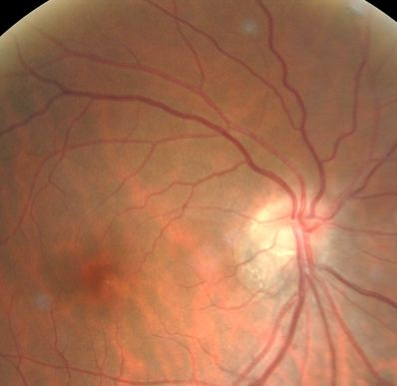

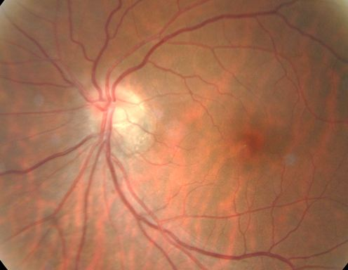

## Question 1 / 6

What is the MOST likely diagnosis of the patient's optic nerve findings?

a) Morning glory syndrome

b) Optic disc drusen

c) Tilted disc syndrome

d) Optic disc coloboma

e) Pseudopapilledema

f) Optic nerve hypoplasia

## Question 2 / 6

Which of the following visual field defects is MOST frequently associated with this patient’s condition?

a) Bilateral inferior-temporal defects

b) Bilateral superior-temporal defects

c) Bilateral superior-nasal defects

d) Bilateral inferior-nasal defects

## Question 3 / 6

What other ocular anomaly is MOST commonly associated with this condition?

a) Posterior subcapsular cataract

b) Keratoconus

c) Cystoid macular edema

d) Pars planitis

e) Situs inversus

## Question 4 / 6

Although this patient does not display any systemic associations, his ocular condition may present in conjunction with which of the following syndromes?

a) Crouzon syndrome

b) Sjogren syndrome

c) Oculoglandular syndrome

d) Horner syndrome

## Question 5 / 6

When performing direct ophthalmoscopy, how will the refractive error of this patient (if left uncorrected) alter the image?

a) The image will be magnified

b) The image will appear inverted

c) The image will be minified

d) The image will appear reversed

## Question 6 / 6

If you were to measure the axial length of this patient's eye, what value would you MOST expect to see based on his examination findings?

a) 27 mm

b) 21 mm

c) 29 mm

d) 25 mm

e) 23 mm