Case srDBqhdCepPIOvgO7742 Details

**Demographics**

* 53-year-old Asian female; model

**Chief complaint**

* ocular irritation

**History of present illness**

* Character/signs/symptoms:eyes water excessively; often feels sandy/gritty sensation
* Location:OD, OS
* Severity:moderate
* Nature of onset:gradual
* Duration:3 months
* Frequency:daily
* Exacerbations/remissions:worse in the morning, notices improvement after sheshowers
* Relationship to activity or function:none
* Accompanying signs/symptoms:blurred vision in the morning, mild redness

**Secondary complaints/symptoms**

* none

**Patient ocular history**

* last eye exam 2 years ago; wears PALs full time

**Family ocular history**

* brother: glaucoma, father: glaucoma

**Patient medical history**

* asthma

**Medications taken by patient**

* albuterol inhaler

**Patient allergy history**

* thimerosal

**Family medical history**

* mother: cardiovascular disease, father: unremarkable

**Review of systems**

* Constitutional/general health:denies
* Ear/nose/throat:denies
* Cardiovascular:denies
* Pulmonary:occasional shortness of breath
* Dermatological:denies
* Gastrointestinal:denies
* Genitourinary:denies
* Musculoskeletal:denies
* Neuropsychiatric:denies
* Endocrine:denies
* Hematologic:denies
* Immunologic:denies

**Mental status**

* Orientation:oriented to time, place, and person
* Mood:appropriate
* Affect:appropriate

**Clinical findings**

**Habitual spectacle Rx**

* OD:-1.00 -0.25 x 162 add: +2.00; VA distance: 20/20, VA near: 20/20 @ 40 cm
* OS:-2.25 -0.50 x 171 add: +2.00; VA distance: 20/20, VA near: 20/20 @ 40 cm

**Pupils:**

* PERRL, negative APD

**EOMs:**

* full, no restrictions OU

**Confrontation fields:**

* full to finger counting OD, OS

**Slit lamp**

* lids/lashes/adnexa:normal OD, OS
* conjunctiva:1+ interpalpebral injection OD, OS
* cornea:see image 1 OD, OS similar to OD
* anterior chamber:deep and quiet OD, OS
* iris:normal OD, OS
* lens:tr nuclear sclerosis OD, OS
* vitreous:clear OD, OS

**Phenol red thread test:**

* OD: 16 mm, OS: 15 mm (without anesthesia)

**IOPs:**

* OD: 17 mmHg, OS: 16 mmHg @ 8:25 am by Goldmann applanation tonometry

**Fundus OD**

* C/D:see image 2
* macula:see image 2
* posterior pole:see image 2
* periphery:unremarkable

**Fundus OS**

* C/D:see image 3
* macula:see image 3
* posterior pole:see image 3
* periphery:unremarkable

**Blood pressure:**

* 102/72 mmHg, right arm, sitting

**Pulse:**

* 62 bpm, regular

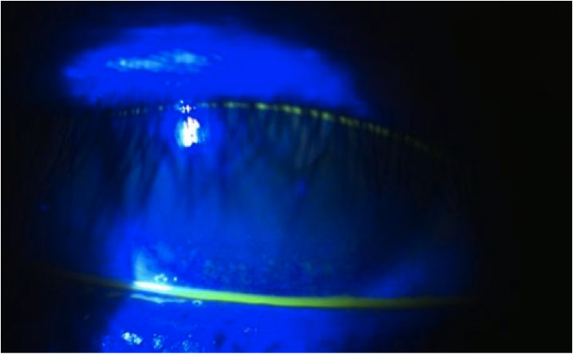

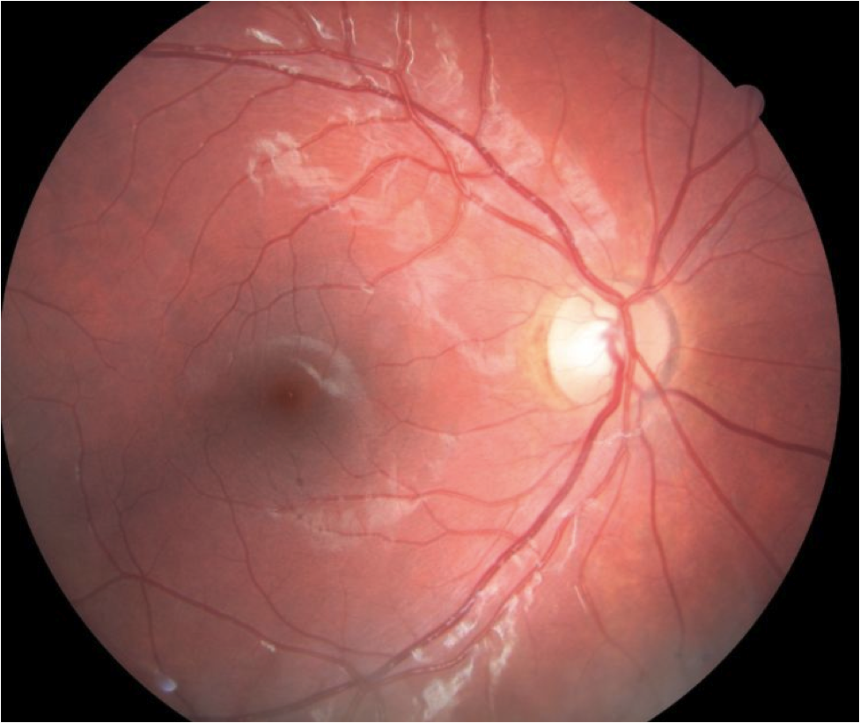

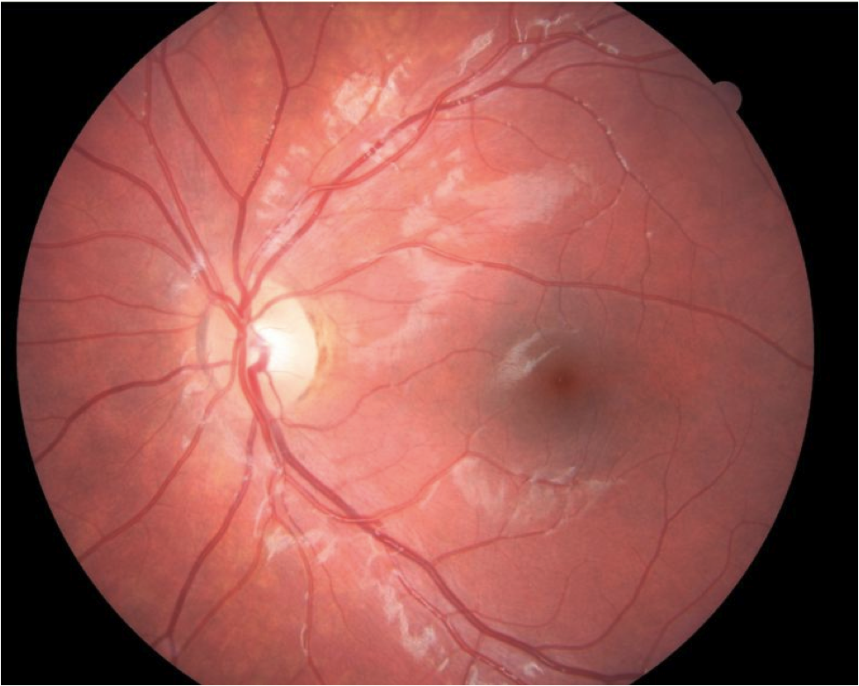

## Question 1 / 5

What is the MOST likely diagnosis of the patient's corneal findings and cause of her chief complaint?

a) Marginal keratitis

b) Sjogren syndrome

c) Thygeson superficial punctate keratitis

d) Nocturnal lagophthalmos

## Question 2 / 5

Which of the following tests may be performed to help confirm your suspected diagnosis?

a) Recline the patient, have her gently close her eyes, and observe eyelid position after several minutes

b) Stain the cornea with Lissamine green

c) The Jones I dye test

d) Pull downward on the patient's lower lid while directing her gaze upwards, and evaluate for displacement of the conjunctiva

e) The Schirmer II test

## Question 3 / 5

What is the MOST appropriate initial treatment for the patient's anterior segment condition?

a) Prescribe a bland ophthalmic ointment q.h.s. OU

b) Prescribe moxifloxacin q.i.d. OU x 7 days

c) Refer for an injection of Botox®

d) Prescribe Restasis® BID OU

e) Refer for blepharoplasty

f) Prescribe loteprednol q.i.d. OU x 7 days

## Question 4 / 5

Which of the following is a common side effect of albuterol?

a) Tardive dyskinesia

b) Depression

c) Tremors

d) Bradycardia

e) Glaucoma

## Question 5 / 5

Thimerosal is a common allergen that has become more of a concern in recent years as it is found in many vaccines as a preservative. What component of thimerosal renders it toxic?

a) Copper

b) Arsenic

c) Lead

d) Sulfur

e) Titanium

f) Mercury