Case tiFUJaTIMJAUnNP13906 Details

**Demographics**

* 76-year-old white male; retired military officer

**Chief complaint**

* visual hallucinations

**History of present illness**

* Character/signs/symptoms:patient has been experiencing visual hallucinations; sees faces in plants on his patio and cartoon-like animals in his house; he is not afraid of these images and he knows that they are not real
* Location:OD, OS
* Severity:mild-moderate
* Nature of onset:gradually increasing in frequency
* Duration:3 months
* Frequency:once per week; lasts for about 1 minute
* Exacerbations/remissions:none
* Relationship to activity or function:none
* Accompanying signs/symptoms:none

**Secondary complaints/symptoms**

* worsening vision in both eyes with his current glasses

**Patient ocular history**

* cataracts, dry age-related macular degeneration OU

**Family ocular history**

* mother: macular degeneration

**Patient medical history**

* hypertension, hyperlipidemia, history of myocardial infarction

**Medications taken by patient**

* Lipitor®, Coumadin®, Zestril®

**Patient allergy history**

* NKDA

**Family medical history**

* mother: type II diabetes, father: hypertension

**Review of systems**

* Constitutional/general health:denies
* Ear/nose/throat:denies
* Cardiovascular:denies
* Pulmonary:denies
* Dermatological:denies
* Gastrointestinal:denies
* Genitourinary:denies
* Musculoskeletal:denies
* Neuropsychiatric:visual hallucinations
* Endocrine:denies
* Hematologic:denies
* Immunologic:denies

**Mental status**

* Orientation:oriented to time, place, and person
* Mood:appropriate
* Affect:appropriate

**Clinical findings**

**Habitual spectacle Rx**

* OD:-4.00 -1.75 x 165 add: +3.00; VA distance: 20/400 (PHNI)
* OS:-3.50 -1.00 x 020 add: +3.00; VA distance: 20/200 (PH 20/150)

**Pupils:**

* PERRL, negative APD

**EOMs:**

* full, no restrictions OU

**Confrontation fields:**

* full to finger counting OD, OS

**Subjective refraction**

* OD:-4.50 -1.25 x 165 add: +3.00; VA distance: 20/400, VA near: 20/400 @ 33 cm
* OS:-4.00 -1.50 x 020 add: +3.00; VA distance: 20/150, VA near: 20/150 @ 33 cm

**Slit lamp**

* lids/lashes/adnexa:2+ dermatochalasis OD, OS
* conjunctiva:normal OD, OS
* cornea:2+ arcus OD, OS
* anterior chamber:deep and quiet OD, OS
* iris:normal OD, OS
* lens:2+ nuclear sclerosis OD, OS
* vitreous:PVD OD, OS

**IOPs:**

* OD: 18 mmHg, OS: 19 mmHg @ 9:45 am by Goldmann applanation tonometry

**Fundus OD**

* C/D:0.25 H/0.25 V
* macula:see image 1
* posterior pole:see image 1
* periphery:unremarkable

**Fundus OS**

* C/D:0.25 H/0.25 V
* macula:see image 2
* posterior pole:see image 2
* periphery:unremarkable

**Blood pressure:**

* 128/84 mmHg, right arm, sitting

**Pulse:**

* 64 bpm, regular

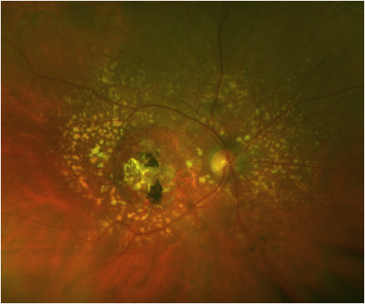

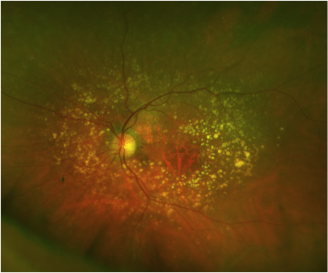

## Question 1 / 6

Which of the following diagnoses BEST describes the etiology of the patient's visual hallucinations?

a) Charles Bonnet syndrome

b) Anton syndrome

c) Schizophrenia

d) Delirium

e) Alzheimer disease

f) Acute psychosis

## Question 2 / 6

Which of the following ocular conditions has the HIGHEST association with these types of visual hallucinations?

a) Glaucoma

b) Diabetic retinopathy

c) Optic neuritis

d) Age-related macular degeneration

e) Corneal scars

f) Cataracts

## Question 3 / 6

What is the MOST common type of visual hallucination in a patient with this diagnosis?

a) Buildings

b) Shapes

c) Trees

d) Animals

e) Faces

## Question 4 / 6

Which of the following is LEAST likely to cause visual hallucinations?

a) Recreational drug use

b) Parkinson disease

c) Intracranial tumors

d) Lack of exercise

e) Sleep deprivation

## Question 5 / 6

Which 2 of the following images can be considered simple visual hallucinations? (Select 2)

a) Striped cat

b) Floating bubbles

c) Redwood tree

d) Checkerboard pattern

e) Cartoon character

## Question 6 / 6

What can be included in the education of patients with this condition to help reduce the appearance of visual hallucinations when they occur?

a) Walk toward the hallucination

b) Decrease lighting conditions

c) Relaxation

d) Rapid blinking