Case ulcRPPWgIOhiFlvw3135 Details

**Demographics**

* 68-year-old Asian female; pharmacist

**Chief complaint**

* blurred vision

**History of present illness**

* Character/signs/symptoms:cloudy vision; feels like looking through a "dirty windshield"
* Location:left eye
* Severity:moderate
* Nature of onset:gradual
* Duration:3 months
* Frequency:constant
* Exacerbations/remissions:worse at night
* Relationship to activity or function:none
* Accompanying signs/symptoms:glare from oncoming headlights; difficulty driving at night

**Secondary complaints/symptoms**

* none

**Patient ocular history**

* last eye exam 1 year ago; wears PALs occasionally; cataract surgery OU 2 years ago; retinal detachment OS 20 years ago

**Family ocular history**

* mother: cataracts

**Patient medical history**

* unremarkable

**Medications taken by patient**

* glucosamine, chondroitin, ginkgo biloba

**Patient allergy history**

* sulfa-based medications, benzalkonium chloride

**Family medical history**

* father: hypercholesterolemia

**Review of systems**

* Constitutional/general health:denies
* Ear/nose/throat:tinnitus
* Cardiovascular:denies
* Pulmonary:denies
* Dermatological:denies
* Gastrointestinal:denies
* Genitourinary:denies
* Musculoskeletal:denies
* Neuropsychiatric:denies
* Endocrine:denies
* Hematologic:denies
* Immunologic:denies

**Mental status**

* Orientation:oriented to time, place, and person
* Mood:appropriate
* Affect:appropriate

**Clinical findings**

**Habitual spectacle Rx**

* OD:+0.25 -1.00 x 180 add: +2.25; VA distance: 20/20, VA near: 20/20 @ 40 cm
* OS:+0.50 -1.00 x 175 add: +2.25; VA distance: 20/60 (PH 20/50), VA near: 20/50 @ 40 cm

**Pupils:**

* PERRL, negative APD

**EOMs:**

* full, no restrictions OU

**Confrontation fields:**

* full to finger counting OD, OS

**Keratometry**

* OD:44.25 @ 170 / 45.00 @ 080; no distortion of mires
* OS:44.50 @ 180 / 45.25 @ 090; no distortion of mires

**Subjective refraction**

* OD:+0.25 -1.00 x 175 add: +2.50; VA distance: 20/20, VA near: 20/20 @ 40 cm
* OS:+0.25 -1.00 x 180 add: +2.50; VA distance: 20/50, VA near: 20/40 @ 40 cm

**Slit lamp**

* lids/lashes/adnexa:dermatochalasis OD, OS
* conjunctiva:nasal pinguecula OD, OS
* cornea:1+ arcus, limbal girdle of Vogt OD, OS
* anterior chamber:deep and quiet OD, OS
* iris:normal OD, OS
* lens:PCIOL; clear and centered OD, PCIOL; see image 1 OS
* vitreous:PVD OD, OS

**IOPs:**

* OD: 11 mmHg, OS: 12 mmHg @ 3:50 pm by Goldmann applanation tonometry

**Fundus OD**

* C/D:0.20 H/0.25 V
* macula:normal
* posterior pole:normal
* periphery:unremarkable

**Fundus OS**

* C/D:0.20 H/0.25 V
* macula:normal
* posterior pole:normal
* periphery:old retinal tear with cryo scars superior temporal

**Blood pressure:**

* 116/72 mmHg, right arm, sitting

**Pulse:**

* 68 bpm, regular

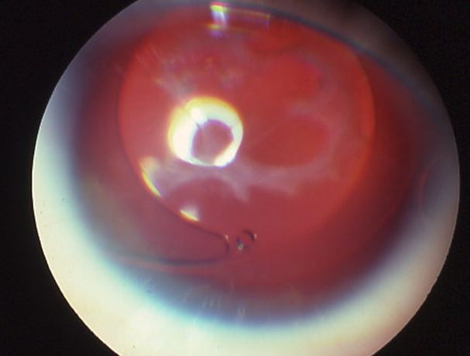

## Question 1 / 5

Which of the following represents the MOST likely cause of the patient’s decrease in visual acuity of the left eye?

a) Posterior subcapsular cataract

b) Retinal detachment

c) Posterior capsular opacification

d) Posterior vitreous detachment

e) Dermatochalasis

f) Corneal arcus

## Question 2 / 5

What is the MOST appropriate treatment for the patient's left eye condition?

a) Blepharoplasty

b) YAG iridotomy

c) Systemic control of cholesterol levels

d) No treatment is indicated at this time

e) IOL exchange

f) Vitrectomy

g) YAG capsulotomy

h) Cataract surgery

## Question 3 / 5

What is the MOST common complication associated with this treatment option?

a) Infection

b) Cystoid macular edema

c) Retinal detachment

d) Hyphema

e) Elevated intraocular pressure

f) There are no associated complications

## Question 4 / 5

After performing the appropriate treatment, the patient returns for a follow-up exam. At that visit, her IOPs are 17 mmHg OD and 32 mmHg OS. Which of the following medications should be prescribed to manage her elevated intraocular pressure?

a) Alphagan-P®

b) Cosopt®

c) Diamox®

d) Trusopt®

e) Pilocarpine

## Question 5 / 5

Which (2) of the following are NOT considered individually identifiable health information, according to HIPAA? (Select 2)

a) Email address

b) Medical record numbers

c) Vehicle identifiers

d) Phone number

e) Eye color

f) Initials