Case vIsErmBdHxVZiFt10471 Details

**Demographics**

* 32-year-old Asian female; small business owner

**Chief complaint**

* blurry vision

**History of present illness**

* Character/signs/symptoms:worsening vision and monocular diplopia
* Location:OD
* Severity:severe
* Nature of onset:gradual
* Duration:2 months
* Frequency:constant
* Exacerbations/remissions:none
* Relationship to activity or function:was involved in a car accident 2 months ago; vision started changing shortly after
* Accompanying signs/symptoms:none

**Secondary complaints/symptoms**

* eyes itch often; rubs them frequently

**Patient ocular history**

* last eye exam 1 year ago; wears monthly disposable soft contact lenses, reports compliance with cleaning regimen and replacement schedule, does not sleep in lenses

**Family ocular history**

* mother: keratoconus

**Patient medical history**

* unremarkable

**Medications taken by patient**

* unknown OTC diet pills

**Patient allergy history**

* nickel, NKDA

**Family medical history**

* father: vitiligo

**Review of systems**

* Constitutional/general health:denies
* Ear/nose/throat:denies
* Cardiovascular:denies
* Pulmonary:denies
* Dermatological:denies
* Gastrointestinal:denies
* Genitourinary:denies
* Musculoskeletal:denies
* Neuropsychiatric:denies
* Endocrine:denies
* Hematologic:denies
* Immunologic:denies

**Mental status**

* Orientation:oriented to time, place, and person
* Mood:appropriate
* Affect:appropriate

**Clinical findings**

**Habitual contact lens Rx**

* ODCoopervision Biofinity / -3.00 DS / 8.6 / 14.0; VA distance: 20/100 (PH 20/25)
* OSCoopervision Biofinity / -3.25 DS / 8.6 / 14.0; VA distance: 20/20

**Pupils:**

* PERRL, negative APD

**EOMs:**

* full, no restrictions OU

**Cover test:**

* distance: 10 exophoria, near: orthophoria

**Confrontation fields:**

* full to finger counting OD, OS

**Keratometry**

* OD:43.50 @ 180 / 43.75 @ 090; no distortion of mires
* OS:43.75 @ 180 / 44.00 @ 075; no distortion of mires

**Subjective refraction**

* *patient reported double vision and fluctuation in vision during OD refraction
* OD:-2.50 -4.75 x 112; VA distance: 20/40
* OS:-3.00 -0.50 x 170; VA distance: 20/20

**Slit lamp**

* lids/lashes/adnexa:unremarkable OD, OS
* conjunctiva:normal OD, OS
* cornea:clear OD, OS
* anterior chamber:deep and quiet OD, OS
* iris:normal OD, OS
* lens:see image 1 OD, OS
* vitreous:clear OD, OS

**IOPs:**

* OD: 15 mmHg, OS: 14 mmHg @ 12:00 pm by Goldmann applanation tonometry

**Fundus OD**

* C/D:0.40 H/0.45 V
* macula:normal
* posterior pole:normal
* periphery:unremarkable

**Fundus OS**

* C/D:0.40 H/0.40 V
* macula:normal
* posterior pole:normal
* periphery:unremarkable

**Blood pressure:**

* 112/68 mmHg, right arm, sitting

**Pulse:**

* 72 bpm, regular

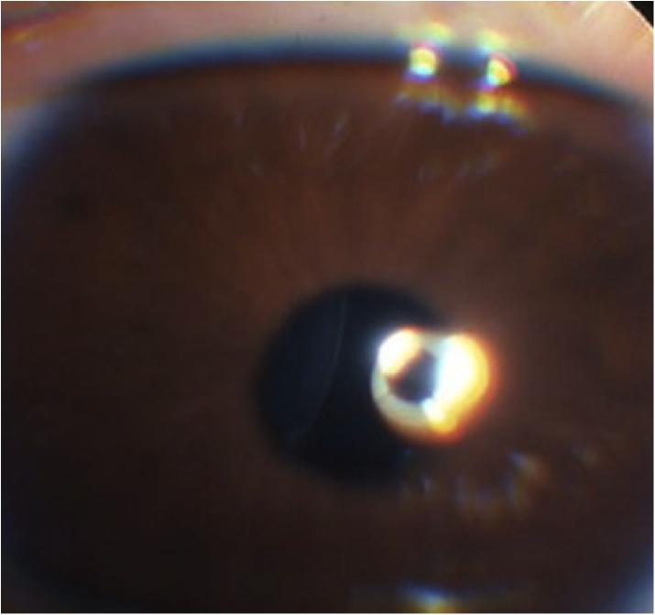

## Question 1 / 5

Given the findings observed in image 1, what is the MOST appropriate diagnosis of the patient's right ocular condition?

a) Anterior cortical cataract

b) Lens dislocation

c) Posterior lenticonus

d) Lens subluxation

e) Traumatic cataract

## Question 2 / 5

Which of the following systemic disorders is MOST frequently associated with the patient’s ocular condition?

a) Hallermann-Streiff syndrome

b) Lowe (oculocerebrorenal) syndrome

c) Homocystinuria

d) Tubulointerstitial nephritis

e) Vogt-Koyanagi-Harada syndrome

f) Whipple disease

## Question 3 / 5

Which of the following ocular signs is typically observed in conjunction with the patient’s ocular condition?

a) Keratoconus

b) Iris coloboma

c) Ectopic pupil

d) Retinal detachment

e) Posterior subcapsular cataract

f) Iridodonesis

## Question 4 / 5

What is the MOST appropriate treatment of the patient's ocular condition at this time?

a) Patch the right eye

b) Lensectomy

c) Vitrectomy

d) An iris opaque contact lens with a decentered pupil

## Question 5 / 5

What is the MOST common etiology of the patient’s ocular condition?

a) An associated systemic condition

b) Trauma

c) Frequent eye rubbing

d) Congenital

e) Idiopathic

f) An associated ocular condition