Case vSWXTXFteKgwESSI8290 Details

**Demographics**

* 68-year-old Asian female; psychologist

**Chief complaint**

* blurred vision

**History of present illness**

* Character/signs/symptoms:decreased vision in left eye with current glasses
* Location:OS
* Severity:moderate
* Nature of onset:acute
* Duration:2 weeks
* Frequency:constant
* Exacerbations/remissions:none
* Relationship to activity or function:none
* Accompanying signs/symptoms:none

**Secondary complaints/symptoms**

* none

**Patient ocular history**

* last eye exam 2 years ago; wears PALs full time

**Family ocular history**

* mother: cataract surgery, paternal grandfather: primary open angle glaucoma

**Patient medical history**

* hyperlipidemia; type II diabetes, FBS: 112 mg/dL (this morning), HbA1c: 7.2% (2 months ago)

**Medications taken by patient**

* lovastatin, metformin

**Patient allergy history**

* NKDA

**Family medical history**

* mother: kidney disease, maternal grandfather: Alzheimer disease, maternal grandmother: breast cancer

**Review of systems**

* Constitutional/general health:denies
* Ear/nose/throat:denies
* Cardiovascular:denies
* Pulmonary:denies
* Dermatological:denies
* Gastrointestinal:denies
* Genitourinary:denies
* Musculoskeletal:denies
* Neuropsychiatric:denies
* Endocrine:denies
* Hematologic:denies
* Immunologic:denies

**Mental status**

* Orientation:oriented to time, place, and person
* Mood:appropriate
* Affect:appropriate

**Clinical findings**

**Habitual spectacle Rx**

* OD:-0.75 -0.74 x 078 add: +2.25; VA distance: 20/25, VA near: 20/25 @ 40 cm
* OS:-1.25 -0.25 x 154 add: +2.25; VA distance: 20/200 (PHNI), VA near: 20/200 @ 40 cm

**Pupils:**

* PERRL, negative APD

**EOMs:**

* full, no restrictions OU

**Confrontation fields:**

* full to finger counting OD, OS

**Keratometry**

* OD:42.25 @ 177 / 42.75 @ 087; no distortion of mires
* OS:43.25 @ 180 / 43.00 @ 090; no distortion of mires

**Subjective refraction**

* OD:-1.00 -0.75 x 082 add: +2.50; VA distance: 20/25, VA near: 20/25 @ 40 cm
* OS:-1.50 -0.25 x 093 add: +2.50; VA distance: 20/200, VA near: 20/200 @ 40 cm

**Slit lamp**

* lids/lashes/adnexa:dermatochalasis, 1+ MGD OD, OS
* conjunctiva:mild conjunctivochalasis OD, OS
* cornea:2+ arcus OD, OS
* anterior chamber:deep and quiet OD, OS
* iris:normal OD, OS
* lens:1+ nuclear sclerosis OD, OS
* vitreous:posterior vitreous detachment OD, OS

**IOPs:**

* OD: 12 mmHg, OS: 11 mmHg @ 8:35 am by Goldmann applanation tonometry

**Fundus OD**

* C/D:see image 1
* macula:see image 1
* posterior pole:see image 1
* periphery:unremarkable

**Fundus OS**

* C/D:see image 2
* macula:see image 2
* posterior pole:see image 2
* periphery:unremarkable

**Blood pressure:**

* 114/78 mmHg, right arm, sitting

**Pulse:**

* 72 bpm, regular

**Optical coherence tomography (OCT)**

* OS:see images 3 & 4

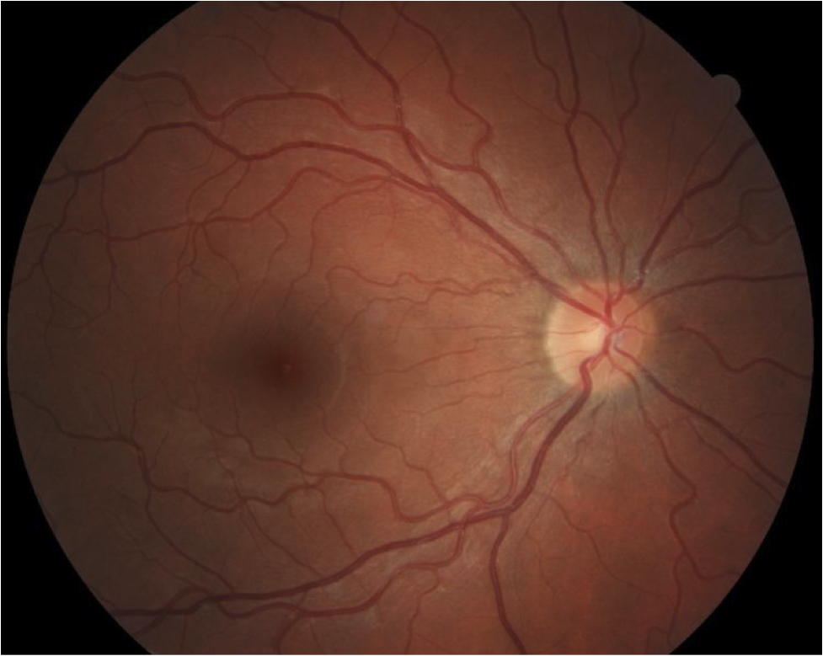

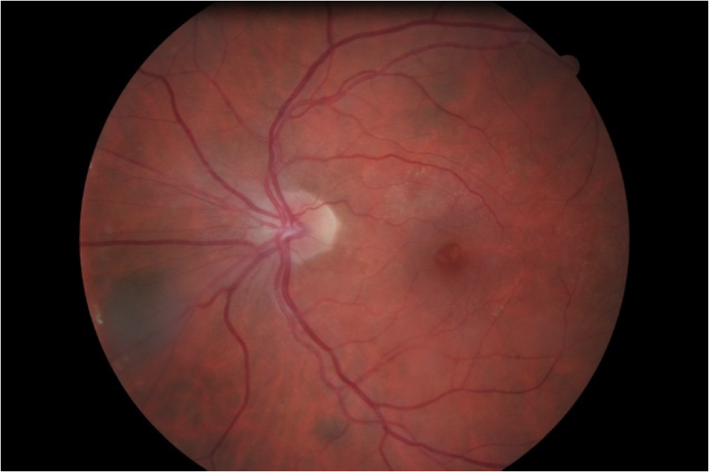

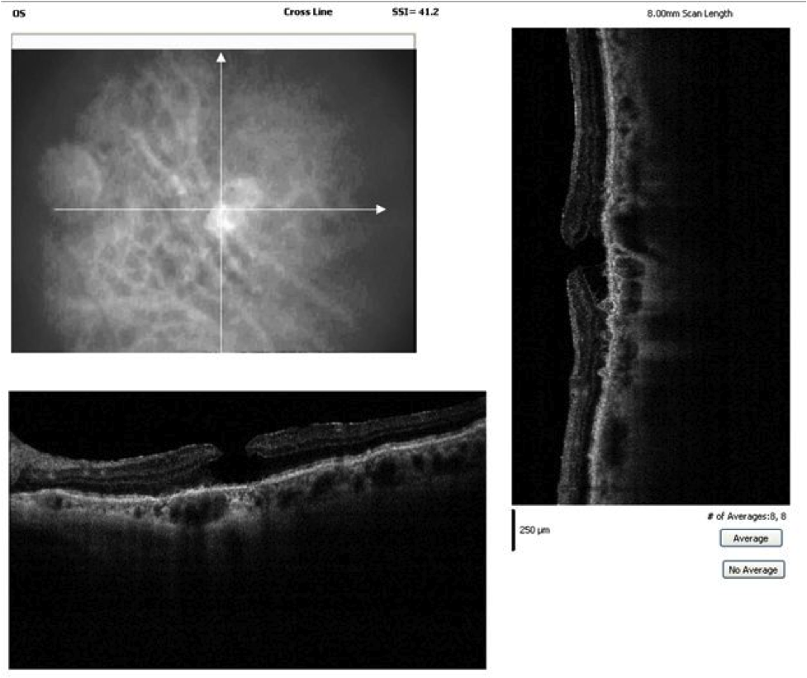

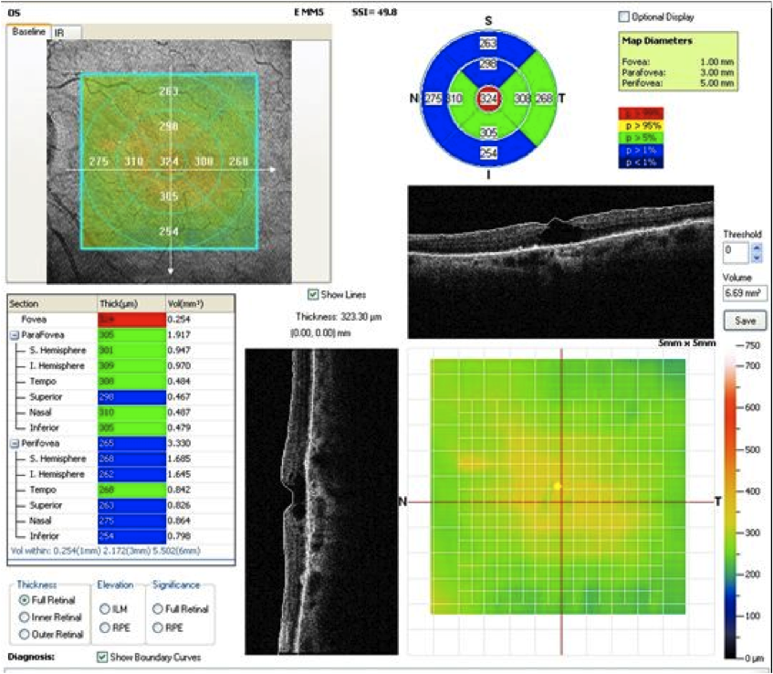

## Question 1 / 5

Given the examination findings, what is the MOST likely etiology of the patient's reduced visual acuity of the left eye?

a) Central serous retinopathy

b) Solar retinopathy

c) Epiretinal membrane

d) Clinically significant macular edema

e) Cystoid macular edema

f) Macular hole

## Question 2 / 5

If you were to perform the Watzke-Allen test on the patient's left eye, which of the following results would you MOST likely expect the patient to report?

a) The patient will be unable to perceive the light beam

b) A broken, straight light beam

c) An intact, curved light beam

d) A broken, curved light beam

e) An intact, straight light beam

## Question 3 / 5

What is the MOST appropriate treatment of the patient's left eye condition?

a) Focal laser treatment

b) Careful observation

c) Vitrectomy with internal limiting membrane peel

d) Topical NSAID drop

e) Intravitreal ocriplasmin injection

f) Anti-VEGF injection

g) Topical corticosteroid drop

## Question 4 / 5

Upon examination of the OCT images, which of the following BEST describes the retinal defects depicted in the left eye?

a) Full-thickness loss of neurosensory tissue within the fovea

b) Cystic changes between the outer plexiform layer and inner nuclear layer

c) A band of tissue overlying the internal limiting membrane

d) Focal loss of retinal tissue with intact photoreceptor layer

e) A focal detachment of the sensory retina

## Question 5 / 5

Which of the following serves as a protective factor against the development of this retinal condition in the fellow eye?

a) White without pressure

b) AREDS II ocular vitamins

c) Posterior vitreous detachment

d) Prophylactic use of topical corticosteroids

e) UV protection

f) Prophylactic use of topical NSAIDs