Case vnvKWqSdlmgwWphbrw62 Details

**Demographics**

* 52-year-old white male; bookkeeper

**Chief complaint**

* unhappy with new bifocal glasses

**History of present illness**

* Character/signs/symptoms:experiencing double vision when reading with new glasses
* Location:OU
* Severity:moderate
* Nature of onset:since he picked up his new glasses
* Duration:2 weeks
* Frequency:constant when reading; no diplopia at distance
* Exacerbations/remissions:none
* Relationship to activity or function:only occurs with new glasses; does not have double vision with old pair
* Accompanying signs/symptoms:headaches

**Secondary complaints/symptoms**

* none

**Patient ocular history**

* last eye exam 1 month ago; wears flat-top bifocals

**Family ocular history**

* mother: cataract surgery, father: glaucoma

**Patient medical history**

* hypercholesterolemia

**Medications taken by patient**

* lovastatin

**Patient allergy history**

* NKDA

**Family medical history**

* mother: hypertension, father: diabetes

**Review of systems**

* Constitutional/general health:denies
* Ear/nose/throat:denies
* Cardiovascular:denies
* Pulmonary:denies
* Dermatological:denies
* Gastrointestinal:denies
* Genitourinary:denies
* Musculoskeletal:denies
* Neuropsychiatric:denies
* Endocrine:denies
* Hematologic:denies
* Immunologic:denies

**Mental status**

* Orientation:oriented to time, place, and person
* Mood:appropriate
* Affect:appropriate

**Clinical findings**

**Habitual spectacle Rx**

* polycarbonate, flat-top 28 bifocal
* OD:-4.00 -1.50 x 090 add: +1.75; VA distance: 20/20, VA near: 20/20 @ 40 cm
* OS:-7.50 DS add: +1.75; VA distance: 20/20, VA near: 20/20 @ 40 cm

**Habitual spectacles with markings and frame measurements:**

* see image 1

**External assessment:**

* frame is noted to be properly aligned and adjusted

**Pupils:**

* PERRL, negative APD

**EOMs:**

* full, no restrictions OU

**Cover test:**

* distance: 4 exophoria, near: 4 exophoria

**Confrontation fields:**

* full to finger counting OD, OS

**Keratometry**

* OD:OD: 45.50 @ 175 / 43.75 @ 085; no distortion of mires
* OS:44.25 @ 180 / 44.00 @ 090; no distortion of mires

**Subjective refraction**

* OD:-4.00 -1.50 x 090 add: +1.75; VA distance: 20/20, VA near: 20/20 @ 40 cm
* OS:-7.50 DS add: +1.75; VA distance: 20/20, VA near: 20/20 @ 40 cm

**Pupillary distance:**

* 61 mm

**Slit lamp**

* lids/lashes/adnexa:unremarkable OD, OS
* conjunctiva:nasal pinguecula OD, OS
* cornea:1+ arcus OD, OS
* anterior chamber:deep and quiet OD, OS
* iris:normal OD, OS
* lens:clear OD, OS
* vitreous:clear OD, OS

**IOPs:**

* OD: 15 mmHg, OS: 13 mmHg @ 10:55 am by Goldmann applanation tonometry

**Fundus OD**

* C/D:0.20 H/0.20 V
* macula:normal
* posterior pole:normal
* periphery:unremarkable

**Fundus OS**

* C/D:0.20 H/0.20 V
* macula:normal
* posterior pole:normal
* periphery:unremarkable

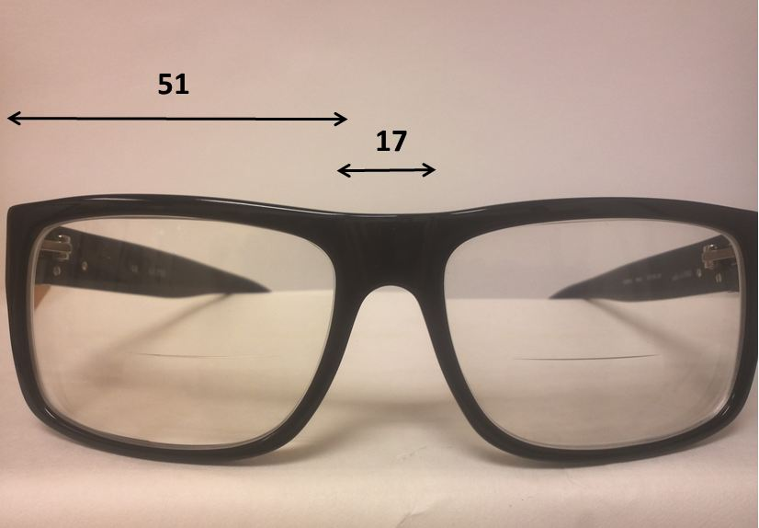

## Question 1 / 5

Given the examination findings what is the MOST likely cause of the patient's double vision at near?

a) Anisometropia; causing a vertical diplopia when reading

b) The patient's pupillary distance does not match that of the frame; causing horizontal diplopia when reading

c) Unequal reading segment heights; causing vertical diplopia when reading

d) Too much frame wrap; causing horizontal diplopia when reading

e) Too much frame wrap; causing vertical diplopia when reading

f) Anisometropia; causing a horizontal diplopia when reading

g) The lens material; causing chromatic aberration and diplopia when reading

## Question 2 / 5

If the patient looks 7 mm below the optical centers of the lenses, how much prism is induced?

a) 5.25 prism diopters base up OD

b) 5.25 prism diopters base in OD

c) 2.45 prism diopters base down OS

d) 3.50 prism diopters base up OD

e) 2.45 prism diopters base out OS

f) 1.40 prism diopters base out OS

## Question 3 / 5

Which 3 of the following will help to eliminate the patient's complaint of double vision when reading? (Select 3)

a) Prescribe slab-off prism

b) Add base out prism to each eye

c) Prescribe 2 pairs of single vision glasses; one for distance and one for reading

d) Prescribe reverse slab-off prism

e) Add base in prism to each eye

f) Select a frame with a larger A measurement

g) Prescribe progressive addition lenses (PALs) in lieu of lined bifocals

## Question 4 / 5

The patient wishes to know if he would be a good candidate for LASIK to correct his distance vision. Given the examination findings, what is his prognosis?

a) He is not a candidate for LASIK because his prescription is outside the specified parameters for surgery

b) His diplopia would be eliminated with LASIK because it is caused by the anisometropia in his glasses

c) His diplopia would persist following LASIK, and he would still require glasses with prescribed prism to correct his imbalance

d) He should not undergo LASIK as it will make his diplopia worse

## Question 5 / 5

If the pantoscopic tilt of this patient's frame were to be increased, what would happen to the resultant prescription?

a) Only minus power would induced

b) Only astigmatism would be induced

c) Plus power and astigmatism would be induced

d) Minus power and astigmatism would be induced

e) Only plus power would be induced