Case wZrzOVisOhlCjpC14743 Details

**Demographics**

* 14-year-old white female; student

**Chief complaint**

* referred by another optometrist for corneal collagen cross-linking evaluation

**History of present illness**

* Character/signs/symptoms:worsening vision at all distances
* Location:OD, OS
* Severity:moderate (OS worse than OD)
* Nature of onset:gradual
* Duration:6 months
* Frequency:constant
* Exacerbations/remissions:none
* Relationship to activity or function:struggling at school with seeing the board and reading
* Accompanying signs/symptoms:halos around lights; mostly at night

**Secondary complaints/symptoms**

* itchy eyes

**Patient ocular history**

* last eye exam 1 month ago

**Family ocular history**

* unremarkable

**Patient medical history**

* seasonal allergies

**Medications taken by patient**

* Zyrtec® PRN

**Patient allergy history**

* NKDA

**Family medical history**

* mother: breast cancer

**Review of systems**

* Constitutional/general health:denies
* Ear/nose/throat:occasional runny nose and sinus congestion
* Cardiovascular:denies
* Pulmonary:denies
* Dermatological:denies
* Gastrointestinal:denies
* Genitourinary:denies
* Musculoskeletal:denies
* Neuropsychiatric:denies
* Endocrine:denies
* Hematologic:denies
* Immunologic:denies

**Mental status**

* Orientation:oriented to time, place, and person
* Mood:appropriate
* Affect:appropriate

**Clinical findings**

**Habitual spectacle Rx**

* OD:+0.75 -0.75 x 090; VA distance: 20/40, PH 20/30
* OS:+1.00 -1.00 x 105; VA distance: 20/70, PH 20/60

**Pupils:**

* PERRL, negative APD

**EOMs:**

* full, no restrictions OU

**Confrontation fields:**

* full to finger counting OD, OS

**Subjective refraction**

* OD:+0.50 -1.50 x 085; VA distance: 20/30
* OS:plano -3.00 x 110; VA distance: 20/60

**Topography:**

* OD: see images 1 & 2, OS: see images 3 & 4

**Slit lamp**

* lids/lashes/adnexa:unremarkable OD, OS
* conjunctiva:normal OD, OS
* cornea:faint Vogt striae OD, OS
* anterior chamber:deep and quiet OD, OS
* iris:normal OD, OS
* lens:clear OD, OS
* vitreous:clear OD, OS

**IOPs:**

* OD: 12 mmHg, OS: 12 mmHg @ 10:15 am by Goldmann applanation tonometry

**Fundus OD**

* C/D:0.20 H/0.20 V
* macula:normal
* posterior pole:normal
* periphery:unremarkable

**Fundus OS**

* C/D:0.20 H/0.20 V
* macula:normal
* posterior pole:normal
* periphery:unremarkable

**Blood pressure:**

* 110/64 mmHg, right arm, sitting

**Pulse:**

* 60 bpm, regular

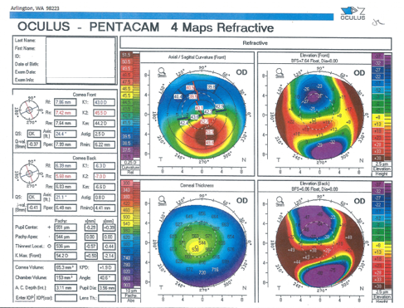

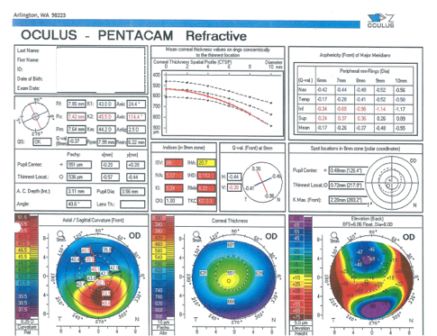

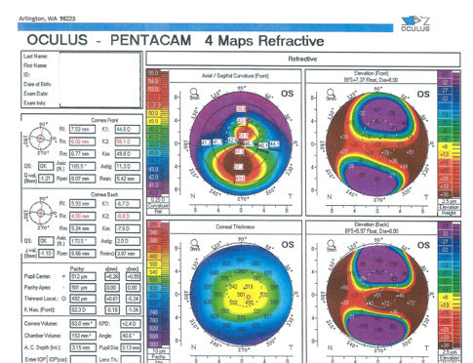

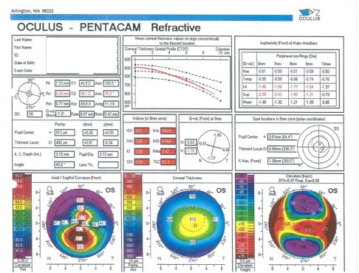

## Question 1 / 5

Based on the refractive data and corneal topographies, what is the BEST diagnosis for this patient's right and left eyes?

a) Terrien's marginal degeneration

b) Keratoconus

c) Pellucid marginal degeneration

d) Forme fruste keratoconus

e) Keratoglobus

## Question 2 / 5

Based on the patient's age and clinical findings, which eye(s) would benefit from undergoing corneal collagen cross-linking (CXL)?

a) Both eyes

b) Neither eye

c) Right eye only

d) Left eye only

## Question 3 / 5

After removal of the corneal epithelium in patients undergoing corneal collagen cross-linking,, what is the minimum residual corneal thickness required to maintain the integrity of the corneal endothelium (according to the standard protocol)?

a) 400 microns

b) 300 microns

c) 200 microns

d) 500 microns

e) 250 microns

f) 350 microns

## Question 4 / 5

Which of the following is considered a relative contraindication for corneal collagen cross-linking?

a) Glaucoma

b) Prior history of INTACS

c) Prior history of herpes keratitis

d) Prior history of LASIK

e) Diabetes

## Question 5 / 5

When explaining corneal collagen cross-linking to the patient and her parents, which of the following statements BEST describes the ultimate goal of the procedure?

a) To slow down or halt the progression of her eye disease

b) To improve her best corrected vision with her glasses

c) To prevent her from requiring rigid gas-permeable contact lenses

d) To allow her to be able to wear soft contact lenses

e) To correct her refractive error

f) To allow her to be a candidate for LASIK in the future