Case wpcFyWhIffXjmhmho100 Details

**Demographics**

* 52-year-old white male; accountant

**Chief complaint**

* blurry vision at near

**History of present illness**

* Character/signs/symptoms:difficulty with computer and reading with his current glasses
* Location:OD, OS
* Severity:moderate
* Nature of onset:gradual
* Duration:6 months
* Frequency:constant
* Exacerbations/remissions:vision is better if he pushes reading material further away
* Relationship to activity or function:had a separate pair of reading glasses that worked well but he lost them
* Accompanying signs/symptoms:fatigue and headaches with prolonged near work

**Secondary complaints/symptoms**

* none

**Patient ocular history**

* last eye exam 3 years ago; wearing single vision distance glasses full time, lost single vision reading glasses

**Family ocular history**

* mother: toxoplasmosis, father: glaucoma

**Patient medical history**

* hypercholesterolemia

**Medications taken by patient**

* lovastatin

**Patient allergy history**

* NKDA

**Family medical history**

* mother: hyperthyroid, depression, father: hypertension

**Review of systems**

* Constitutional/general health:denies
* Ear/nose/throat:denies
* Cardiovascular:denies
* Pulmonary:denies
* Dermatological:denies
* Gastrointestinal:denies
* Genitourinary:denies
* Musculoskeletal:denies
* Neuropsychiatric:denies
* Endocrine:denies
* Hematologic:denies
* Immunologic:denies

**Mental status**

* Orientation:oriented to time, place, and person
* Mood:appropriate
* Affect:appropriate

**Clinical findings**

**Habitual spectacle Rx**

* OD:+4.25 DS; VA distance: 20/25, VA near: 20/60 @ 40 cm
* OS:+5.00 -0.50 x 098; VA distance: 20/25, VA near: 20/60 @ 40 cm

**Pupils:**

* PERRL, negative APD

**EOMs:**

* full, no restrictions OU

**Confrontation fields:**

* full to finger counting OD, OS

**Keratometry**

* OD:45.00 @ 175 / 44.75 @ 085; no distortion of mires
* OS:44.35 @ 180 / 44.00 @ 090; no distortion of mires

**Subjective refraction**

* OD:+4.75 -0.25 x 092 add: +1.75; VA near: 20/20, VA distance: 20/20 @ 40 cm
* OS:+5.25 -0.25 x 096 add: +1.75; VA distance: 20/20, VA near: 20/20 @ 40 cm

**Slit lamp**

* lids/lashes/adnexa:unremarkable OD, OS
* conjunctiva:nasal pinguecula OD, OS
* cornea:see image 1 OD, see image 2 OS
* anterior chamber:deep and quiet OD, OS
* iris:normal OD, OS
* lens:clear OD, OS
* vitreous:clear OD, OS

**IOPs:**

* OD: 14 mmHg, OS: 13 mmHg @ 11:55 am by Goldmann applanation tonometry

**Fundus OD**

* C/D:0.20 H/0.20 V
* macula:normal
* posterior pole:normal
* periphery:white without pressure temporally

**Fundus OS**

* C/D:0.20 H/0.20 V
* macula:normal
* posterior pole:normal
* periphery:white without pressure temporally

**Blood pressure:**

* 112/80 mmHg, right arm, sitting

**Pulse:**

* 76 bpm, regular

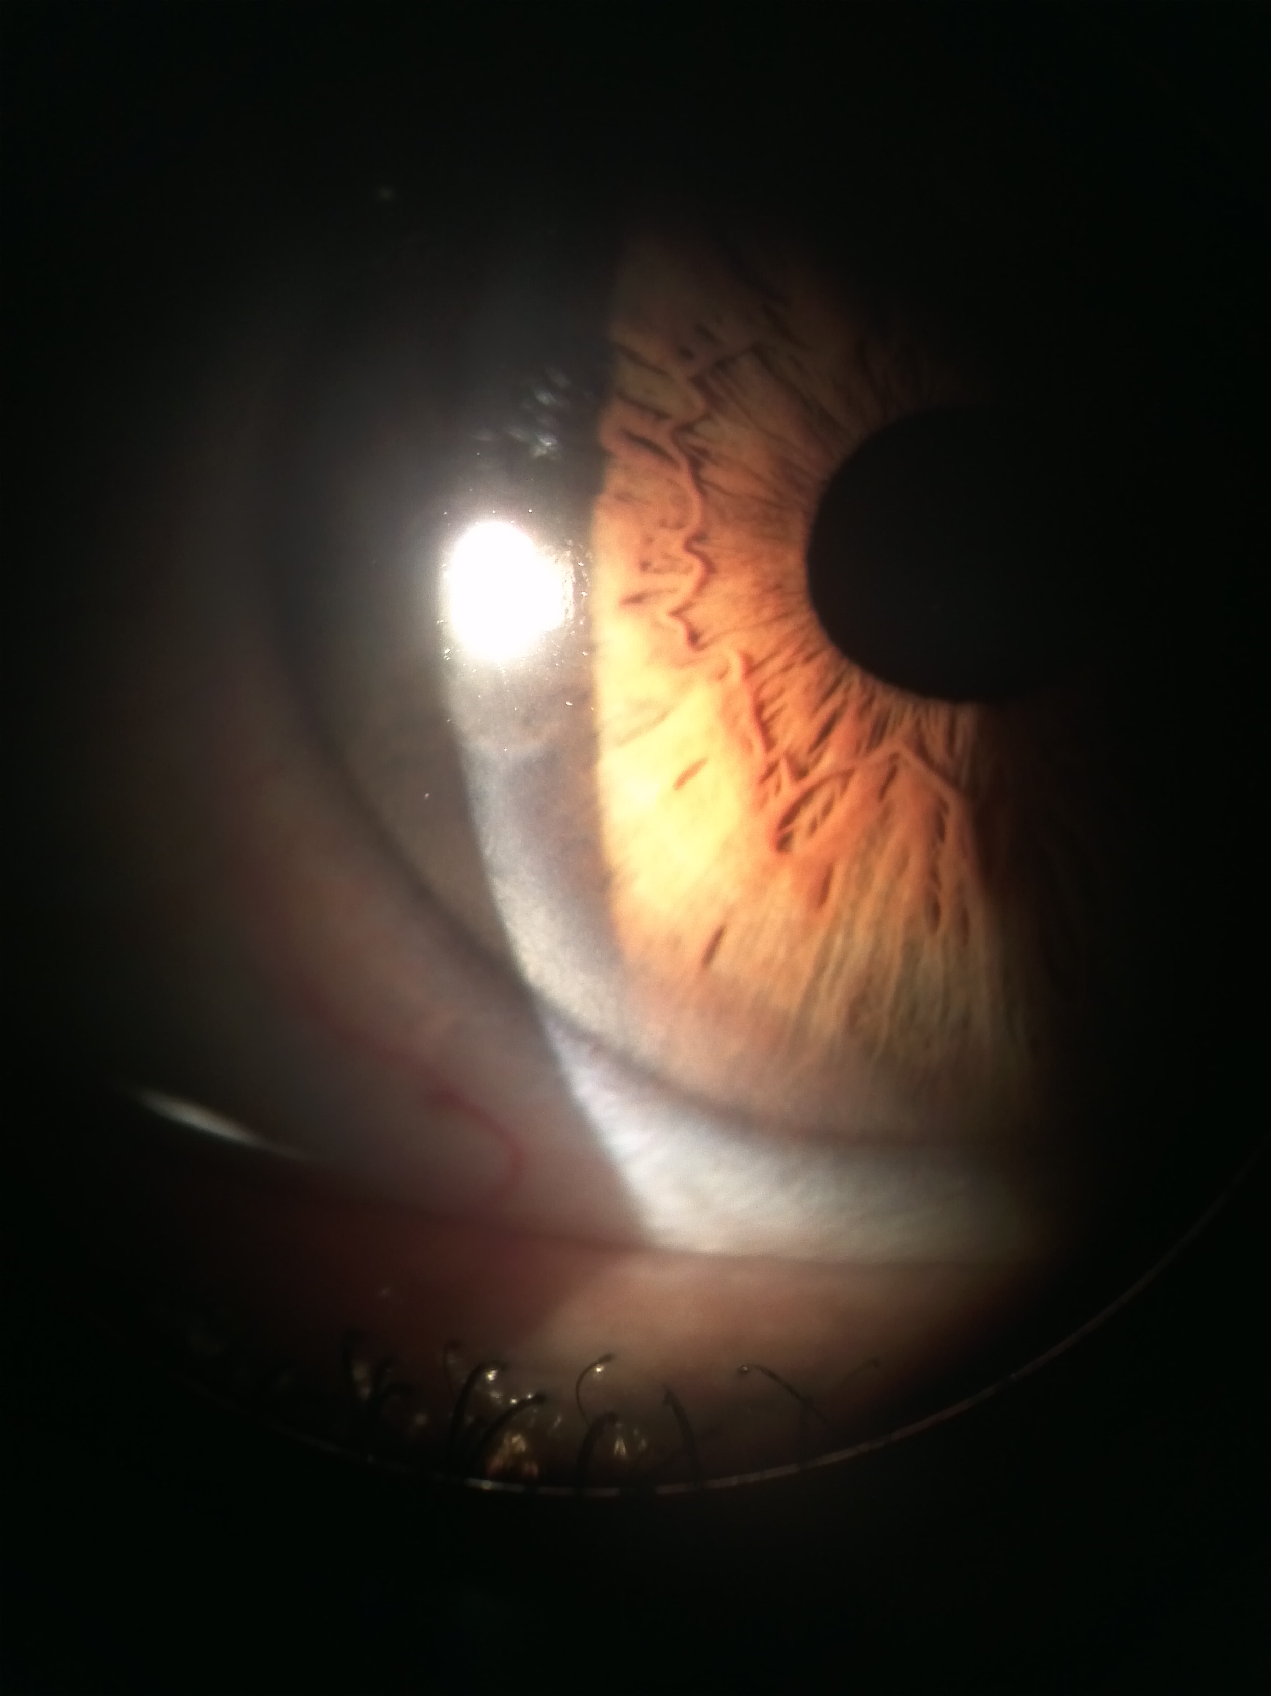

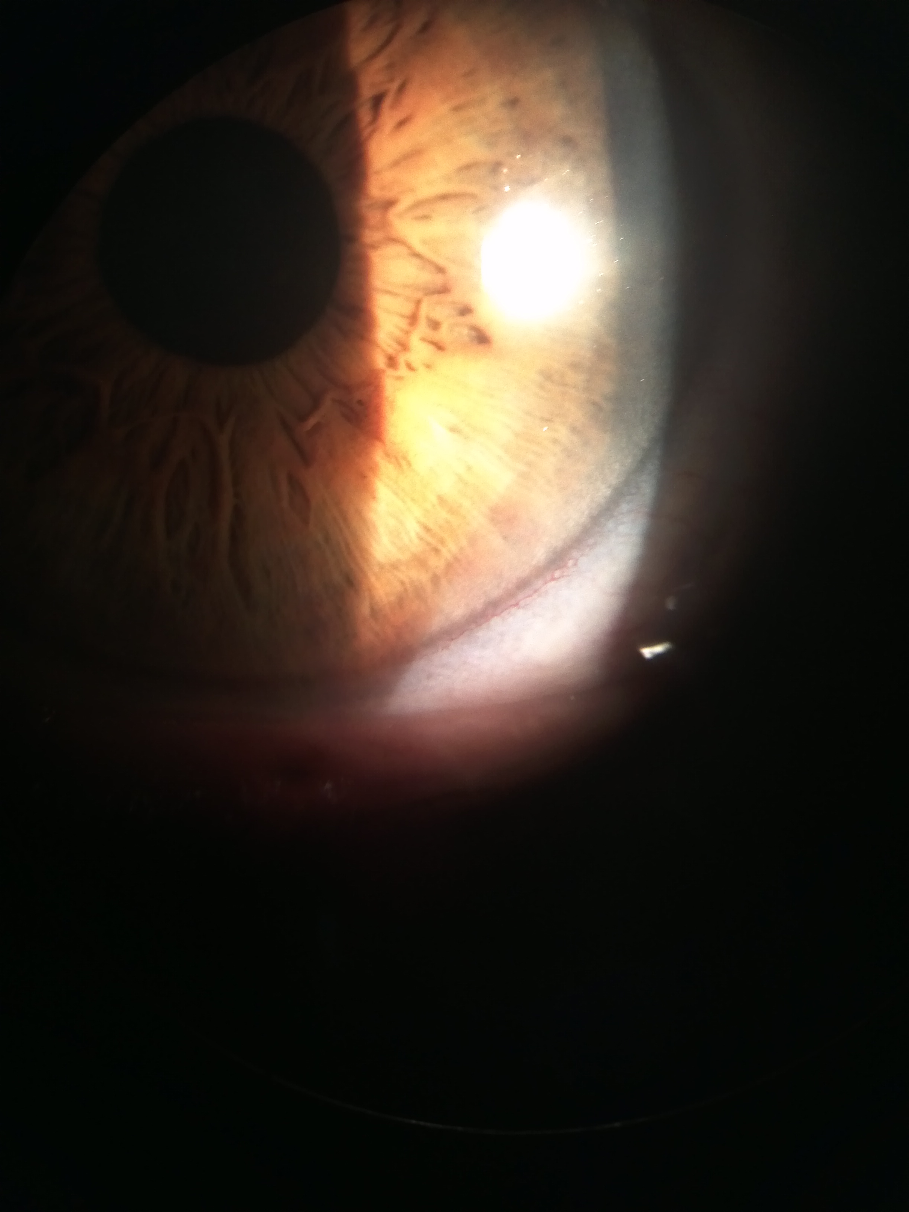

## Question 1 / 5

Given this patient's visual needs, you decide to fit him with progressive addition lenses (PALs). Which of the following represents the location in which the segment height should be measured?

a) At the height of his lower pupil margin

b) 2 mm above his lower eyelid margin

c) 3 mm below the center of his pupil

d) At the height of his lower eyelid margin

e) At the center of his pupil

## Question 2 / 5

The patient returns two weeks after receiving his glasses and complains that he has to tilt his chin down towards his chest in order to see distant objects clearly. How can you adjust his frame to help eliminate this problem?

a) Decrease the pantoscopic tilt

b) Increase the face wrap/face form

c) Push the nose pads closer together, pushing the frame up

d) Pull the nose pads further apart, dropping the frame down

## Question 3 / 5

Which of the following lens options would you recommend for a patient who works on the computer for long periods of time and reports that overhead fluorescent lighting is very bothersome?

a) A transition gray lens with a back surface anti-reflective coating

b) A light rose tinted lens with an anti-reflective coating

c) A polarized gray lens with an anti-reflective coating

d) A gray tinted lens with a mirrored front surface coating

## Question 4 / 5

The patient reports diplopia after 20 minutes of reading with his new glasses. You perform further binocular testing at near and decide to order a separate pair of single vision reading glasses made of high-index, aspheric lenses with 4 base-in prism. What is the BEST way to achieve 4 BI prism in these glasses?

a) Decenter the optical centers of the right and left lenses temporally

b) Decenter the optical centers of the right and left lenses nasally

c) Decenter only the optical center of the right lens temporally

d) Decenter only the optical center of the left lens nasally

e) The prescribed prism must be ground into the lenses

## Question 5 / 5

Which of the following terms represents the distortion that results from viewing a grid through a high plus-powered lens?

a) Pincushion distortion

b) Barrel distortion

c) Pear distortion

d) Star distortion

e) Tree distortion