Case yFFkiCAAwnCLQdEa8502 Details

**Demographics**

* 58-year-old black male; security guard

**Chief complaint**

* blurred vision

**History of present illness**

* Character/signs/symptoms:difficulty reading with current glasses; has to hold material too far away
* Location:OD, OS
* Severity:mild
* Nature of onset:gradual
* Duration:2 years
* Frequency:constant
* Exacerbations/remissions:vision is clear if he pushes near material away
* Relationship to activity or function:only occurs with near tasks; distance vision is adequate
* Accompanying signs/symptoms:eyestrain and fatigue

**Secondary complaints/symptoms**

* none

**Patient ocular history**

* blunt ocular trauma OD (10 years ago), herpes simplex keratitis (unsure of eye, 5 years ago); last eye exam 4 years ago

**Family ocular history**

* mother: glaucoma suspect

**Patient medical history**

* hypertension, hyperlipidemia, sleep apnea

**Medications taken by patient**

* hydrochlorothiazide, Lipitor®

**Patient allergy history**

* sulfa-based medications

**Family medical history**

* mother: hypothyroidism, father: hypertension, hyperlipidemia

**Review of systems**

* Constitutional/general health:denies
* Ear/nose/throat:denies
* Cardiovascular:denies
* Pulmonary:sleep apnea (uses CPAP)
* Dermatological:denies
* Gastrointestinal:denies
* Genitourinary:denies
* Musculoskeletal:denies
* Neuropsychiatric:denies
* Endocrine:denies
* Hematologic:denies
* Immunologic:denies

**Mental status**

* Orientation:oriented to time, place, and person
* Mood:appropriate
* Affect:appropriate

**Clinical findings**

**Habitual spectacle Rx**

* OD:-3.25 -0.75 x 175 add: +1.50; VA distance: 20/20, VA near: 20/30 @ 40 cm
* OS:-2.50 -1.25 x 010 add: +1.50; VA distance: 20/20, VA near: 20/30 @ 40 cm

**Pupils:**

* PERRL, negative APD

**EOMs:**

* full, no restrictions OU

**Confrontation fields:**

* full to finger counting OD, OS

**Subjective refraction**

* OD:-3.25 -1.00 x 170 add: +2.00; VA distance: 20/20, VA near: 20/20 @ 40 cm
* OS:-2.75 -1.00 x 008 add: +2.00; VA distance: 20/20, VA near: 20/20 @ 40 cm

**Slit lamp**

* lids/lashes/adnexa:unremarkable OD, OS
* conjunctiva:normal OD, OS
* cornea:1+ arcus OD, OS
* anterior chamber:deep and quiet OD, OS
* iris:normal OD, OS
* lens:clear OD, OS
* vitreous:clear OD, OS

**IOPs:**

* OD: 22 mmHg, OS: 23 mmHg @ 9:10 am by Goldmann applanation tonometry

**Fundus OD**

* C/D:see image 1
* macula:normal
* posterior pole:normal
* periphery:unremarkable

**Fundus OS**

* C/D:see image 2
* macula:normal
* posterior pole:normal
* periphery:unremarkable

**Gonioscopy:**

* open to ciliary body band, 1+ pigment inferior, (-) peripheral anterior synechiae, (-) angle recession OD, OS

**Blood pressure:**

* 114/76 mmHg, right arm, sitting

**Pulse:**

* 58 bpm, regular

**Threshold visual fields:**

* OD:see image 3
* OS:see image 4

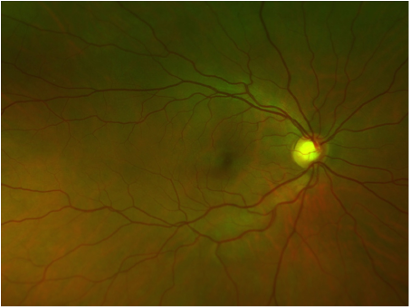

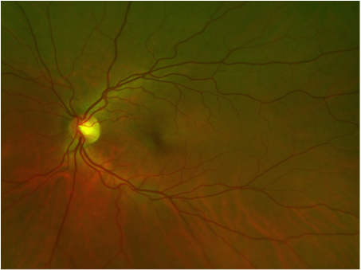

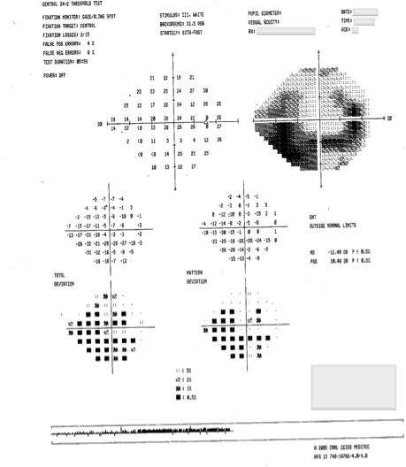

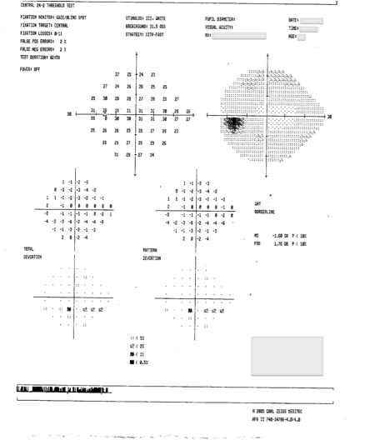

## Question 1 / 5

Considering the case history and examination findings, what is the MOST appropriate diagnosis for this patient?

a) Pigment dispersion glaucoma

b) Primary open angle glaucoma

c) Traumatic glaucoma

d) Physiologic optic nerve cupping

e) Normal tension glaucoma

f) Angle recession glaucoma

g) Ocular hypertension

## Question 2 / 5

Which of the following represents the MOST common early pattern of a glaucomatous visual field loss?

a) Enlarged blind spot

b) Inferior nasal step

c) Inferior arcuate

d) Paracentral scotoma

e) Superior arcuate

f) Superior nasal step

## Question 3 / 5

Which of the following BEST describes the etiology of increased intraocular pressure in the classic presentation of this patient’s condition?

a) Deposition of pigment within the trabecular meshwork

b) Increased aqueous production by active secretion

c) Resistance of outflow within the trabecular meshwork

d) Increased aqueous production through ultrafiltration

e) Damage to the trabecular meshwork from a history of trauma

## Question 4 / 5

After initiating treatment with topical IOP-lowering medications, when is the MOST appropriate time to follow-up with this patient?

a) 1 month

b) 3 months

c) 6 months

d) 1 day

e) 1 week

## Question 5 / 5

According to the American Optometric Association's Standards of Professional Conduct, "An optometrist has the duty to involve the patient in care and treatment decisions in a meaningful way, with due consideration of the patient's needs, desires, abilities, and understanding, while safeguarding the patient's privacy." Which of the following terms BEST describes this statement?

a) Justice

b) Non-maleficence

c) Patient autonomy

d) Beneficence