Case yREbIbRPmJgaPzNb5697 Details

**Demographics**

* 32-year-old Asian female; waitress

**Chief complaint**

* blurred vision and ocular discomfort

**History of present illness**

* Character/signs/symptoms:sees halos and rainbows around lights; experiencing mild eye pain
* Location:OD
* Severity:mild
* Nature of onset:acute
* Duration:1 day
* Frequency:constant
* Exacerbations/remissions:none
* Relationship to activity or function:none
* Accompanying signs/symptoms:none

**Secondary complaints/symptoms**

* none

**Patient ocular history**

* last eye exam 2 years ago; does not wear correction; had similar episode ~1 year ago, but it resolved on its own after 24 hours

**Family ocular history**

* paternal grandfather: cataracts

**Patient medical history**

* unremarkable

**Medications taken by patient**

* oral contraceptives

**Patient allergy history**

* NKDA

**Family medical history**

* mother: hepatitis C

**Review of systems**

* Constitutional/general health:denies
* Ear/nose/throat:denies
* Cardiovascular:denies
* Pulmonary:denies
* Dermatological:denies
* Gastrointestinal:denies
* Genitourinary:denies
* Musculoskeletal:denies
* Neuropsychiatric:denies
* Endocrine:denies
* Hematologic:denies
* Immunologic:denies

**Mental status**

* Orientation:oriented to time, place, and person
* Mood:appropriate
* Affect:appropriate

**Clinical findings**

**Uncorrected visual acuity**

* OD:VA distance: 20/50 (PHNI)
* OS:VA distance: 20/20

**Pupils:**

* PERRL, negative APD

**EOMs:**

* full, no restrictions OU

**Confrontation fields:**

* full to finger counting OD, OS

**Slit lamp**

* lids/lashes/adnexa:unremarkable OD, OS
* conjunctiva:trace injection OD, normal OS
* cornea:see image 1 OD, clear OS
* anterior chamber:trace cells (see image 2 OD), deep and quiet OS
* iris:normal OD, OS
* lens:clear OD, OS
* vitreous:clear OD, OS

**IOPs:**

* OD: 52 mmHg, OS: 12 mmHg @ 10:00 am by Goldmann applanation tonometry

**Fundus OD**

* C/D:0.35 H/0.35 V
* macula:normal
* posterior pole:normal
* periphery:unremarkable

**Fundus OS**

* C/D:0.35 H/0.35 V
* macula:normal
* posterior pole:normal
* periphery:unremarkable

**Blood pressure:**

* 101/68 mmHg, right arm, sitting

**Pulse:**

* 82 bpm, regular

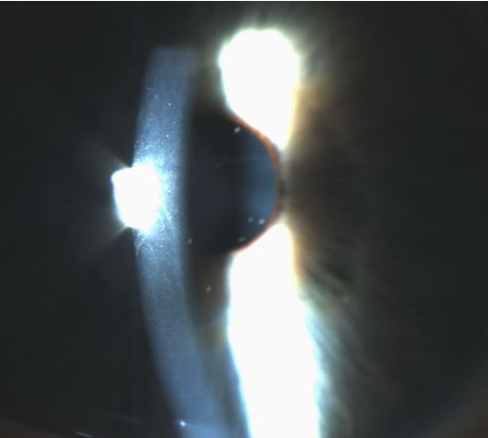

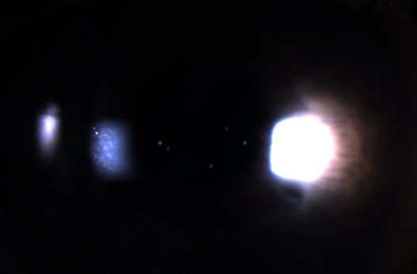

## Question 1 / 5

What is the MOST appropriate diagnosis of the patient's right eye condition?

a) Posner-Schlossman syndrome

b) Iritis

c) Acute angle-closure glaucoma

d) Pseudoexfoliation

e) Posterior uveitis

## Question 2 / 5

Considering this patient’s ocular condition, what findings would you expect to observe if gonioscopy were performed on the right eye?

a) An open angle

b) A heavily pigmented trabecular meshwork

c) Neovascularization of the iris

d) Plateau iris

e) A closed angle with only Schwalbe's line visible

f) Peripheral anterior synechiae

## Question 3 / 5

Which 2 of the following represent the MOST appropriate treatment for the patient's right eye condition? (Select 2)

a) Refer for lensectomy OD

b) Timolol maleate 0.5% b.i.d. OD

c) Prednisolone acetate 1% q.i.d. OD

d) Cyclopentolate 1% q.h.s. OD

e) Lumigan® q.h.s. OD

f) Refer for a laser peripheral iridotomy OD

## Question 4 / 5

After the initiation of treatment, when should the patient return to your office for a follow-up visit?

a) 1 week

b) 1-2 days

c) 6 months

d) 3 weeks

e) 1 year

f) 3 months

## Question 5 / 5

The patient returns to your office 6 months later and wishes to be fit with colored contact lenses. Which of the following agencies regulates contact lenses?

a) State Board of Optometry (SBO)

b) Contact Lens Manufacturing Association (CLMA)

c) American National Standards Institute (ANSI)

d) American Optometric Association (AOA)

e) Food and Drug Administration (FDA)