Case yjLJWjGydLjMtpbB6196 Details

**Demographics**

* 50-year-old white male; media director

**Chief complaint**

* referred by local optometrist for a glaucoma evaluation due to elevated intraocular pressure in the left eye

**History of present illness**

* Character/signs/symptoms:none; patient is asymptomatic
* Location:OS
* Severity:IOP was 20 mmHg OD and 29 mmHg OS at last exam
* Nature of onset:unknown
* Duration:unknown; was told by OD at his exam last month
* Frequency:unknown
* Exacerbations/remissions:unknown
* Relationship to activity or function:unknown
* Accompanying signs/symptoms:none

**Secondary complaints/symptoms**

* none

**Patient ocular history**

* last eye exam 1 month ago; wears SV reading glasses only

**Family ocular history**

* father: cataract surgery

**Patient medical history**

* unremarkable

**Medications taken by patient**

* multivitamins

**Patient allergy history**

* macrolides

**Family medical history**

* mother: heart disease

**Review of systems**

* Constitutional/general health:denies
* Ear/nose/throat:denies
* Cardiovascular:denies
* Pulmonary:denies
* Dermatological:denies
* Gastrointestinal:denies
* Genitourinary:denies
* Musculoskeletal:denies
* Neuropsychiatric:denies
* Endocrine:denies
* Hematologic:denies
* Immunologic:denies

**Mental status**

* Orientation:oriented to time, place, and person
* Mood:appropriate
* Affect:appropriate

**Clinical findings**

**Uncorrected visual acuity**

* OD:VA distance: 20/25
* OS:VA distance: 20/25

**Pupils:**

* PERRL, negative APD

**EOMs:**

* full, no restrictions OU

**Confrontation fields:**

* full to finger counting OD, OS

**Slit lamp**

* lids/lashes/adnexa:unremarkable OD, OS
* conjunctiva:normal OD, OS
* cornea:1+ pigment deposition on endothelium OD, OS
* anterior chamber:deep and quiet OD, OS
* iris:normal OD, loss of pupillary ruff, iridodonesis OS
* lens:clear OD, see image 1 OS
* vitreous:clear OD, OS

**IOPs:**

* OD: 22 mmHg, OS: 27 mmHg @ 1:15 pm by Goldmann applanation tonometry

**Fundus OD**

* C/D:see image 2
* macula:normal
* posterior pole:normal
* periphery:unremarkable

**Fundus OS**

* C/D:see image 3
* macula:normal
* posterior pole:normal
* periphery:unremarkable

**Blood pressure:**

* 130/84 mmHg, right arm, sitting

**Pulse:**

* 68 bpm, regular

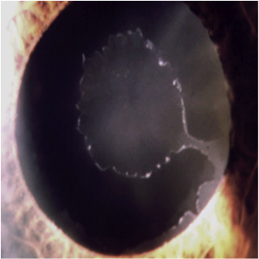

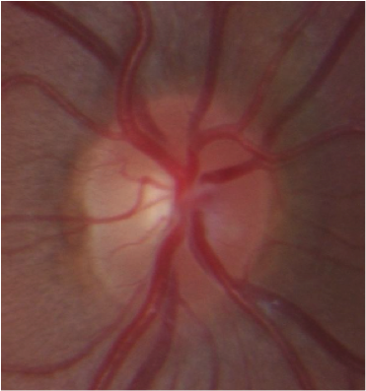

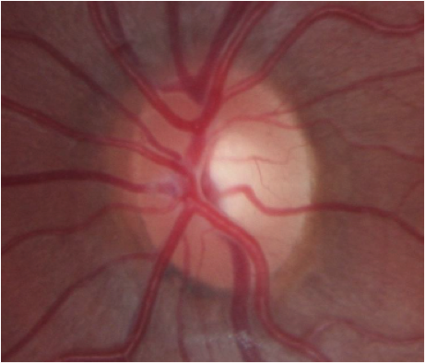

## Question 1 / 5

Which of the following represents the MOST appropriate diagnosis based on the patient's clinical examination findings?

a) Pseudoexfoliation syndrome

b) Ocular hypertension

c) Pigment dispersion syndrome

d) Normal tension glaucoma

e) Primary open-angle glaucoma

## Question 2 / 5

Iridodonesis observed in the left eye is MOST likely indicative of which of the following?

a) Weak lens zonules, causing the lens to move against the iris

b) Disinsertion of iris from the scleral spur

c) Weak iris sphincter muscles

d) Weak iris dilator muscles

## Question 3 / 5

Which of the following conditions is a possible secondary complication of the patient's ocular condition of the left eye?

a) Central serous chorioretinopathy

b) Epiretinal membrane

c) Posterior subcapsular cataract

d) Acute angle closure

e) Retinal detachment

## Question 4 / 5

If this patient is referred for cataract extraction with an intraocular lens implant, what should the patient be warned about that can occur at a higher rate than the average population?

a) Increased risk of post-surgical neuralgia

b) Increased risk of post-surgical macular edema

c) Increased risk of retinal detachment

d) Increased risk of posterior capsular opacification

e) Increased risk of dislocation of the lens implant

## Question 5 / 5

Which one of the following statements is TRUE regarding the intraocular pressure (IOP) findings commonly observed in patients with this condition?

a) Intraocular pressure is elevated due to faster rates of aqueous production

b) The intraocular pressure typically undergoes large diurnal fluctuations

c) The intraocular pressure usually responds well to topical treatment

d) Intraocular pressure is always asymmetric between the eyes