Case ykOLFrbLBresqwd10270 Details

**Demographics**

* 28-year-old Asian female; human resource director

**Chief complaint**

* itchy, red eyes

**History of present illness**

* Character/signs/symptoms:eyes are often itchy, red, and watery
* Location:OD, OS
* Severity:moderate
* Nature of onset:acute
* Duration:2 weeks
* Frequency:daily
* Exacerbations/remissions:worse towards the end of the day
* Relationship to activity or function:none
* Accompanying signs/symptoms:swollen eyelids due to frequent eye rubbing

**Secondary complaints/symptoms**

* none

**Patient ocular history**

* last comprehensive eye exam 5 years ago; no vision correction

**Family ocular history**

* father: fundus albipunctatus

**Patient medical history**

* unremarkable

**Medications taken by patient**

* oral contraceptives

**Patient allergy history**

* pollens and ragweed; NKDA

**Family medical history**

* mother: melanoma

**Review of systems**

* Constitutional/general health:denies
* Ear/nose/throat:denies
* Cardiovascular:denies
* Pulmonary:denies
* Dermatological:denies
* Gastrointestinal:denies
* Genitourinary:denies
* Musculoskeletal:denies
* Neuropsychiatric:denies
* Endocrine:denies
* Hematologic:denies
* Immunologic:denies

**Mental status**

* Orientation:oriented to time, place, and person
* Mood:appropriate
* Affect:appropriate

**Clinical findings**

**Uncorrected visual acuity**

* OD:distance: 20/20, near: 20/20 @ 40 cm
* OS:distance: 20/20, near: 20/20 @ 40 cm

**Pupils:**

* PERRL, negative APD

**EOMs:**

* full, no restrictions OU

**Confrontation fields:**

* full to finger counting OD, OS

**Subjective refraction**

* OD:plano -0.50 x 175; VA distance: 20/20
* OS:-0.25 -0.25 x 010; VA distance: 20/20

**Slit lamp**

* lids/lashes/adnexa:trace erythema and edema of upper eyelid OD, OS
* conjunctiva:1+ bulbar injection and chemosis, 1+ inferior palpebral papillae OD, OS
* cornea:clear OD, OS
* anterior chamber:deep and quiet OD, OS
* iris:normal OD, OS
* lens:clear OD, OS
* vitreous:clear OD, OS

**IOPs:**

* OD: 19 mmHg, OS:19 mmHg @ 4:45 pm by Goldmann applanation tonometry

**Fundus OD**

* C/D:0.15 H/0.15 V
* macula:normal
* posterior pole:normal
* periphery:see image 1

**Fundus OS**

* C/D:0.15 H/0.15 V
* macula:normal
* posterior pole:normal
* periphery:unremarkable

**Blood pressure:**

* 108/78 mmHg, right arm, sitting

**Pulse:**

* 68 bpm, regular

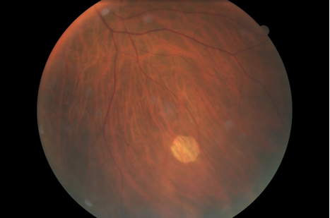

## Question 1 / 5

What is the MOST appropriate diagnosis of the patient's retinal condition as observed in image 1?

a) Gyrate atrophy

b) RPE window defect

c) Atrophic retinal hole

d) Geographic atrophy

e) Cobblestone degeneration

## Question 2 / 5

What is the MOST appropriate treatment for the patient's retinal condition?

a) Refer for genetic testing

b) Start AREDS II vitamin supplements

c) Refer for cryotherapy

d) Refer for laser photocoagulation

e) Monitor annually

## Question 3 / 5

Given your suspected diagnosis based on the patient’s chief complaint and examination findings, which of the following topical ophthalmic preparations would be appropriate for once a day use?

a) Zaditor®

b) Patanol®

c) Alrex®

d) Lastacaft®

e) Cromolyn sodium

f) Acular®

## Question 4 / 5

If preauricular nodes were to be evaluated on this patient, which of the following results would you expect to observe?

a) Unilateral, tender, palpable node

b) Bilateral, non-tender, palpable nodes

c) Bilateral, tender, palpable nodes

d) Bilateral, tender, non-palpable node

e) Unilateral, non-tender, palpable node

f) Bilateral, non-palpable, non-tender nodes

## Question 5 / 5

If an optometrist has completed a residency in contact lenses, which of the following statements is TRUE regarding the standards of professional conduct adopted by the American Optometric Association?

a) The optometrist does not have to release a written copy of a specialty contact lens prescription

b) Because the optometrist is more advanced in contact lenses, he or she may NOT charge insurance plans for medically necessary contact lenses

c) The optometrist may advertise that he or she specializes in contact lenses

d) Only optometrists who completed a residency in contact lenses should fit specialty contact lenses

e) The optometrist may charge a higher fee for a difficult contact lens fitting