**Mechanical Subsystem**

The importance of having a mechanical subsystem in housing solutions can not be felt under the circumstances in which it relaxes one the most. Having built a fantastically beautiful infrastructure but lacking the implementation of the mechanical aspect into it, tragedies like Sick Building Syndrome become inevitable consequences.

Mechanical systems are responsible for maintaining thermal comfort in the house. Regulating heat, airflow, ventilation, air conditioning, and plumbing networking of an entire building falls in its domain.

Now that the team is aiming for net positive self-sustained housing solutions, all subsystems, including the mechanical team, have to look for approaches to fulfill the aim. To achieve it, the team is focusing on solar thermal heat to minimize its dependence on the electricity generated by the PV Solar panel. The team is also focusing on passive ways to maintain thermal comfort so that the house becomes self-sustained with minimal maintenance cost.

**Innovations**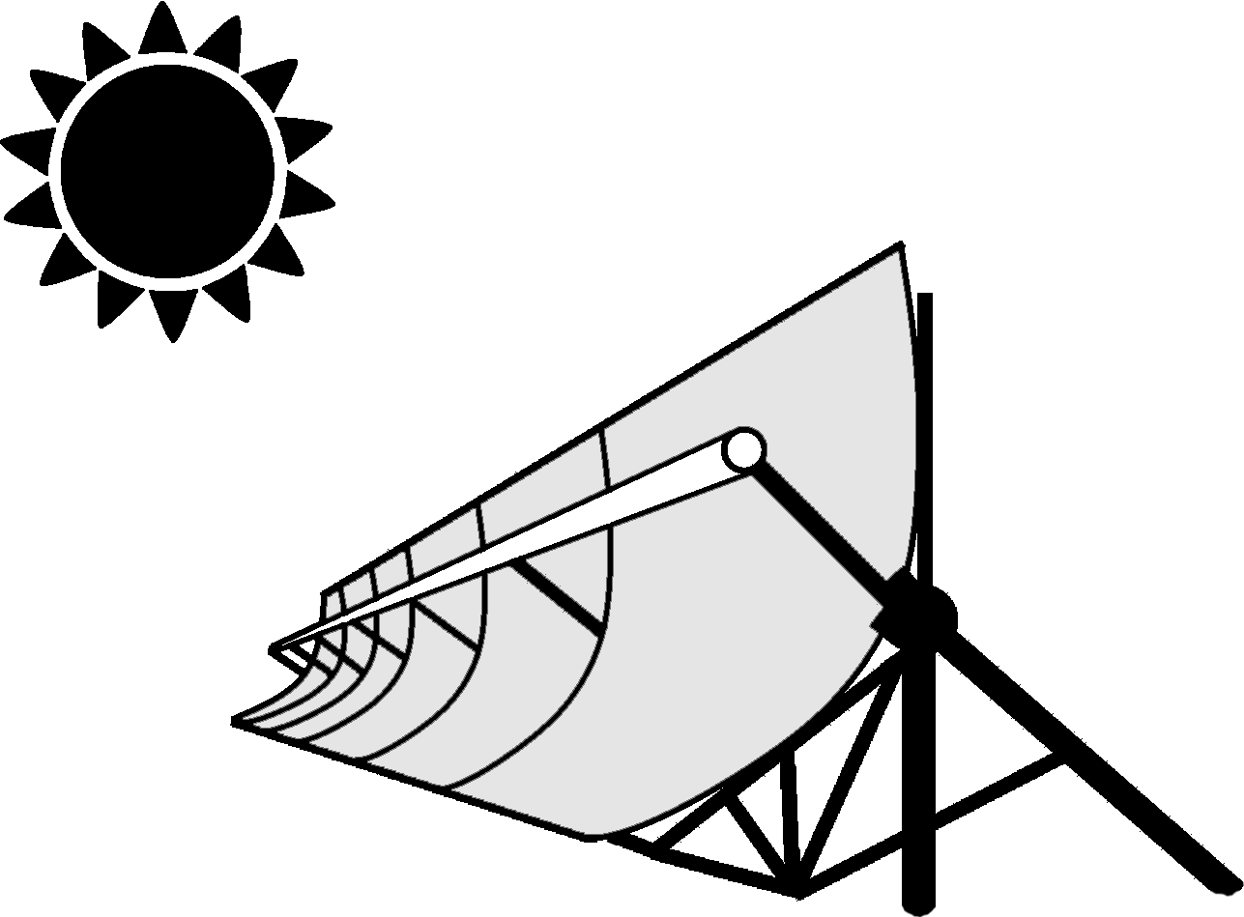

## **Solar Thermal:**

Solar thermal systems are generally up to 70% more efficient in capturing heat from sun rays than solar PV systems. Thus, we plan to integrate the solar thermal system to meet the thermal energy requirements of the house viz. water heating, cooking, and clothes drying. A conventional commercially available Evacuated Tube Collector-based solar water heater will accomplish water heating in the house.   
*Image Link:* [Click Here](https://drive.google.com/file/d/1jUw2jFg4FydQwOS8f9B2PJWY8_qCPd3z/view?usp=sharing)

## **Solar Cooking:**

Team Shunya aims to incorporate an innovative solar thermal oven suitable for household use, generating temperatures of about 220-240 oC, and storing heat. The oven will be based on a novel seasonally tracked solar thermal collector developed in HPL at IIT Bombay by Prof M V Rane.

The collector is an evacuated glass tube-based concentrated type solar collector with absorber integrated heat storage. The thermal efficiency of the collector is 40-60% based on global solar insolation. The international search report on a patent filed by HPL_IITB confirmed novelty, utility, and non-obviousness of the present collector design. Cost-effectiveness, use of sustainable materials, durability, lightweight, and less maintenance are the key features of the design.   
*Image Link:* [Click Here](https://drive.google.com/file/d/1rfjlknRu1zoEuA_wKpJL4n2wvKBHk463/view?usp=sharing)

## **Clothes Dryer:**

Drying clothes is one of the essential requirements in any residential building. Being able to dry clothes quickly and in an energy-efficient manner is a remarkable achievement of the team. Team Shunya’s house will be equipped with a custom clothes dryer. That will use the waste heat from the ODU of the air conditioning unit and hot water from the solar thermal water heater in aluminium pipes. The clothes will be hung on the same aluminium pipe to counter the energy load of the mechanical dryer and slow sunlight drying.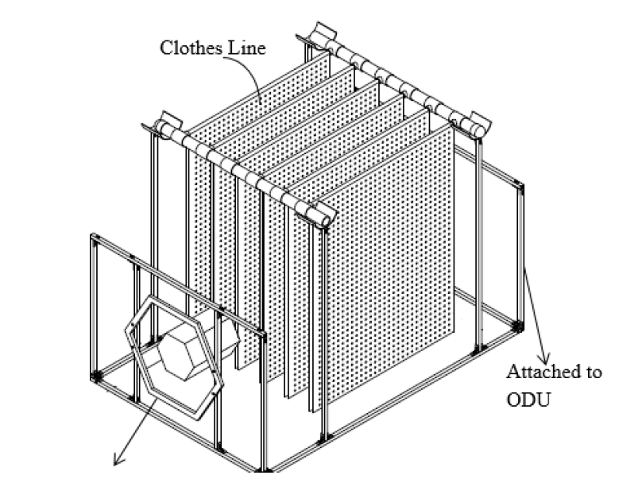

Energy conservation, affordability, ease of operation, portability, and ease of manufacturing are the key impacts of the design. The design can cut down up to 80% electricity consumption for clothes drying and thus recuperating the sustainability of the house. The technology was successfully implemented in the Project H-Naught of Team Shunya. Project H-Naught was a solar-powered house designed for the Solar Decathlon Europe 2014. The technology implemented in the cloth dryer has already been filed for the patent.

*Image Link:*  [Click Here](https://drive.google.com/file/d/1eVTKNtXAMV6-AmYzRTTmhfgC08Mer1o5/view?usp=sharing)

**FacAd Details**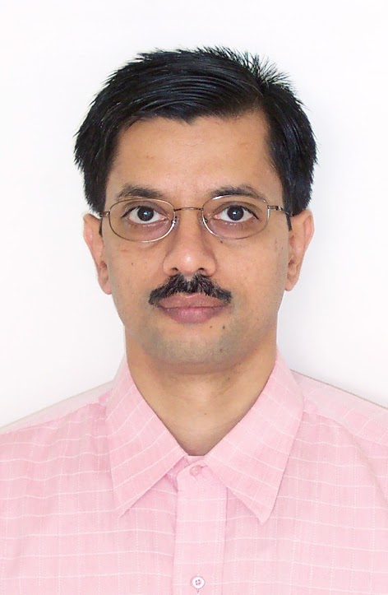

**Prof. M. V. Rane** is a leading researcher in HVAC and solar thermal applications in cooling and heating. He received the Bry-Air Awards for Excellence in HVAC&R. 12 Patents signed by him through IIT Bombay have been granted.

*Department:* Mechanical Engineering

*Personal Website:* <https://sites.google.com/view/ranemv>

*Email ID:*  [ranemv@iitb.ac.in](mailto:ranemv@iitb.ac.in)

*Image Link:*  [Click Here](https://drive.google.com/file/d/1dmGrOQ4ywdkwkZP0UmoGjOr3TXAEGgy6/view?usp=sharing)

**PoC**

1. Akshata Nagare

Third Year, Dual Degree, ME Department

[17D100003@iitb.ac.in](mailto:17D100003@iitb.ac.in)

+91-7506274848

1. Yash Mandhana

Third Year, Dual Degree, ME Department

[170100039@iitb.ac.in](mailto:170100039@iitb.ac.in)

+91-7774037322

1. Md Saif Ansari

Third Year, B.Tech, ME Department

[mdsaifansari@iitb.ac.in](mailto:mdsaifansari@iitb.ac.in)

+91-9131383154

**Repository**

Image Folder: [Click Here](https://drive.google.com/drive/folders/1-mXaFVjCFd18YFeNZCAZwsIQjrOAxxYV?usp=sharing)