# Website Brief:

VoucherCodesDirect.co.uk

# Web Design Brief for VoucherCodesDirect.co.uk

## Background

### A Short Overview

VoucherCodesDirect.co.uk (VCD) is an online voucher / discount code site allowing users to search a database of brands or categories to ﬁnd a discount code for a retailer who is advertising discount code offers on the site.

The discount code sector is a successful one as it taps into the users who are looking to get a good deal on the products they are looking to purchase.

As a startup business we will need to develop a robust website and gather good retailers / vendors to advertise their offers on this new site.

Please note that all IP for the design and programming will be owned by us upon the completion of the project. We will however be looking for a long term relationship for future additional functionality added later.

## Budget and Deadline

The budget for this project is £140 using a trusted freelance developer to deliver this site within 4 weeks.

## Your target audience

VDC is targeted at the pierce / offer conscious individual looking to source good deals on the items / product or service they are looking to purchase. The site is aimed at 18+ ranging from students to workers and families.

We will be looking to deploy Google Analytics, Search Console and Crazyegg.com etc. systems into the site so we can better understand our users and what they are looking for while browsing for voucher codes.

## Your current website

As this is a new business the VoucherCodesDirect.co.uk domain doesn’t have a site currently on it with this brief being used to develop the ﬁrst site for the business.

## Main Aims and Objectives

The site will need to be clean and easy to use for our customers, they should be able to search via a search feature using keywords or brand name to quickly ﬁnd vouchers that may interest them. The site must carry forward the clean brand design and use of warm inviting colours would be a beneﬁt to make the site as welcoming as possible rustling in the highest level of user conversions as it can.

## Website Competitors

We are entering a market that is already established by some big players but this doesn’t mean we can’t get a good share of the users looking for offers. Most of the sites in this sector all have similarities which makes us think it's a winning formula. Some of our competitors are listed below:

**MyVoucherCodes.co.uk** - a well established nice and clean site that is easy to use. They may want to consider putting brands and categories as A-Z but then they might be promoting the top sectors ﬁrst.

**VoucherCodes.co.uk** - Again they have a very simple to use site with good search box prominence.

**Codes.co.uk** - Another nice and clean site that has a clear search box at the top of the site but seems to have more categories in the navigation than other sites do.

**NetVoucherCodes.co.uk** - This site has less in the main navigation than the other sites and no search bar to get your attention but rather a search that you click on then it appears for you to type. We are not too keen on this way of doing it as we want the user to quickly see and search.

## Website you like

As already mentioned we are looking for the site to be clean and tidy so it is very easy for the users to navigate and search the site and then ﬁnd and copy the code for use on the retailers website. If they click on the link to the retailers site it will embed the code in the URL for the retailers site to use for tracking.

## Web Content

We must be able to maintain all pages created as well as add new pages as needed so the site must have CMS capabilities for example WordPress. This is also important for us to be able to optimise the pages for better search engine rankings.

All pages that need content will be provided by word or google docs so that they can be placed in the site as its built or place holder text put in place for us to then change via the CMS before launch.

The site will not be heavy on imagery as we will ask the retailers to provide us with their logo to place on their discount offers example below:

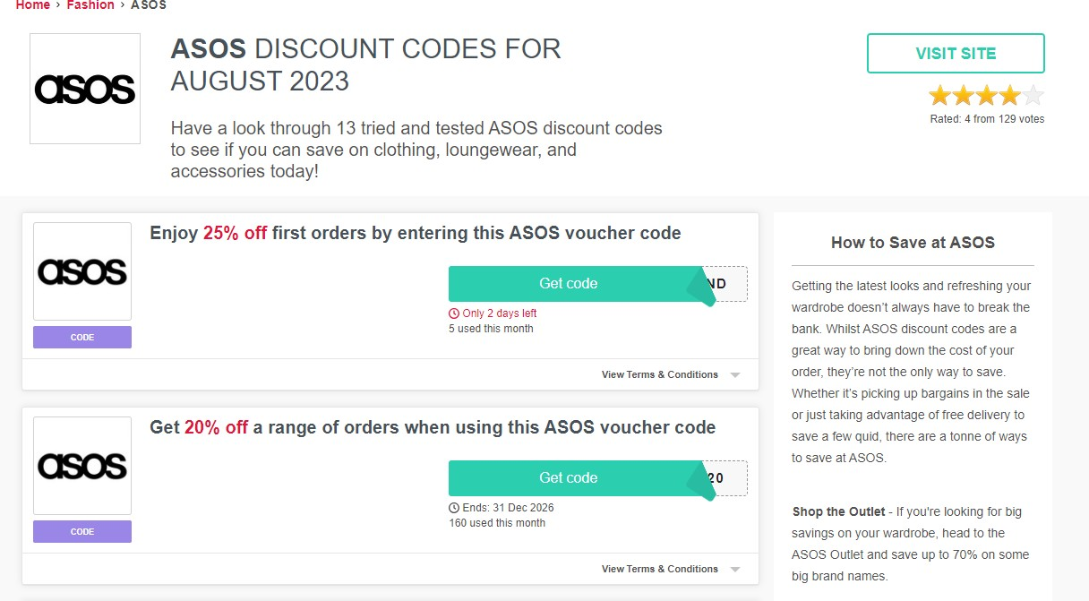

## Branding and Marketing

A logo for VCD is currently underway and will be used as the basis for the site. As soon as this has been done we will share this with the web design and development team to allow you to carry forward the brand look, feel and colours.

### Brand Direction

We are happy to allow some degree of ﬂexibility on the site design as the key is making it clean and easy to use.

It will be important to allow early views of the design concept so we can ensure time isn’t wasted on something that doesn’t ﬁt what we need.

## Technicalities

1. Add, Remove and Edit Merchants.
2. Add, Remove, Edit and Archive Code
   1. Select Merchant
   2. Affiliate / Voucher Code
   3. Deal Description
   4. Expiry Date
   5. Other information e.g. special terms
3. Search Voucher Codes
   1. Show top deals
   2. Type search term
      1. Show results
4. Add remove and edit Brands (A-Z)
   1. Adidas
   2. AO.com
   3. Currys
   4. Etc….
5. Add, remove and edit Categories and Sub-Categories
6. The ability to hide brands, Categories, Sub-Categories and pages like blog.
7. User Account - Signup / login
   1. My Account
      1. My Details
         1. First Name
         2. Last Name
         3. Email
         4. Gender- Male / Female / Unspecified
         5. Date of Birth - Day / Month / Year
         6. Mobile Number
         7. Postcode
         8. Country
         9. Current Password - encrypted
         10. New Password - encrypted
         11. Save
   2. Logout

The above is a bullet point list of main technical abilities. If any expansion is needed please let us know and we will expand as best we can.

## 11. Website Support

It is likely that we may think and wish to add additional functionality once the site is live however any bugs found in the system at any time will need to be supported and resolved at no extra cost as they would be issues from the initial project development that require ﬁxing.

Upon taking on the project you are deemed to be agreeing to this support but we are fair that any additional functionality asked for will be at an extra cost that we will agree before the work is done.

As with all our projects we are looking to build a long term relationship with the developers doing this work as it helps with ongoing site development and growth.