Reward Design with Generalized Prioritized Sweeping in Taxi-v4
Student: Ali Shawahna, Maimas Aamar, Rober Saliba
Course: Reinforcement Learning
Date: July 2026

1. AI Use Disclaimer
We used AI assistance from OpenAI’s ChatGPT/Codex and Anthropic’s Claude during this project to support understanding of RL concepts, debugging, checking project requirements, improving the experiment runner, and revising parts of the report. After we decided on the project architecture, reward designs, and experiment structure, AI helped draft and refine implementation snippets and explanations. All AI-suggested code, text, and conclusions were reviewed, tested, and adapted by us against the project instructions and the actual results. The final implementation decisions, experiment interpretation, conclusions, and responsibility for the submission remain ours.

2. Work Beyond the Minimum Requirements
The minimum project requires four reward designs, SARSA, prioritized sweeping, a generalization mechanism, reward comparison, parameter sweeps, component ablations, plots, and policy visualization. This project includes those core parts and adds several extra pieces:
- Five reward designs are implemented instead of four.
- The fifth reward is a custom Composite Remaining Path reward.
- The reward comparison plot uses a normalized environment reward so different training reward scales do not distort the main comparison.
- Trained Q-tables are saved under results/models, so policies can be visualized without retraining.
- A --fast mode gives a short single-seed development run.
The extra reward design is discussed in Section 5.5. The normalized reward comparison is discussed in Section 9.2. The saved-policy visualization workflow is discussed in Section 8 and Section 13.

3. Environment and Map
The project uses Gymnasium Taxi-v4 with the default Taxi map. The code attempts to create the environment with is_rainy=False, as required. If the installed Gymnasium version does not support that argument, the code falls back to the standard deterministic Taxi-v4 environment.
Taxi-v4 has 500 discrete states and 6 actions: south, north, east, west, pickup, and dropoff. The state is decoded as:
(taxi_row, taxi_col, passenger_location, destination)
The passenger can be at one of four landmarks or inside the taxi. The destination is one of the same four landmarks. This representation is used by the custom rewards and by the kernel generalization mechanism.

4. Algorithm Specification
The base learner is tabular SARSA with epsilon-greedy action selection. The SARSA update is:
Q(s, a) <- Q(s, a) + alpha * delta
delta = r + gamma * Q(s_next, a_next) - Q(s, a)
The implementation uses one agent class, GeneralizedSweepingSARSAAgent, with flags for prioritized sweeping and kernel generalization. This keeps the ablations consistent because the same code path is used with components switched on or off.
Main hyperparameters in the full framework:
alpha = 0.5
gamma = 0.99
epsilon starts at 0.3
epsilon_min = 0.01
epsilon_decay = 0.05 ** (1 / (0.6 * num_episodes)) (per-episode multiplicative)
planning_steps n = 5
theta = 1e-4
beta = 4.0
c = 0.5
max_kernel_neighbors = 4
kernel_scale = 0.5
The discount factor was fixed at gamma = 0.99 across all reward comparisons, parameter sweeps, and component ablations. We kept gamma constant intentionally because changing gamma would change the discounted MDP itself and would make the reward and algorithm comparisons less meaningful.
Epsilon decays multiplicatively each episode with decay factor 0.05 ** (1 / (0.6 * num_episodes)). This factor is chosen so epsilon shrinks to about 5% of its starting value after 60% of training (for example, with 500 episodes the factor is about 0.9901, so epsilon reaches roughly 0.015 around episode 300 and then settles at epsilon_min = 0.01). This keeps meaningful exploration for most of the run while still leaving a small amount of random action selection at the end.

4.1 Why These Hyperparameters Were Chosen
Each value in the specification above was selected for a concrete reason, and several of the choices were later validated by the parameter sweep:
- alpha = 0.5 (learning rate). Alpha balances learning speed against noise and oscillation in the value estimates. Taxi with is_rainy=False is deterministic, so each observed transition is exact and there is little stochastic noise to average out; this allows a relatively high learning rate without destabilizing the Q-table. A very small alpha (for example 0.1-0.2) wastes episodes because value information propagates slowly along the long pickup-dropoff routes; a very large alpha combined with planning can overshoot, because planning replays model transitions whose stored values may be stale. The parameter sweep (Section 9.3) confirmed that low alpha = 0.2 was consistently the weakest setting for both swept rewards.
- gamma = 0.99 (discount factor). The Taxi payoff is delayed: the +20 dropoff reward arrives only after a route of roughly 10-20 steps. A discount factor close to 1 makes the agent “look far ahead”, so the terminal reward remains visible through the whole route instead of being drowned out by the per-step -1 penalty. With a low gamma, the discounted value of the distant dropoff would be negligible compared to immediate step costs, and the greedy policy would have little reason to head toward the goal. Gamma was fixed at 0.99 across every experiment, as the project requires, because changing gamma changes the discounted MDP itself and would contaminate any comparison between rewards or components.
- epsilon schedule (start 0.3, multiplicative decay, min 0.01). The starting value 0.3 gives enough random exploration to discover the full pickup-then-dropoff sequence early, which is essential for the sparse reward in particular. The decay factor 0.05 ** (1 / (0.6 * num_episodes)) anneals exploration so that epsilon reaches roughly epsilon_min after about 60% of training; the remaining 40% of episodes train nearly on-policy-greedy, which matters because SARSA is on-policy: the Q-values converge toward the value of the policy actually being followed, so the final policy quality is determined by the late low-epsilon phase. Keeping epsilon_min = 0.01 instead of 0 preserves a small amount of exploration so the agent cannot lock permanently into a bad action loop during training.
- n = 5 (planning steps). Each planning step pops the highest-priority transition and propagates its TD error backward through the model. Five steps per real step are enough to push new information several cells back along a corridor within a single episode. The sweep showed diminishing or even negative returns from deeper planning for the penalty-heavy Reward 4, because planning replays whatever the model contains - including early, biased, penalty-dominated estimates.
- beta = 4, c = 0.5 (kernel shape). These values create a deliberately tight and sharp similarity neighborhood: K(d=1) is about 0.12 and K(d=2) is about 0.003, so only immediately adjacent taxi positions receive a meaningful generalized update. This conservatism is intentional. The kernel distance is Manhattan distance, which ignores Taxi’s walls; a wide, soft kernel (small beta, large c) would leak value information across walls between positions that are actually far apart along legal paths. A sharp kernel limits that structural error to at most one cell.
- max_kernel_neighbors = 4 and kernel_scale = 0.5. Restricting each update to the 4 closest compatible neighbors bounds the per-step cost of generalization (the project spec suggests 10-20; the deterministic small map makes an even tighter cap sufficient). The additional 0.5 scaling damps the generalized updates, treating them as hints rather than full observations, since the neighbor’s stored transition may be older than the current estimate.
- theta = 1e-4 and queue size 5000. Priorities below theta are discarded so the planning queue is not flooded with negligible updates, and the bounded queue caps memory. Both are standard prioritized-sweeping hygiene and had no visible effect on final quality.

4.2 Prioritized Sweeping
After each real SARSA update, the agent stores the observed transition in an internal model:
M(s, a) = (r, s_next, done)
The absolute TD error is used as the priority. High-priority state-action pairs are pushed into a priority queue. During planning, the agent pops high-priority transitions and performs SARSA-style model updates. The next action during planning is selected with the same epsilon-greedy action rule, which keeps the update on-policy in the SARSA sense.
This is not simple Dyna-Q. Simple Dyna-Q would sample previously observed transitions more uniformly. Here, transitions with larger estimated learning impact receive planning attention first.

4.3 Kernel Generalization
The generalization mechanism updates nearby, semantically compatible state-action pairs after a real transition. The kernel is:
K(s, s_hat) = 1 / (1 + exp(beta * (d(s, s_hat) - c)))
Here, d is the Manhattan distance between taxi positions. The kernel is symmetric because the Manhattan distance is symmetric. Two Taxi states are considered candidates for generalization only when they have the same passenger status/location and the same destination. This is important because two nearby taxi positions can belong to completely different subtasks if the passenger or destination differs.
The kernel update uses the neighbor’s own stored transition:
delta_hat = r_hat + gamma * Q(s_hat_next, a_hat_next) - Q(s_hat, a)
Q(s_hat, a) <- Q(s_hat, a) + alpha * K(s, s_hat) * delta_hat
The implementation applies kernel generalization only to movement actions. Pickup and dropoff are not generalized because their validity depends on exact location. This avoids spreading illegal pickup/dropoff values into nearby but invalid states.

5. Reward Designs
The project implements five rewards. The first two are required baselines, rewards 3 and 4 are custom required rewards, and reward 5 is an extra custom reward.

5.1 Base Environment Reward
The base reward is the reward returned by Taxi-v4:
R = R_base
This reward preserves the original environment objective. It is the most direct way to measure whether the agent is solving the task according to Taxi’s native scoring.

5.2 Sparse Reward
Sparse reward ignores most feedback:
R = 1.0 if successful dropoff
R = 0.0 otherwise
This design is conceptually clean but difficult for learning. Most transitions provide no useful signal, so the agent must discover the full pickup-and-dropoff sequence before it receives meaningful feedback.

5.3 Reward 3: Dense Target Progress Reward
Reward 3 gives immediate feedback for moving toward the current subgoal. Before pickup, the target is the passenger. After pickup, the target is the destination.
progress = old_distance_to_target - new_distance_to_target
R = 0.75 * progress - 0.05
+ 2.0 for successful pickup
+ 5.0 for successful dropoff
- 2.0 for illegal pickup/dropoff
- 0.5 for wall bump
The intuition is that navigation should be reinforced before the final dropoff. This can reduce the exploration burden compared with sparse reward because the agent receives a signal even before completing the full task.

5.4 Reward 4: Subgoal Safety Reward
Reward 4 emphasizes safe task completion:
R = -0.10
+ 3.0 for successful pickup
+ 10.0 for successful dropoff
- 4.0 for illegal pickup/dropoff
- 1.0 for wall bump
- 0.25 when moving away from the current target
This reward is designed to strongly discourage illegal pickup/dropoff actions and wall bumps while still rewarding the two meaningful subgoals: pickup and final dropoff. It should help when illegal actions are the main failure mode, but the stronger penalties can also make learning more sensitive to alpha and planning depth.

5.5 Reward 5: Composite Remaining Path Reward
Reward 5 measures whether the estimated full remaining task becomes shorter. If the passenger is not inside the taxi:
remaining = distance(taxi, passenger) + distance(passenger, destination)
If the passenger is already inside the taxi:
remaining = distance(taxi, destination)
The reward is:
R = (remaining_before - remaining_after) / 16.0
- 0.02
+ 1.0 for successful dropoff
- 0.3 for illegal pickup/dropoff
This reward is a full replacement reward, not base reward plus shaping. It gives a task-level signal: the agent is rewarded when the whole remaining route is estimated to become shorter. A limitation is that Manhattan distance ignores Taxi walls, so the distance is a heuristic rather than an exact shortest path.

6. Summary of Findings
The main finding is that reward design, planning, and generalization interact strongly. The best reward is not simply the one with the largest internal training reward scale. For comparison across reward designs, the fairest metrics are environment reward, normalized environment reward, success rate, and illegal-action count.
In the latest reward comparison, Base Environment Reward and Composite Remaining Path Reward reached strong final performance. Over the last 50 episodes per seed, the base reward reached 100% success and the Composite reward reached 99.2% success, both with near-perfect normalized environment reward (0.999 and 0.998). Sparse Reward also improved, but it retained many illegal actions and lower environment reward because the agent receives little guidance before success. Reward 3 and Reward 4 were more difficult under the shared full-framework hyperparameters. This does not mean the reward ideas are useless; it means their scales and penalties interact with alpha, planning, and exploration.
The ablation results show that all base-reward setups eventually reached high success, but their final environment reward and illegal-action behavior differed. Kernel generalization alone was particularly strong in the final tail (final environment reward 5.76, the best of the four setups). Prioritized sweeping alone finished weakest (-1.74) even though it also reached 100% success, because with imperfect early values planning can replay and amplify those estimates, leaving more residual illegal actions in the tail. The full framework remains important because it combines real SARSA updates, model-based replay, and local value propagation, but it requires careful hyperparameter selection.
The parameter sweep supports this interpretation. For the base reward, every cell of the 3x3 grid reached 100% final success, but the learning rate separated the cells clearly: alpha = 0.2 left the final environment reward around -20 to -27, while alpha = 0.5 and 0.8 reached positive values around +2 to +4, with the single best cell at alpha = 0.5 and n = 10. This validates the alpha = 0.5 used in the main experiments. For Reward 4, no swept setting solved the task; final success rose monotonically with alpha (from about 0% at alpha = 0.2 to 20-28% at alpha = 0.8), and at alpha = 0.5 deeper planning made the environment reward strictly worse (-242 at n = 2 down to -272 at n = 10). This suggests that the penalty-heavy safety reward needs stronger learning updates to escape its passive local optimum, and that planning replays penalty-dominated estimates and entrenches that passivity.

7. Experiment Setup
The latest available result files use:
Environment: Taxi-v4, is_rainy=False when supported
Seeds: [1, 2, 3, 4, 5]
Reward comparison episodes: 500
Component ablation episodes: 500
Parameter sweep episodes: 400
Smoothing window: 50 episodes
Confidence interval: 95% across 5 seeds
The reward comparison trains the full framework on all five rewards. The component ablation compares four setups under the base reward:
- Pure SARSA.
- SARSA + Prioritized Sweeping.
- SARSA + Kernel.
- Full Framework: SARSA + Prioritized Sweeping + Kernel.
Regarding which reward designs see the sweeps and ablations: the custom-reward side of this requirement is covered by the Reward 4 parameter sweep, while the component ablation is deliberately kept on the base reward in order to isolate the algorithmic effects of planning and kernel generalization from reward-design effects. Running the ablation on the base reward means that any difference between the four setups can only come from the components themselves, not from an interaction with a custom reward scale.
The parameter sweep evaluates two parameters:
alpha in {0.2, 0.5, 0.8}
planning_steps n in {2, 5, 10}
The sweep is run for Base Environment Reward and Reward 4, so both the base reward and a custom designed reward are evaluated in the sweep section.
The main metrics were chosen because each one captures a different part of policy quality:
- Environment reward: Taxi-v4's original accumulated reward over an episode. We chose it as the main task-quality metric because it combines the final dropoff reward, the per-step cost, and illegal-action penalties under the original environment objective. Higher environment reward usually means a shorter, cleaner, more efficient route.
- Normalized environment reward: environment reward scaled relative to the optimal reward achievable from the same initial state. We chose it for cross-reward comparison because different reward designs use different internal training scales, and different start states have different optimal path lengths. A value close to 1.0 means the policy is close to the best possible behavior for that start state.
- Success rate: the fraction of episodes that end with a successful dropoff. We chose it because it answers the most basic question: did the policy complete the pickup-and-dropoff task at all? It separates policies that solve the task from policies that only collect partial progress.
- Illegal actions: the number of invalid pickup/dropoff attempts in an episode. We chose it as the error/correctness metric because a policy can sometimes reach the goal while still making many invalid actions. Lower illegal-action count means the learned behavior is safer, cleaner, and more aligned with the Taxi rules.
For the main visual comparison we emphasize three interpretable metrics across the experiment families: accumulated environment reward, success rate, and illegal actions. Together they separate route quality, task completion, and policy errors. We did not use training reward as a cross-reward comparison metric because the designed rewards have different scales. We also avoided claiming unique-state and mean-TD-error plots in the final report because those metrics are not currently saved in the main result CSV files. The analysis therefore focuses on metrics that are present, reproducible, and comparable across the saved runs.

8. Saved Policy Visualization
The project supports two saved-policy visualization paths. For the clearest live demo across all saved seeds and reward designs, use the dedicated script:
python run_trained_model.py
In addition to the live demo command, the submission includes generated saved-policy GIF animations under reports/policy_animations/. These GIFs are attached as submission artifacts, not only referenced in the source code. They provide compact visual examples for each reward design. Rewards that complete the regular greedy episode are saved as policy GIFs, while Reward 4 is submitted as a regular failed attempt because its learned greedy policy does not complete the task reliably.
base_policy.gif
sparse_policy.gif
reward_3_policy.gif
reward_4_regular_attempt.gif
reward_5_policy.gif
The GIFs were produced from Gymnasium render_mode="rgb_array" frames using saved Q-tables from results/models, via make_policy_gifs.py. The GIF generator now renders a fixed regular episode by default rather than searching for the easiest successful start state. This makes the animations representative demonstrations rather than cherry-picked best cases. Taxi-v4 allows the taxi itself to start from any valid grid cell the colored landmarks restrict the passenger and destination locations. Reward 4 is intentionally submitted as reward_4_regular_attempt.gif because the regular greedy episode illustrates the penalty-dominated behavior discussed in Sections 9.2 and 9.3.
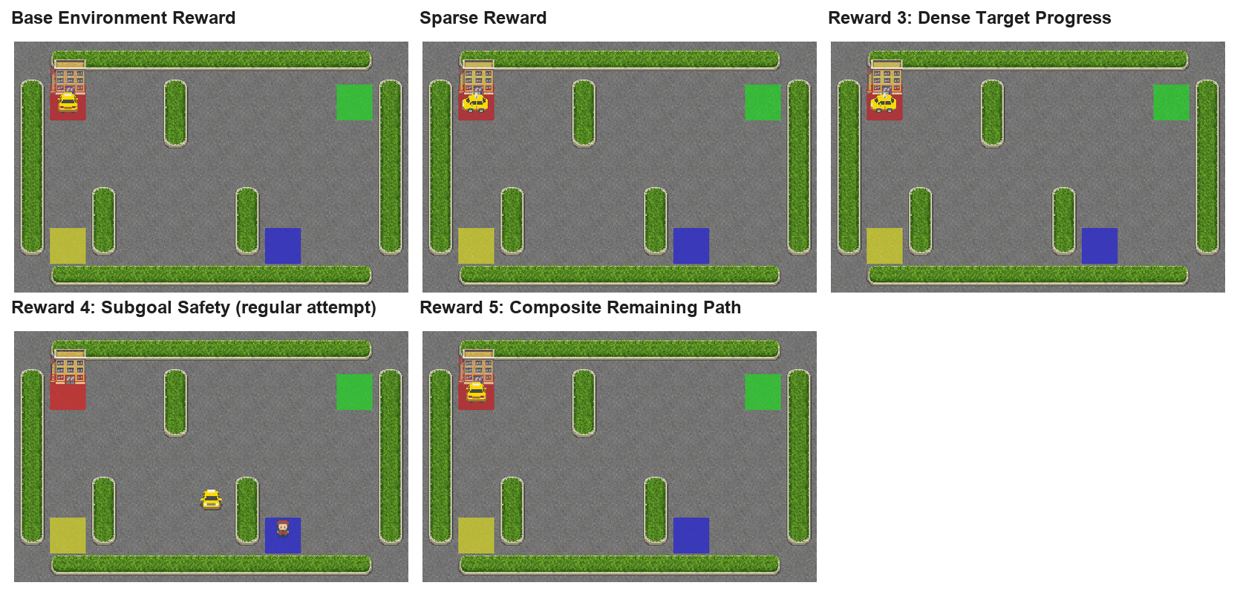
Regular saved-policy animation contact sheet
The same saved policies can be visualized live with clear per-step printing and loop stopping via:
python run_trained_model.py
Optional focused single-policy visualization:
python main.py --visualize-saved --visualize-reward base --seed 1
The live animation uses Gymnasium's native Taxi display (render_mode="human"). During demonstration, epsilon is set to 0 so the animation shows the pure greedy policy. run_trained_model.py prints the loaded model, seed, reward type, step-by-step state/action/reward information, and stops quickly when a loop is detected. The optional main.py visualizer remains useful for focused single-policy checks, but the dedicated script is clearer for reviewing all saved rewards and seeds.
During development, some saved policies succeeded immediately while others entered loops for certain start states. This is a useful reminder that one animation is not the whole evaluation. The learning curves, final-tail metrics, confidence intervals, and attached GIF artifacts should be interpreted together.

9. Results and Deep Interpretation

9.1 Component Ablation
The ablation compares the contribution of prioritized sweeping and kernel generalization under the base reward.
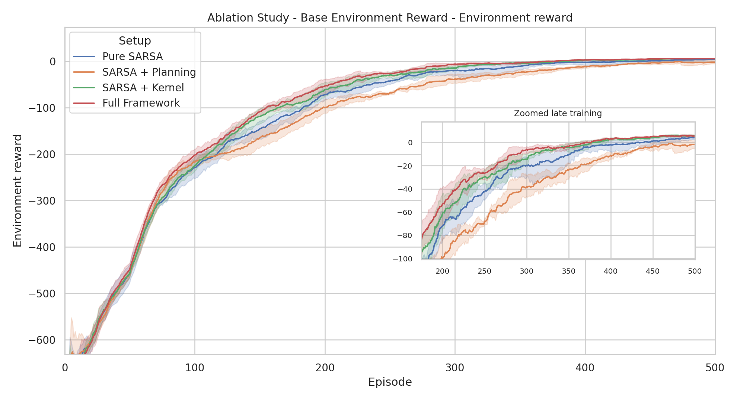
Ablation base environment reward
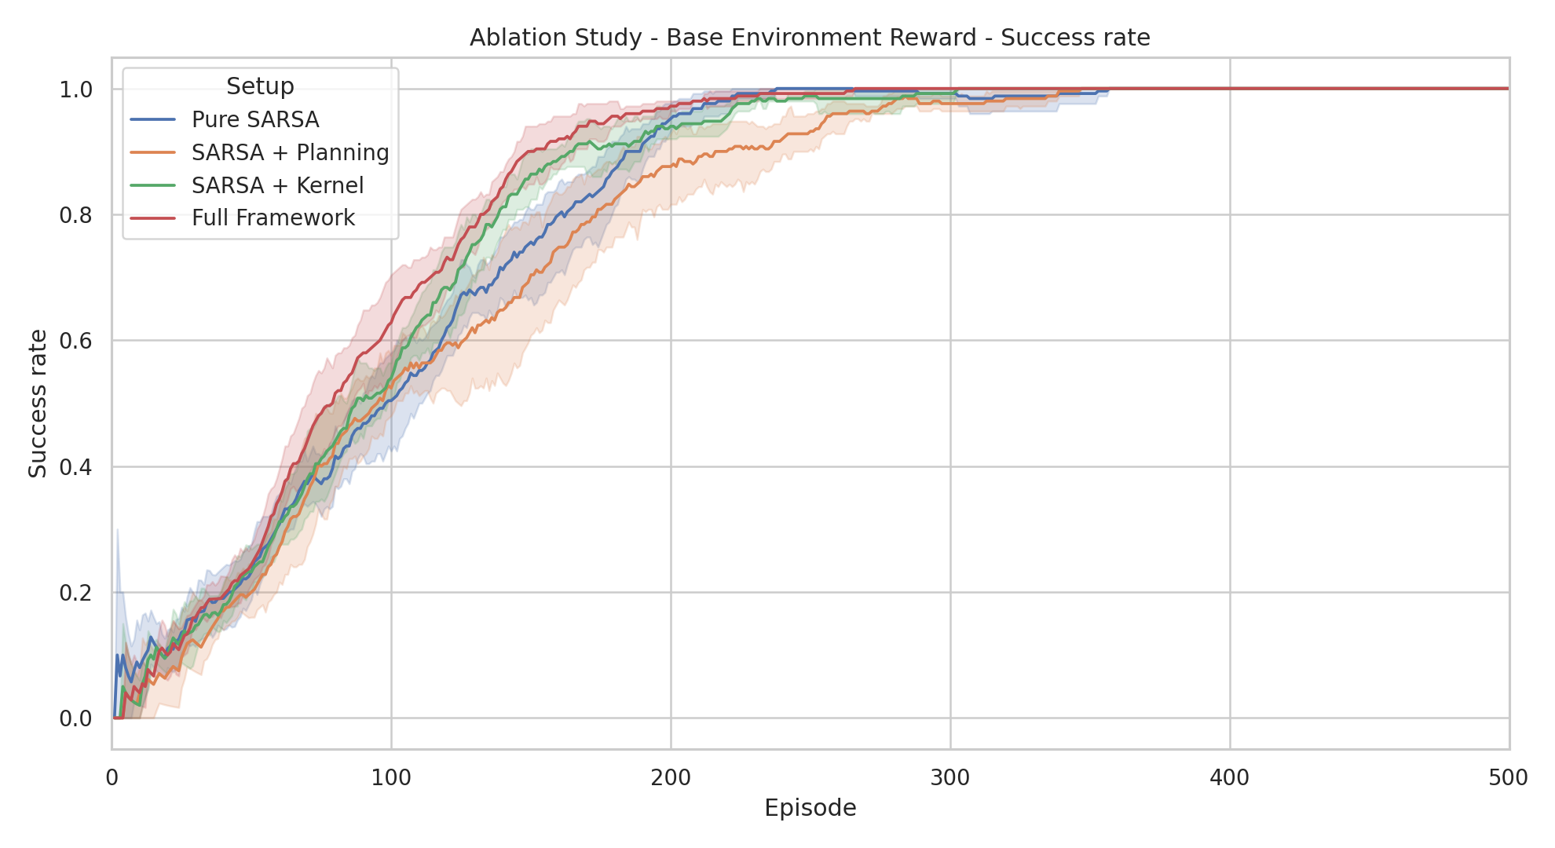
Ablation base success rate
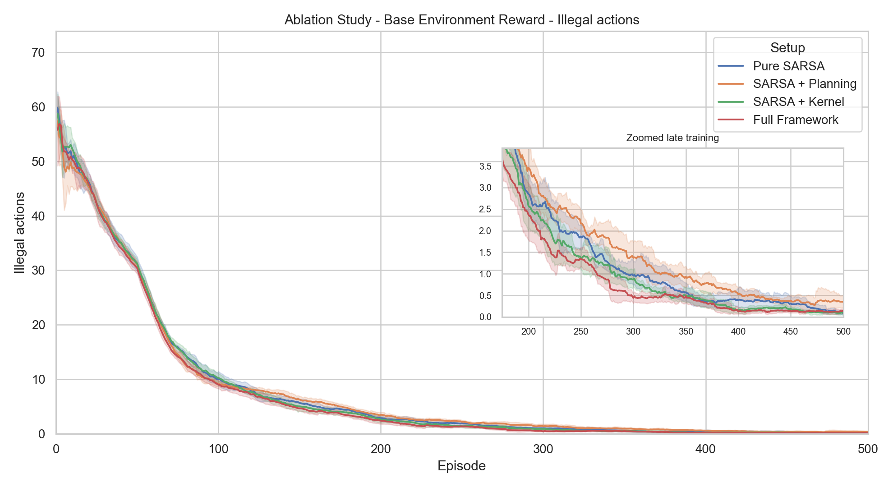
Ablation base illegal actions
How to read these plots: the x-axis is the training episode (1-500). The three displayed metrics are environment reward, success rate, and illegal actions. Environment reward measures route quality under the original Taxi-v4 objective; success rate measures task completion: illegal actions measure policy errors. Each curve is the mean over 5 seeds, the shaded band is the 95% confidence interval across those seeds, and a rolling mean with window 50 is applied to make the curves readable. Higher environment reward and success are better, while lower illegal-action count is better.
In the final 50-episode tail, all four base-reward setups reached 100% success in the current results. The final mean environment reward was approximately:
Pure SARSA: 4.28
SARSA + Planning: -1.74
SARSA + Kernel: 5.76
Full Framework: 5.48
The ablation graphs show why kernel generalization was more useful than planning alone in this setting. Kernel SARSA finished with the strongest environment reward because nearby Taxi states with the same passenger status and destination often need similar movement decisions. The kernel therefore spreads useful value information to nearby compatible states before each state has to be visited many times. Planning SARSA was weaker because it reuses transitions already stored in the model; early in training many stored transitions come from exploratory, inefficient, or illegal behavior, so replay can amplify imperfect estimates. This is why all methods eventually learn the task, but kernel generalization produces cleaner final behavior than planning alone.
The illegal-action graph explains why success rate alone is not enough. All four ablation variants eventually reach high success, but planning-only keeps slightly more invalid pickup/dropoff attempts in the late phase. Those extra mistakes reduce environment reward even when the episode still ends successfully. Kernel and full-framework policies are better here because they not only complete the task, but also complete it with fewer rule violations.

9.2 Reward Comparison
The reward comparison uses the full framework for all reward designs. Since internal training rewards have different scales, the main environment reward plot is normalized.
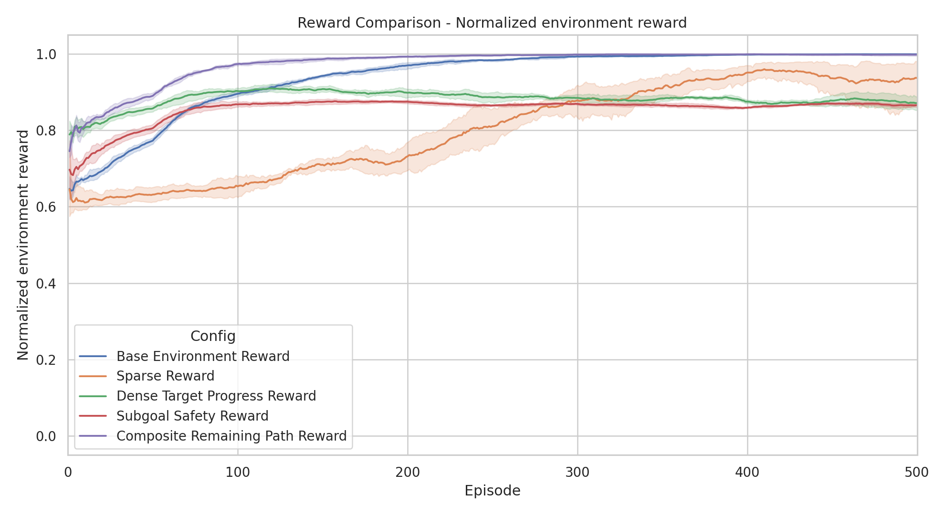
Reward comparison normalized environment reward
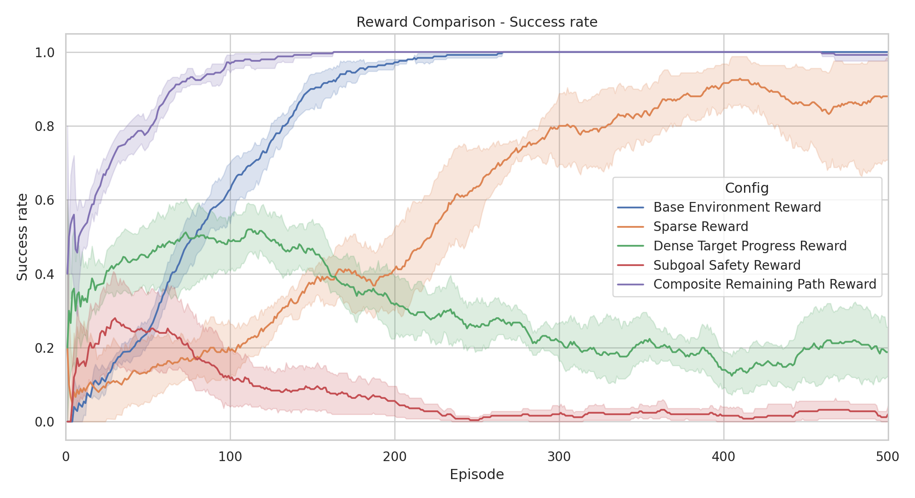
Reward comparison success rate
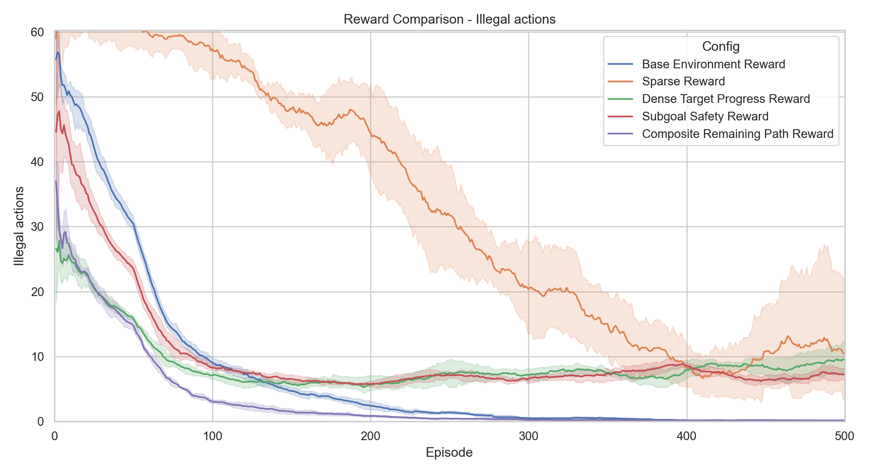
Reward comparison illegal actions
How to read these plots: the x-axis is the training episode. The first plot shows normalized environment reward, where 1.0 means the episode achieved the optimal environment reward possible from its start state. The second plot shows success rate, meaning the fraction of episodes ending in a successful dropoff. The third plot shows illegal actions, which is the error/correctness metric: lower values mean fewer invalid pickup/dropoff attempts. All curves are means over 5 seeds with a 95% confidence interval band and rolling-mean smoothing with window 50.
Over the final 50 episodes per seed, the approximate results were:
Base: env 5.48, success 1.000, illegal 0.14, normalized 0.999
Sparse: env -118.79, success 0.880, illegal 10.47, normalized 0.937
Reward 3: env -250.99, success 0.188, illegal 9.55, normalized 0.871
Reward 4: env -261.78, success 0.020, illegal 7.20, normalized 0.866
Reward 5: env 3.26, success 0.992, illegal 0.10, normalized 0.998
The reward-comparison graphs show that a reward is better only if it produces successful, efficient, and clean behavior under the original Taxi-v4 objective. Base reward and Reward 5 are the strongest because they reach very high success while keeping illegal actions low, so their high normalized reward is meaningful rather than accidental. Sparse reward eventually succeeds in many episodes, but it is worse because the agent receives little guidance before dropoff, so learning is slower and invalid actions persist. Reward 3 and Reward 4 are worse under the shared hyperparameters because their replacement reward scales create harder optimization problems: Reward 3 does not reliably turn progress into full task completion, and Reward 4 penalizes mistakes so strongly that the learned policy often becomes cautious or passive instead of completing the task.
The illegal-action comparison gives the clearest reason why Base and Reward 5 are preferable. They drive invalid actions almost to zero, which means the learned policies are not only successful but also well-behaved. Sparse reward has more illegal actions because it gives no intermediate correction signal, so the agent can keep trying invalid pickup/dropoff actions while searching for rare successes. Reward 3 and Reward 4 also keep higher error levels, which shows that their reward signals did not consistently teach clean execution under the same training budget.

9.3 Parameter Sweep
The parameter sweep compares learning rate and planning depth for the base reward and Reward 4.
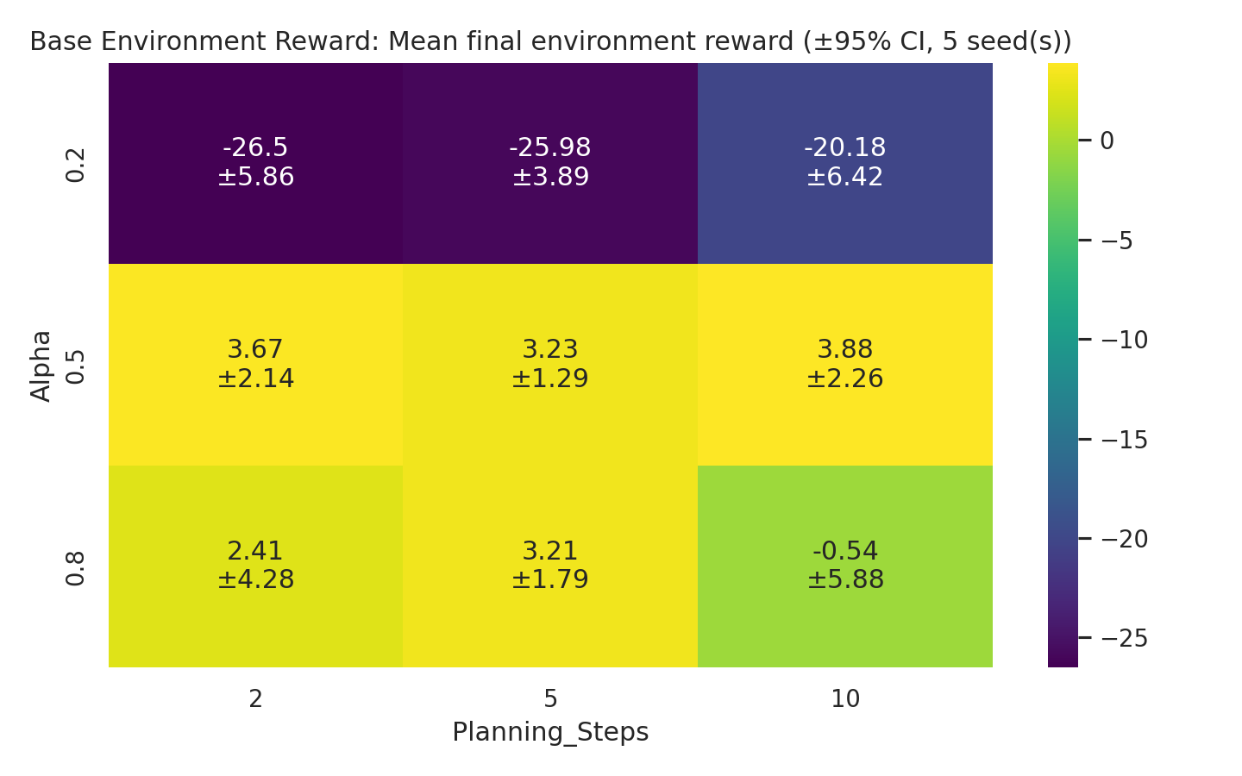
Parameter sweep base heatmap
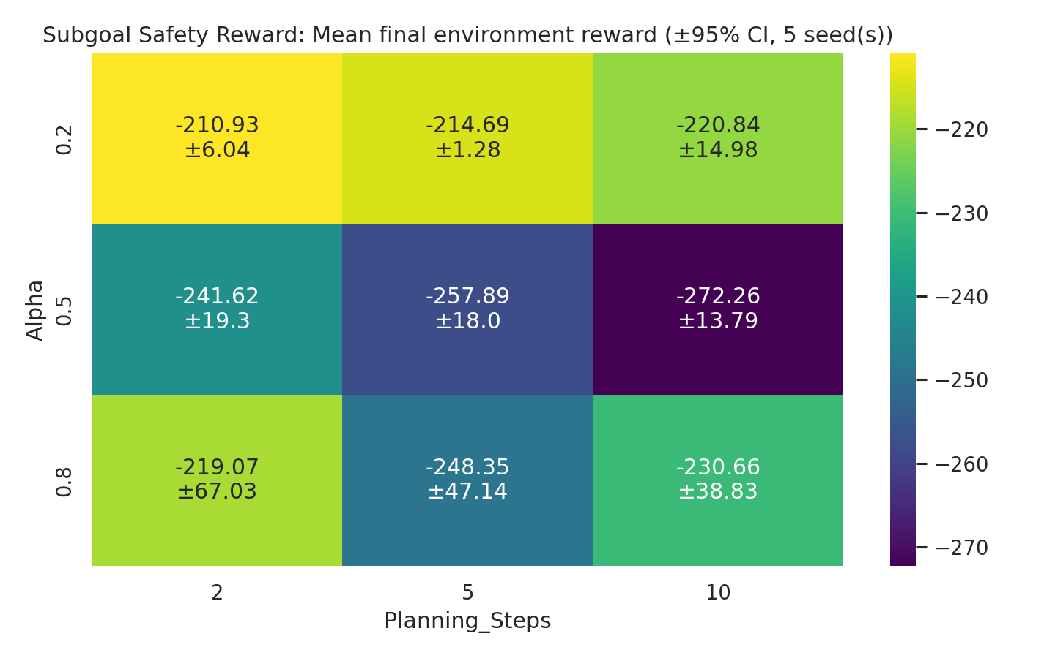
Parameter sweep reward 4 heatmap
How to read these heatmaps: rows are learning-rate values (alpha in 0.2, 0.5, 0.8), columns are planning depths (n in 2, 5, 10), and each cell shows the mean environment reward over the final 50 episodes, averaged over 5 seeds, together with its 95% confidence interval (the +/- value in each cell). Brighter cells are better. The sweep uses 400 training episodes per configuration.
For the base reward, all nine cells eventually solve the task, so the heatmap is mainly about efficiency rather than basic success. Alpha = 0.2 is worse because updates are too small: value information propagates slowly along the pickup-dropoff route, so the agent needs more episodes to clean up its policy. Alpha = 0.5 and 0.8 are better because they move values fast enough to learn efficient routes within the training budget. Planning depth has a smaller effect once alpha is healthy; n = 10 is sometimes slightly better, but the gain is small relative to the extra runtime. This supports the chosen default of alpha = 0.5 and n = 5 as a balanced setting rather than chasing a tiny improvement at much higher planning cost.
For Reward 4, the heatmap shows a different failure mode. Higher alpha helps because the pickup/dropoff bonuses must overcome the strong accumulated penalties, but even the best swept settings remain much weaker than the base reward. Deeper planning is not automatically better here: when the model is filled early with penalty-heavy experience, planning replays those estimates and can reinforce passive behavior. This is why Reward 4 remains worse even after tuning alpha and planning depth: the reward design itself pushes the agent toward avoiding mistakes rather than actively completing the task.
Together, the heatmaps show that hyperparameters and reward design interact. A good reward can tolerate a range of planning depths once the learning rate is reasonable, while a harsh replacement reward can remain poor even after tuning. The practical conclusion is that better numerical rewards are not just larger bonuses or penalties; they must guide the agent toward the desired task behavior without making exploration too costly.

10. Surprising Results and Agent Behavior
One practical visualization issue was that some saved policies entered loops from specific start states even though the same learned policy performed well on average. This happened during greedy visualization, where epsilon is set to zero and the agent always takes the current highest-valued action. If a rarely visited state has a slightly wrong argmax, the taxi can repeat a local cycle.
This does not mean the training run failed. It means that a single greedy animation is only one sample from one start state. The project therefore evaluates policies using full learning curves, final-tail statistics, 5 seeds, confidence intervals, and illegal-action counts. The GIFs and live demos are useful qualitative checks, but they are not the main metric used to judge policy quality.
Another important limitation appears in Reward 5. Reward 5 is based on reducing the remaining Manhattan distance to the passenger and destination, so it usually encourages shorter routes. However, Manhattan distance ignores Taxi-v4 walls and legal corridors. As a result, Reward 5 can successfully complete an episode without always taking the true shortest legal path. This is a limitation of the heuristic shaping signal, not a contradiction of the reward design.
Another surprising result was that the most carefully penalized reward, Reward 4, did not dominate in the reward comparison. Its design is logical, but strong penalties can make the learning signal harsh. If early exploration produces many illegal actions, planning can replay those negative updates and slow down useful behavior unless the hyperparameters are tuned.
Finally, the Taxi animation appears to jump between cells. This is expected because Taxi-v4 is a discrete gridworld. The renderer displays one state per action; it does not simulate continuous driving.

11. Exploration vs. Exploitation
Exploration is most difficult for sparse reward. The agent receives almost no signal until the final dropoff, so early exploration often looks random and unproductive. Dense rewards reduce this burden by giving feedback before the full task is solved.
Base reward gives a useful balance because every step is penalized, illegal actions are strongly penalized, and successful dropoff gives a large positive reward. Reward 5 also gives useful intermediate feedback because reducing the remaining task distance is rewarded.
Prioritized sweeping changes the exploration-exploitation tradeoff indirectly. It lets the agent exploit its internal model by replaying important transitions, but those transitions come from past exploration. If early exploration discovers useful transitions, planning accelerates learning. If early exploration mostly discovers bad transitions, planning may replay those too.
Kernel generalization also changes the tradeoff. It exploits spatial similarity: learning from one taxi position can help nearby compatible positions. This improves sample efficiency, but only because the kernel is restricted to states with the same passenger status and destination.

12. Pragmatic Engineering Choices
Several practical choices were made to keep the project runnable:
- Kernel neighbors are precomputed once when the agent is created.
- Only the closest kernel neighbors are used.
- The priority queue is bounded.
- Kernel generalization is restricted to movement actions.
- Kernel updates are not applied inside every planning step by default.
- Plots use rolling mean smoothing to make noisy learning curves readable.
- Model artifacts are saved so visualization does not require retraining.
- A one-seed command and a short --fast command are provided for checking.
These choices reduce runtime while preserving the core scientific comparisons.

13. Quick Start
Install dependencies:
pip install -r requirements.txt
Run the full experiment:
python main.py
Run a one-seed check:
python main.py --seed 1
Run a short development run:
python main.py --fast
Run the clear live visualization script across saved seeds and reward designs:
python run_trained_model.py
Regenerate the submitted policy GIFs from saved models (needs pip install -r requirements-dev.txt):
python make_policy_gifs.py
Submitted GIF artifacts:
reports/policy_animations/base_policy.gif
reports/policy_animations/sparse_policy.gif
reports/policy_animations/reward_3_policy.gif
reports/policy_animations/reward_4_regular_attempt.gif
reports/policy_animations/reward_5_policy.gif
Important files:
agent.py - SARSA, prioritized sweeping, kernel generalization
main.py - rewards, experiments, plots, model saving, CLI
visualize.py - Gymnasium Taxi visualization helper
run_trained_model.py - clear live visualization across saved rewards/seeds
make_policy_gifs.py - regenerates submitted policy GIFs from saved models
results/ - CSV files, plots, saved models
reports/ - report artifacts and policy animations

14. Project Structure
RL_PROJECT/
agent.py
main.py
visualize.py
run_trained_model.py
make_policy_gifs.py
requirements.txt (runtime dependencies)
requirements-dev.txt (report/GIF tooling only)
results/
component_ablation.csv
reward_comparison.csv
parameter_sweep_seed_results.csv
parameter_sweep_summary.csv
*.png plots
models/*.npz
reports/
final_report.md
final_report.pdf
final_report.docx
policy_animations/*.gif

15. Additional Insights
Reward design should be evaluated with external metrics, not only the internal reward used for training. Otherwise, a reward with a larger numerical scale can look better even when the learned policy is worse. This is why the report emphasizes original environment reward, normalized environment reward, success rate, and illegal actions.
The best learning setup depends on the reward. Planning and generalization are not universally beneficial in the same way for every reward function. They can improve sample efficiency, but they can also amplify biased or noisy estimates. In Taxi, the most reliable improvements came from combining a meaningful intermediate signal with careful restrictions on generalization.

16. Conclusion
This project shows that reward design can substantially change the behavior of a SARSA-based Taxi agent. Sparse reward is simple but weak. Dense progress rewards are intuitive but can be sensitive to scale and penalties. Subgoal safety rewards can reduce bad behavior, but they require careful tuning. The Composite Remaining Path reward performed well because it gave a global signal aligned with the full task while staying relatively stable.
Prioritized sweeping improves learning by focusing model updates on high-error transitions. Kernel generalization spreads value information across nearby states, but only works safely when the states are semantically compatible. The final system is reproducible, supports 5-seed evaluation with confidence intervals, saves learned policies, and provides commands for both full runs and quick single-seed checks.

