**Exp No: 1 IP/Networking Commands**

**Date:**

**AIM**

**COMMANDS**

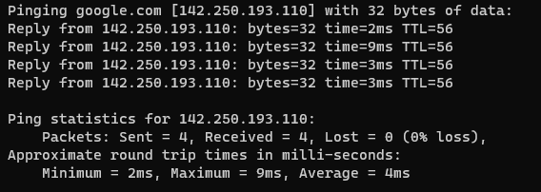**1) Ping:** The **ping** command is used to test connectivity between two hosts. It sendsICMP echo request messages to the destination. The destination host replies with ICMP reply messages. If the ping command gets a reply from the destination host, it displays the reply along with round-trip times

**2) ipconfig:** This command displays all current TCP/IP network configuration values and refreshes Dynamic Host Configuration Protocol (DHCP) and Domain Name System (DNS) settings. This command is mainly used to view the IP addresses on the computers that are configured to obtain their IP address automatically.

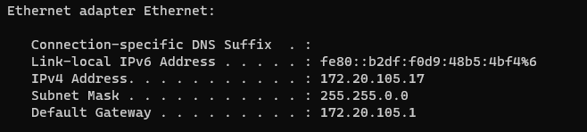

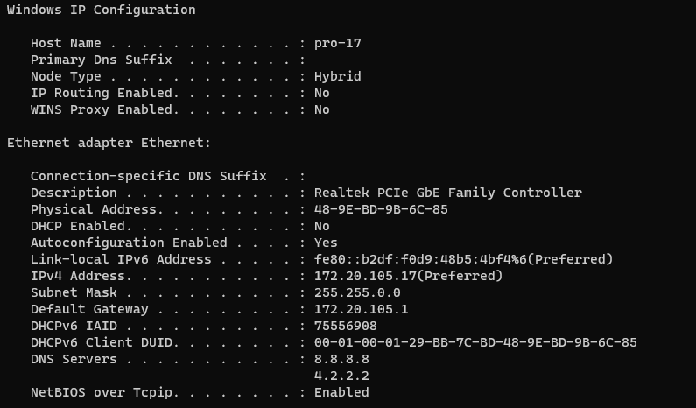**3) ipconfig/all:** Displays the full TCP/IP configuration for all adapters (Wired Ethernet, WiFi, Vmware adapters etc).

**4) ipconfig/flushdns:** This deletes the local DNS resolver cache of the computer. This cache stores DNS entries of frequently accessed internet resources so that the computer will not query an external DNS server every time you try to access an internet resource (website etc). This command is useful when troubleshooting DNS connection problems.

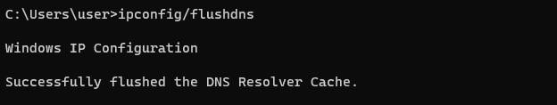

**5) ipconfig/renew:** The command "ipconfig /renew" is used in the Windows Command Prompt to renew the IP address of a network adapter. It's typically used to refresh the DHCP-assigned IP address of a device when it's connected to a network.

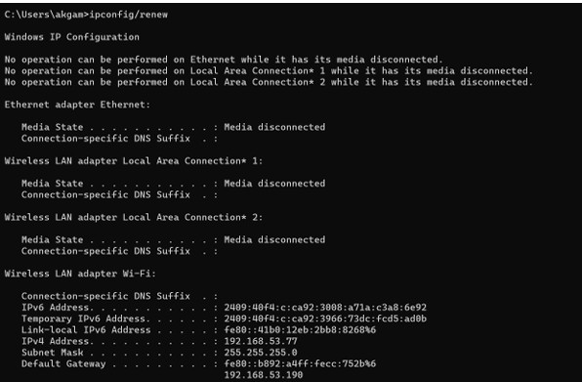

**6) ipconfig/release:** The ipconfig /release command tells the server that provides the Dynamic Host Configuration Protocol (DHCP) to assign IP addresses to your computers that you no longer want to be part of the network.

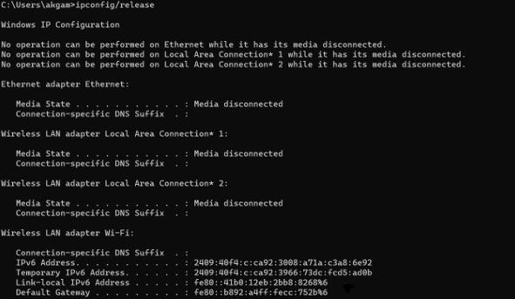

**7) nslookup:** stands for “Name System Lookup” and is very useful in obtaining Domain Name System (DNS) related information about a domain or about an IP address (reverse DNS lookup).

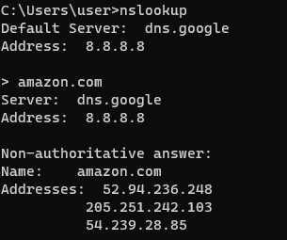

**8) nbtstat -a:** This command helps solve problems with NetBIOS name resolution. (Nbt stands for NetBIOS over TCP/IP).

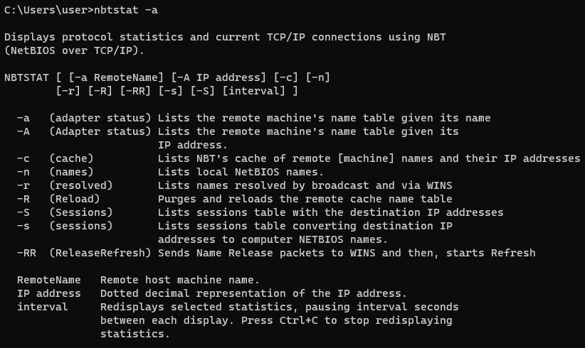

**9) netstat:** Netstat displays a variety of statistics about a computers active TCP/IP connections. This tool is most useful when you’re having trouble with TCP/IP applications such as HTTP, and FTP

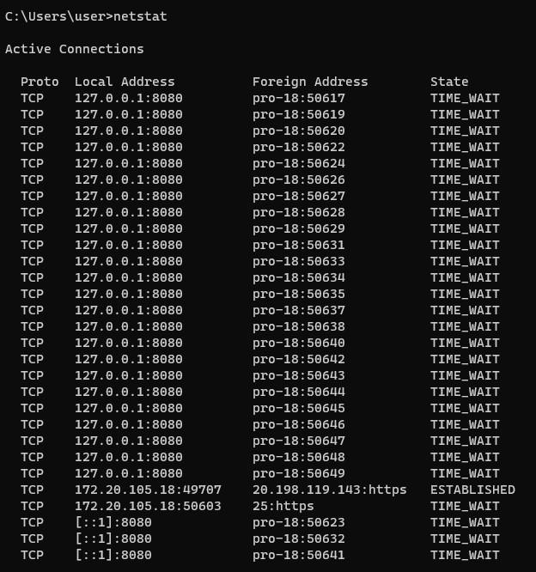

**10) arp -a:** arp -a is short for address resolution protocol, It will show the IP address of your computer along with the IP address and MAC address of your router

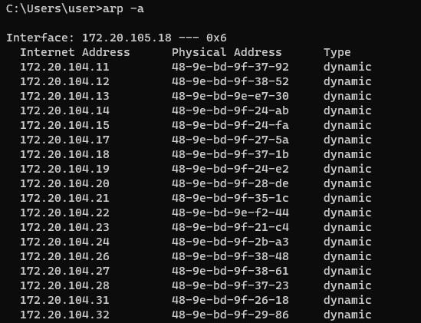

**11) tracert:** The tracert command displays a list of all the routers that a packet has to go through to get from the computer where tracert is run to any other computer on the internet.

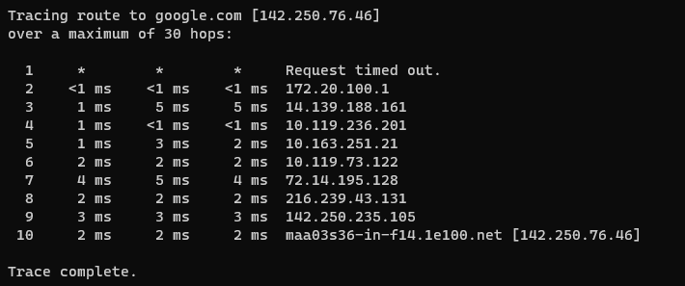

**12) systeminfo:** Systeminfo displays detailed configuration information about a computer and its operating system, including operating system configuration, security information, product ID, and hardware properties (such as RAM, disk space, and network cards).

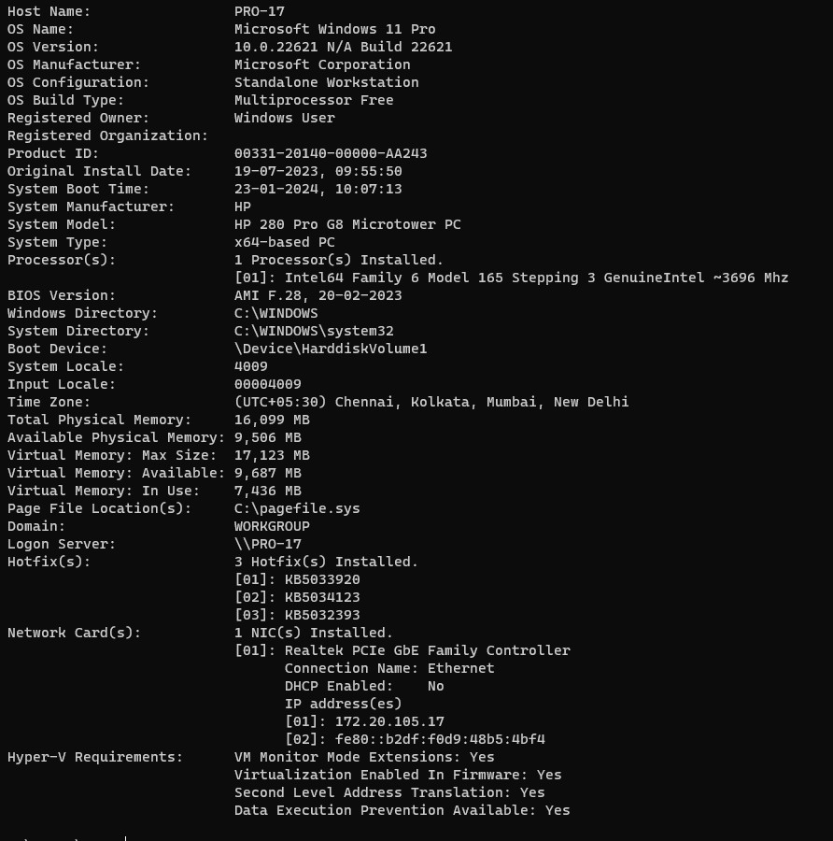

**13) hostname:** This is the simplest of all TCP/IP commands. It simply displays the name of your computer.



**14) pathping:** Pathping is unique to Window’s, and is basically a combination of the Ping and Tracert commands. Pathping traces the route to the destination address then launches a 25 second test of each router along the way, gathering statistics on the rate of data loss along each hop.

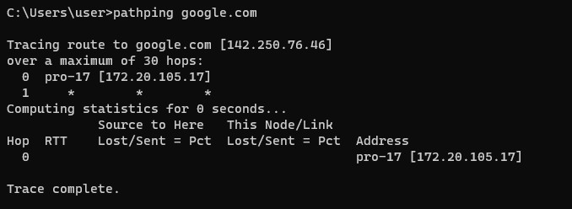

**15) getmac:** The 'getmac' command is a Windows command-line utility used to retrieve the media access control (MAC) address and the list of network protocols associated with each, locally or across a network.

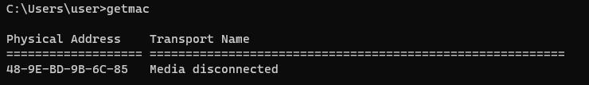

**16) route:** The route command displays the computers routing table. A typical computer, with a single network interface, connected to a LAN, with a router is fairly simple and generally doesn’t pose any network problems. But if you’re having trouble accessing other computers on your network, you can use the route command to make sure the entries in the routing table are correct.

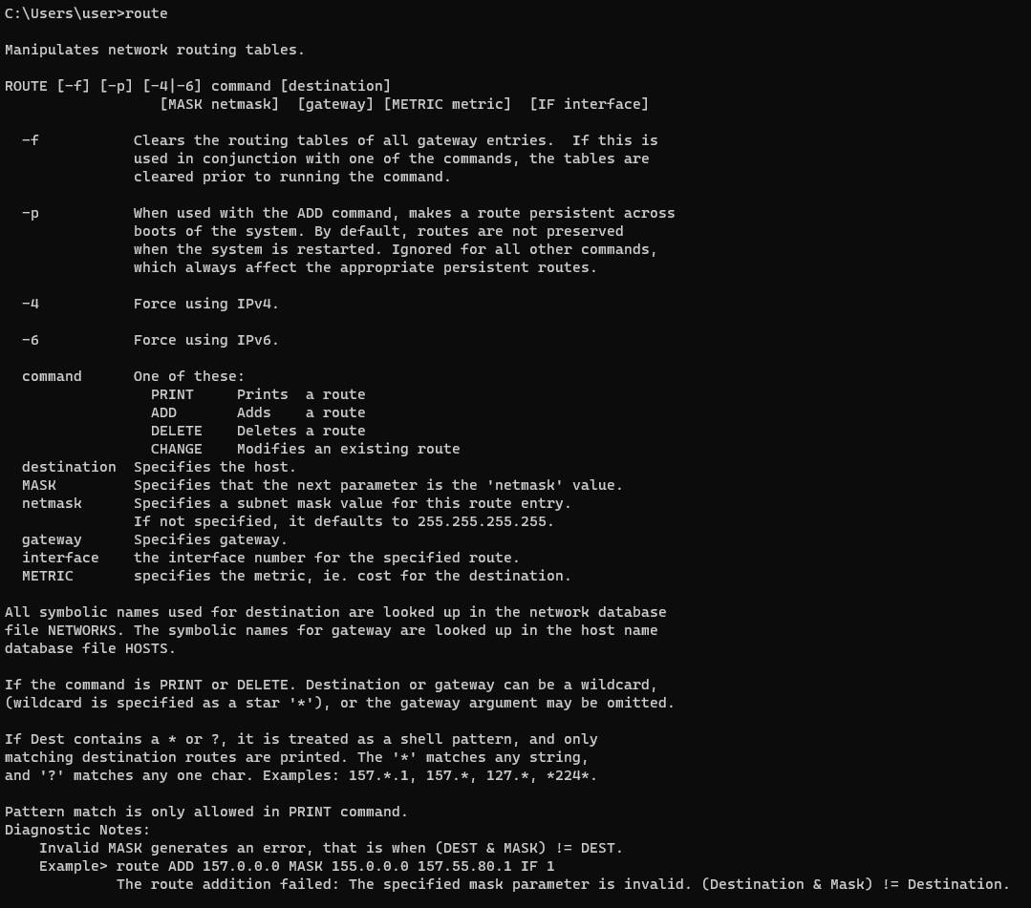

**17) netsh:** Netsh is a command-line scripting utility that allows you to display or modify the network configuration of a computer that is currently running.

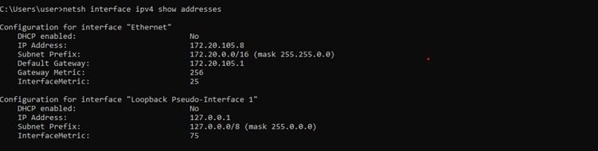

**18) net share:** We can use net share command from command line to create, configure and delete network shares.

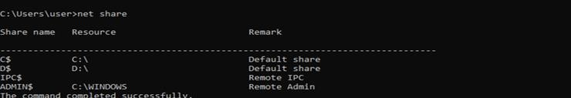

**19) net use:** Connects a computer to or disconnects a computer from a shared resource, or displays information about computer connections. The command also controls persistent net connections. Used without parameters, net use retrieves a list of network connections.

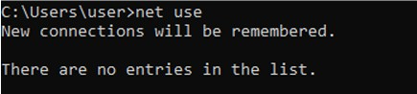

**20) net user:** Net user command is used to Connects a computer or disconnects a computer from a shared resource, or displays information about computer connections. The command also controls persistent net connections. Used without parameters, net use retrieves a list of network connections.

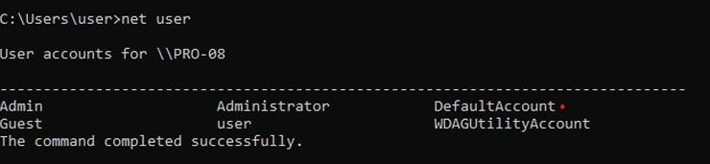

**21) netsh wlan show networks:** WLAN Show All: shows detailed information about your Wi-Fi adapter including the adapter’s capabilities, the Wi-Fi profiles on your PC (not including security keys or passwords), and a list of the Wi-Fi networks that were found when you ran the report.

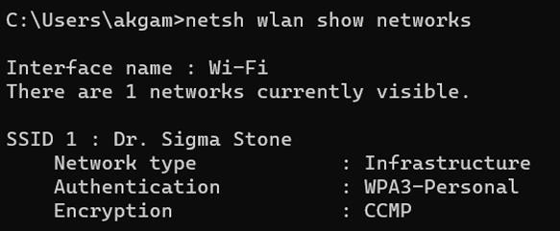

**22) taskkill:** With the taskkill command is used to shutdown whole batches of processes at once, based on specific filters.



**23) netview:** Netview is a command used to manage files shares, printer shares, and sessions in Windows.

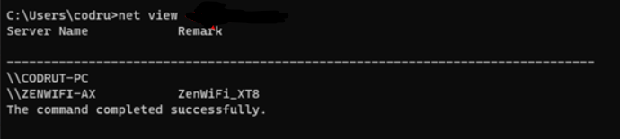

**24) typeperf:** Windows allows you to see the network traffic easily in the *Task Manager*. However, that’s a visual tool, and some users might want to get network utilization from the command line. Fortunately, there’s a command for that too. It’s called typeperf and lets you check the network traffic from CMD, although not in a friendly manner.

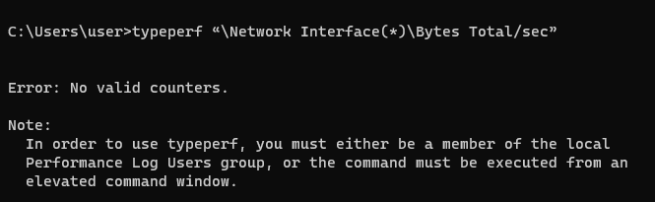

**25) whoami:** Displays user , group and priveleges information for the user who is currently logged on to the local system.



**RESULT**