**Exp No: 2 PROGRAM FOR ECHO**

**Date:**

**AIM**

**ALGORITHM**

**CODE**

import java.util.Scanner;

public class Main {

    public static void main(String[] args) {

        String a;

        Scanner scanner = new Scanner(System.in);

        System.out.print("Enter the text to echo: ");

        a = scanner.nextLine();

        scanner.close();

        System.out.println(a);

    }

}

**OUTPUT**

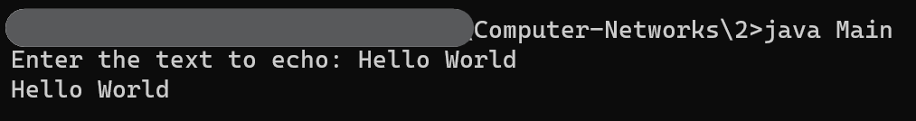

**RESULT**