**Exp No: 3 PROGRAM FOR PING**

**Date:**

**AIM**

**ALGORITHM**

**CODE**

import java.io.*;

import java.net.*;

import java.lang.*;

import java.util.Arrays;

public class Main {

    public static void sendPingReq(String ipAdrr, int timeout) throws UnknownHostException, IOException {

        InetAddress ip = InetAddress.getByName(ipAdrr);

        System.out.println("Sending ping request to " + ipAdrr);

        if (ip.isReachable(timeout)) {

            System.out.println("Host is reachable");

            System.out.println("\nDetails: ");

            System.out.println("Address (+ 256. since it is unsigned bytes): " + Arrays.toString(ip.getAddress()));

            System.out.println("Host Address: " + ip.getHostAddress());

            System.out.println("isAnyLocalAddress: " +ip.isAnyLocalAddress());

            System.out.println("HashCode of the ip addr (can be negative): " + ip.hashCode());

        } else {

            System.out.println("Can't reach the host!");

        }

    }

    public static void main(String[] args) throws IllegalArgumentException, NumberFormatException {

        String ipAddress;

        int timeout;

        if (args.length != 2) {

            throw new IllegalArgumentException("Two arguments are required. IP Address and Timeout");

        }

        ipAddress = args[0];

        try {

            timeout = Integer.parseInt(args[1]);

        } catch(NumberFormatException e) {

            throw new NumberFormatException("Timeout should be a number");

        }

        try {

            sendPingReq(ipAddress, timeout);

        } catch(UnknownHostException e) {

            System.out.println("IP address of the host could not be determined");

        } catch(IOException e) {

            System.out.println("Something went wrong!");

        }

    }

};

**OUTPUT**

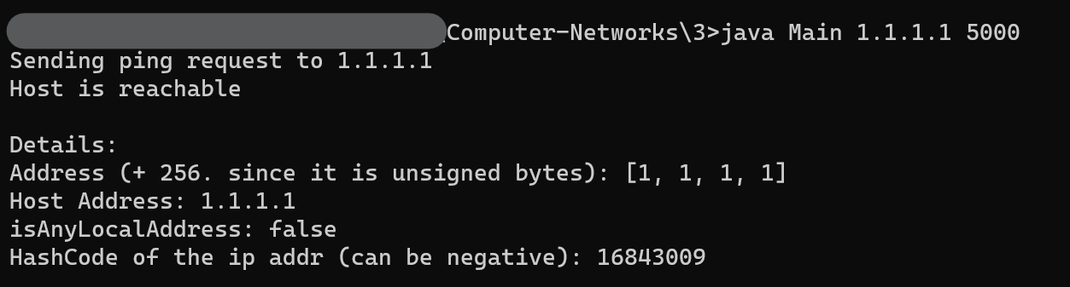

**RESULT**