**Exp No: 5 CLIENT SERVER APPLICATION FOR CHAT**

**Date:**

**AIM**

**ALGORITHM**

**CODE**

**Server.java**

import java.net.*;

import java.io.*;

public class Server{

public static void main(String[] args){

try {

String msg = "";

ServerSocket ss = new ServerSocket(1999);

System.out.println("Waiting for Client..");

Socket s = ss.accept();

System.out.println("Connection Established With Client");

DataOutputStream dos = new DataOutputStream(s.getOutputStream());

DataInputStream dis = new DataInputStream(s.getInputStream());

BufferedReader br = new BufferedReader(new InputStreamReader(System.in));

while (true) {

System.out.println("Message From Client: " + dis.readUTF());

System.out.print("Enter Message: ");

msg = br.readLine();

if (msg.equals("!quit")) break;

dos.writeUTF(msg);

}

ss.close();

}

catch (EOFException ie){

System.out.println("Can't connect to the Client.");

} catch (IOException ie){

ie.printStackTrace();

}

}

}

**Client/Main.java**

import java.net.*;

import java.io.*;

public class Client{

public static void main(String[] args){

try {

String msg = "";

Socket s = new Socket("localhost",1999);

System.out.println("Connection Established With Server");

DataOutputStream dos = new DataOutputStream(s.getOutputStream());

DataInputStream dis = new DataInputStream(s.getInputStream());

BufferedReader br = new BufferedReader(new InputStreamReader(System.in));

while (true) {

System.out.print("Enter Message: ");

msg = br.readLine();

if (msg.equals("!quit")) break;

dos.writeUTF(msg);

System.out.println("Message From Server:" + dis.readUTF());

}

s.close();

} catch (SocketException ie){

System.out.println("Can't connect to the Server.");

} catch (IOException ie){

ie.printStackTrace();

}

}

}

**OUTPUT**

**Client:**

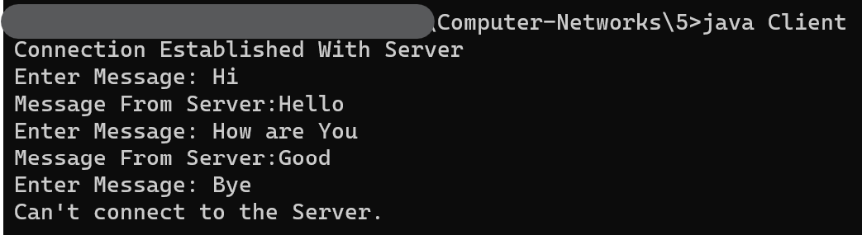

**Server:**

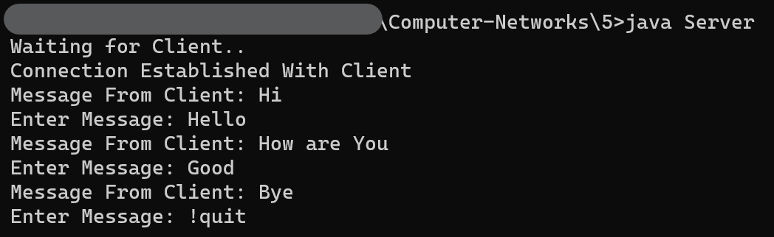

**RESULT**