**Exp No: 6 REMOTE COMMAND EXECUTION**

**Date:**

**AIM**

**ALGORITHM**

**CODE**

**Server.java**

import java.io.*;

import java.net.*;

class Server {

public static void main(String args[]) throws IOException {

try {

String str;

ServerSocket server=new ServerSocket(6555);

System.out.println("Waiting For Client..");

Socket socket=server.accept();

System.out.println("Connection Established..");

DataOutputStream dos = new DataOutputStream(socket.getOutputStream());

DataInputStream dis = new DataInputStream(socket.getInputStream());

str=dis.readUTF();

Runtime r=Runtime.getRuntime();

Process p=r.exec(str);

BufferedReader stdInput = new BufferedReader(new InputStreamReader(p.getInputStream()));

String fullstring = "";

String string = null;

while ((string = stdInput.readLine()) != null) {

fullstring = fullstring.concat("\n");

fullstring = fullstring.concat(string);

}

dos.writeUTF(fullstring);

}

catch(IOException e) {

System.out.println("Error");

System.out.println(e);

}

}

}

**Client.java**

import java.io.*;

import java.net.*;

import java.util.Scanner;

class Client {

public static void main(String args[]) throws IOException {

try {

Scanner s = new Scanner(System.in);

String str;

Socket socket=new Socket("127.0.0.1",6555);

DataOutputStream dos = new DataOutputStream(socket.getOutputStream());

DataInputStream din = new DataInputStream(socket.getInputStream());

System.out.print("Enter The Command: ");

str=s.nextLine();

dos.writeUTF(str);

System.out.println(din.readUTF());

} catch(IOException e) {

System.out.println("Error");

System.out.println(e);

}

}

}

**OUTPUT**

**Client:**

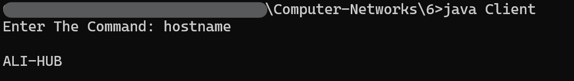

**Server:**

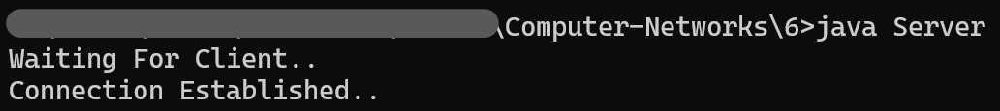

**RESULT**