Program: 3 **Implementation Of GCD Using Euclidean Algorithm**

Date:

**AIM**

**ALGORITHM**

**CODE**

#include <iostream>

using namespace std;

int gcd(int a, int b) {

int step = 1;

while (b != 0) {

cout << "Step " << step << ": a = " << a << ", b = " << b << endl;

// Calculate a % b and store it in a temporary variable

int temp = b;

b = a % b;

a = temp;

step++;

}

return a;

}

int main() {

int num1, num2;

cout << "Enter two integers to compute gcd: ";

cin >> num1 >> num2;

cout << endl;

int result = gcd(num1, num2);

cout << endl;

cout << "GCD of " << num1 << " and " << num2 << " is " << result << endl;

return 0;

}

**OUTPUT**

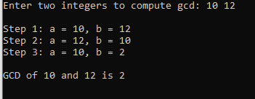

**RESULT**

Thus, the program to compute GCD of two numbers is executed successfully.