Program: 4 **Extended Euclidean algorithm**

Date:

**AIM**

**ALGORITHM**

**CODE**

#include <iostream>

using namespace std;

int extendedEuclidean(int a, int b, int &x, int &y) {

    if (a == 0) {

        x = 0;

        y = 1;

        return b;

    }

    cout << "a: " << a << ", b: " << b << endl;

    int x1, y1;

    int gcd = extendedEuclidean(b%a, a, x1, y1);

    x = y1 - (b/a) * x1;

    y = x1;

    cout << "x: " << x << ", y: " << y << endl;

    return gcd;

}

int multiplicativeInverseBF(int A, int M) {

    cout << "\nBrute Force (calc): " << endl;

    for (int X=1; X<M; X++) {

        int res = (A * X) % M;

        cout << "( " << A << " * " << X << " ) % " << M << " = " << res << endl;

        if (res == 1) {

            return X;

        }

    }

    return -1;

}

int multiplicativeInverseUsingExtendedEuclidean(int A, int M) {

    int x, y;

    cout << "\nExtended Euclidean (calc): " << endl;

    int gcd = extendedEuclidean(A, M, x, y);

    cout << "\nGCD: " << gcd << endl;

    if (gcd != 1) {

        return -1;

    }

    int inverse = (x % M + M) % M;

    return inverse;

}

int main() {

    int A, M, choice;

    cout << "Enter value of A: ";

    cin >> A;

    cout << "Enter value of M: ";

    cin >> M;

    while (true) {

        cout << "Enter 1 for brute force method, 2 for extended Euclidean: ";

        cin >> choice;

        if (choice != 1 && choice != 2) {

            cout << "Invalid choice" << endl;

            continue;

        } else {

            break;

        }

    }

    if (choice == 1) {

        int inverse = multiplicativeInverseBF(A, M);

        if (inverse == -1) {

            cout << "Multiplicative inverse doesn't exist." << endl;

        } else {

            cout << "\nInverse: " << inverse << endl;

        }

    } else {

        int inverse = multiplicativeInverseUsingExtendedEuclidean (A, M);

        if (inverse == -1) {

            cout << "Multiplicative inverse doesn't exist." << endl;

        } else {

            cout << "Inverse: " << inverse << endl;

        }

    }

    return 0;

}

**OUTPUT**

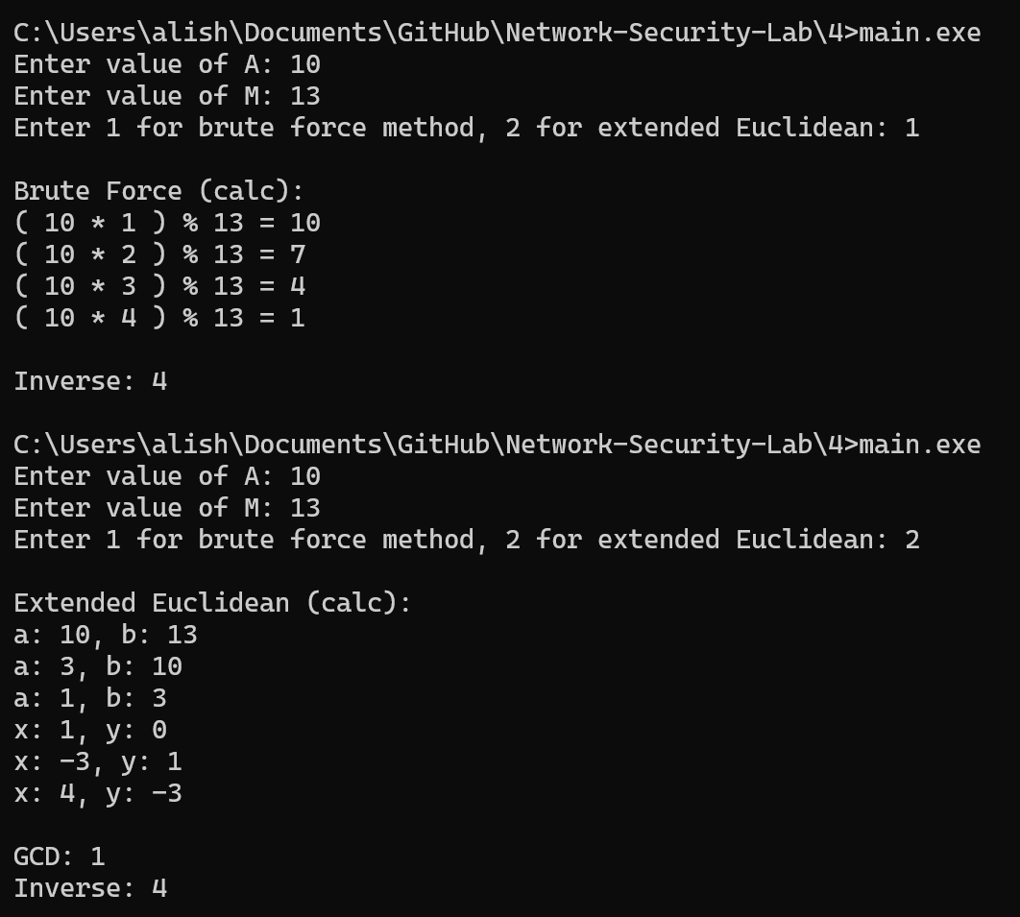

**RESULT**

Thus, the program to compute Modular Multiplicative Inverse of two numbers is executed successfully.