Program: 9 **Diffie-Hellman Key Exchange Algorithm**

Date:

**AIM**

**ALGORITHM**

**CODE**

#include <iostream>

#include <vector>

#include <random>

using namespace std;

long int power(int a, int b, int mod) {

long long int t;

if(b==1)

return a;

t = power(a,b/2,mod);

if(b%2==0)

return (t*t)%mod;

else

return (((t*t)%mod)*a)%mod;

}

int isPrime(int n) {

int is_prime = 1;

int i;

// 0 and 1 are not prime numbers

if (n == 0 || n == 1) {

is_prime = 1;

}

// loop to check if n is prime

for (i = 2; i <= n/2; ++i) {

if (n % i == 0) {

is_prime = 0;

break;

}

}

return is_prime;

}

int calculateAlpha(int q) {

int curAlpha = 1;

vector<int> alpha_values;

while (true) {

int validAlpha = 1;

vector<int> vec(q, 0);

for (int i=1; i<q; i++) {

int res = power(curAlpha, i, q);

if (vec[res] == 1) {

validAlpha = 0;

break;

}

vec[res] = 1;

}

if (validAlpha) {

alpha_values.push_back(curAlpha);

}

curAlpha++;

if (curAlpha >= q) break;

}

std::random_device rd; // obtain a random number from hardware

std::mt19937 gen(rd()); // seed the generator

std::uniform_int_distribution<> distr(0, alpha_values.size()-1); // define the range

return alpha_values[distr(gen)];

}

int main() {

int q;

cout << "Enter q value (prime number): ";

cin >> q;

if (!isPrime(q)) {

cout << "q must be a prime number!" << endl;

return 1;

}

int alpha = calculateAlpha(q);

cout << "alpha: " << alpha << endl;

int xA, yA, xB, yB, k1, k2;

cout << "\nEnter a private key for user 1 (less than q): ";

cin >> xA;

if (xA >= q) {

cout << "private key must be less than q!" << endl;

return 1;

}

yA = power(alpha, xA, q);

cout << "Public key for user 1: " << yA << endl;

cout << "\nEnter a private key for user 2 (less than q): ";

cin >> xB;

if (xB >= q) {

cout << "private key must be less than q!" << endl;

return 1;

}

yB = power(alpha, xB, q);

cout << "Public key for user 2: " << yB << endl;

k1 = power(yB, xA, q);

k2 = power(yA, xB, q);

cout << "\nSecret key for user 1: " << k1 << endl;

cout << "Secret key for user 2: " << k2 << endl;

return 0;

}

**OUTPUT**

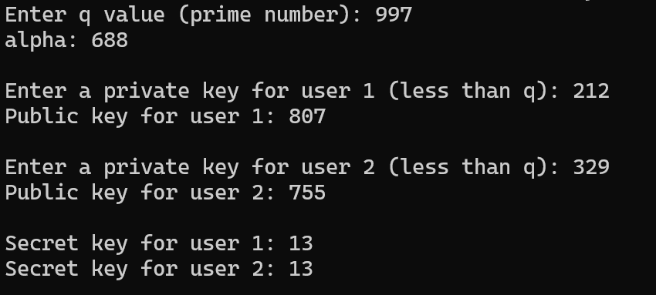

**RESULT**

Thus, the program to implement secret key generation using diffie-hellman key exchange algorithm.