Exp No: 1 **Implementing User Interface Features**

Date:

**AIM**

**ALGORITHM**

**SOURCE CODE**

*activity_main.xml*

<?xml version="1.0" encoding="utf-8"?>  
<androidx.constraintlayout.widget.ConstraintLayout xmlns:android="http://schemas.android.com/apk/res/android"  
 xmlns:app="http://schemas.android.com/apk/res-auto"  
 xmlns:tools="http://schemas.android.com/tools"  
 android:id="@+id/main"  
 android:layout_width="match_parent"  
 android:layout_height="match_parent"  
 tools:context=".MainActivity">  
  
 <ImageView  
 android:id="@+id/imageView4"  
 android:layout_width="match_parent"  
 android:layout_height="match_parent"  
 android:scaleType="centerCrop"  
 app:layout_constraintBottom_toBottomOf="parent"  
 app:layout_constraintEnd_toEndOf="parent"  
 app:layout_constraintHorizontal_bias="0.0"  
 app:layout_constraintStart_toStartOf="parent"  
 app:layout_constraintTop_toTopOf="parent"  
 app:layout_constraintVertical_bias="0.0"  
 app:srcCompat="@drawable/bday" />  
  
 <TextView  
 android:id="@+id/textView"  
 android:layout_width="wrap_content"  
 android:layout_height="wrap_content"  
 android:text="Happy Birthday"  
 android:textColor="#FFC107"  
 android:textSize="50sp"  
 android:textStyle="bold"  
 app:layout_constraintBottom_toBottomOf="parent"  
 app:layout_constraintEnd_toEndOf="parent"  
 app:layout_constraintStart_toStartOf="parent"  
 app:layout_constraintTop_toTopOf="@+id/imageView4" />  
  
 <TextView  
 android:id="@+id/textView2"  
 android:layout_width="wrap_content"  
 android:layout_height="wrap_content"  
 android:text="John Doe"  
 android:layout_marginTop="30dp"  
 android:textColor="#FAF8F8"  
 android:textSize="40sp"  
 app:layout_constraintEnd_toEndOf="parent"  
 app:layout_constraintStart_toStartOf="parent"  
 app:layout_constraintTop_toBottomOf="@+id/textView" />  
</androidx.constraintlayout.widget.ConstraintLayout>

*MainActivity.java*

package com.example.lab1;  
  
import android.os.Bundle;  
  
import androidx.activity.EdgeToEdge;  
import androidx.appcompat.app.AppCompatActivity;  
import androidx.core.graphics.Insets;  
import androidx.core.view.ViewCompat;  
import androidx.core.view.WindowInsetsCompat;  
  
public class MainActivity extends AppCompatActivity {  
  
 @Override  
 protected void onCreate(Bundle savedInstanceState) {  
 super.onCreate(savedInstanceState);  
 EdgeToEdge.*enable*(this);  
 setContentView(R.layout.*activity_main*);  
 ViewCompat.*setOnApplyWindowInsetsListener*(findViewById(R.id.*main*), (v, insets) -> {  
 Insets systemBars = insets.getInsets(WindowInsetsCompat.Type.*systemBars*());  
 v.setPadding(systemBars.left, systemBars.top, systemBars.right, systemBars.bottom);  
 return insets;  
 });  
 }  
}

**OUTPUT**

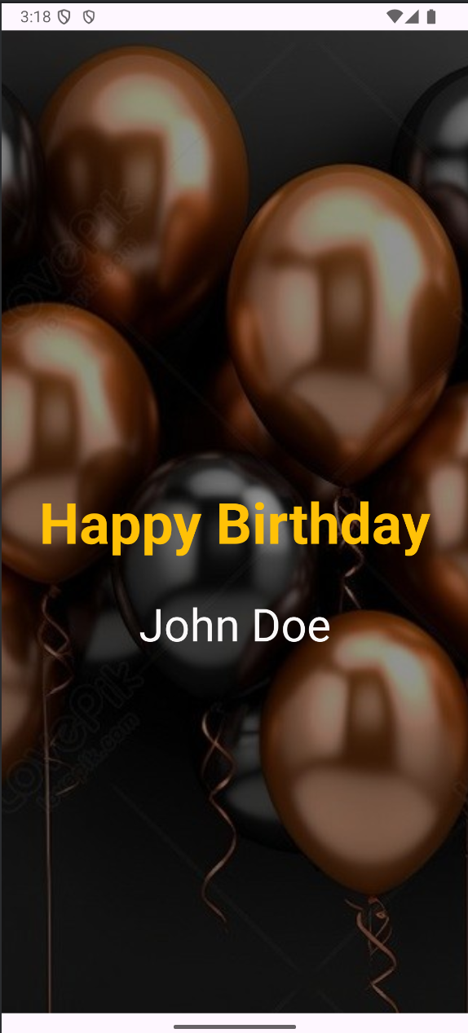

**RESULT**