Exp No: 2 **Implementing Intent in Mobile Application**

Date:

**AIM**

**ALGORITHM**

**SOURCE CODE**

*activity_main.xml*

<?xml version="1.0" encoding="utf-8"?>  
<androidx.constraintlayout.widget.ConstraintLayout xmlns:android="http://schemas.android.com/apk/res/android"  
 xmlns:app="http://schemas.android.com/apk/res-auto"  
 xmlns:tools="http://schemas.android.com/tools"  
 android:id="@+id/main"  
 android:layout_width="match_parent"  
 android:layout_height="match_parent"  
 tools:context=".MainActivity">  
  
 <Button  
 android:id="@+id/button"  
 android:layout_width="wrap_content"  
 android:layout_height="wrap_content"  
 android:text="Open Next Acitivity"  
 android:onClick="openNextActivity"  
 app:layout_constraintBottom_toBottomOf="parent"  
 app:layout_constraintEnd_toEndOf="parent"  
 app:layout_constraintStart_toStartOf="parent"  
 app:layout_constraintTop_toTopOf="parent" />  
  
 <Button  
 android:id="@+id/button2"  
 android:layout_width="wrap_content"  
 android:layout_height="wrap_content"  
 android:backgroundTint="#2196F3"  
 android:layout_marginTop="30dp"  
 android:text="Open Google"  
 android:onClick="openWebsite"  
 app:layout_constraintEnd_toEndOf="@+id/button"  
 app:layout_constraintStart_toStartOf="@+id/button"  
 app:layout_constraintTop_toBottomOf="@+id/button" />  
</androidx.constraintlayout.widget.ConstraintLayout>

*activity_main2.xml*

<?xml version="1.0" encoding="utf-8"?>  
<androidx.constraintlayout.widget.ConstraintLayout xmlns:android="http://schemas.android.com/apk/res/android"  
 xmlns:app="http://schemas.android.com/apk/res-auto"  
 xmlns:tools="http://schemas.android.com/tools"  
 android:id="@+id/main"  
 android:layout_width="match_parent"  
 android:layout_height="match_parent"  
 tools:context=".MainActivity2">  
  
 <TextView  
 android:id="@+id/textView"  
 android:layout_width="wrap_content"  
 android:layout_height="wrap_content"  
 android:text="Second Activity"  
 android:textSize="30sp"  
 app:layout_constraintBottom_toBottomOf="parent"  
 app:layout_constraintEnd_toEndOf="parent"  
 app:layout_constraintStart_toStartOf="parent"  
 app:layout_constraintTop_toTopOf="parent" />  
  
 <Button  
 android:id="@+id/button3"  
 android:layout_width="wrap_content"  
 android:layout_height="wrap_content"  
 android:text="Go Back"  
 android:onClick="goBack"  
 android:layout_marginTop="30dp"  
 app:layout_constraintEnd_toEndOf="parent"  
 app:layout_constraintStart_toStartOf="parent"  
 app:layout_constraintTop_toBottomOf="@+id/textView" />  
</androidx.constraintlayout.widget.ConstraintLayout>

*MainActivity.xml*

package com.example.lab2;  
  
import android.content.Intent;  
import android.net.Uri;  
import android.os.Bundle;  
import android.view.View;  
  
import androidx.activity.EdgeToEdge;  
import androidx.appcompat.app.AppCompatActivity;  
import androidx.core.graphics.Insets;  
import androidx.core.view.ViewCompat;  
import androidx.core.view.WindowInsetsCompat;  
  
public class MainActivity extends AppCompatActivity {  
  
 @Override  
 protected void onCreate(Bundle savedInstanceState) {  
 super.onCreate(savedInstanceState);  
 EdgeToEdge.*enable*(this);  
 setContentView(R.layout.*activity_main*);  
 ViewCompat.*setOnApplyWindowInsetsListener*(findViewById(R.id.*main*), (v, insets) -> {  
 Insets systemBars = insets.getInsets(WindowInsetsCompat.Type.*systemBars*());  
 v.setPadding(systemBars.left, systemBars.top, systemBars.right, systemBars.bottom);  
 return insets;  
 });  
 }  
  
 public void openNextActivity(View v) {  
  
 Intent implicit = new Intent(MainActivity.this, MainActivity2.class);  
 startActivity(implicit);  
  
 }  
  
 public void openWebsite(View v) {  
  
 Intent intent = new Intent(Intent.*ACTION_VIEW*);  
 intent.setData(Uri.*parse*("https://www.google.com"));  
 startActivity(intent);  
  
 }  
  
}

*MainActivity2.xml*

package com.example.lab2;

import android.content.Intent;

import android.os.Bundle;

import android.view.View;

import androidx.activity.EdgeToEdge;

import androidx.appcompat.app.AppCompatActivity;

import androidx.core.graphics.Insets;

import androidx.core.view.ViewCompat;

import androidx.core.view.WindowInsetsCompat;

public class MainActivity2 extends AppCompatActivity {

@Override

protected void onCreate(Bundle savedInstanceState) {

super.onCreate(savedInstanceState);

EdgeToEdge.enable(this);

setContentView(R.layout.activity_main2);

ViewCompat.setOnApplyWindowInsetsListener(findViewById(R.id.main), (v, insets) -> {

Insets systemBars = insets.getInsets(WindowInsetsCompat.Type.systemBars());

v.setPadding(systemBars.left, systemBars.top, systemBars.right, systemBars.bottom);

return insets;

});

}

public void goBack(View v) {

Intent i = new Intent(MainActivity2.this, MainActivity.class);

startActivity(i);

}

}

**OUTPUT**

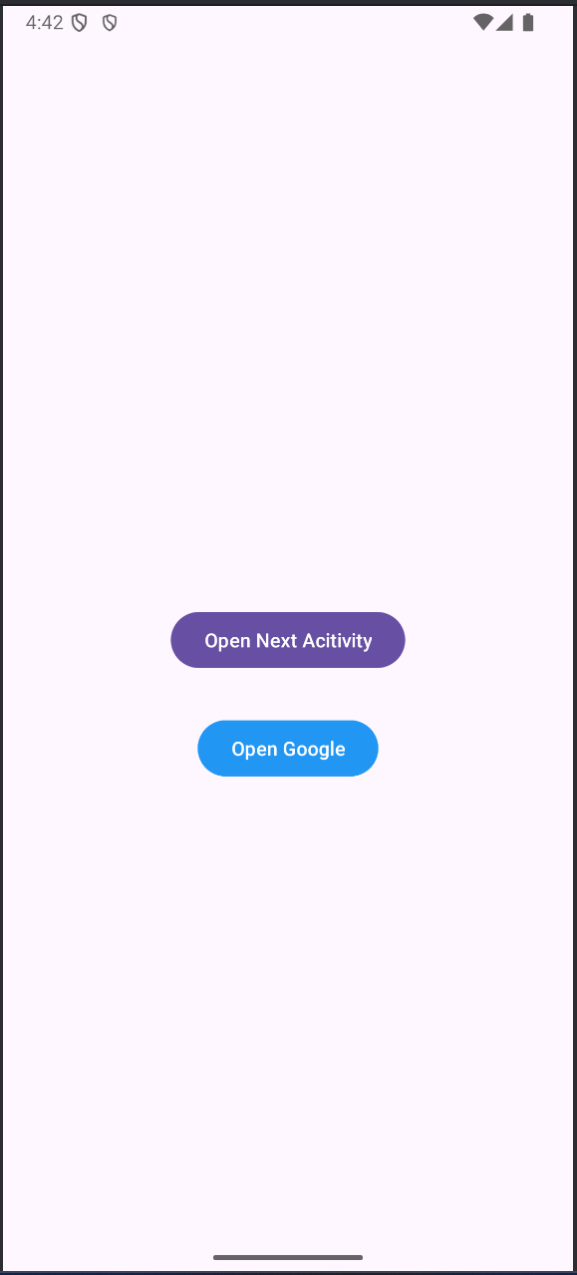 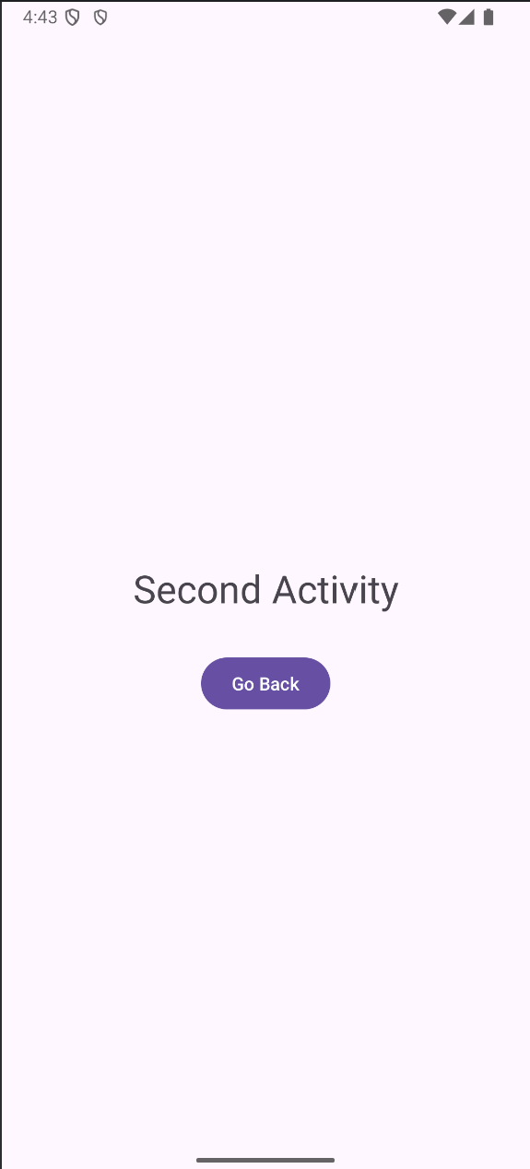 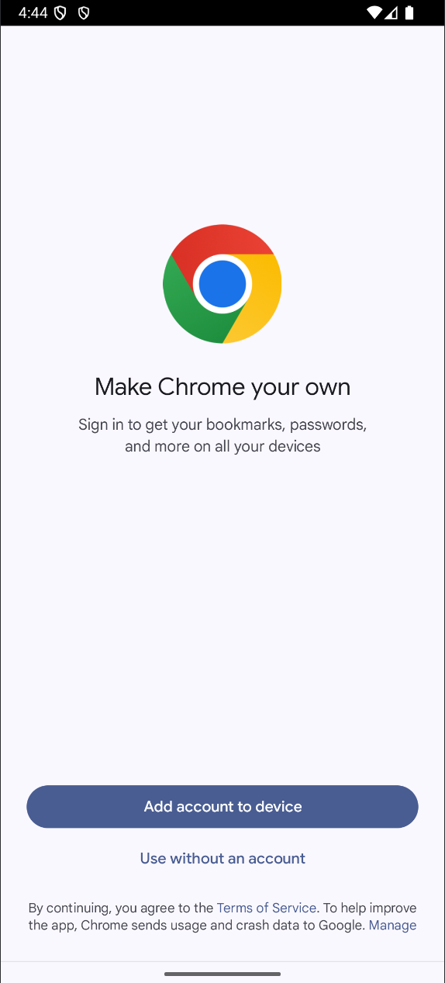

**RESULT**