Exp No: 3 **Creating a Simple Calculator Application**

Date:

**AIM**

**ALGORITHM**

**SOURCE CODE**

*activity_main.xml*

<?xml version="1.0" encoding="utf-8"?>  
<androidx.constraintlayout.widget.ConstraintLayout xmlns:android="http://schemas.android.com/apk/res/android"  
 xmlns:app="http://schemas.android.com/apk/res-auto"  
 xmlns:tools="http://schemas.android.com/tools"  
 android:id="@+id/main"  
 android:layout_width="match_parent"  
 android:layout_height="match_parent"  
 tools:context=".MainActivity">  
  
 <EditText  
 android:id="@+id/num1"  
 android:layout_width="wrap_content"  
 android:layout_height="wrap_content"  
 android:layout_marginTop="72dp"  
 android:ems="15"  
 android:inputType="number|numberDecimal"  
 android:hint="Enter num 1"  
 app:layout_constraintEnd_toEndOf="parent"  
 app:layout_constraintHorizontal_bias="0.278"  
 app:layout_constraintStart_toStartOf="parent"  
 app:layout_constraintTop_toTopOf="parent" />  
  
 <EditText  
 android:id="@+id/num2"  
 android:layout_width="wrap_content"  
 android:layout_height="wrap_content"  
 android:layout_marginTop="144dp"  
 android:ems="15"  
 android:hint="Enter num 2"  
 android:inputType="number|numberDecimal"  
 app:layout_constraintEnd_toEndOf="parent"  
 app:layout_constraintHorizontal_bias="0.278"  
 app:layout_constraintStart_toStartOf="parent"  
 app:layout_constraintTop_toTopOf="parent" />  
  
 <Button  
 android:id="@+id/add"  
 android:layout_width="wrap_content"  
 android:layout_height="wrap_content"  
 android:layout_marginTop="20dp"  
 android:backgroundTint="#03A9F4"  
 android:text="+"  
 android:onClick="add"  
 android:textSize="30sp"  
 app:layout_constraintStart_toStartOf="@+id/num2"  
 app:layout_constraintTop_toBottomOf="@+id/num2" />  
  
 <Button  
 android:id="@+id/sub"  
 android:layout_width="wrap_content"  
 android:layout_height="wrap_content"  
 android:layout_marginLeft="13dp"  
 android:layout_marginTop="20dp"  
 android:backgroundTint="#03A9F4"  
 android:text="-"  
 android:onClick="subtract"  
 android:textSize="30sp"  
 app:layout_constraintStart_toEndOf="@+id/add"  
 app:layout_constraintTop_toBottomOf="@+id/num2" />  
  
 <Button  
 android:id="@+id/mul"  
 android:layout_width="wrap_content"  
 android:layout_height="wrap_content"  
 android:layout_marginLeft="13dp"  
 android:layout_marginTop="20dp"  
 android:backgroundTint="#03A9F4"  
 android:text="x"  
 android:onClick="multiply"  
 android:textSize="30sp"  
 app:layout_constraintStart_toEndOf="@+id/sub"  
 app:layout_constraintTop_toBottomOf="@+id/num2" />  
  
 <Button  
 android:id="@+id/div"  
 android:layout_width="wrap_content"  
 android:layout_height="wrap_content"  
 android:layout_marginTop="10dp"  
 android:backgroundTint="#03A9F4"  
 android:text="/"  
 android:onClick="divide"  
 android:textSize="30sp"  
 app:layout_constraintStart_toStartOf="@+id/add"  
 app:layout_constraintTop_toBottomOf="@+id/add" />  
  
 <TextView  
 android:id="@+id/result"  
 android:layout_width="wrap_content"  
 android:layout_height="wrap_content"  
 android:text="Result: "  
 android:textSize="30sp"  
 android:layout_marginTop="60dp"  
 app:layout_constraintStart_toStartOf="@+id/div"  
 app:layout_constraintTop_toBottomOf="@+id/div" />  
</androidx.constraintlayout.widget.ConstraintLayout

*MainActivity.java*

package com.example.lab3;  
  
import android.os.Bundle;  
import android.view.View;  
import android.widget.EditText;  
import android.widget.TextView;  
  
import androidx.activity.EdgeToEdge;  
import androidx.appcompat.app.AppCompatActivity;  
import androidx.core.graphics.Insets;  
import androidx.core.view.ViewCompat;  
import androidx.core.view.WindowInsetsCompat;  
  
public class MainActivity extends AppCompatActivity {  
  
 EditText num1, num2;  
 TextView result;  
  
 @Override  
 protected void onCreate(Bundle savedInstanceState) {  
 super.onCreate(savedInstanceState);  
 EdgeToEdge.*enable*(this);  
 setContentView(R.layout.*activity_main*);  
  
 num1 = findViewById(R.id.*num1*);  
 num2 = findViewById(R.id.*num2*);  
  
 result = findViewById(R.id.*result*);  
  
 ViewCompat.*setOnApplyWindowInsetsListener*(findViewById(R.id.*main*), (v, insets) -> {  
 Insets systemBars = insets.getInsets(WindowInsetsCompat.Type.*systemBars*());  
 v.setPadding(systemBars.left, systemBars.top, systemBars.right, systemBars.bottom);  
 return insets;  
 });  
 }  
  
 public void displayResult(String text) {  
 result.setText("Result: " + text);  
 }  
  
 public void add(View v) {  
 if (!num1.getText().toString().isEmpty() && !num2.getText().toString().isEmpty()) {  
 Float number1 = Float.*parseFloat*(num1.getText().toString());  
 Float number2 = Float.*parseFloat*(num2.getText().toString());  
 displayResult(String.*valueOf*(number1 + number2));  
 } else {  
 displayResult("Invalid Input");  
 }  
 }  
  
 public void subtract(View v) {  
 if (!num1.getText().toString().isEmpty() && !num2.getText().toString().isEmpty()) {  
 Float number1 = Float.*parseFloat*(num1.getText().toString());  
 Float number2 = Float.*parseFloat*(num2.getText().toString());  
 displayResult(String.*valueOf*(number1 - number2));  
 } else {  
 displayResult("Invalid Input");  
 }  
 }  
  
 public void multiply(View v) {  
 if (!num1.getText().toString().isEmpty() && !num2.getText().toString().isEmpty()) {  
 Float number1 = Float.*parseFloat*(num1.getText().toString());  
 Float number2 = Float.*parseFloat*(num2.getText().toString());  
 displayResult(String.*valueOf*(number1 * number2));  
 } else {  
 displayResult("Invalid Input");  
 }  
 }  
  
 public void divide(View v) {  
 if (!num1.getText().toString().isEmpty() && !num2.getText().toString().isEmpty()) {  
 Float number1 = Float.*parseFloat*(num1.getText().toString());  
 Float number2 = Float.*parseFloat*(num2.getText().toString());  
 displayResult(String.*valueOf*(number1 / number2));  
 } else {  
 displayResult("Invalid Input");  
 }  
 }  
  
}

**OUTPUT**

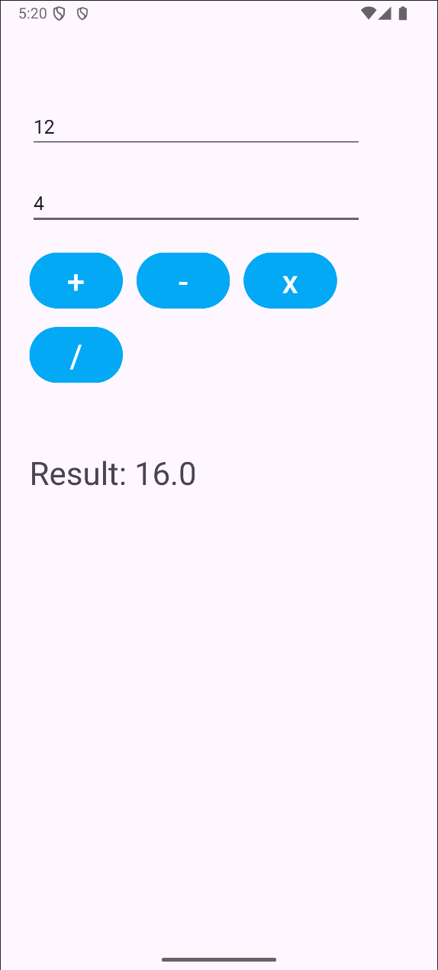

**RESULT**