Exp No: 4 **Developing Action Listeners For Rating App**

Date:

**AIM**

**ALGORITHM**

**SOURCE CODE**

*activity_main.xml*

<?xml version="1.0" encoding="utf-8"?>  
<?xml version="1.0" encoding="utf-8"?>  
<androidx.constraintlayout.widget.ConstraintLayout xmlns:android="http://schemas.android.com/apk/res/android"  
 xmlns:app="http://schemas.android.com/apk/res-auto"  
 xmlns:tools="http://schemas.android.com/tools"  
 android:id="@+id/main"  
 android:layout_width="match_parent"  
 android:layout_height="match_parent"  
 tools:context=".MainActivity">  
  
  
 <RatingBar  
 android:id="@+id/ratingBar"  
 android:layout_width="wrap_content"  
 android:layout_height="wrap_content"  
 app:layout_constraintBottom_toBottomOf="parent"  
 app:layout_constraintEnd_toEndOf="parent"  
 app:layout_constraintStart_toStartOf="parent"  
 app:layout_constraintTop_toTopOf="parent" />  
  
 <Button  
 android:id="@+id/submit_btn"  
 android:layout_width="wrap_content"  
 android:layout_height="wrap_content"  
 android:layout_marginTop="24dp"  
 android:text="Submit Rating"  
 app:layout_constraintEnd_toEndOf="@+id/ratingBar"  
 app:layout_constraintHorizontal_bias="0.493"  
 app:layout_constraintStart_toStartOf="@+id/ratingBar"  
 app:layout_constraintTop_toBottomOf="@+id/ratingBar" />  
  
 <TextView  
 android:id="@+id/textView"  
 android:layout_width="wrap_content"  
 android:layout_height="wrap_content"  
 android:text="Rating: 0"  
 android:layout_marginTop="16dp"  
 app:layout_constraintEnd_toEndOf="parent"  
 app:layout_constraintStart_toStartOf="parent"  
 app:layout_constraintTop_toBottomOf="@+id/submit_btn" />  
</androidx.constraintlayout.widget.ConstraintLayout>

*MainActivity.java*

package com.example.lab4;  
  
import android.os.Bundle;  
import android.view.View;  
import android.widget.Button;  
import android.widget.RatingBar;  
import android.widget.TextView;  
import android.widget.Toast;  
  
import androidx.activity.EdgeToEdge;  
import androidx.appcompat.app.AppCompatActivity;  
import androidx.core.graphics.Insets;  
import androidx.core.view.ViewCompat;  
import androidx.core.view.WindowInsetsCompat;  
  
public class MainActivity extends AppCompatActivity {  
  
 RatingBar ratingBar;  
 Button submit_btn;  
 TextView textView;  
  
 @Override  
 protected void onCreate(Bundle savedInstanceState) {  
 super.onCreate(savedInstanceState);  
 EdgeToEdge.*enable*(this);  
 setContentView(R.layout.*activity_main*);  
  
 ratingBar = findViewById(R.id.*ratingBar*);  
 submit_btn = findViewById(R.id.*submit_btn*);  
 textView = findViewById(R.id.*textView*);  
  
 submit_btn.setOnClickListener(new View.OnClickListener() {  
 @Override  
 public void onClick(View view) {  
 float currentRating = ratingBar.getRating();  
 textView.setText("Rating: " + currentRating);  
 Toast.*makeText*(MainActivity.this, "Submitted Rating: " + currentRating,  
 Toast.*LENGTH_SHORT*).show();  
 ratingBar.setEnabled(false);  
 }  
 });  
  
 ratingBar.setOnRatingBarChangeListener(new RatingBar.OnRatingBarChangeListener() {  
 @Override  
 public void onRatingChanged(RatingBar ratingBar, float rating, boolean fromUser) {  
 textView.setText("Rating: " + rating);  
 }  
 });  
  
 ViewCompat.*setOnApplyWindowInsetsListener*(findViewById(R.id.*main*), (v, insets) -> {  
 Insets systemBars = insets.getInsets(WindowInsetsCompat.Type.*systemBars*());  
 v.setPadding(systemBars.left, systemBars.top, systemBars.right, systemBars.bottom);  
 return insets;  
 });  
 }  
}

**OUTPUT**

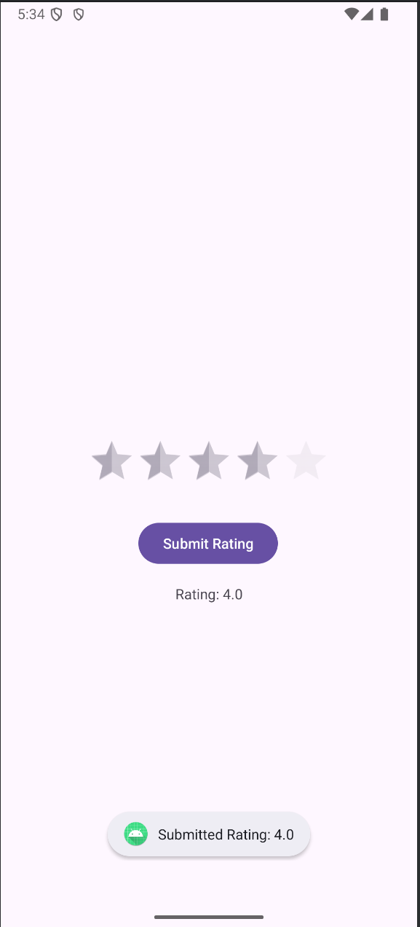

**RESULT**