Exp No: 5 **Creating Radio Buttons and Checkboxes with Action Listeners**

Date:

**AIM**

**ALGORITHM**

**SOURCE CODE**

*activity_main.xml*

<?xml version="1.0" encoding="utf-8"?>  
<androidx.constraintlayout.widget.ConstraintLayout xmlns:android="http://schemas.android.com/apk/res/android"  
 xmlns:app="http://schemas.android.com/apk/res-auto"  
 xmlns:tools="http://schemas.android.com/tools"  
 android:id="@+id/main"  
 android:layout_width="match_parent"  
 android:layout_height="match_parent"  
 tools:context=".MainActivity">  
  
 <TextView  
 android:id="@+id/textView"  
 android:layout_width="match_parent"  
 android:layout_height="wrap_content"  
 android:layout_marginTop="32dp"  
 android:layout_marginRight="32dp"  
 android:layout_marginLeft="32dp"  
 android:text="What is the capital of Spain ?"  
 android:textSize="20sp"  
 app:layout_constraintEnd_toEndOf="parent"  
 app:layout_constraintHorizontal_bias="0.0"  
 app:layout_constraintStart_toStartOf="parent"  
 app:layout_constraintTop_toTopOf="parent" />  
  
 <RadioGroup  
 android:id="@+id/radiogrp"  
 android:layout_width="wrap_content"  
 android:layout_height="wrap_content"  
 android:layout_marginTop="20dp"  
 app:layout_constraintStart_toStartOf="@id/textView"  
 app:layout_constraintTop_toBottomOf="@id/textView">  
  
 <RadioButton  
 android:id="@+id/rb1"  
 android:layout_width="wrap_content"  
 android:layout_height="wrap_content"  
 android:text="Barcelona"  
 android:layout_marginTop="0dp"  
 app:layout_constraintStart_toStartOf="@id/textView"  
 app:layout_constraintTop_toBottomOf="@id/textView" />  
  
 <RadioButton  
 android:id="@+id/rb2"  
 android:layout_width="wrap_content"  
 android:layout_height="wrap_content"  
 android:text="Madrid"  
 android:layout_marginTop="10dp"  
 app:layout_constraintStart_toStartOf="@+id/textView"  
 app:layout_constraintTop_toBottomOf="@id/rb1" />  
  
 <RadioButton  
 android:id="@+id/rb3"  
 android:layout_width="wrap_content"  
 android:layout_height="wrap_content"  
 android:text="Sevilla"  
 android:layout_marginTop="10dp"  
 app:layout_constraintStart_toStartOf="@+id/textView"  
 app:layout_constraintTop_toBottomOf="@id/rb2" />  
  
 </RadioGroup>  
  
 <Button  
 android:id="@+id/button"  
 android:layout_width="wrap_content"  
 android:layout_height="wrap_content"  
 android:text="Submit"  
 android:onClick="submitFirst"  
 android:layout_marginTop="20dp"  
 app:layout_constraintStart_toStartOf="@+id/textView"  
 app:layout_constraintTop_toBottomOf="@+id/radiogrp" />  
  
 <TextView  
 android:id="@+id/textView2"  
 android:layout_width="match_parent"  
 android:layout_height="wrap_content"  
 android:layout_marginLeft="32dp"  
 android:layout_marginRight="32dp"  
 android:layout_marginTop="40dp"  
 android:text="Which of the following are programming languages?"  
 android:textSize="20sp"  
 app:layout_constraintEnd_toEndOf="parent"  
 app:layout_constraintHorizontal_bias="0.0"  
 app:layout_constraintStart_toStartOf="parent"  
 app:layout_constraintTop_toBottomOf="@+id/button" />  
  
 <CheckBox  
 android:id="@+id/check1"  
 android:layout_width="wrap_content"  
 android:layout_height="wrap_content"  
 android:text="Java"  
 android:layout_marginTop="20dp"  
 app:layout_constraintStart_toStartOf="@+id/textView2"  
 app:layout_constraintTop_toBottomOf="@+id/textView2" />  
  
 <CheckBox  
 android:id="@+id/check2"  
 android:layout_width="wrap_content"  
 android:layout_height="wrap_content"  
 android:text="Python"  
 android:layout_marginTop="10dp"  
 app:layout_constraintStart_toStartOf="@+id/textView2"  
 app:layout_constraintTop_toBottomOf="@+id/check1" />  
  
 <CheckBox  
 android:id="@+id/check3"  
 android:layout_width="wrap_content"  
 android:layout_height="wrap_content"  
 android:text="HTML"  
 android:layout_marginTop="10dp"  
 app:layout_constraintStart_toStartOf="@+id/textView2"  
 app:layout_constraintTop_toBottomOf="@+id/check2" />  
  
 <Button  
 android:id="@+id/button2"  
 android:layout_width="wrap_content"  
 android:layout_height="wrap_content"  
 android:text="Submit"  
 android:onClick="submitSecond"  
 android:layout_marginTop="20dp"  
 app:layout_constraintStart_toStartOf="@+id/textView2"  
 app:layout_constraintTop_toBottomOf="@+id/check3" />  
  
 <TextView  
 android:id="@+id/feedback1"  
 android:layout_width="wrap_content"  
 android:layout_height="wrap_content"  
 android:layout_marginTop="13dp"  
 android:text=""  
 app:layout_constraintEnd_toEndOf="@+id/textView"  
 app:layout_constraintTop_toTopOf="@+id/button" />  
  
 <TextView  
 android:id="@+id/feedback2"  
 android:layout_width="wrap_content"  
 android:layout_height="wrap_content"  
 android:layout_marginTop="13dp"  
 android:text=""  
 app:layout_constraintEnd_toEndOf="@+id/textView"  
 app:layout_constraintTop_toTopOf="@+id/button2" />  
  
  
</androidx.constraintlayout.widget.ConstraintLayout>

*MainActivity.java*

package com.example.lab5;  
  
import android.graphics.Color;  
import android.os.Bundle;  
import android.view.View;  
import android.widget.Button;  
import android.widget.CheckBox;  
import android.widget.RadioButton;  
import android.widget.RadioGroup;  
import android.widget.TextView;  
import android.widget.Toast;  
  
import androidx.activity.EdgeToEdge;  
import androidx.appcompat.app.AppCompatActivity;  
import androidx.core.graphics.Insets;  
import androidx.core.view.ViewCompat;  
import androidx.core.view.WindowInsetsCompat;  
  
public class MainActivity extends AppCompatActivity {  
  
 RadioGroup radiogrp;  
 RadioButton r1, r2, r3;  
 CheckBox check1, check2, check3;  
 TextView feedback1, feedback2;  
  
 @Override  
 protected void onCreate(Bundle savedInstanceState) {  
 super.onCreate(savedInstanceState);  
 EdgeToEdge.*enable*(this);  
 setContentView(R.layout.*activity_main*);  
  
 radiogrp = findViewById(R.id.*radiogrp*);  
 r1 = findViewById(R.id.*rb1*);  
 r2 = findViewById(R.id.*rb2*);  
 r3 = findViewById(R.id.*rb3*);  
 check1 = findViewById(R.id.*check1*);  
 check2 = findViewById(R.id.*check2*);  
 check3 = findViewById(R.id.*check3*);  
 feedback1 = findViewById(R.id.*feedback1*);  
 feedback2 = findViewById(R.id.*feedback2*);  
  
 ViewCompat.*setOnApplyWindowInsetsListener*(findViewById(R.id.*main*), (v, insets) -> {  
 Insets systemBars = insets.getInsets(WindowInsetsCompat.Type.*systemBars*());  
 v.setPadding(systemBars.left, systemBars.top, systemBars.right, systemBars.bottom);  
 return insets;  
 });  
 }  
  
 public void disableFirst() {  
 r1.setEnabled(false);  
 r2.setEnabled(false);  
 r3.setEnabled(false);  
 }  
  
 public void disableSecond() {  
 check1.setEnabled(false);  
 check2.setEnabled(false);  
 check3.setEnabled(false);  
 }  
  
 public void submitFirst(View v) {  
  
 int selectedId = radiogrp.getCheckedRadioButtonId();  
 if (selectedId != -1) {  
 RadioButton selectedRadioButton = findViewById(selectedId);  
 String selectedText = selectedRadioButton.getText().toString();  
  
 if (selectedText.equals("Madrid")) {  
 selectedRadioButton.setTextColor(Color.*rgb*(0, 255, 0));  
 Toast.*makeText*(this, "Correct Answer", Toast.*LENGTH_SHORT*).show();  
 feedback1.setText("Correct Ans");  
 feedback1.setTextColor(Color.*rgb*(0, 255, 0));  
 } else {  
 selectedRadioButton.setTextColor(Color.*rgb*(255, 0, 0));  
 Toast.*makeText*(this, "Wrong Answer", Toast.*LENGTH_SHORT*).show();  
 feedback1.setText("Wrong Ans");  
 feedback1.setTextColor(Color.*rgb*(255, 0, 0));  
 }  
  
 ((Button) v).setEnabled(false);  
 disableFirst();  
  
 } else {  
 Toast.*makeText*(this, "Please select an option", Toast.*LENGTH_SHORT*).show();  
 }  
  
 }  
  
 public void submitSecond(View v) {  
  
 if (check1.isChecked() || check2.isChecked() || check3.isChecked()) {  
 if (check1.isChecked() && check2.isChecked() && !check3.isChecked()) {  
 Toast.*makeText*(this, "Correct Answer", Toast.*LENGTH_SHORT*).show();  
 feedback2.setText("Correct Ans");  
 feedback2.setTextColor(Color.*rgb*(0, 255, 0));  
 } else {  
 Toast.*makeText*(this, "Wrong Answer", Toast.*LENGTH_SHORT*).show();  
 feedback2.setText("Wrong Ans");  
 feedback2.setTextColor(Color.*rgb*(255, 0, 0));  
 }  
  
 check1.setTextColor(Color.*rgb*(0, 255, 0));  
 check2.setTextColor(Color.*rgb*(0, 255, 0));  
 check3.setTextColor(Color.*rgb*(255, 0, 0));  
  
 ((Button) v).setEnabled(false);  
 disableSecond();  
  
 } else {  
 Toast.*makeText*(this, "Please select an option", Toast.*LENGTH_SHORT*).show();  
 }  
  
  
 }  
  
}

**OUTPUT**

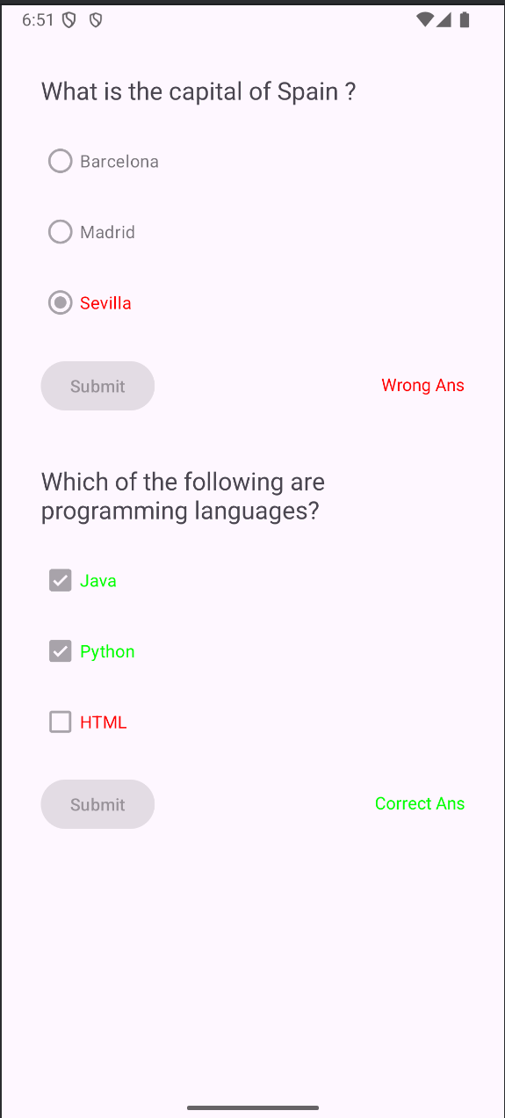

**RESULT**