
FAST NUCES — ISLAMABAD
Department of Computer Science
Computer Networks
Final Project Report

Submitted by
Alishba Inam
Student ID: 24i-2036

Lab Teacher: Mam Rubab Zainab
Date of Submission: 6th May 2026

Table of Contents
Table of Contents 2
1. Introduction & Objectives 5
Project Objectives 5
Assigned Data 5
2. VLSM Subnetting Calculations 6
2.1 Base Network 6
2.2 Host Requirements (Sorted Largest to Smallest) 6
2.3 VLSM Allocation Table 6
2.4 WAN Link Subnets (/30 — Point-to-Point) 7
3. Network Topology Overview 8
3.1 Routing Domains 8
3.2 Redistribution Points 8
3.3 Network-to-Gateway Mapping 8
4. Device Inventory 9
4.1 Routers (All Cisco 2811) 9
4.2 Switches 9
4.3 End Devices 10
4.4 Servers Summary 10
5. Cabling & Port Mapping 12
5.1 Cable Types Used 12
5.2 WAN Cabling (Router-to-Router) 12
OSPF Area 1 12
EIGRP 5 12
OSPF Area 2 12
RIP 13
5.3 LAN Cabling (Switch-to-Router, all Straight-Through) 13
6. Routing Protocol Configurations 14
6.1 OSPF Area 1 14
Router4 — Network A Gateway 14
Router1 — Network B+C Gateway (Hub) 14
Router0 — Transit 14
Router2 — OSPF ↔ EIGRP Border (Redistribution) 15
6.2 EIGRP 5 15
Router3 — EIGRP Entry 15
Router5 — Transit 15
Router6 — Transit (No LAN) 16
Router7 — Network D Gateway 16
Router9 — Network E Gateway 16
Router8 — Network F Gateway + EIGRP→OSPF2 Border 17
6.3 OSPF Area 2 17
Router10 — EIGRP ↔ OSPF2 Border (Redistribution) 17
Router11 — OSPF2 Hub 17
Router12 — Network G Gateway 18
Router13 — Network H+I Gateway 18
6.4 RIP (Version 2) 18
Router18 — OSPF2 ↔ RIP Border (Redistribution) 18
Router14 — Core RIP 19
Router15 — RIP Transit 19
Router16 — Network K Gateway 19
Router17 — Network J Gateway 20
7. Route Redistribution 21
8. DHCP Configuration 22
8.1 DHCP Server — Server1 (72.8.0.2) 22
Server1 Static IP Configuration 22
8.2 DHCP Pools 22
8.3 DHCP Relay (ip helper-address) 22
9. DNS, Mail & Web Server Setup 24
9.1 Server0 Configuration — 72.0.0.2 (Network C) 24
9.2 DNS Service 24
9.3 HTTP/Web Service 24
9.4 Email Service (SMTP/POP3) 24
Registered Users 24
9.5 Email Client Configuration (Example: Laptop2) 24
10. NAT Configuration 26
10.1 NAT Details 26
10.2 NAT Commands on Router17 26
10.3 Verification 26
11. Access Control Lists (ACLs) 27
11.1 ACL 1: Block ONE Host in Network A from Web Server 27
11.2 ACL 2: Block ALL of Network D from Web Server 27
12. Testing & Verification 28
12.1 Routing Table Verification 28
12.2 End-to-End Ping Tests 28
12.3 DHCP Verification 28
12.4 Service Tests 28
13. Conclusion 30

1. Introduction & Objectives
This project implements a complex enterprise network consisting of four routing domains interconnected through route redistribution. The network serves 11 subnets across multiple departments using VLSM (Variable Length Subnet Masking) for efficient IP allocation.

Project Objectives
- Design a multi-area network using VLSM from base network 72.0.0.0/8
- Implement OSPF Area 1, EIGRP AS 5, OSPF Area 2, and RIPv2
- Configure route redistribution between all routing domains
- Deploy a centralized DHCP server for all networks
- Set up Mail, Web, and DNS services
- Apply NAT (Network Address Translation) on a border router
- Implement ACLs to restrict specific traffic flows

Assigned Data
Item | Value
Public IP (for NAT) | 72.195.221.244
Private IP (for NAT) | 1.139.135.189
Base Network | 72.0.0.0/8

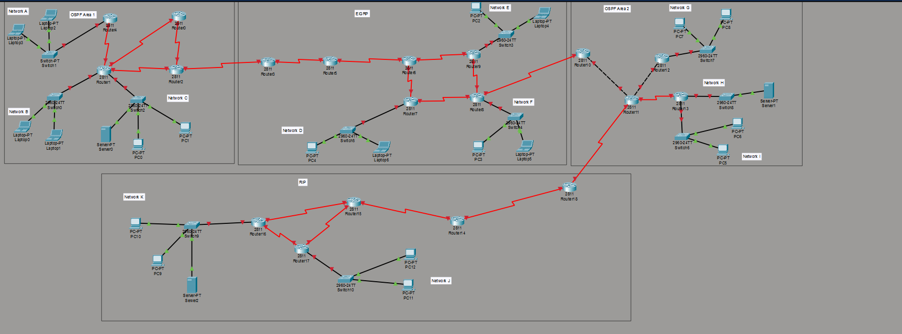

2. VLSM Subnetting Calculations

2.1 Base Network
72.0.0.0/8 — Total available addresses: 16,777,214

2.2 Host Requirements (Sorted Largest to Smallest)
# | Network | Required Hosts | Host Bits (n) | Block Size (2^n) | Usable Hosts | CIDR
1 | C | 107,957 | 17 | 131,072 | 131,070 | /15
2 | A | 101,175 | 17 | 131,072 | 131,070 | /15
3 | F | 98,305 | 17 | 131,072 | 131,070 | /15
4 | E | 87,687 | 17 | 131,072 | 131,070 | /15
5 | H | 81,173 | 17 | 131,072 | 131,070 | /15
6 | J | 66,518 | 17 | 131,072 | 131,070 | /15
7 | B | 64,770 | 16 | 65,536 | 65,534 | /16
8 | I | 57,250 | 16 | 65,536 | 65,534 | /16
9 | D | 49,116 | 16 | 65,536 | 65,534 | /16
10 | G | 46,641 | 16 | 65,536 | 65,534 | /16
11 | K | 36,065 | 16 | 65,536 | 65,534 | /16

2.3 VLSM Allocation Table
# | Network | CIDR | Subnet Mask | Network Address | First Usable | Last Usable | Broadcast
1 | C | /15 | 255.254.0.0 | 72.0.0.0 | 72.0.0.1 | 72.1.255.254 | 72.1.255.255
2 | A | /15 | 255.254.0.0 | 72.2.0.0 | 72.2.0.1 | 72.3.255.254 | 72.3.255.255
3 | F | /15 | 255.254.0.0 | 72.4.0.0 | 72.4.0.1 | 72.5.255.254 | 72.5.255.255
4 | E | /15 | 255.254.0.0 | 72.6.0.0 | 72.6.0.1 | 72.7.255.254 | 72.7.255.255
5 | H | /15 | 255.254.0.0 | 72.8.0.0 | 72.8.0.1 | 72.9.255.254 | 72.9.255.255
6 | J | /15 | 255.254.0.0 | 72.10.0.0 | 72.10.0.1 | 72.11.255.254 | 72.11.255.255
7 | B | /16 | 255.255.0.0 | 72.12.0.0 | 72.12.0.1 | 72.12.255.254 | 72.12.255.255
8 | I | /16 | 255.255.0.0 | 72.13.0.0 | 72.13.0.1 | 72.13.255.254 | 72.13.255.255
9 | D | /16 | 255.255.0.0 | 72.14.0.0 | 72.14.0.1 | 72.14.255.254 | 72.14.255.255
10 | G | /16 | 255.255.0.0 | 72.15.0.0 | 72.15.0.1 | 72.15.255.254 | 72.15.255.255
11 | K | /16 | 255.255.0.0 | 72.16.0.0 | 72.16.0.1 | 72.16.255.254 | 72.16.255.255

2.4 WAN Link Subnets (/30 — Point-to-Point)
All WAN links use /30 subnets starting at 72.17.0.0:
WAN | Link | Network | Side-1 IP | Side-2 IP
W1 | Router4 ↔ Router1 | 72.17.0.0/30 | .1 (R4) | .2 (R1)
W2 | Router1 ↔ Router0 | 72.17.0.4/30 | .5 (R1) | .6 (R0)
W3 | Router0 ↔ Router2 | 72.17.0.8/30 | .9 (R0) | .10 (R2)
W4 | Router2 ↔ Router3 | 72.17.0.12/30 | .13 (R2) | .14 (R3)
W5 | Router3 ↔ Router5 | 72.17.0.16/30 | .17 (R3) | .18 (R5)
W6 | Router5 ↔ Router6 | 72.17.0.20/30 | .21 (R5) | .22 (R6)
W7 | Router6 ↔ Router7 | 72.17.0.24/30 | .25 (R6) | .26 (R7)
W8 | Router6 ↔ Router9 | 72.17.0.28/30 | .29 (R6) | .30 (R9)
W9 | Router9 ↔ Router8 | 72.17.0.32/30 | .33 (R9) | .34 (R8)
W10 | Router8 ↔ Router10 | 72.17.0.36/30 | .37 (R8) | .38 (R10)
W11 | Router10 ↔ Router11 | 72.17.0.40/30 | .41 (R10) | .42 (R11)
W12 | Router11 ↔ Router12 | 72.17.0.44/30 | .45 (R11) | .46 (R12)
W13 | Router11 ↔ Router13 | 72.17.0.48/30 | .49 (R11) | .50 (R13)
W14 | Router11 ↔ Router18 | 72.17.0.52/30 | .53 (R11) | .54 (R18)
W15 | Router18 ↔ Router14 | 72.17.0.56/30 | .57 (R18) | .58 (R14)
W16 | Router14 ↔ Router15 | 72.17.0.60/30 | .61 (R14) | .62 (R15)
W17 | Router15 ↔ Router16 | 72.17.0.64/30 | .65 (R15) | .66 (R16)
W18 | Router16 ↔ Router17 | 72.17.0.68/30 | .69 (R16) | .70 (R17)
W19 | Router15 ↔ Router17 | 72.17.0.72/30 | .73 (R15) | .74 (R17)
W20 | Router7 ↔ Router8 | 72.17.0.76/30 | .77 (R7) | .78 (R8)
W21 | Router17 ↔ Router14 | 72.17.0.80/30 | .81 (R17) | .82 (R14)
W22 | Router1 ↔ Router2 | 72.17.0.84/30 | .85 (R1) | .86 (R2)

3. Network Topology Overview

3.1 Routing Domains
Domain | Protocol | Routers | Purpose
OSPF Area 1 | OSPF Process 1, Area 1 | Router4, Router1, Router0, Router2 | Campus core with servers
EIGRP 5 | EIGRP AS 5 | Router2, Router3, Router5, Router6, Router7, Router9, Router8, Router10 | Distribution layer
OSPF Area 2 | OSPF Process 1, Area 2 | Router10, Router11, Router12, Router13, Router18 | Secondary campus
RIP | RIPv2 | Router18, Router14, Router15, Router16, Router17 | Remote sites

3.2 Redistribution Points
Border Router | Connects | Redistribution
Router2 | OSPF Area 1 ↔ EIGRP 5 | Mutual redistribution between OSPF and EIGRP
Router10 | EIGRP 5 ↔ OSPF Area 2 | Mutual redistribution between EIGRP and OSPF
Router18 | OSPF Area 2 ↔ RIP | Mutual redistribution between OSPF and RIP

3.3 Network-to-Gateway Mapping
Network | Subnet | Gateway Router | Interface | Gateway IP | Routing Domain
A | 72.2.0.0/15 | Router4 | Fa0/1 | 72.2.0.1 | OSPF Area 1
B | 72.12.0.0/16 | Router1 | Fa0/0 | 72.12.0.1 | OSPF Area 1
C | 72.0.0.0/15 | Router1 | Fa0/1 | 72.0.0.1 | OSPF Area 1
D | 72.14.0.0/16 | Router7 | Fa0/0 | 72.14.0.1 | EIGRP 5
E | 72.6.0.0/15 | Router9 | Fa0/0 | 72.6.0.1 | EIGRP 5
F | 72.4.0.0/15 | Router8 | Fa0/0 | 72.4.0.1 | EIGRP 5
G | 72.15.0.0/16 | Router12 | Fa0/0 | 72.15.0.1 | OSPF Area 2
H | 72.8.0.0/15 | Router13 | Fa0/0 | 72.8.0.1 | OSPF Area 2
I | 72.13.0.0/16 | Router13 | Fa0/1 | 72.13.0.1 | OSPF Area 2
J | 72.10.0.0/15 | Router17 | Fa0/0 | 72.10.0.1 | RIP
K | 72.16.0.0/16 | Router16 | Fa0/0 | 72.16.0.1 | RIP

4. Device Inventory

4.1 Routers (All Cisco 2811)
Router | Role | WIC-2T Modules | LAN Networks
Router4 | Network A gateway | 1 | A
Router1 | Network B+C gateway, OSPF hub | 2 (3 serial ports) | B, C
Router0 | OSPF transit | 1 | None
Router2 | OSPF ↔ EIGRP border | 2 (3 serial ports) | None
Router3 | EIGRP entry | 1 | None
Router5 | EIGRP transit | 1 | None
Router6 | EIGRP transit | 2 (3 serial ports) | None
Router7 | Network D gateway | 1 | D
Router9 | Network E gateway | 1 | E
Router8 | Network F gateway, EIGRP→OSPF2 | 2 (3 serial ports) | F
Router10 | EIGRP ↔ OSPF2 border | 1 | None
Router11 | OSPF2 hub | 1 | None
Router12 | Network G gateway | 0 (Ethernet only) | G
Router13 | Network H+I gateway | 1 | H, I
Router18 | OSPF2 ↔ RIP border | 1 | None
Router14 | RIP core | 2 (3 serial ports) | None
Router15 | RIP transit | 2 (3 serial ports) | None
Router16 | Network K gateway | 1 | K
Router17 | Network J gateway | 2 (3 serial ports) | J

4.2 Switches
Switch | Model | Network | Connected To Router | Port to Router
Switch1 | Switch-PT | A | Router4 Fa0/1 | Straight-through
Switch0 | 2960-24TT | B | Router1 Fa0/0 | Straight-through
Switch2 | 2960-24TT | C | Router1 Fa0/1 | Straight-through
Switch5 | 2960-24TT | D | Router7 Fa0/0 | Straight-through
Switch3 | 2960-24TT | E | Router9 Fa0/0 | Straight-through
Switch4 | 2960-24TT | F | Router8 Fa0/0 | Straight-through
Switch7 | 2960-24TT | G | Router12 Fa0/0 | Straight-through
Switch8 | 2960-24TT | H | Router13 Fa0/0 | Straight-through
Switch6 | 2960-24TT | I | Router13 Fa0/1 | Straight-through
Switch9 | 2960-24TT | K | Router16 Fa0/0 | Straight-through
Switch10 | 2960-24TT | J | Router17 Fa0/0 | Straight-through

4.3 End Devices
Device | Type | Network | Switch | Switch Port | IP Method
Laptop3 | Laptop-PT | A | Switch1 | Fa0/1 | DHCP
Laptop2 | Laptop-PT | A | Switch1 | Fa0/2 | DHCP
Laptop0 | Laptop-PT | B | Switch0 | Fa0/1 | DHCP
Laptop1 | Laptop-PT | B | Switch0 | Fa0/2 | DHCP
PC0 | PC-PT | C | Switch2 | Fa0/1 | DHCP
PC1 | PC-PT | C | Switch2 | Fa0/2 | DHCP
Server0 | Server-PT | C | Switch2 | Fa0/3 | Static: 72.0.0.2
PC4 | PC-PT | D | Switch5 | Fa0/1 | DHCP
Laptop6 | Laptop-PT | D | Switch5 | Fa0/2 | DHCP
PC2 | PC-PT | E | Switch3 | Fa0/1 | DHCP
Laptop4 | Laptop-PT | E | Switch3 | Fa0/2 | DHCP
PC3 | PC-PT | F | Switch4 | Fa0/1 | DHCP
Laptop5 | Laptop-PT | F | Switch4 | Fa0/2 | DHCP
PC7 | PC-PT | G | Switch7 | Fa0/1 | DHCP
PC8 | PC-PT | G | Switch7 | Fa0/2 | DHCP
Server1 | Server-PT | H | Switch8 | Fa0/1 | Static: 72.8.0.2
PC5 | PC-PT | I | Switch6 | Fa0/1 | DHCP
PC6 | PC-PT | I | Switch6 | Fa0/2 | DHCP
PC10 | PC-PT | K | Switch9 | Fa0/1 | DHCP
PC9 | PC-PT | K | Switch9 | Fa0/2 | DHCP
Server2 | Server-PT | K | Switch9 | Fa0/3 | Static: 72.16.0.2
PC12 | PC-PT | J | Switch10 | Fa0/1 | DHCP
PC11 | PC-PT | J | Switch10 | Fa0/2 | DHCP

4.4 Servers Summary
Server | Location | IP | Subnet Mask | Gateway | Services
Server0 | Network C (Switch2) | 72.0.0.2 | 255.254.0.0 | 72.0.0.1 | DNS, HTTP, SMTP/POP3
Server1 | Network H (Switch8) | 72.8.0.2 | 255.254.0.0 | 72.8.0.1 | DHCP
Server2 | Network K (Switch9) | 72.16.0.2 | 255.255.0.0 | 72.16.0.1 | —

5. Cabling & Port Mapping

5.1 Cable Types Used
Cable Type | Usage | Color in Packet Tracer
Serial DCE | Router-to-Router WAN links | Red solid lines
Crossover Ethernet | Router10↔Router11, Router11↔Router12 | Black dashed lines
Straight-Through | Switch-to-Router, Switch-to-PC/Laptop/Server | Green lines

5.2 WAN Cabling (Router-to-Router)

OSPF Area 1
From | Port | To | Port | Cable | WAN
Router4 | Se0/0/0 | Router1 | Se0/0/0 | Serial DCE | W1
Router1 | Se0/0/1 | Router0 | Se0/0/0 | Serial DCE | W2
Router0 | Se0/0/1 | Router2 | Se0/0/0 | Serial DCE | W3
Router1 | Se0/1/0 | Router2 | Se0/1/0 | Serial DCE | W22
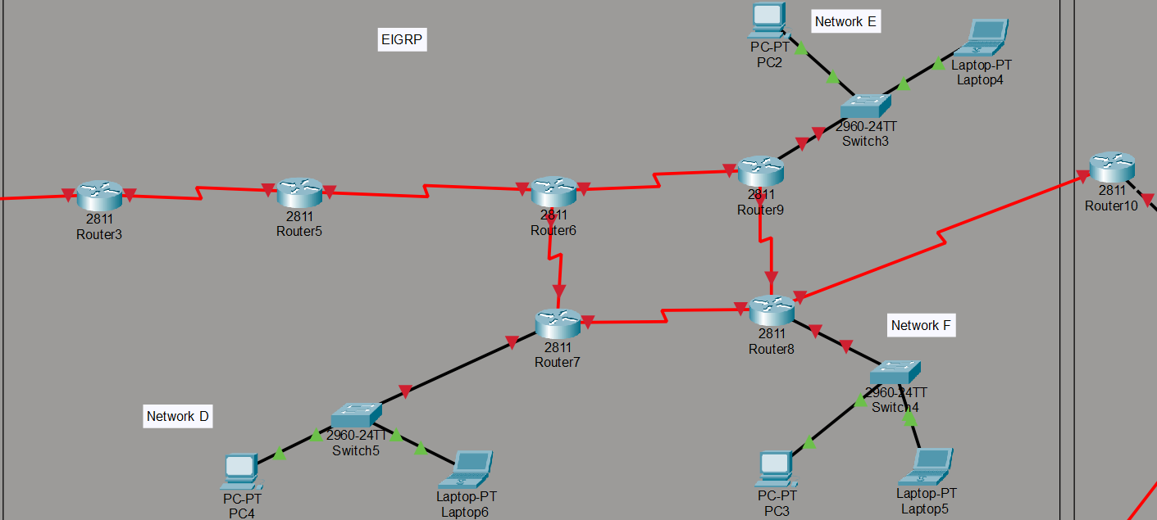

EIGRP 5
From | Port | To | Port | Cable | WAN
Router2 | Se0/0/1 | Router3 | Se0/0/0 | Serial DCE | W4
Router3 | Se0/0/1 | Router5 | Se0/0/0 | Serial DCE | W5
Router5 | Se0/0/1 | Router6 | Se0/0/0 | Serial DCE | W6
Router6 | Se0/0/1 | Router7 | Se0/0/0 | Serial DCE | W7
Router6 | Se0/1/0 | Router9 | Se0/0/0 | Serial DCE | W8
Router9 | Se0/0/1 | Router8 | Se0/0/0 | Serial DCE | W9
Router7 | Se0/0/1 | Router8 | Se0/1/0 | Serial DCE | W20


OSPF Area 2
From | Port | To | Port | Cable | WAN
Router8 | Se0/0/1 | Router10 | Se0/0/0 | Serial DCE | W10
Router10 | Fa0/0 | Router11 | Fa0/0 | Crossover | W11
Router11 | Fa0/1 | Router12 | Fa0/1 | Crossover | W12
Router11 | Se0/0/0 | Router13 | Se0/0/0 | Serial DCE | W13
Router11 | Se0/0/1 | Router18 | Se0/0/0 | Serial DCE | W14

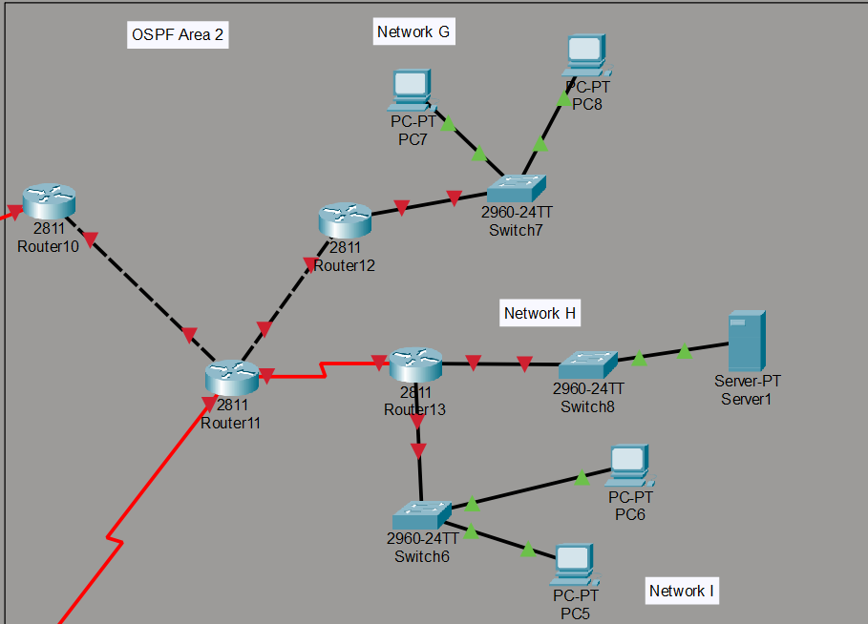RIP
From | Port | To | Port | Cable | WAN
Router18 | Se0/0/1 | Router14 | Se0/0/0 | Serial DCE | W15
Router14 | Se0/0/1 | Router15 | Se0/0/0 | Serial DCE | W16
Router15 | Se0/0/1 | Router16 | Se0/0/0 | Serial DCE | W17
Router16 | Se0/0/1 | Router17 | Se0/0/0 | Serial DCE | W18
Router15 | Se0/1/0 | Router17 | Se0/0/1 | Serial DCE | W19
Router17 | Se0/1/0 | Router14 | Se0/1/0 | Serial DCE | W21
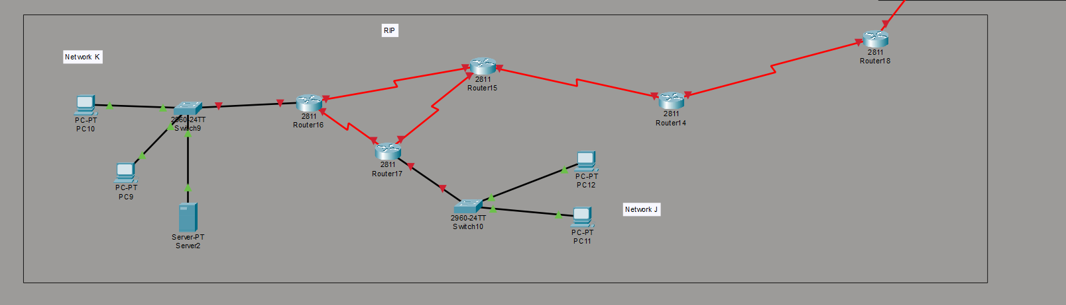

5.3 LAN Cabling (Switch-to-Router, all Straight-Through)
Switch | Switch Port | Router | Router Port
Switch1 | Fa0/1 | Router4 | Fa0/1
Switch0 | Fa0/1 | Router1 | Fa0/0
Switch2 | Fa0/4 | Router1 | Fa0/1
Switch5 | Fa0/1 | Router7 | Fa0/0
Switch3 | Fa0/1 | Router9 | Fa0/0
Switch4 | Fa0/1 | Router8 | Fa0/0
Switch7 | Fa0/1 | Router12 | Fa0/0
Switch8 | Fa0/1 | Router13 | Fa0/0
Switch6 | Fa0/1 | Router13 | Fa0/1
Switch9 | Fa0/1 | Router16 | Fa0/0
Switch10 | Fa0/1 | Router17 | Fa0/0

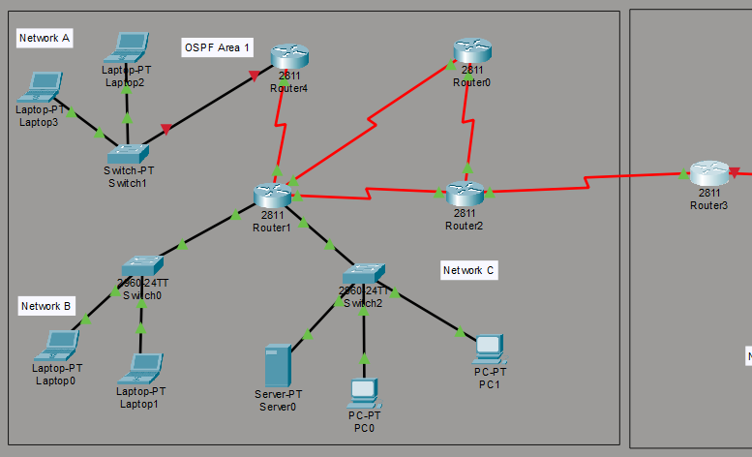6. Routing Protocol Configurations

6.1 OSPF Area 1
OSPF Process ID: 1, Area: 1

Router4 — Network A Gateway
hostname Router4

interface FastEthernet0/1
ip address 72.2.0.1 255.254.0.0
ip helper-address 72.8.0.2
interface Serial0/0/0
ip address 72.17.0.1 255.255.255.252

router ospf 1
network 72.2.0.0 0.1.255.255 area 1
network 72.17.0.0 0.0.0.3 area 1

Router1 — Network B+C Gateway (Hub)

interface FastEthernet0/0
ip address 72.12.0.1 255.255.0.0
ip helper-address 72.8.0.2
interface FastEthernet0/1
ip address 72.0.0.1 255.254.0.0
ip helper-address 72.8.0.2
interface Serial0/0/0
ip address 72.17.0.2 255.255.255.252
interface Serial0/0/1
ip address 72.17.0.5 255.255.255.252
interface Serial0/1/0
ip address 72.17.0.85 255.255.255.252

router ospf 1
network 72.12.0.0 0.0.255.255 area 1
network 72.0.0.0 0.1.255.255 area 1
network 72.17.0.0 0.0.0.3 area 1
network 72.17.0.4 0.0.0.3 area 1
network 72.17.0.84 0.0.0.3 area 1

hostname Router0

interface Serial0/0/0
ip address 72.17.0.6 255.255.255.252

Router0 — Transit
ip address 72.17.0.9 255.255.255.252

router ospf 1
network 72.17.0.4 0.0.0.3 area 1
network 72.17.0.8 0.0.0.3 area 1

hostname Router2

interface Serial0/0/0
ip address 72.17.0.10 255.255.255.252
interface Serial0/0/1
ip address 72.17.0.13 255.255.255.252

Router2 — OSPF ↔ EIGRP Border (Redistribution)
ip address 72.17.0.86 255.255.255.252

router ospf 1
network 72.17.0.8 0.0.0.3 area 1
network 72.17.0.84 0.0.0.3 area 1
redistribute eigrp 5 subnets

router eigrp 5
network 72.17.0.12 0.0.0.3
redistribute ospf 1 metric 1500 100 255 1 1500
no auto-summary

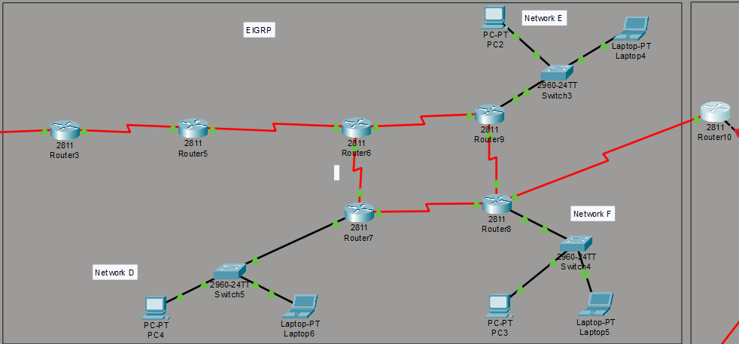6.2 EIGRP 5
EIGRP Autonomous System: 5

Router3 — EIGRP Entry
hostname Router3

interface Serial0/0/0
ip address 72.17.0.14 255.255.255.252
interface Serial0/0/1
ip address 72.17.0.17 255.255.255.252

router eigrp 5
network 72.17.0.12 0.0.0.3
network 72.17.0.16 0.0.0.3
no auto-summary

Router5 — Transit

interface Serial0/0/0
ip address 72.17.0.18 255.255.255.252
interface Serial0/0/1
ip address 72.17.0.21 255.255.255.252

router eigrp 5
network 72.17.0.16 0.0.0.3
network 72.17.0.20 0.0.0.3
no auto-summary

Router6 — Transit (No LAN)

interface Serial0/0/0
ip address 72.17.0.22 255.255.255.252
interface Serial0/0/1
ip address 72.17.0.25 255.255.255.252
interface Serial0/1/0
ip address 72.17.0.29 255.255.255.252

router eigrp 5
network 72.17.0.20 0.0.0.3
network 72.17.0.24 0.0.0.3
network 72.17.0.28 0.0.0.3
no auto-summary

hostname Router7

Router7 — Network D Gateway
interface FastEthernet0/0
ip address 72.14.0.1 255.255.0.0
ip helper-address 72.8.0.2
interface Serial0/0/0
ip address 72.17.0.26 255.255.255.252
interface Serial0/0/1
ip address 72.17.0.77 255.255.255.252

router eigrp 5
network 72.14.0.0 0.0.255.255
network 72.17.0.24 0.0.0.3
network 72.17.0.76 0.0.0.3
no auto-summary

hostname Router9

Router9 — Network E Gateway
interface FastEthernet0/0
ip address 72.6.0.1 255.254.0.0
ip helper-address 72.8.0.2
interface Serial0/0/0
ip address 72.17.0.30 255.255.255.252
interface Serial0/0/1
ip address 72.17.0.33 255.255.255.252

router eigrp 5
network 72.6.0.0 0.1.255.255
network 72.17.0.28 0.0.0.3
network 72.17.0.32 0.0.0.3
no auto-summary

hostname Router8

Router8 — Network F Gateway + EIGRP→OSPF2 Border
interface FastEthernet0/0
ip address 72.4.0.1 255.254.0.0
ip helper-address 72.8.0.2
interface Serial0/0/0
ip address 72.17.0.34 255.255.255.252
interface Serial0/0/1
ip address 72.17.0.37 255.255.255.252
interface Serial0/1/0
ip address 72.17.0.78 255.255.255.252

router eigrp 5
network 72.4.0.0 0.1.255.255
network 72.17.0.32 0.0.0.3
network 72.17.0.36 0.0.0.3
network 72.17.0.76 0.0.0.3
no auto-summary

6.3 OSPF Area 2

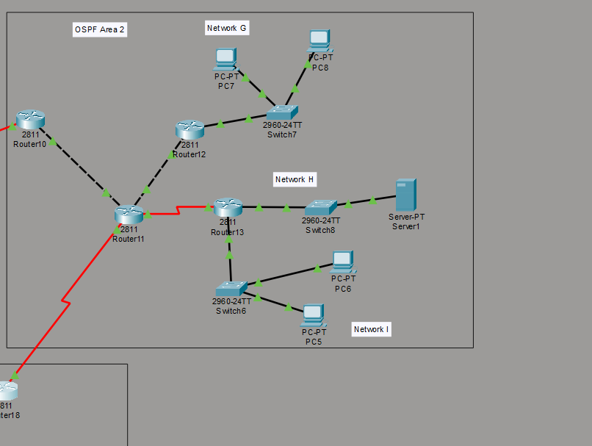

Router10 — EIGRP ↔ OSPF2 Border (Redistribution)
hostname Router10

interface Serial0/0/0
ip address 72.17.0.38 255.255.255.252
interface FastEthernet0/0
ip address 72.17.0.41 255.255.255.252

router eigrp 5
network 72.17.0.36 0.0.0.3
redistribute ospf 1 metric 1500 100 255 1 1500
no auto-summary

router ospf 1
network 72.17.0.40 0.0.0.3 area 2
redistribute eigrp 5 subnets

hostname Router11

Router11 — OSPF2 Hub
interface FastEthernet0/0
ip address 72.17.0.42 255.255.255.252
interface FastEthernet0/1
ip address 72.17.0.45 255.255.255.252
interface Serial0/0/0
ip address 72.17.0.49 255.255.255.252
interface Serial0/0/1
ip address 72.17.0.53 255.255.255.252

router ospf 1
network 72.17.0.40 0.0.0.3 area 2
network 72.17.0.44 0.0.0.3 area 2
network 72.17.0.48 0.0.0.3 area 2
network 72.17.0.52 0.0.0.3 area 2

hostname Router12

interface FastEthernet0/0

Router12 — Network G Gateway
ip helper-address 72.8.0.2
interface FastEthernet0/1
ip address 72.17.0.46 255.255.255.252

router ospf 1
network 72.15.0.0 0.0.255.255 area 2
network 72.17.0.44 0.0.0.3 area 2

hostname Router13

interface FastEthernet0/0

Router13 — Network H+I Gateway
interface FastEthernet0/1
ip address 72.13.0.1 255.255.0.0
ip helper-address 72.8.0.2
interface Serial0/0/0
ip address 72.17.0.50 255.255.255.252

router ospf 1
network 72.8.0.0 0.1.255.255 area 2
network 72.13.0.0 0.0.255.255 area 2
network 72.17.0.48 0.0.0.3 area 2
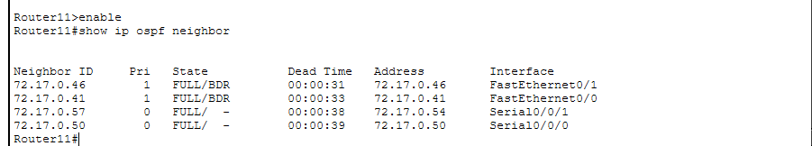
show ip ospf neighbor on Router11

6.4 RIP (Version 2)

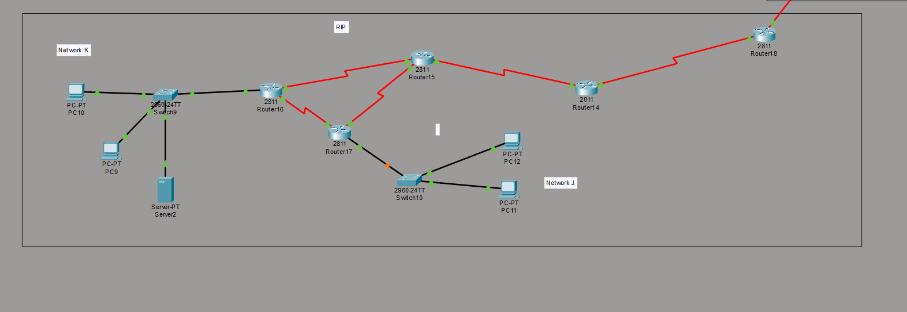

Router18 — OSPF2 ↔ RIP Border (Redistribution)
hostname Router18

interface Serial0/0/0
ip address 72.17.0.54 255.255.255.252
interface Serial0/0/1
ip address 72.17.0.57 255.255.255.252

router ospf 1
network 72.17.0.52 0.0.0.3 area 2
redistribute rip subnets

router rip
version 2
network 72.17.0.56
redistribute ospf 1 metric 5
no auto-summary

Router14 — Core RIP

interface Serial0/0/0
ip address 72.17.0.58 255.255.255.252
interface Serial0/0/1
ip address 72.17.0.61 255.255.255.252
interface Serial0/1/0
ip address 72.17.0.82 255.255.255.252

router rip
version 2
network 72.17.0.56
network 72.17.0.60
network 72.17.0.80
no auto-summary

hostname Router15

Router15 — RIP Transit
interface Serial0/0/0
ip address 72.17.0.62 255.255.255.252
interface Serial0/0/1
ip address 72.17.0.65 255.255.255.252
interface Serial0/1/0
ip address 72.17.0.73 255.255.255.252

router rip
version 2
network 72.17.0.60
network 72.17.0.64
network 72.17.0.72
no auto-summary

hostname Router16

Router16 — Network K Gateway
interface FastEthernet0/0
ip address 72.16.0.1 255.255.0.0
ip helper-address 72.8.0.2
interface Serial0/0/0
ip address 72.17.0.66 255.255.255.252
interface Serial0/0/1
ip address 72.17.0.69 255.255.255.252

router rip
version 2
network 72.16.0.0
network 72.17.0.64
network 72.17.0.68
no auto-summary

hostname Router17

Router17 — Network J Gateway
ip address 72.10.0.1 255.254.0.0
ip helper-address 72.8.0.2
interface Serial0/0/0
ip address 72.17.0.70 255.255.255.252
interface Serial0/0/1
ip address 72.17.0.74 255.255.255.252
interface Serial0/1/0
ip address 72.17.0.81 255.255.255.252

router rip
version 2
network 72.10.0.0
network 72.17.0.68
network 72.17.0.72
network 72.17.0.80
no auto-summary

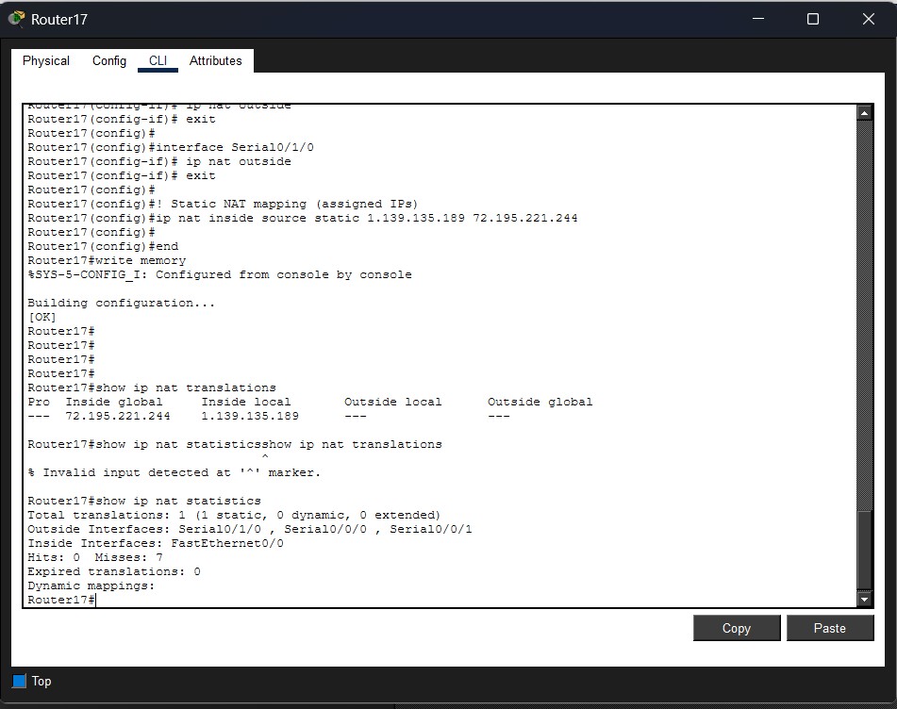

7. Route Redistribution
Route redistribution allows different routing protocols to share route information across domain boundaries.

Border Router | From Protocol | To Protocol | Command
Router2 | EIGRP 5 → OSPF 1 | Under router ospf 1 | redistribute eigrp 5 subnets
Router2 | OSPF 1 → EIGRP 5 | Under router eigrp 5 | redistribute ospf 1 metric 1500 100 255 1 1500
Router10 | EIGRP 5 → OSPF 1 | Under router ospf 1 | redistribute eigrp 5 subnets
Router10 | OSPF 1 → EIGRP 5 | Under router eigrp 5 | redistribute ospf 1 metric 1500 100 255 1 1500
Router18 | RIP → OSPF 1 | Under router ospf 1 | redistribute rip subnets
Router18 | OSPF 1 → RIP | Under router rip | redistribute ospf 1 metric 5

EIGRP Metric Format: Bandwidth, Delay, Reliability, Load, MTU (1500 100 255 1 1500)

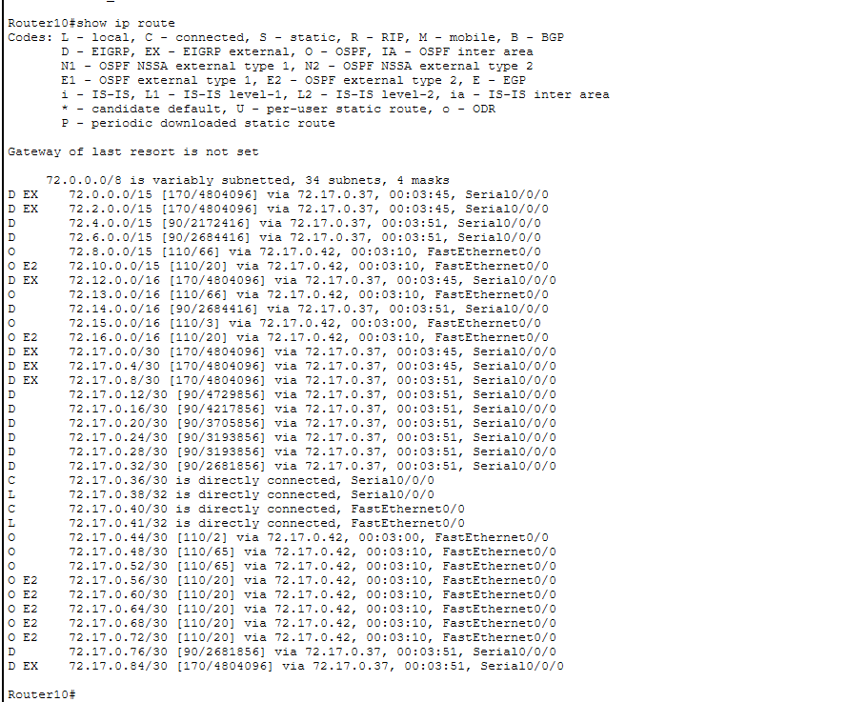
show ip route on Router10 showing both EIGRP (D) and OSPF (O) routes

8. DHCP Configuration

8.1 DHCP Server — Server1 (72.8.0.2)
Server1 acts as the centralized DHCP server for all 11 networks. It is located in Network H.

Server1 Static IP Configuration
Setting | Value
IP | 72.8.0.2
Subnet Mask | 255.254.0.0
Gateway | 72.8.0.1
DNS | 72.0.0.2

8.2 DHCP Pools
Pool | Network | Default Gateway | DNS Server | Start IP | Subnet Mask
Net-A | A | 72.2.0.1 | 72.0.0.2 | 72.2.0.10 | 255.254.0.0
Net-B | B | 72.12.0.1 | 72.0.0.2 | 72.12.0.10 | 255.255.0.0
Net-C | C | 72.0.0.1 | 72.0.0.2 | 72.0.0.10 | 255.254.0.0
Net-D | D | 72.14.0.1 | 72.0.0.2 | 72.14.0.10 | 255.255.0.0
Net-E | E | 72.6.0.1 | 72.0.0.2 | 72.6.0.10 | 255.254.0.0
Net-F | F | 72.4.0.1 | 72.0.0.2 | 72.4.0.10 | 255.254.0.0
Net-G | G | 72.15.0.1 | 72.0.0.2 | 72.15.0.10 | 255.255.0.0
Net-I | I | 72.13.0.1 | 72.0.0.2 | 72.13.0.10 | 255.255.0.0
Net-J | J | 72.10.0.1 | 72.0.0.2 | 72.10.0.10 | 255.254.0.0
Net-K | K | 72.16.0.1 | 72.0.0.2 | 72.16.0.10 | 255.255.0.0

8.3 DHCP Relay (ip helper-address)
Each gateway router forwards DHCP requests to Server1 using ip helper-address 72.8.0.2:
Router | Interface | Network
Router4 | Fa0/1 | A
Router1 | Fa0/0 | B
Router1 | Fa0/1 | C
Router7 | Fa0/0 | D
Router9 | Fa0/0 | E
Router8 | Fa0/0 | F
Router12 | Fa0/0 | G
Router13 | Fa0/1 | I
Router17 | Fa0/0 | J
Router16 | Fa0/0 | K

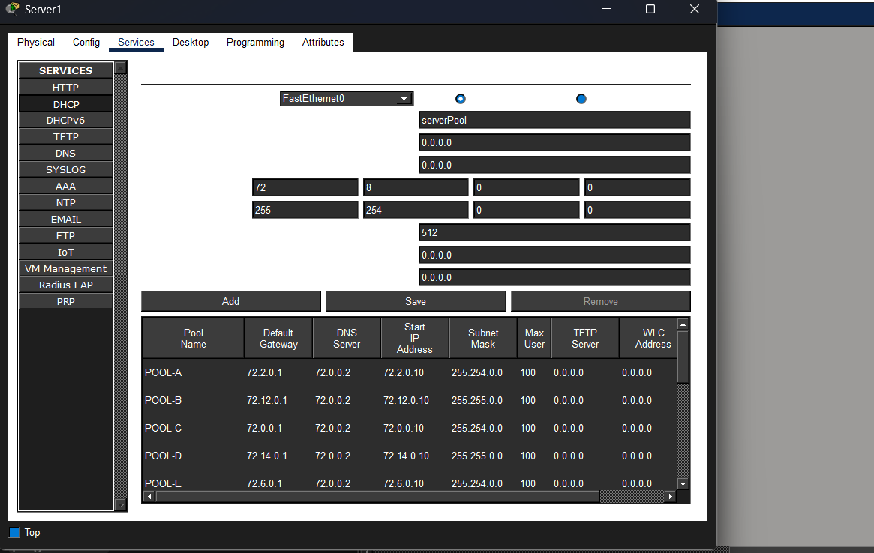9. DNS, Mail & Web Server Setup

9.1 Server0 Configuration — 72.0.0.2 (Network C)
Setting | Value
IP Address | 72.0.0.2
Subnet Mask | 255.254.0.0
Default Gateway | 72.0.0.1
DNS Server | 72.0.0.2 (itself)
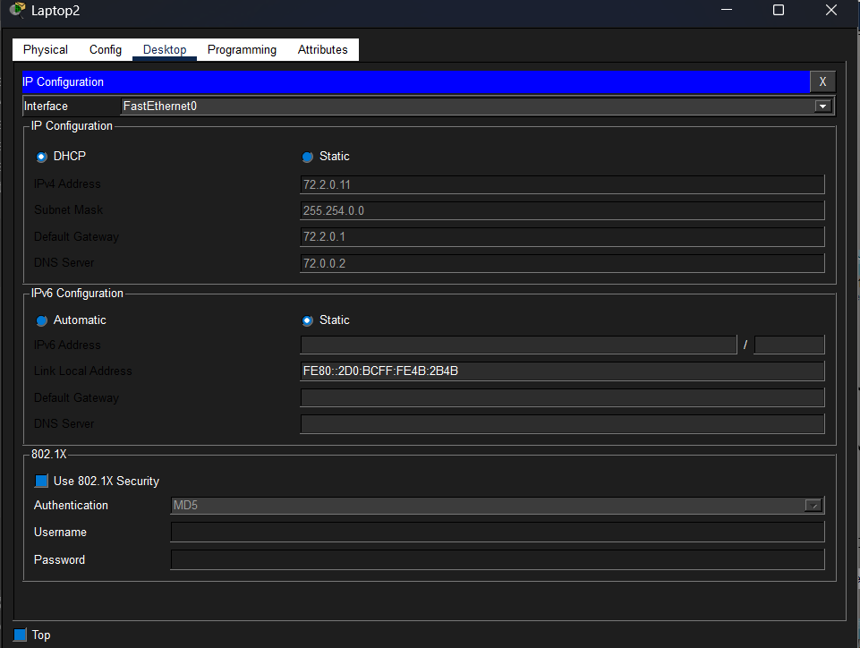

9.2 DNS Service
Hostname | Type | Address
www.project.com | A Record | 72.0.0.2

9.3 HTTP/Web Service
HTTP Service: ON — Default page serves to any browser accessing http://www.project.com or http://72.0.0.2

9.4 Email Service (SMTP/POP3)
Domain: project.com SMTP: ON POP3: ON

Registered Users
User | Password | Email
laptop0 | laptop0 | laptop0@project.com
laptop1 | laptop1 | laptop1@project.com
laptop2 | laptop2 | laptop2@project.com
laptop3 | laptop3 | laptop3@project.com
pc0 | pc0 | pc0@project.com
pc1 | pc1 | pc1@project.com

9.5 Email Client Configuration (Example: Laptop2)
Field | Value
Your Name | Laptop2
Email Address | laptop2@project.com
Incoming Mail Server | 72.0.0.2
Outgoing Mail Server | 72.0.0.2
User Name | laptop2
Password | laptop2
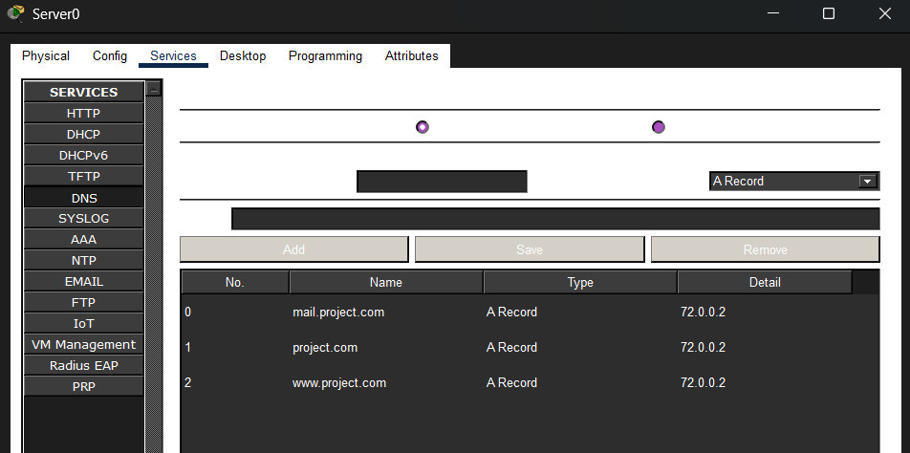 Server0 DNS services 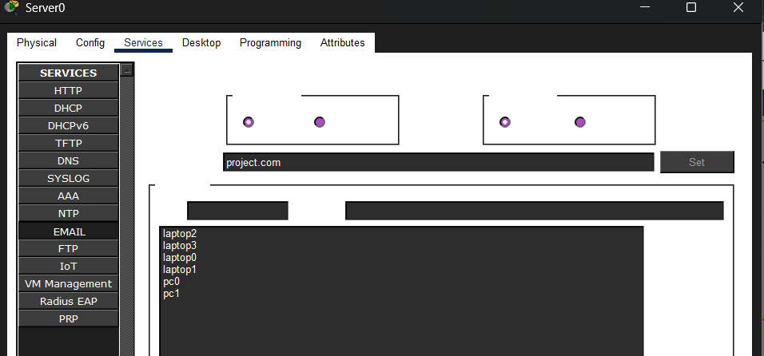
Server0 Email service showing user list
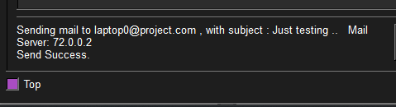
Email send success from Laptop2
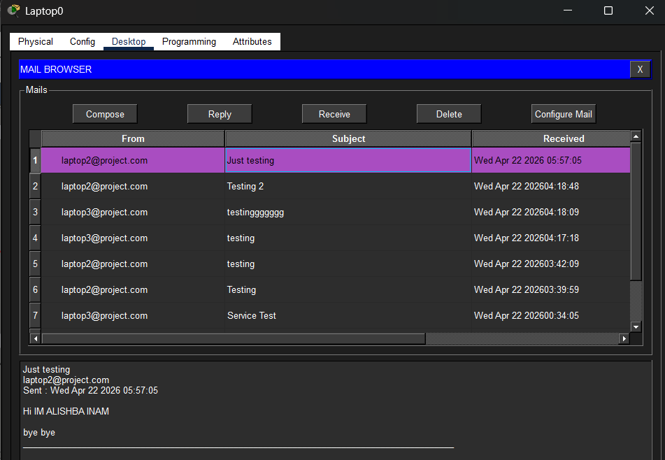 Email receive on Laptop0
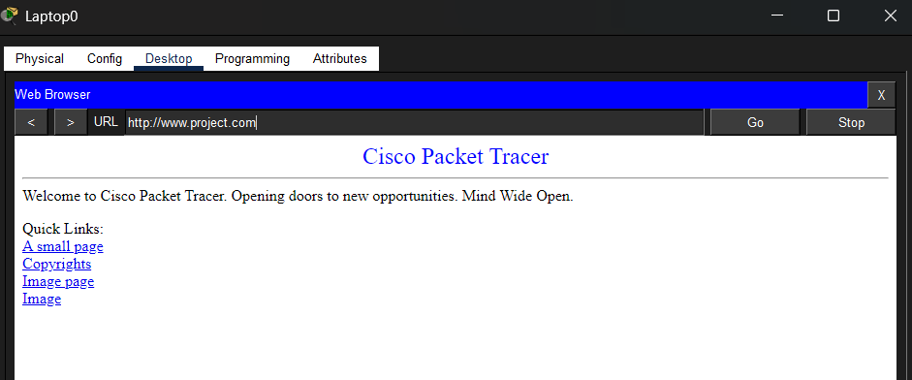
Web browser on any PC accessing www.project.com

10. NAT Configuration
NAT is configured on Router17 (gateway for Network J) to translate the private IP address to the public IP address.

10.1 NAT Details
Setting | Value
Inside Local | 1.139.135.189
Inside Global (Public) | 72.195.221.244
NAT Type | Static
Inside Interface | Fa0/0 (Network J)
Outside Interfaces | Se0/0/0, Se0/0/1, Se0/1/0 (WAN serial links)

10.2 NAT Commands on Router17
interface FastEthernet0/0
ip nat inside

interface Serial0/0/0
ip nat outside

interface Serial0/0/1
ip nat outside

interface Serial0/1/0
ip nat outside

ip nat inside source static 1.139.135.189 72.195.221.244

10.3 Verification
Router17#show ip nat translations

Pro Inside global Inside local Outside local Outside global
--- 72.195.221.244 1.139.135.189 --- ---

Router17#show ip nat statistics

Total translations: 1 (1 static, 0 dynamic)
Outside Interfaces: Serial0/0/0, Serial0/0/1, Serial0/1/0
Inside Interfaces: FastEthernet0/0
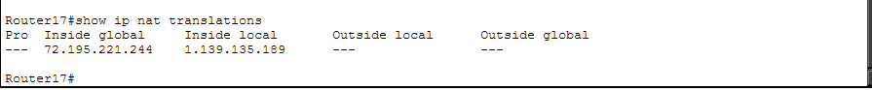
show ip nat translations output on Router17
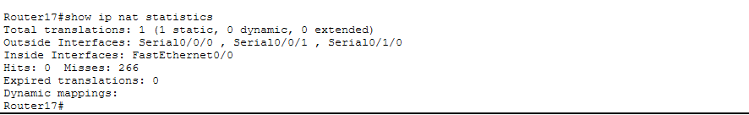
show ip nat statistics output on Router17

11. Access Control Lists (ACLs)

11.1 ACL 1: Block ONE Host in Network A from Web Server
Purpose: Prevent a specific host (first DHCP-assigned PC) in Network A from accessing Server0.
Setting | Value
Applied On | Router4
Interface | Fa0/1 (inbound)
Blocked Source | 72.2.0.10 (first DHCP host)
Blocked Destination | 72.0.0.2 (Server0)

access-list 100 deny ip host 72.2.0.10 host 72.0.0.2
access-list 100 permit ip any any

interface FastEthernet0/1
ip access-group 100 in

11.2 ACL 2: Block ALL of Network D from Web Server
Purpose: Prevent the entire Network D subnet from accessing Server0.
Setting | Value
Applied On | Router7
Interface | Fa0/0 (inbound)
Blocked Source | 72.14.0.0/16 (entire Network D)
Blocked Destination | 72.0.0.2 (Server0)

access-list 101 deny ip 72.14.0.0 0.0.255.255 host 72.0.0.2
access-list 101 permit ip any any

interface FastEthernet0/0
ip access-group 101 in
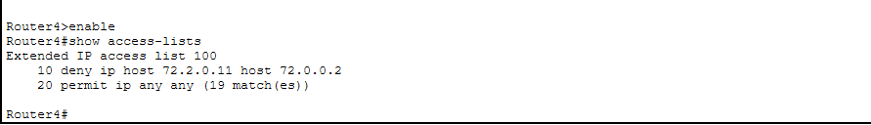
show access-lists on Router4
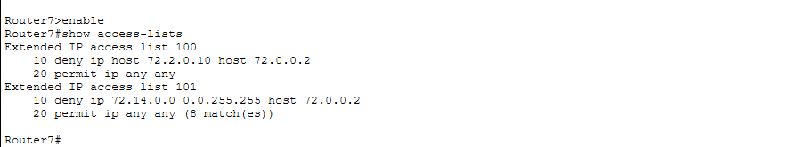
show access-lists on Router7
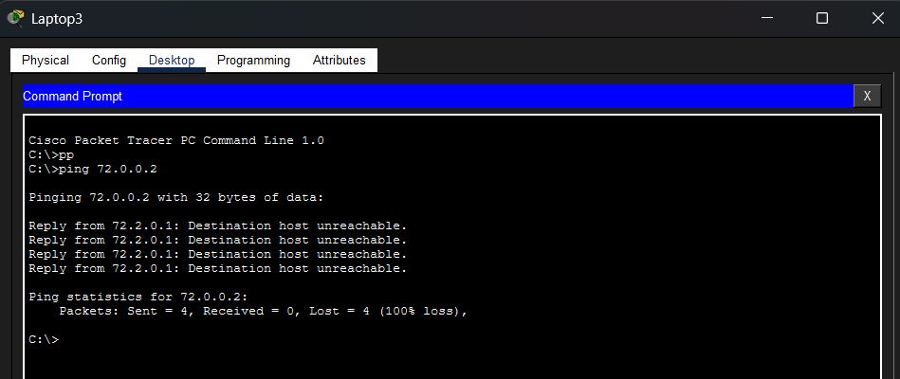
Ping from blocked host (72.2.0.11) to 72.0.0.2 — FAILING]
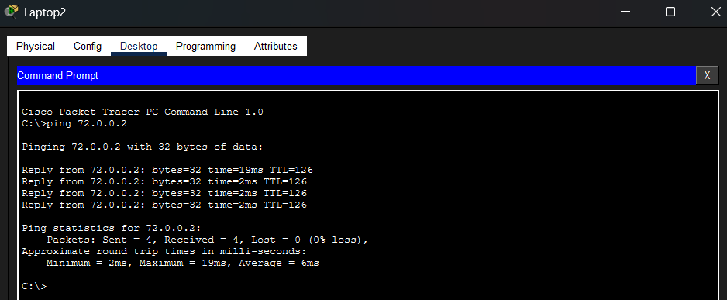
Ping from non-blocked host (72.2.0.10) in Network A to 72.0.0.2 — SUCCESS]

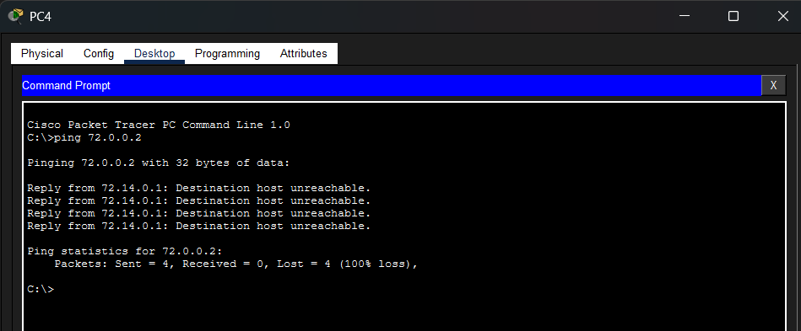
Ping from Network D host to 72.0.0.2 — FAILING

12. Testing & Verification

12.1 Routing Table Verification
Run show ip route on key routers to verify all networks are reachable:
Router | Expected Route Types
Router2 | O (OSPF), D EX (EIGRP external)
Router10 | D (EIGRP), O (OSPF), O E2 (OSPF external)
Router18 | O (OSPF), R (RIP)
Router17 | R (RIP routes to all networks)
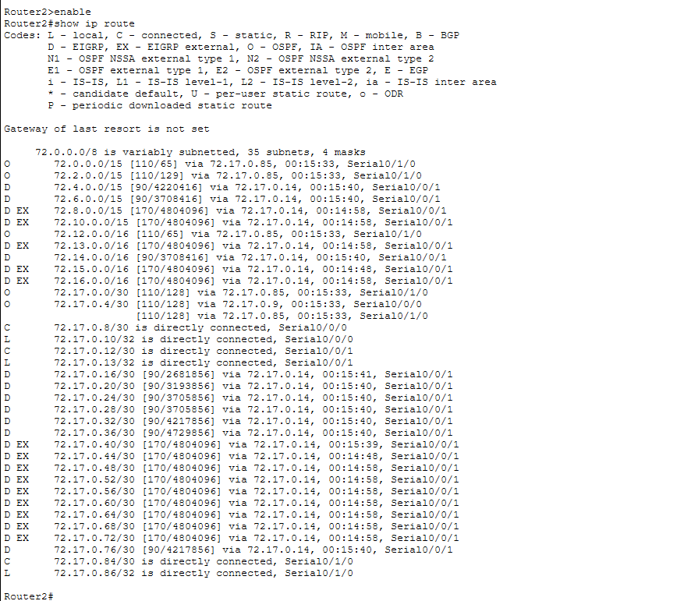
show ip route on Router2
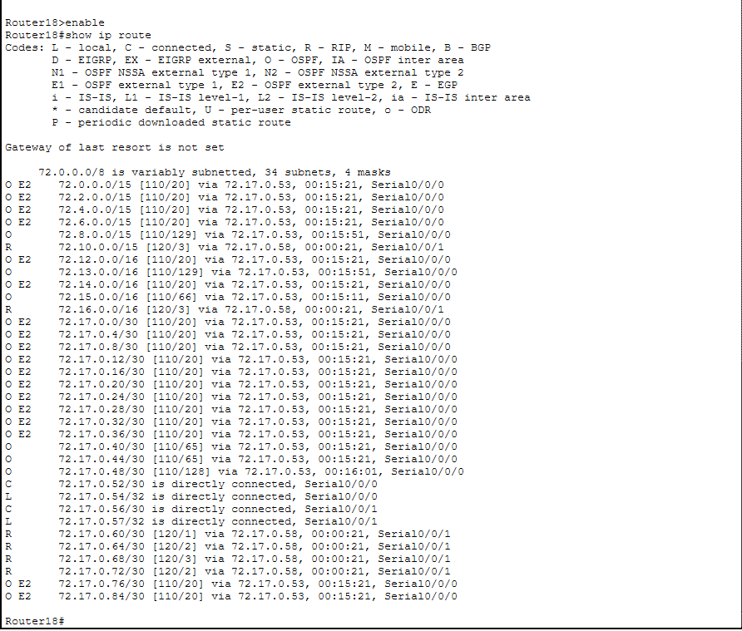
show ip route on Router18

12.2 End-to-End Ping Tests
From | To | Expected | Why
Laptop3 (Net A) | 72.0.0.2 (Server0) | Success | Normal connectivity
Laptop0 (Net B) | 72.10.0.1 (Net J gateway) | Success | Cross-domain via redistribution
PC4 (Net D) | 72.0.0.2 (Server0) | Fail | ACL blocks Network D
PC7 (Net G) | 72.2.0.1 (Net A gateway) | Success | OSPF2 to EIGRP to OSPF1
PC12 (Net J) | 72.15.0.1 (Net G gateway) | Success | RIP to OSPF2
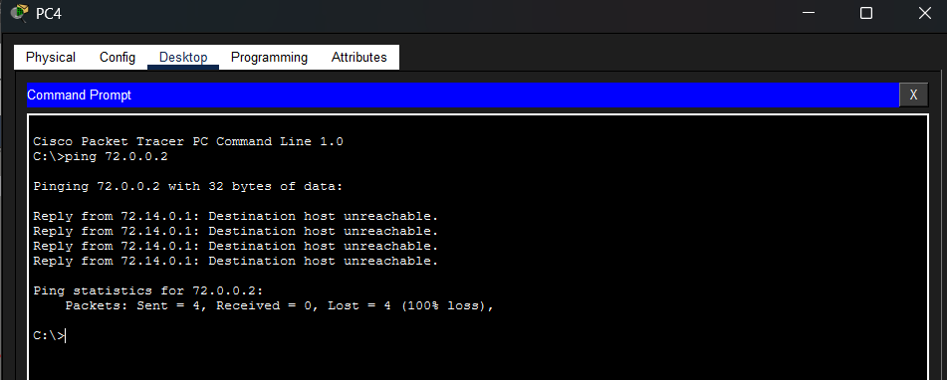
Ping from Network D to Server0 — blocked by ACL

12.3 DHCP Verification
Device | Network | Expected IP Range | Gateway
Laptop2 | A | 72.2.0.10+ | 72.2.0.1
Laptop0 | B | 72.12.0.10+ | 72.12.0.1
PC0 | C | 72.0.0.10+ | 72.0.0.1
PC4 | D | 72.14.0.10+ | 72.14.0.1
PC7 | G | 72.15.0.10+ | 72.15.0.1
PC12 | J | 72.10.0.10+ | 72.10.0.1
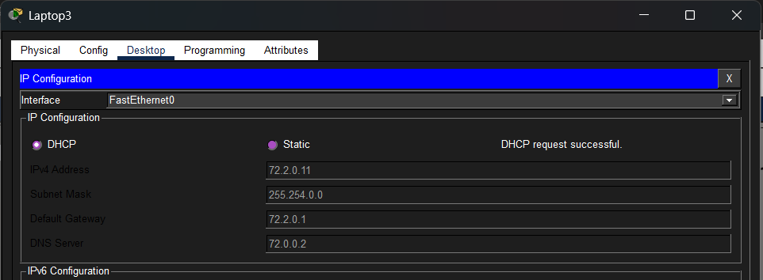
IP Configuration of Laptop 3 showing DHCP-assigned IP

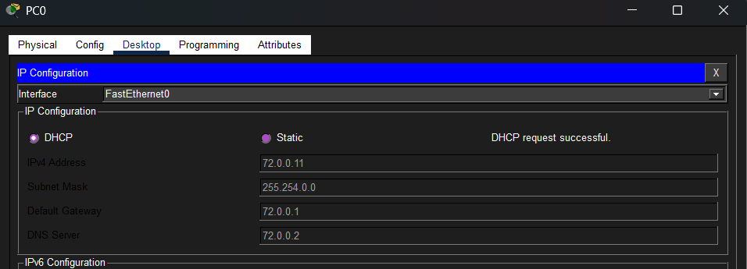
IP Configuration of PC 0 showing DHCP-assigned IP

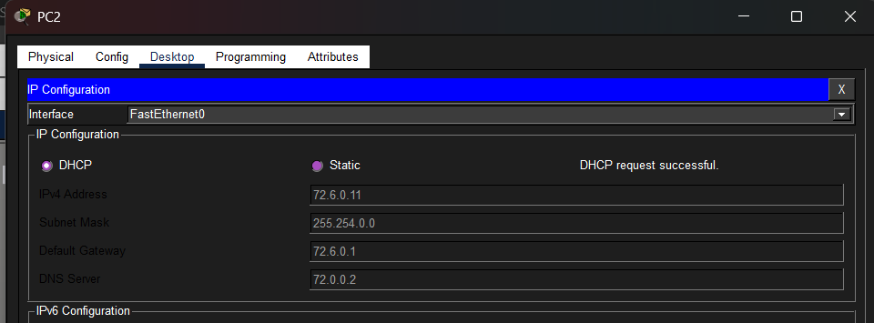
IP Configuration of PC 2 showing DHCP-assigned IP

12.4 Service Tests
Test | How | Expected
DNS | PC → Web Browser → www.project.com | Website loads
Web | PC → Web Browser → http://72.0.0.2 | Website loads
Email Send | Laptop3 → Email → Compose → laptop0@project.com | Send success
Email Receive | Laptop0 → Email → Receive | Email appears
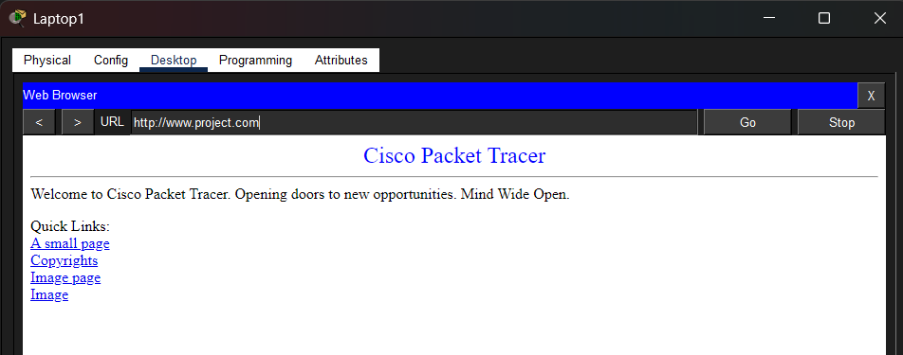Web browser showing www.project.com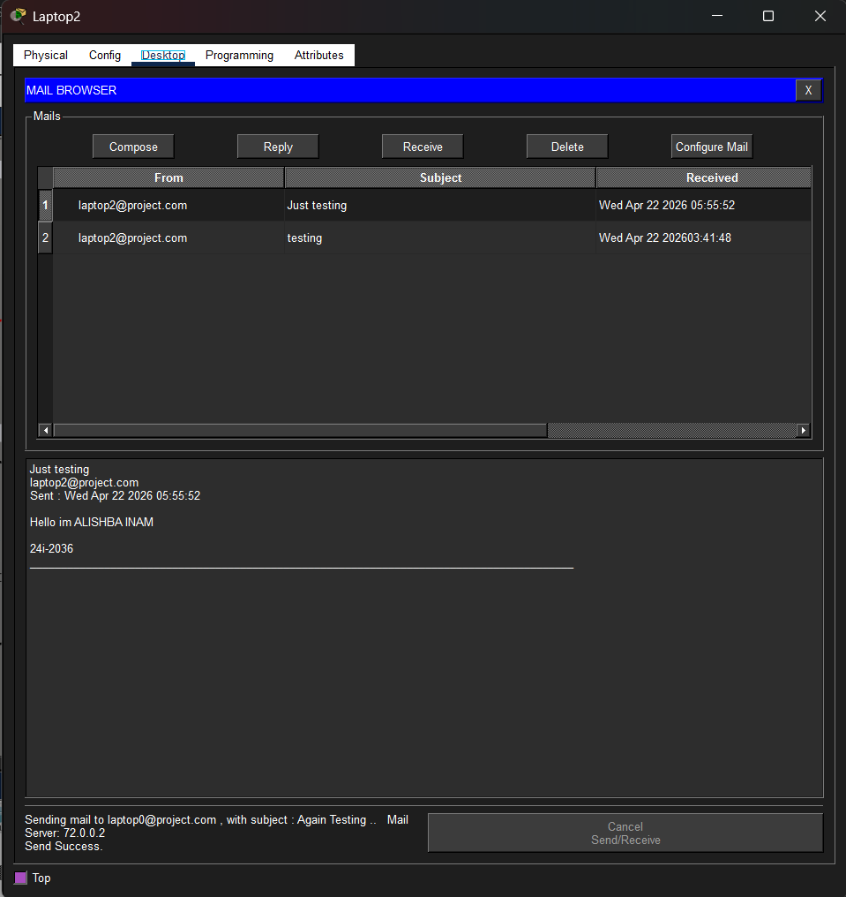
Email compose and send success
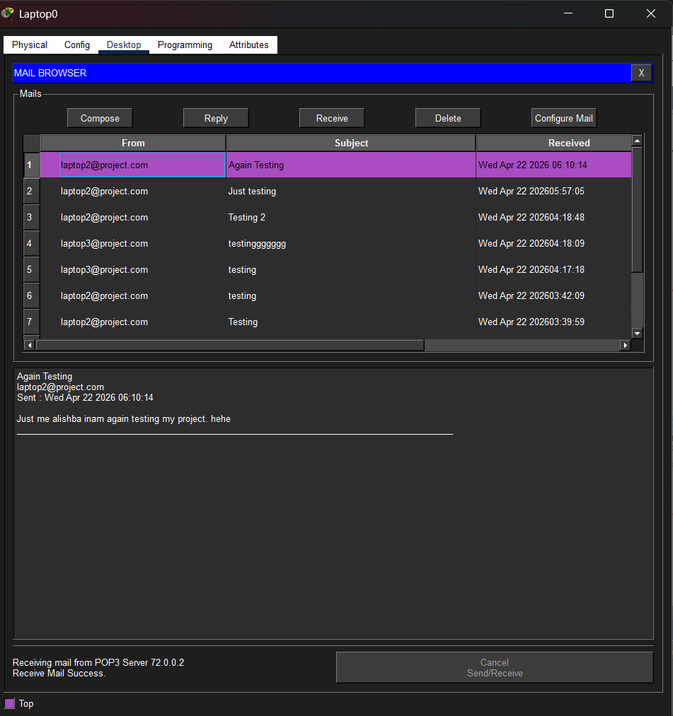
Email received on Laptop0

13. Conclusion
This project successfully demonstrates the design and implementation of a multi-area enterprise network using Cisco Packet Tracer. Key achievements include:

- VLSM Subnetting: Efficiently allocated 11 networks and 22 WAN links from a single /8 address space, minimizing IP waste.
- Multi-Protocol Routing: Successfully configured OSPF (Areas 1 & 2), EIGRP (AS 5), and RIPv2, each serving distinct network segments.
- Route Redistribution: Implemented mutual redistribution at three border routers (Router2, Router10, Router18), enabling full end-to-end connectivity across all routing domains.
- Centralized DHCP: Configured Server1 as a centralized DHCP server with relay agents on all gateway routers, providing automatic IP assignment to all end devices.
- Network Services: Deployed DNS, HTTP, and SMTP/POP3 email services on Server0, enabling web browsing and email communication across the network.
- Security: Applied static NAT on Router17 (Network J) for address translation, and extended ACLs to restrict specific hosts and entire subnets from accessing the web server.
- Redundancy: Multiple parallel paths exist (Router1 to Router2 direct link, Router7 to Router8, Router15 to Router17, Router17 to Router14) providing network resilience.

The network passed all verification tests including cross-domain pings, DHCP assignment, email send/receive, web access, NAT translation, and ACL enforcement.

Prepared by: Alishba Inam (24I-2036)
Date: 6 May 2026

