**Operating System Lab**

**Fall 2024**

**Lab 03 Task**



**Alishba Waqar**

**46997**

**BSCS-5**

**Lab Instructor:**

**Kausar Nasreen Khattak**

**Lab Task**

**Q1.** Make the following directory (03 Marks)

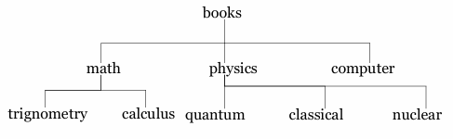

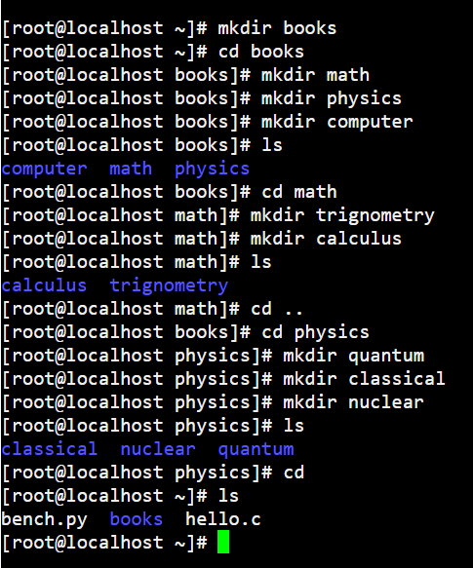

**Q2.** Which are the Linux Directory Commands? Explain the understanding of commands in your own words. Also define what is BASH? (02 Marks)

**Note:** Include screenshots, where required to illustrate your explanation.

Linux directory commands are the simple tools which we can use to move and manage files and directories in a Linux system.

* The **pwd** command tells us the whole path.
* **ls** shows us the whole list.
* **cd** command we can move to another directory.
* We can use the **mkdir** command to create new directory.
* We can use the **rmdir** command to delete directory.
* The **cp** command copies files and directories.
* The **mv** command moves and renames files and directories.
* **cd** command will help to change the directory.

BASH is a program that allows us to write commands to control the computer. It reads the commands that we give and makes the computer follow them. It is easy to use for tasks like moving files. In short, BASH is how we talk to our computer in Linux.

**Q3.** 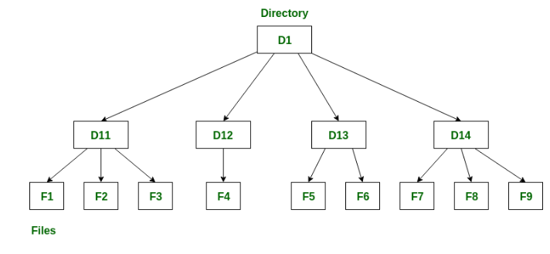

**Note:** Include screenshots, where required to illustrate your explanation. (02 Marks)

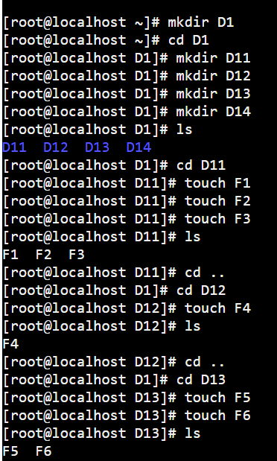

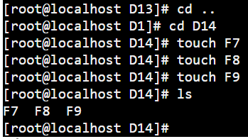

**Q4.** Make the following directory (03 Marks)

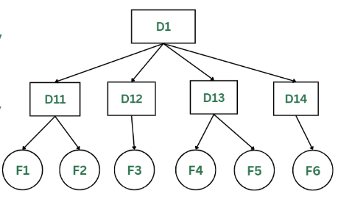

**Note:** Include screenshots, where required to illustrate your explanation.

