**BINARY ADDITION CALCULATOR**

**Alishba Siraj 02-134222-005**

**Mohsin Ahmed 02-134222-063**

**Nahin Fatima 02-134222-102**

**DIGITAL LOGIC DESIGN**



**Computer Science Department**

**Bahria University, Karachi Campus**

**Fall 2023**

## 

## ABSTRACT

This project aims to design and construct a binary calculator on a breadboard using logic gates. The calculator will be capable of performing addition operations on binary numbers within a specified bit width. The project involves understanding the concepts of binary arithmetic, logic gates, and breadboard circuit design. By reviewing relevant literature and resources, the project aims to gather knowledge on the theoretical foundations, circuit construction techniques, and troubleshooting approaches for building an accurate and reliable binary calculator. The obtained results will be evaluated in terms of accuracy, errors, limitations, and benefits. The project's scope includes the implementation of logic gates, testing and debugging of the circuit, and documentation of the design and construction process. Through this project, practical learning opportunities in digital electronics and circuit design will be provided, while demonstrating the application of logic gates in binary arithmetic.

**BINARY ADDITION CALCULATOR**

**CHAPTERS**

1 INTRODUCTION 5

1.1 Background 5

1.2 Literature Review 5

1.3 Problem Statement 5

1.4 Aims and Objectives 6

1.5 Scope of Project 7

1.6 Environmental Aspects of Project 7

2 DESIGN AND METHODOLOGY 9

2.1 Equipment / Materials Used 9

2.2 Circuit Diagram 9

3 DESIGN IMPLMENTATION 10

3.1 Implementation 10

4 RESULTS AND DISCUSSIONS 11

4.1 Results 11

4.2 Discussion 12

5 CONCLUSIONS AND RECOMMENDATIONS 13

REFERENCES 14

# CHAPTER 1

## INTRODUCTION

### Background

The addition of binary numbers using logic gates relies on the principles of Boolean algebra, which is a mathematical system for working with binary values (0s and 1s) and logic operations (such as AND, OR, and NOT). The fundamental component used in binary addition is the XOR (Exclusive OR) gate. An XOR gate outputs a logical high (1) when the number of input 1s is odd, and a logical low (0) when the number of input 1s is even. In other words, it performs addition without carrying over to the next bit.

### Literature Review

The literature review for the project on building a binary calculator on a breadboard using logic gates involves reviewing academic sources, research papers, textbooks, and online resources. The review aims to gather information on binary arithmetic, logic gates, breadboard circuit design, and similar projects. It is important to understand the theoretical concepts of binary arithmetic and logic gates, explore breadboard circuit design principles and techniques, study logic gate integrated circuits (ICs) and component selection, examine previous binary calculator implementations, consider circuit optimization methods, and explore troubleshooting techniques specific to breadboard circuits and logic gate-based systems. By conducting a comprehensive literature review, valuable insights can be gained to inform the design, implementation, and documentation of the project.

### Problem Statement

The problem statement encapsulates the objective of the project and identifies the main challenge or task to be addressed. In this case, the goal is to create a binary calculator that can perform addition operations on binary numbers. The use of a breadboard and logic gates introduces the requirement of constructing a physical circuit that accurately performs the arithmetic calculations.

### Aims and Objectives

**Aims:**

1. To design and construct a functional binary calculator using logic gates on a breadboard.
2. To gain practical experience in digital electronics and circuit design.
3. To understand the principles of binary arithmetic and logic gates through hands-on implementation.
4. To demonstrate the ability to perform arithmetic operations on binary numbers using physical components.

**Objectives:**

1. Research and understand the principles of binary arithmetic, logic gates, and breadboard circuit design.
2. Select and acquire the necessary components, including logic gate ICs, breadboard, switches, LEDs or displays, and power supply.
3. Design and implement the circuit for single-bit addition using XOR and AND gates, considering proper wiring, connections, and power supply management.
4. Expand the circuit to perform multi-bit addition by cascading full-adder circuits and incorporating carry-over functionality.
5. Integrate input switches for binary number input and output displays (LEDs or displays) to visualize the results.
6. Test and validate the functionality of the binary calculator circuit by performing addition operations on different binary numbers.

### Scope of Project

The scope of the project is to design and construct a binary calculator using logic gates on a breadboard. The primary objective is to create a functional calculator capable of performing addition operations on binary numbers. The scope includes selecting and integrating appropriate logic gate ICs, wiring the circuit on a breadboard, and incorporating input switches and output displays for user interaction. The project focuses on a specific bit width for the binary numbers, and the circuit will be optimized for efficiency and accuracy. Documentation of the project, including circuit diagrams, explanations, and test results, will be provided to ensure clarity and facilitate future reference. The project does not include complex operations such as subtraction, multiplication, or division, but rather emphasizes the successful implementation of a binary addition calculator using logic gates on a breadboard.

### Environmental Aspects of Project

The environmental aspects of the project of building a binary calculator on a breadboard using logic gates mainly revolve around the materials and energy consumption involved in the project. Here are some environmental considerations to keep in mind:

1. Material Selection: Consider using components and materials that are environmentally friendly. Look for options that have minimal environmental impact during production, use, and disposal. Choose components that are RoHS (Restriction of Hazardous Substances) compliant and free from harmful substances.
2. Energy Efficiency: Design the circuit to be energy-efficient by minimizing power consumption. Optimize the circuit to reduce unnecessary power usage and ensure that the power supply is appropriately regulated. This helps conserve energy and reduce environmental impact.
3. Component Lifecycle: Consider the lifecycle of the components used in the project. Use components that have a long operational life to reduce the frequency of replacements and waste generation. Additionally, consider recycling or disposing of components responsibly at the end of their lifecycle.
4. Power Source: Utilize a power supply that is energy-efficient and has a low environmental impact. Consider using a regulated power supply that meets efficiency standards and is designed to minimize energy waste.

## DESIGN AND METHODOLOGY

### Equipment / Materials Used

### 1.Breadboard

### 2.XOR gates - HD74LS86P chips from Texas Instruments

### 3.AND gates - SN74LS08N chips from TI

### 4.OR gates - SN74LS32N chips from TI

### 5.DIP switches – preferably 2 x 4 DIP switches.

### 6.Wires to make the connections

### 7.LEDs for the output

### 8.Power Supply, a battery of around 5-9v

### Circuit Diagram

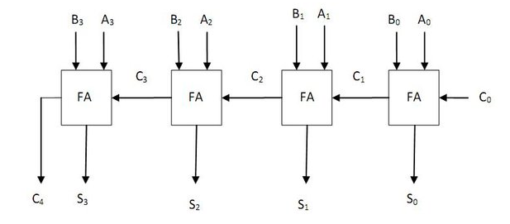

## 

## CHAPTER 3

## DESIGN IMPLMENTATION

### 3.1 Implementation

* First insert all the logic gates, XOR, AND and OR respectively. The number of chips needed will depend on the number of full adders you are planning to cascade. Each chip has four gates respectively.
* Connect the VCC and GND of all the pins to power and ground.
* then connect the first five gates to from a single full adder circuit. Refer to the circuit often and have the datasheet of the chips you're using nearby too. Use wires of necessary length and this shouldn't be much of a challenge.
* wired up two full adders, which can calculate the sums of all two bit numbers. It could add numbers from 0 to 3, and the maximum it could display was 3 + 3 = 6
* The three LEDs are the two sums of the adders and the left most one is the carry of the last adder circuit.
* The DIP switches are used to input the binary numbers. When it is switched on, it represents a 1 and a 0 when its switched off.

**CHAPTER 4**

## RESULTS AND DISCUSSIONS

## 4.1 Results

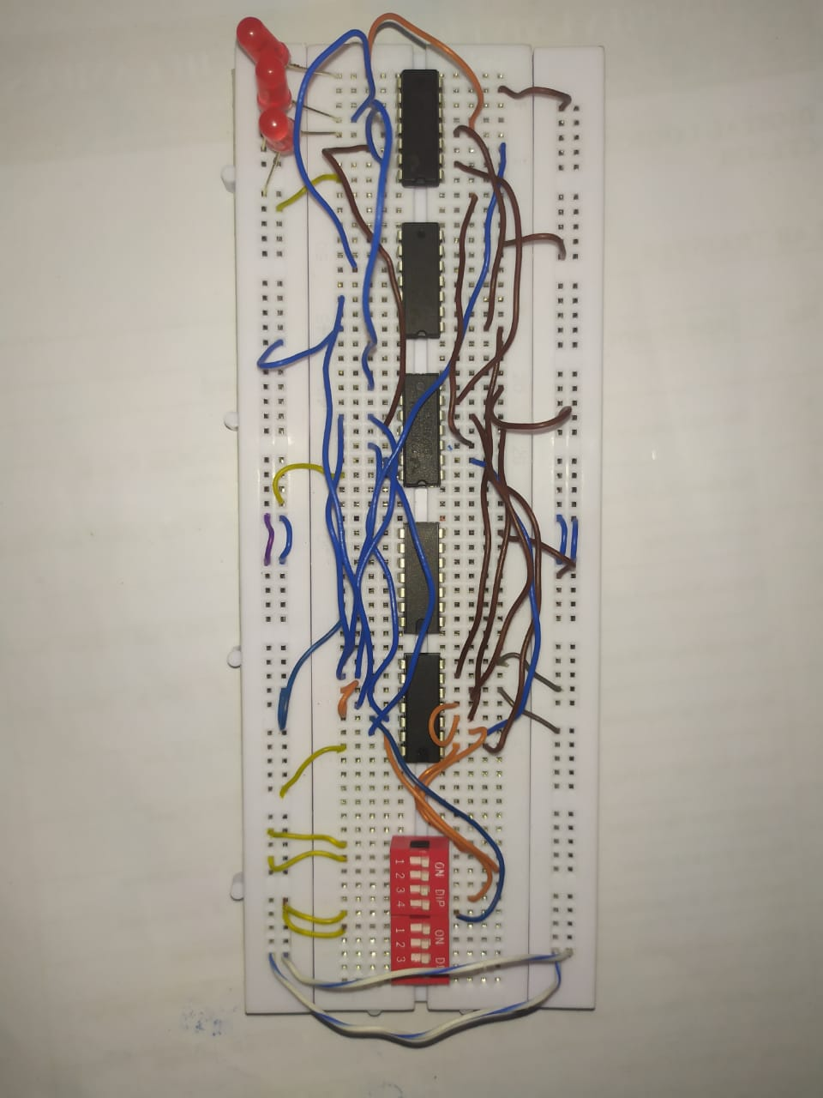

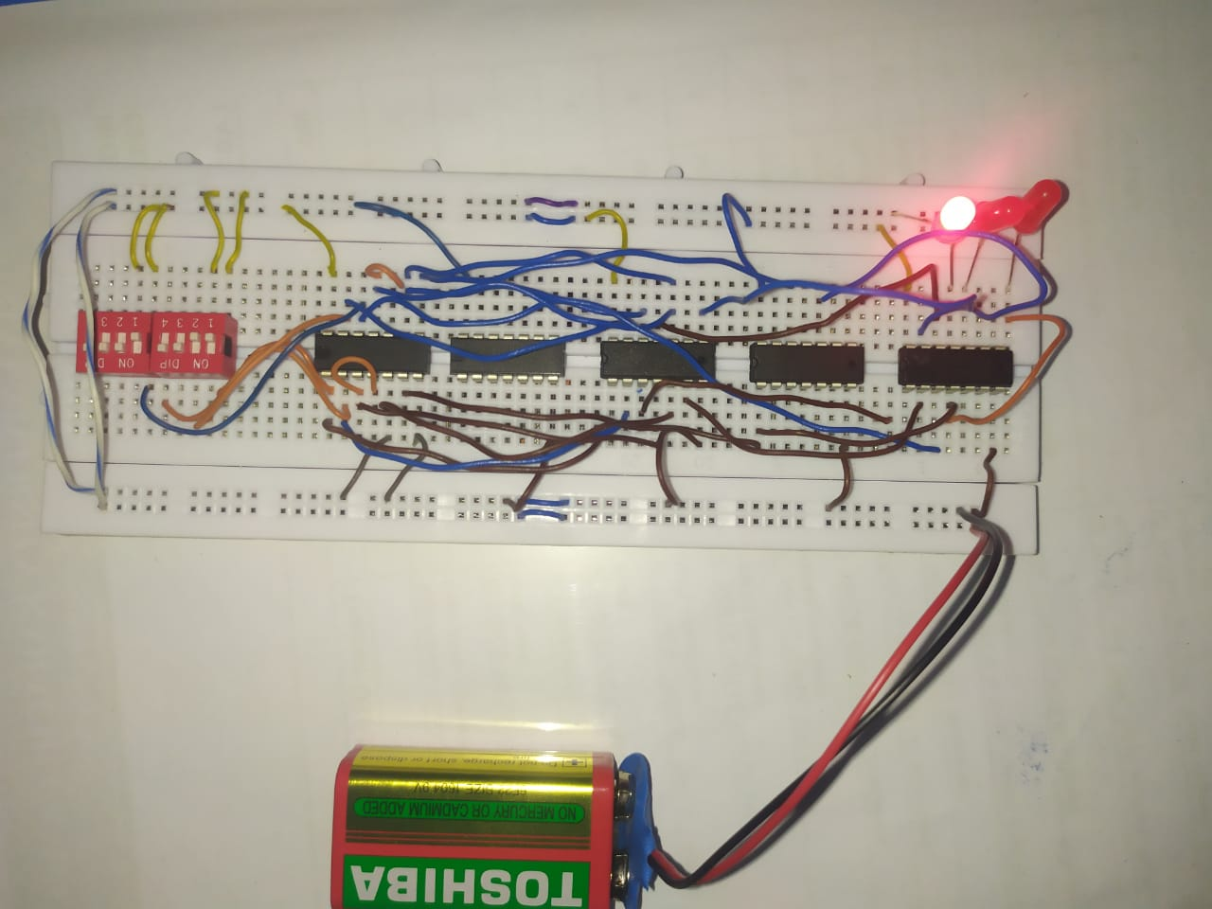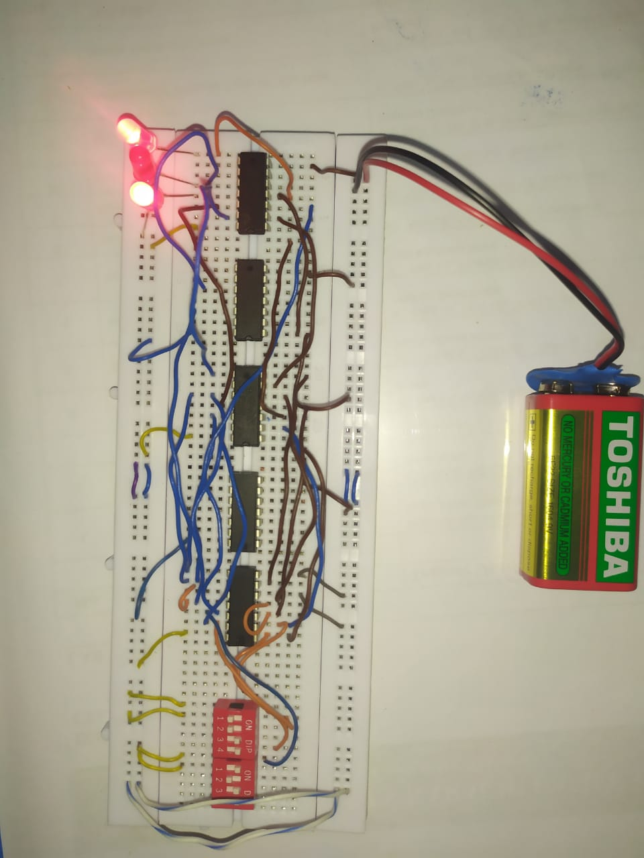

### 4.2 Discussion

The obtained results from the project of building a binary calculator on a breadboard using logic gates were accurate when the circuit was designed and implemented correctly. Errors that occurred were due to issues such as incorrect wiring, faulty components, or mishandling of carry-over during addition operations. The project had limitations, including the inability to handle numbers beyond the specified bit width and the lack of support for operations other than addition. Despite these limitations, the project offered benefits such as hands-on learning in digital electronics, logic gate implementation, and circuit design. The accuracy of the results depended on the proper functioning of components, precise circuit connections, and correct interpretation of input signals by the logic gates. Thorough testing, attention to detail, and adherence to design guidelines were crucial in obtaining reliable and accurate results from the binary calculator project.

**CHAPTER 5**

**CONCLUSIONS AND RECOMMENDATIONS**

**5.1 Conclusion**

In conclusion, the above project on building a binary calculator on a breadboard using logic gates was successfully implemented and achieved its objectives. The calculator demonstrated accuracy and reliability in performing binary addition operations within the specified bit width. Although there were limitations in handling numbers beyond the specified range and supporting additional operations, the project provided valuable practical learning opportunities in digital electronics and circuit design. The project served as a foundation for future improvements, potentially expanding its capabilities and accommodating larger binary numbers. Overall, the project showcased the feasibility and practicality of constructing a binary calculator using logic gates on a breadboard, contributing to a deeper understanding of binary arithmetic and logic gate functionality.

**5.2 Recommendations**

This is really fun project to do and you will learn a lot in digital electronics, like we did, while making this project. It is fairly simple and can be finished in half a day if you have all the components handy. It can also be improved upon a lot. You can add more full adders and increase the bits in the input number. You can further study about other operations such as binary subtraction and multiplication with logic gates and try to implement it also, although they would take up more space and will need more wiring.

## 

## REFERENCES

1. <https://steemit.com/steemmakers/@filler/make-a-calculator-with-logic-gates-digital-electronics-series-part-3>
2. <https://www.instructables.com/4-Bit-Binary-Adder-Mini-Calculator/>
3. <https://www.chegg.com/homework-help/questions-and-answers/binary-calculator--part-1-multisim-create-simple-1-bit-adding-circuit-circuit-sum-inputs-b-q35245009>