Software Requirement Specifications
Portfolio Website with Admin Panel



Submitted by
Alishba Gill (S23BINFT1E02068)

Submitted to
Dr. Muhammad Asad Ullah

Department of Information Technology
Faculty of Computing
The Islamia University of Bahawalpur

Meeting Details
Sr No | Details | Date | Supervisor Signature
Summary
This document presents the Software Requirements Specification for a Portfolio Website with an integrated Admin Panel. The system is designed for professionals, freelancers, and students who want to establish and manage their online presence without needing any programming knowledge. The document outlines the purpose, scope, functional and non-functional requirements, use cases, and relevant diagrams. The system provides a clean frontend for visitors and a secure backend panel for the portfolio owner to manage all content dynamically.

Table of Contents
1. Introduction 5
1.1. Purpose 5
1.2. Scope 5
1.3. Product Perspective 6
1.4. User Characteristics 6
1.5. Similar apps and systems/Literature Review 7
1.6. Proposed Technologies 7
2. Requirements 9
2.1. Function Requirements 9
2.1.1. Admin Login 9
2.1.2. Manage Projects 10
2.1.3. Manage Skills 10
2.1.4. Manage Personal Information 10
2.2. Non-Functional Requirements 11
3. Use Cases and Flow of Processes 13
3.1. Admin Login 14
3.2. Manage Projects 15
3.3. Submit Contact Form 16
3.4. Generate Resume 17
4. References 19

- Introduction
In the current digital era, having a well-structured and professional online presence is no longer optional. It is a necessity for students entering the job market, freelancers looking for clients, and professionals trying to build credibility in their field. A portfolio website serves as a digital resume that goes far beyond a traditional CV. It allows the owner to present their projects visually, share their skillset, publish blogs, and allow recruiters or clients to reach out directly.
The challenge, however, is that most individuals who need such a platform do not have the technical background to build and maintain one. Existing third-party solutions like Wix or Squarespace offer limited customization and keep users dependent on a commercial platform they do not own or control. This project addresses that gap by building a fully custom portfolio website paired with a powerful admin panel that gives the owner complete control over their content without writing a single line of code.

  - Purpose
The purpose of this project is to design and develop a fully responsive portfolio website that is backed by a secure and intuitive admin panel. The system will allow the portfolio owner to manage all visible content on the website including projects, skills, personal information, blog posts, and messages from visitors. The admin panel will use authentication to ensure that only the authorized user can make changes. The frontend will be optimized for both desktop and mobile devices and will provide a professional and modern user experience for every visitor.

  - Scope
The system will include a public-facing portfolio website and a private admin panel. The portfolio website will display a home page with a profile summary, an about section covering education and experience, a projects section with images and descriptions, a skills section, a blog section, and a contact form. The admin panel will allow the owner to log in securely and manage all of this content through a dashboard.
- The admin will be able to add, edit, and delete projects, skills, personal information, and blog posts.
- The admin will also be able to view and respond to messages submitted through the contact form.
- A visitor analytics feature will track basic engagement data such as page visits.
- A resume generation feature will be included so the owner can download a formatted resume based on the content stored in the system.
The following items are outside the scope of this project.
- The system will not support multiple portfolio owners or multi-user collaboration.
- It will not include e-commerce functionality.
- It will not provide social media management tools.
- Advanced SEO automation and AI-generated content are also not within scope.
  - Product Perspective
This system is a standalone web application that does not depend on any larger enterprise system. It replaces the manual effort of editing HTML files or paying for third-party platforms. The frontend and backend are tightly integrated, where the Django REST API serves data to the frontend which is rendered through HTML, CSS, and JavaScript. MongoDB is used as the database to store all content in a flexible schema that can accommodate evolving content types. The system is designed to be hosted independently on a cloud server, giving the owner full ownership over their data and presentation.

  - User Characteristics
There are two types of users who interact with this system.
- The first type is the Administrator, who is the portfolio owner. This person has full control over the admin panel. The administrator is expected to have basic computer literacy such as the ability to fill forms, upload images, and navigate a web dashboard. No technical or programming knowledge is required. The administrator will use the system regularly to keep content updated, monitor visitor messages, and manage the overall appearance of the portfolio.
- The second type is the Visitor, which includes recruiters, potential clients, colleagues, or any member of the general public who lands on the portfolio website. Visitors interact with the public-facing side of the website. They can browse sections, view projects, read blogs, and submit a message through the contact form. Visitors do not need any account or login to use the website.
  - Similar apps and systems/Literature Review
- Several existing platforms and tools serve a similar purpose, but each comes with notable limitations.
- Wix is a popular drag-and-drop website builder that allows users to create portfolio websites. However, it locks users into its proprietary ecosystem, charges recurring fees, and offers limited backend customization. Users cannot access or own their underlying code.
- Squarespace offers visually appealing templates for portfolio websites but suffers from the same dependency issue. Customization beyond the template boundaries is restricted, and data export is limited.
- WordPress with portfolio plugins is more flexible but requires users to manage hosting, updates, plugins, and compatibility issues, which creates a significant technical burden for non-developers.
- Behance and Dribbble are specialized portfolio platforms targeted at designers. While they offer community features, they are not suitable for developers or students in other disciplines, and they provide no admin control over content presentation.
- The proposed system addresses all of these shortcomings by providing full ownership, zero dependency on commercial platforms, and a simple content management experience built specifically for the portfolio owner.

  - Proposed Technologies
The following technologies will be used to build this system.
- For the frontend, HTML5, CSS3, and vanilla JavaScript will be used to build the user interface. These technologies ensure lightweight pages with broad browser compatibility. Figma will be used during the design phase to create wireframes and mockups.
- For the backend, Django will serve as the primary web framework. Django REST Framework will be used to build the REST API that connects the frontend to the database.
- MongoDB will be used as the database to store all portfolio content including projects, skills, blogs, messages, and visitor data. Its flexible document model makes it well-suited for content that may vary in structure over time.
- Git and GitHub will be used for version control throughout the development process.
- Netlify will be used for hosting the deployed application.

- Requirements
The system is organized around two primary user experiences. The visitor experience involves browsing a clean and professional portfolio with sections for the owner's introduction, education, experience, projects, skills, blog posts, and a contact form. The admin experience involves a secure login page leading to a dashboard where all of this content can be managed through simple forms and tables.
The admin must be able to add new projects with a title, description, images, technologies used, and a link. The admin must be able to update or delete existing projects. Skills can be added as individual entries with a name and proficiency level. Personal information such as name, bio, social media links, and profile picture can be updated at any time from the dashboard. Blog posts can be created, edited, published, or unpublished. The contact form on the frontend captures visitor messages which the admin can view and mark as read or delete. Visitor analytics are tracked passively and shown on the admin dashboard as basic metrics. The system also includes a resume generation feature that compiles the stored profile data into a downloadable PDF.
  - Function Requirements
Authors will provide definite number of functional requirements in standard format. These requirements directly in the with functions which are already provided. The requirement format as following.
    - Admin Login
- Name: FR001
- Purpose: This requirement allows the administrator to add, update, and delete portfolio projects visible on the public-facing website.
- User(s): Administrator
- Input:
  - Project Title: The name of the project
  - Description: A written explanation of what the project does and the problem it solves
  - Technologies Used: A list of tools, languages, or frameworks used in the project
  - Project Images: One or more images uploaded to represent the project visually
- Output: The project is saved to the database and immediately reflected on the public portfolio website. Deleted projects are removed permanently.
    - Manage Projects
- Name: FR002
- Purpose: This requirement allows the administrator to add, update, and delete portfolio projects visible on the public-facing website.
- User(s): Administrator
- Input:
  - Project Title: The name of the project
  - Description: A written explanation of what the project does and the problem it solves
  - Technologies Used: A list of tools, languages, or frameworks used in the project
  - Project Images: One or more images uploaded to represent the project visually
- Output: The project is saved to the database and immediately reflected on the public portfolio website. Deleted projects are removed permanently.
    - Manage Skills
- Name: FR003
- Purpose: This requirement enables the admin to add and manage skills that appear in the skills section of the portfolio.
- User(s): Administrator
- Input:
  - Skill Name: The name of the skill such as Python or Django
  - Proficiency Level: A rating or label such as Beginner, Intermediate, or Advanced
- Output: The skill is stored and displayed on the portfolio skills section. Skills can be updated or deleted.
    - Manage Personal Information
- Name: FR004
- Purpose: This requirement allows the administrator to update their personal profile information shown on the portfolio homepage and about section.
- User(s): Administrator
- Input:
  - Full Name: The name to be displayed on the portfolio
  - Bio: A brief personal or professional description
  - Profile Picture: A photograph uploaded from the admin's device
  - Social Media Links: Links to profiles such as LinkedIn, GitHub, or Twitter
  - Contact Email: A publicly visible email for professional contact
  - Project Images: One or more images uploaded to represent the project visually
- Output: The updated information is saved and reflected immediately on the portfolio frontend.

  - Non-Functional Requirements
Security:
- The admin panel must be protected by authentication. Passwords must be stored using secure hashing algorithms. API endpoints that modify data must be accessible only to authenticated users. Protection against common web vulnerabilities such as SQL injection, cross-site scripting, and cross-site request forgery must be implemented.
Performance:
- The public-facing portfolio must load within three seconds on a standard broadband connection. Images must be compressed and optimized before serving to visitors. Database queries must be indexed appropriately to avoid performance bottlenecks.
Usability:
- The admin panel must be intuitive enough for a person with basic computer literacy to use without a manual. Form validation must provide clear and helpful error messages. The public portfolio must follow accessibility standards so it is usable by people with disabilities.
Scalability:
- The system must be structured in a way that allows new sections or features to be added without requiring a redesign of the existing architecture. MongoDB's schema-less nature supports this requirement.
Availability:
- The hosted system must target an uptime of at least 99 percent. Deployment through Netlify provides built-in redundancy and CDN support to help achieve this.
Maintainability:
- The codebase must follow clean code principles with adequate comments and documentation. Django's modular app structure must be used to separate concerns and make future maintenance straightforward.

- Use Cases and Flow of Processes
Below is the system-level use case diagram, followed by individual use case tables and their activity and sequence diagrams.

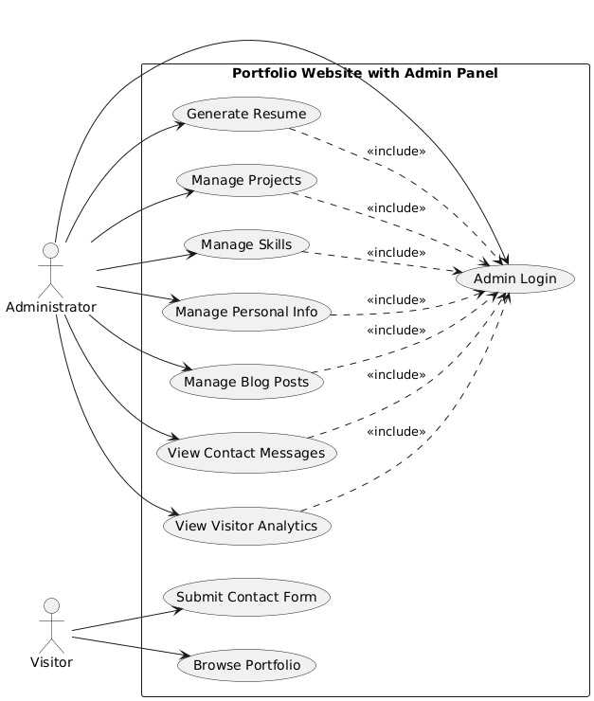
Figure 1: System Level Use Case Diagram
  - Admin Login
ID | UC001
Name | Admin Login
Description | This use case describes the process by which the administrator authenticates into the system to access the admin panel
Requirement(s) | FR001
Actor(s) | Administrator
Precondition | The administrator must have a registered account in the system
Postcondition | The administrator is redirected to the dashboard upon successful login
Basic Flow | Basic Flow  1. The administrator navigates to the login page.  2. The administrator enters their email and password.  3. The system validates the credentials.  4. On successful validation the system creates a session and redirects the admin to the dashboard.
Diagrams
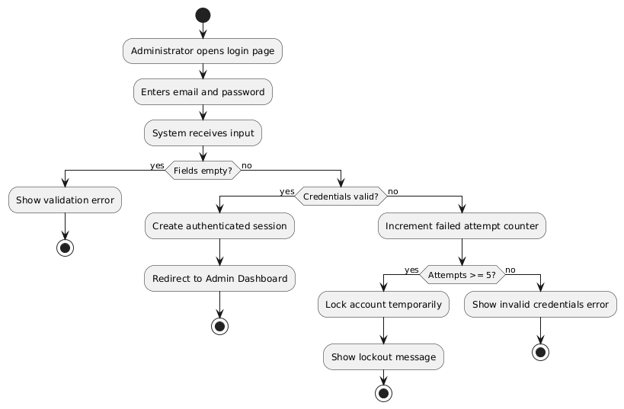
  - Manage Projects
ID | UC002
Name | Manage Projects
Description | The administrator can add, edit, and delete portfolio projects through the admin panel
Requirement(s) | FR002
Actor(s) | Admin, Data Entry, Operator
Precondition | The administrator must be logged in
Postcondition | Changes to projects are immediately reflected on the public portfolio
Basic Flow | Basic Flow  1. Admin navigates to the Projects section in the dashboard.  2. Admin fills in the project form including title, description, technologies, images, and optional link.  3. System validates the input.  4. System saves the project to the database.  5. The project appears on the public portfolio.
Diagrams
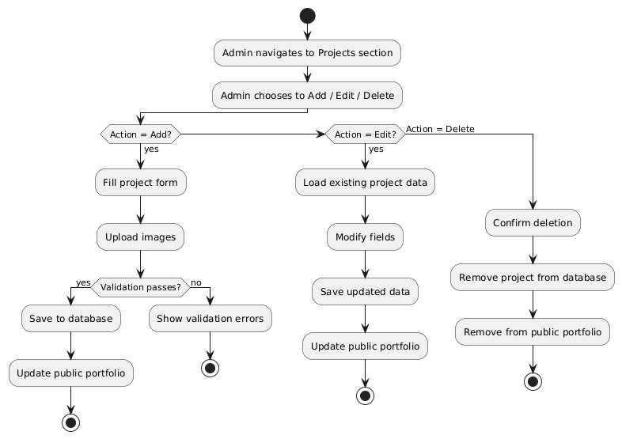
  - Submit Contact Form
ID | UC003
Name | Sign Up
Description | A visitor submits a message through the contact form on the public portfolio
Requirement(s) | FR003
Actor(s) | Administrator
Precondition | The visitor has accessed the public portfolio website
Postcondition | The message is stored in the database and visible in the admin panel
Basic Flow | Basic Flow  - Visitor fills in name, email, and message.  - Visitor submits the form.  - System validates inputs.  - System stores the message.  - Visitor sees a success confirmation.
Diagrams
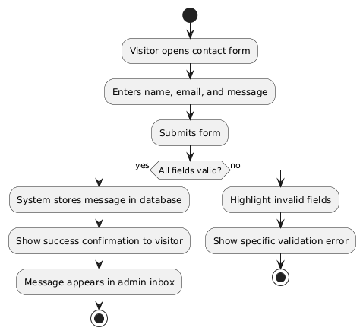
  - Generate Resume
ID | UC004
Name | Generate Resume
Description | The administrator generates a downloadable PDF resume from profile data stored in the system
Requirement(s) | FR004
Actor(s) | Administrator
Precondition | The administrator is logged in and profile information including name, bio, skills, and projects is already stored
Postcondition | A formatted PDF resume is downloaded to the administrator's device
Basic Flow | Basic Flow  1. Admin navigates to the Resume section in the dashboard.  2. Admin clicks Generate Resume.  3. System pulls data from the database including profile, skills, projects, and experience.  4. System compiles the data into a formatted PDF.  5. PDF is downloaded to the admin's device.
Diagrams
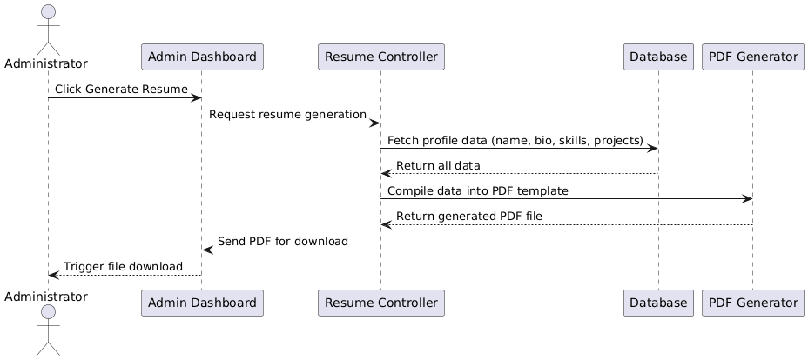

- References
[1] I. Sommerville, Software Engineering, 10th ed. Pearson, 2015.
[2] Wix.com. (2024). Wix Website Builder. [Online]. Available: https://www.wix.com
[3] Squarespace Inc. (2024). Squarespace Portfolio Templates. [Online]. Available: https://www.squarespace.com
[4] Django Software Foundation. (2024). Django Documentation. [Online]. Available: https://docs.djangoproject.com
[5] Django REST Framework. (2024). Django REST Framework Documentation. [Online]. Available: https://www.django-rest-framework.org
[6] MongoDB Inc. (2024). MongoDB Documentation. [Online]. Available: https://www.mongodb.com/docs
[7] Netlify Inc. (2024). Netlify Deployment Docs. [Online]. Available: https://docs.netlify.com
[8] IEEE. (1998). IEEE Recommended Practice for Software Requirements Specifications, IEEE Std 830-1998.

