CODE ALPHA
Internship Program

UI/UX DESIGN INTERNSHIP REPORT
Cartify — E-Commerce Mobile App
Intern Name: Alishba Umar
Email: hafizaalishba.umar@gmail.com
Role: UI/UX Design Intern
Internship Role | UI/UX Design Intern
Project Name | Cartify – E-Commerce Mobile App
Organization | Code Alpha
Duration | Week 1
Design Tool | Figma

Submitted as part of the UI/UX Design Internship Program
July 2026

Table of Contents
Table of Contents 2
1. Introduction 3
2. Internship Objectives 3
3. Project Overview 3
4. Problem Statement 3
5. Design Process 5
5.1 Research 5
5.2 User Flow 5
5.3 Wireframing 6
5.4 High-Fidelity UI Design 6
5.5 Prototyping 6
6. Design Decisions 8
6.1 Typography 8
6.2 Color Palette 8
6.3 Icons 8
6.4 Components 8
6.5 Visual Hierarchy 8
6.6 Consistency 8
7. Features Designed 10
8. Tools Used 12
9. Challenges Faced 12
10. Solutions Implemented 12
11. Skills Learned 12
12. Conclusion 13
13. References 13

1. Introduction
This report documents the work completed during Week 1 of the UI/UX Design Internship at Code Alpha. The internship focuses on strengthening practical design skills through the creation of a complete mobile application experience from concept to interactive prototype. The project selected for this internship is Cartify, an e-commerce mobile application designed to provide users with a smooth, modern, and intuitive shopping experience.
Over the course of the first week, the internship involved research into current e-commerce design trends, structuring the user flow and information architecture, translating ideas into low-fidelity wireframes, and finally producing high-fidelity UI screens and an interactive prototype in Figma. This document summarizes the objectives, process, decisions, and outcomes of that work.

2. Internship Objectives
The key objectives set for this internship phase were as follows:
- To understand and apply the end-to-end UI/UX design process used in real-world product teams.
- To research and analyze modern e-commerce mobile applications and identify best practices.
- To plan a clear and logical user flow and information architecture for an e-commerce app.
- To translate research and planning into low-fidelity wireframes for early validation.
- To design high-fidelity, visually consistent UI screens using Figma.
- To build an interactive prototype that demonstrates realistic navigation and user interaction.
- To apply core design principles including visual hierarchy, spacing, typography, and color consistency.

3. Project Overview
Cartify is a mobile e-commerce application designed to allow users to browse products, view detailed product information, manage a shopping cart, and complete purchases through a streamlined checkout process. The application targets everyday online shoppers who value a fast, clean, and trustworthy interface.
The scope of Week 1 covered the foundational design work: research, planning, wireframing, high-fidelity UI design, and prototyping. The result is a cohesive design system and a set of interactive screens that represent the core shopping journey, from opening the app to receiving order confirmation.

4. Problem Statement
Many existing e-commerce mobile applications suffer from cluttered layouts, inconsistent visual language, and shopping flows that require too many steps to complete a purchase. Users often abandon carts due to confusing navigation, unclear product information, or a checkout process that feels lengthy and untrustworthy.
Cartify aims to address these problems by offering a clean visual layout, a simplified and predictable navigation structure, clear product presentation, and a checkout flow that minimizes friction while maintaining user confidence at every step.

5. Design Process

5.1 Research
The design process began with research into popular e-commerce mobile applications to identify common patterns, layout conventions, and interaction styles that users are already familiar with. This included studying home screen layouts, product card designs, filtering and category navigation, cart structures, and checkout flows. Key takeaways from this research directly informed the structure and visual language of Cartify.

5.2 User Flow
Based on the research findings, a complete user flow was mapped out to define how a user would move through the application, from the splash screen to order confirmation. The flow was designed to keep the number of steps to purchase as low as possible while still providing users with enough information to make confident decisions.

5.3 Wireframing
Low-fidelity wireframes were created to quickly test layout ideas and screen structure before investing time in visual design. These wireframes focused purely on content placement, hierarchy, and flow, without color or detailed styling, allowing for fast iteration on structure.

5.4 High-Fidelity UI Design
Once the wireframe structure was validated, high-fidelity UI screens were designed in Figma. This stage introduced the final color palette, typography, iconography, imagery, and component styling. Special attention was given to consistency across screens so that the app feels unified from screen to screen.

5.5 Prototyping
An interactive prototype was built in Figma to connect the high-fidelity screens using realistic navigation, transitions, and tap interactions. This allows the design to be experienced as if it were a functioning application, making it easier to evaluate the flow and usability before development begins.

6. Design Decisions

6.1 Typography
A clean, highly legible sans-serif typeface was used throughout Cartify to maintain a modern and professional feel. A clear type scale was established for headings, subheadings, body text, and captions, ensuring readability across all screen sizes while keeping the interface visually consistent.

6.2 Color Palette
The color palette was built around a blue and white theme to convey trust, professionalism, and clarity, which are important qualities for a shopping application. Blue tones are used for primary actions and navigation, while white and light neutral tones form the background to keep the interface feeling open and uncluttered.

Swatch | Name | Hex Code | Usage
 | Primary Blue | #1F5C99 | Headers, buttons, navigation bar
 | Deep Navy | #12365B | Headings, top bar, emphasis text
 | Sky Accent | #6FA8DC | Highlights, active states, icons
 | Neutral Grey | #5A6672 | Secondary text, captions
 | Pure White | #FFFFFF | Backgrounds, cards, negative space

6.3 Icons
A consistent icon set was used across the application for navigation, actions, and categories. Icons were kept simple and outline-based to match the clean aesthetic of the app, with a filled state used to indicate active or selected items such as the bottom navigation bar.

6.4 Components
Reusable components such as buttons, product cards, input fields, navigation bars, and list items were built using Figma's Auto Layout and component features. This ensured consistency across screens and made it faster to assemble new screens using existing building blocks.

6.5 Visual Hierarchy
Visual hierarchy was applied through consistent use of font size, weight, color, and spacing to guide the user's attention to the most important elements first, such as product images, prices, and primary call-to-action buttons.

6.6 Consistency
Consistency was maintained across all screens through the reuse of components, a fixed spacing system, and a unified color and typography language. This creates a cohesive experience where every screen feels like part of the same product.

7. Features Designed
The following core screens were designed for Cartify during Week 1 of the internship:
Screen | Description
Splash Screen | Introduces the Cartify brand with a clean, minimal loading screen.
Login / Signup | Allows users to create an account or log in securely to access the app.
Home Screen | Displays featured products, categories, and promotional banners.
Categories | Lets users browse products organized by category for easier discovery.
Product Details | Shows detailed product information, images, pricing, and options.
Shopping Cart | Displays selected items, quantities, and order subtotal before checkout.
Checkout | Guides the user through delivery, payment, and order review steps.
Order Confirmation | Confirms successful order placement with a summary of the purchase.
Profile | Allows users to manage account details, addresses, and order history.

8. Tools Used
The following tools and Figma features were used throughout the design process:
Tool / Feature | Purpose
Figma | Primary design and prototyping tool used for all wireframes, UI screens, and prototypes.
Auto Layout | Used to build flexible, responsive components and screen layouts.
Components | Used to create reusable, consistent UI elements across the application.
Prototyping | Used to connect screens with interactions to simulate real app navigation.

9. Challenges Faced
- Maintaining visual consistency across a large number of screens while keeping the design process efficient.
- Structuring an information architecture that kept the shopping and checkout flow simple without removing necessary steps.
- Balancing visual detail with clarity, especially on content-dense screens such as product details and checkout.
- Ensuring spacing, alignment, and component sizing remained consistent when working across many screens in Figma.

10. Solutions Implemented
- Built a library of reusable components and Auto Layout frames to enforce consistency automatically across screens.
- Simplified the user flow by removing unnecessary steps and combining related actions into single screens where possible.
- Used a clear visual hierarchy, whitespace, and a limited color palette to reduce clutter on information-dense screens.
- Established a consistent spacing and grid system early in the process and applied it across every screen.

11. Skills Learned
- Practical experience applying the full UI/UX design workflow, from research to interactive prototype.
- Improved skills in structuring user flows and information architecture for mobile applications.
- Hands-on experience with Figma features including Auto Layout, components, and prototyping.
- Stronger understanding of visual hierarchy, typography, color theory, and design consistency.
- Better time management and planning skills when working through a structured design process.

12. Conclusion
Week 1 of the UI/UX Design Internship at Code Alpha provided valuable hands-on experience in designing a complete mobile application from the ground up. Through the Cartify project, the internship covered every major stage of the design process, including research, user flow planning, wireframing, high-fidelity UI design, and interactive prototyping.
This foundation of design decisions, reusable components, and a consistent visual system will support the continued development of Cartify in the following weeks of the internship, and has strengthened both technical Figma skills and a broader understanding of user-centered mobile design.

13. References
- Figma Design Files — Cartify E-Commerce Mobile App Project.
- Figma Official Documentation — figma.com/resources
- General UI/UX design principles and mobile e-commerce design best practices.

14. ScreenShots

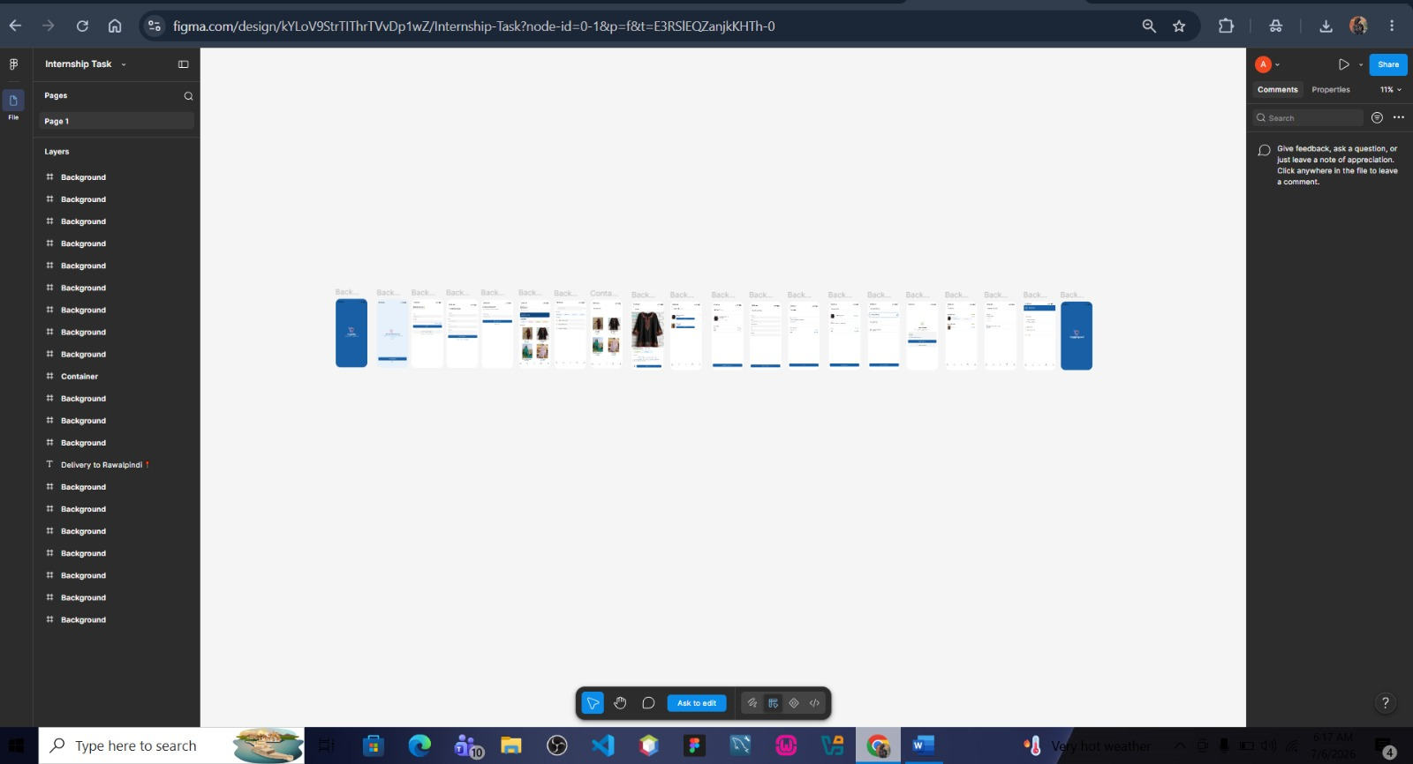
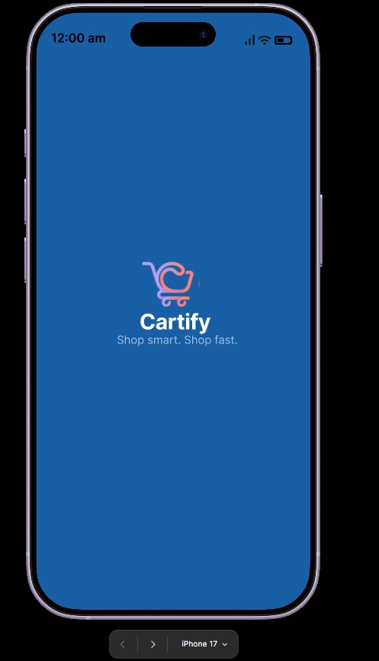
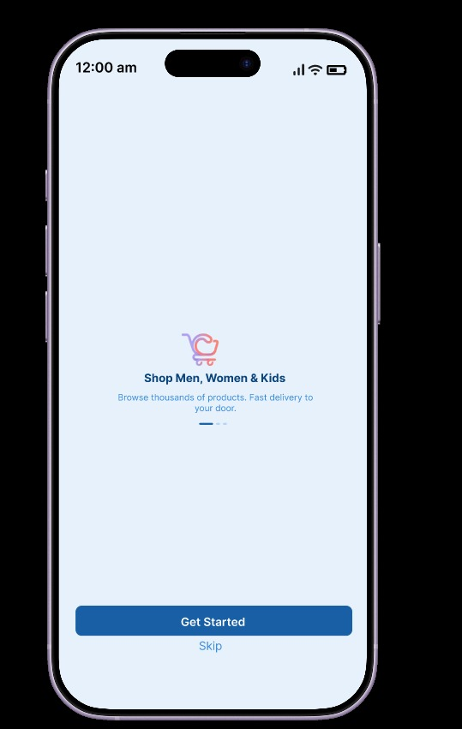
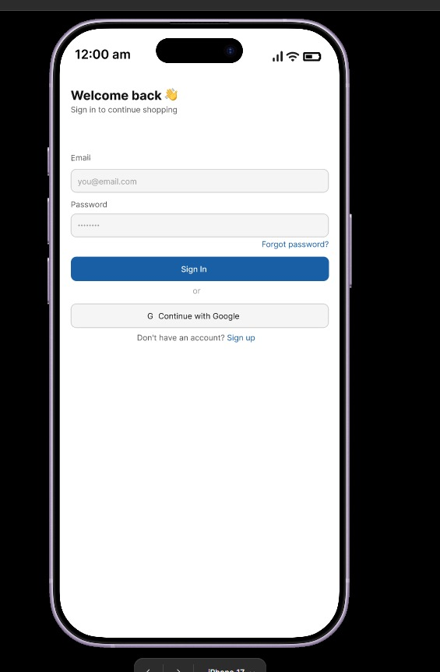
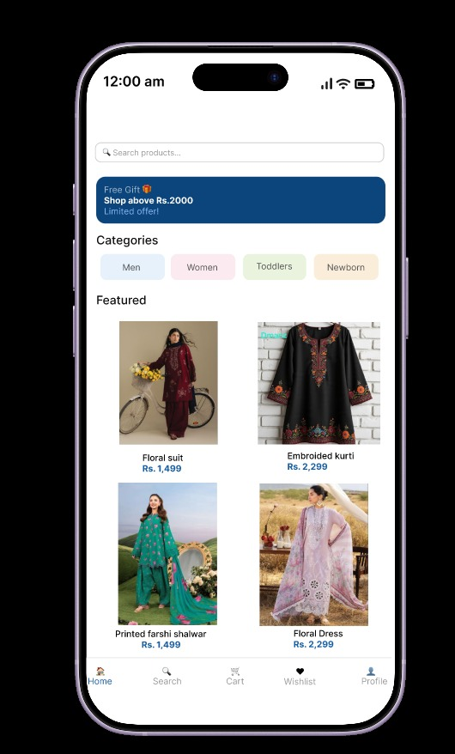
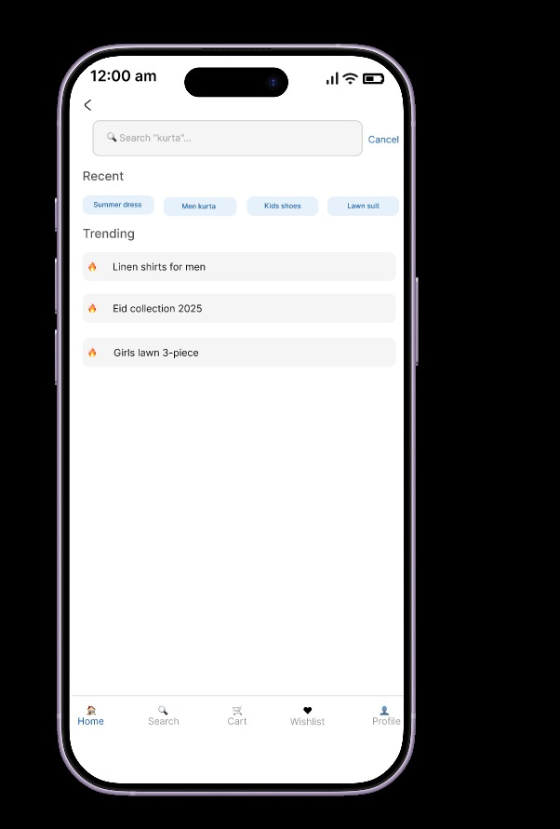

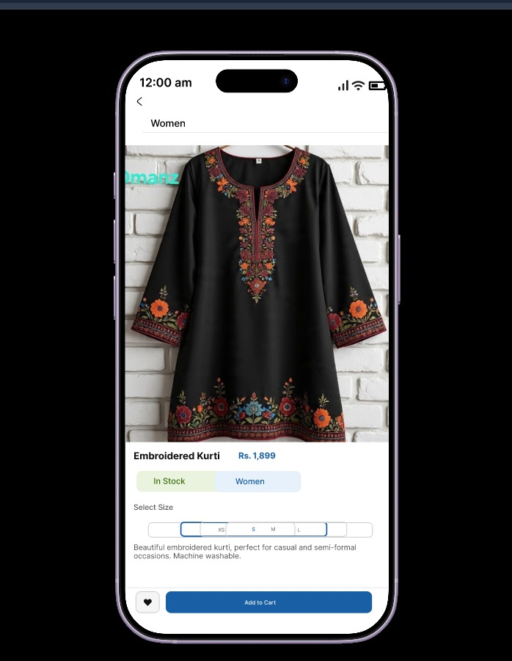
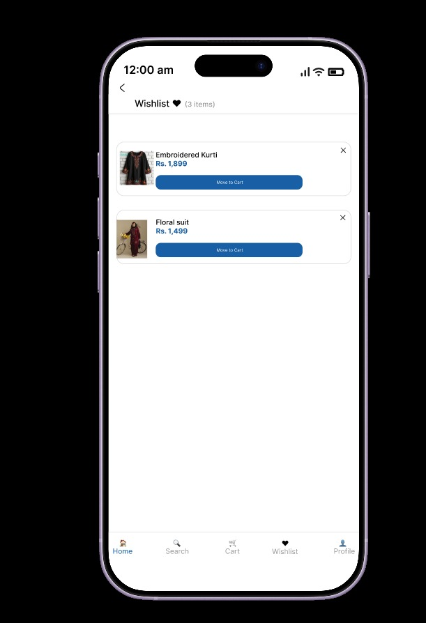
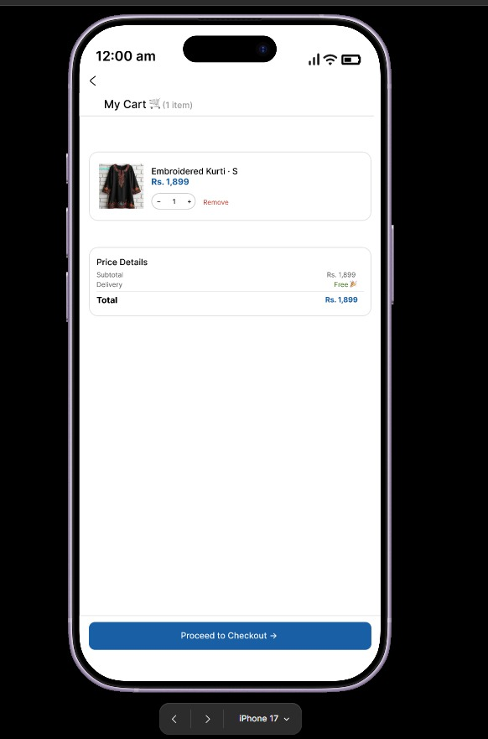
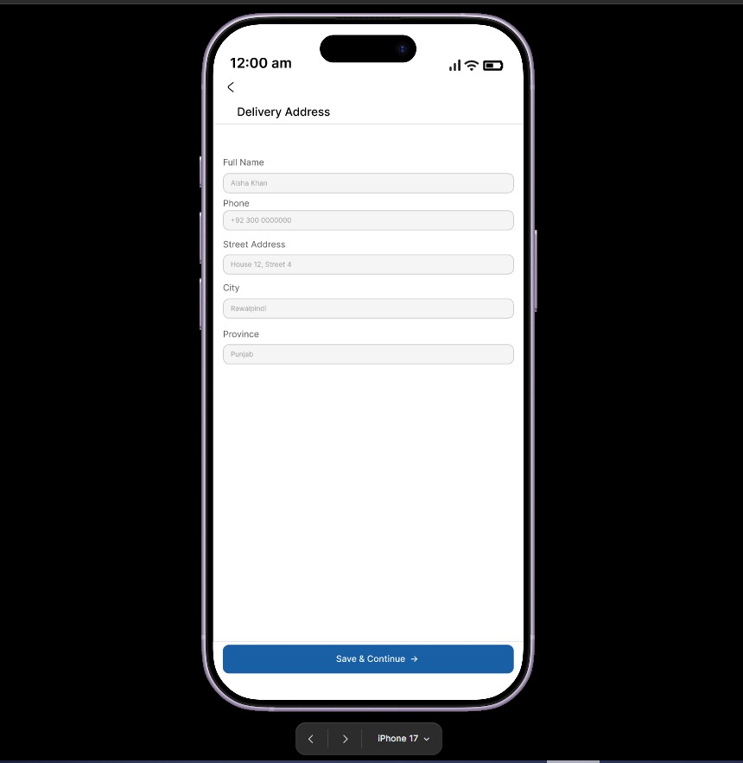
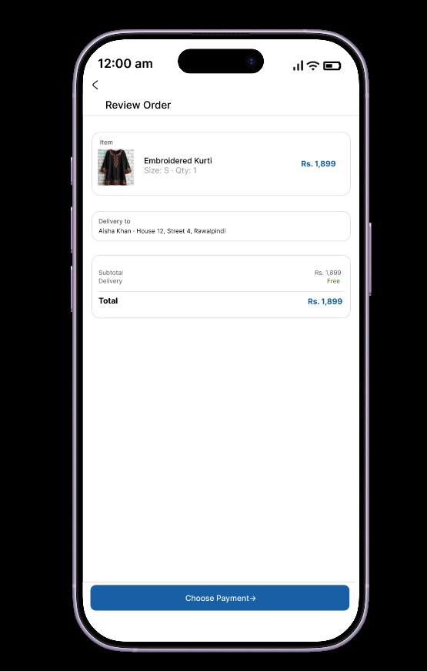
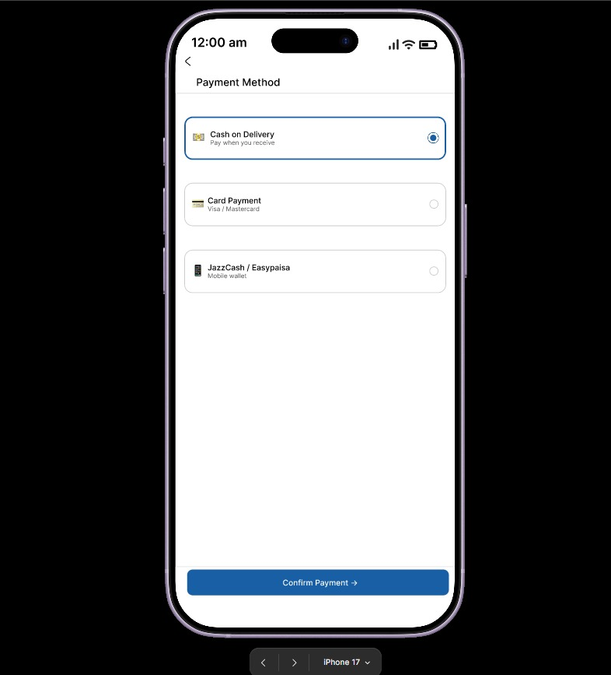
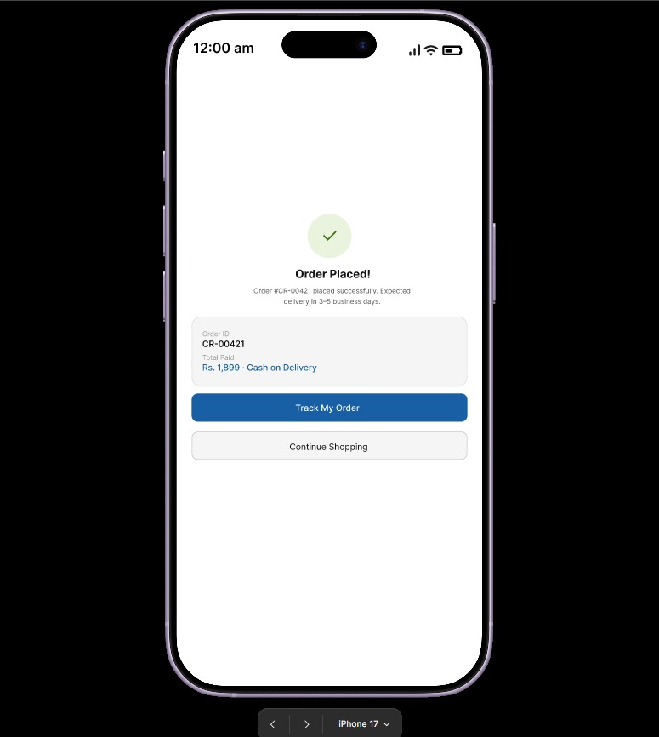
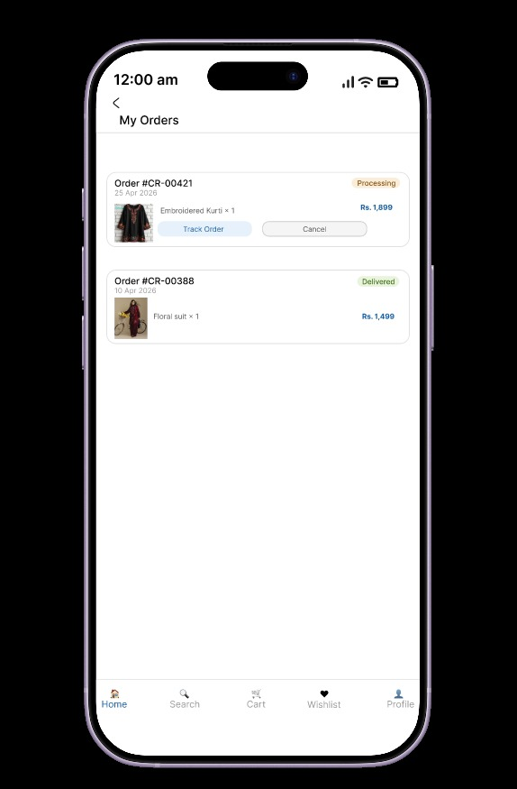
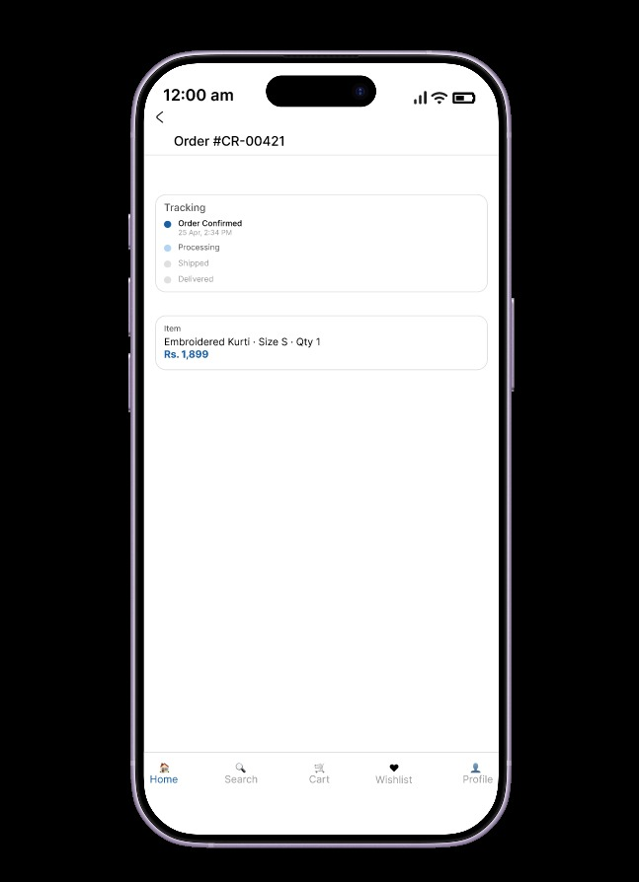
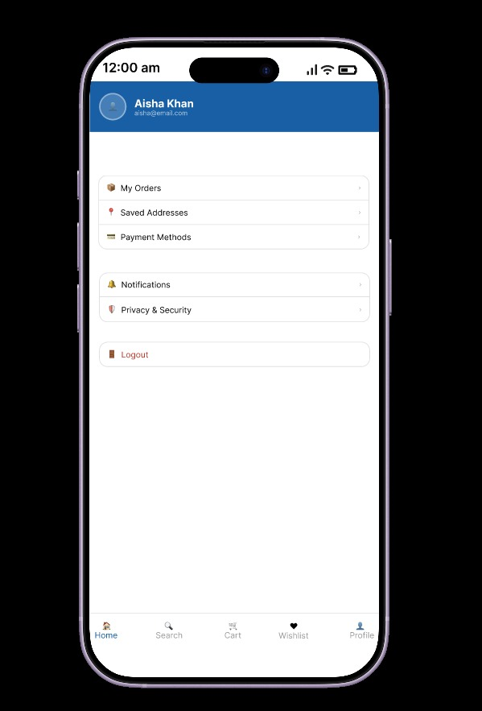
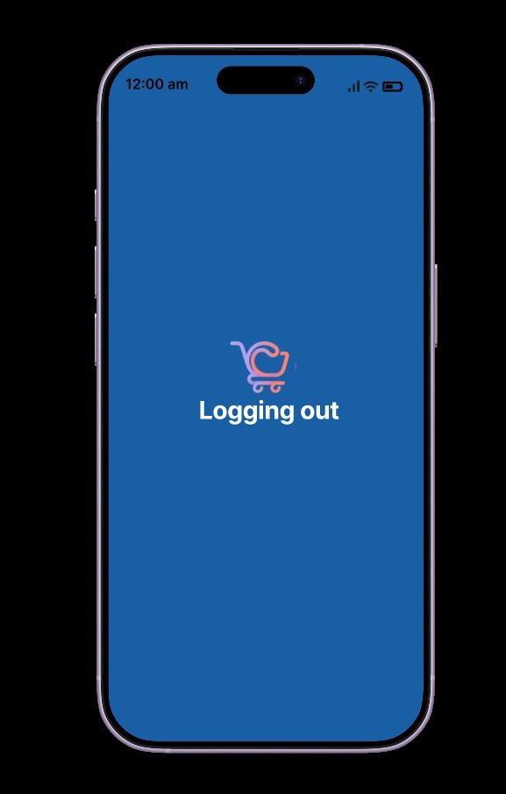

15. Low Fieldity Wireframes
s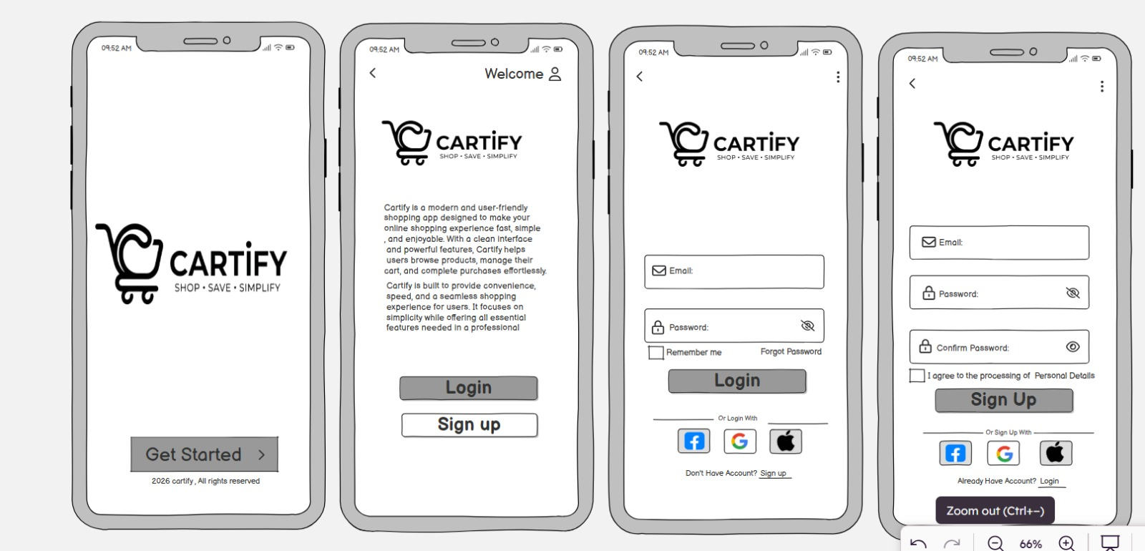
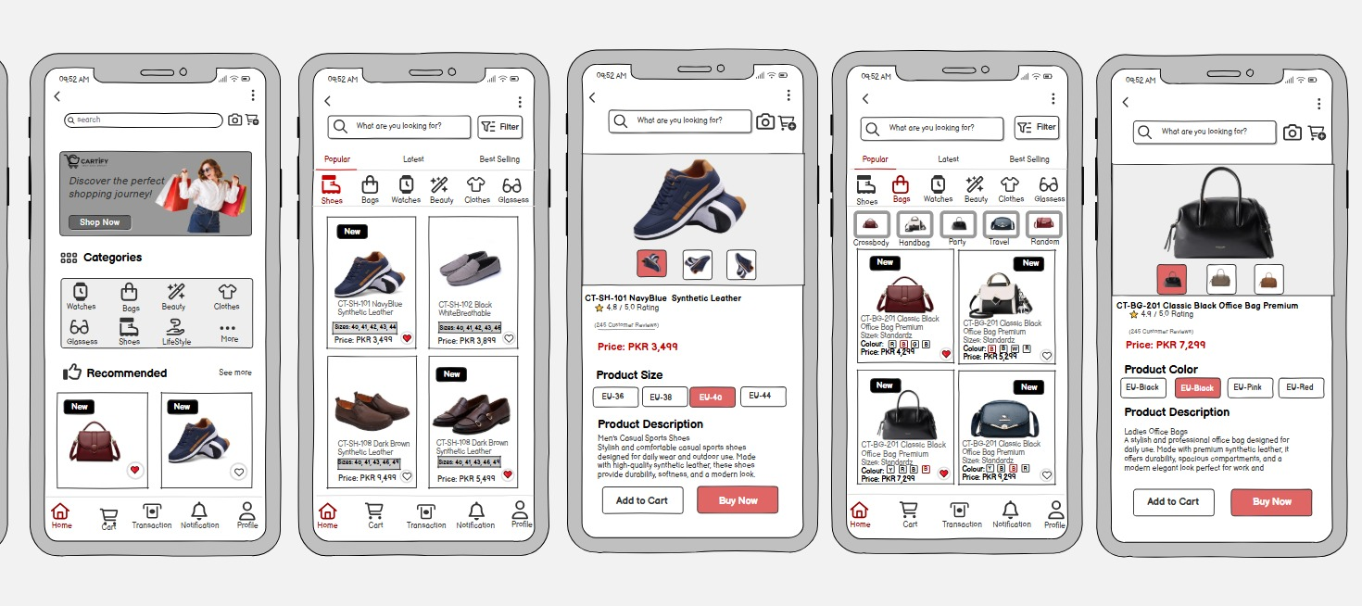
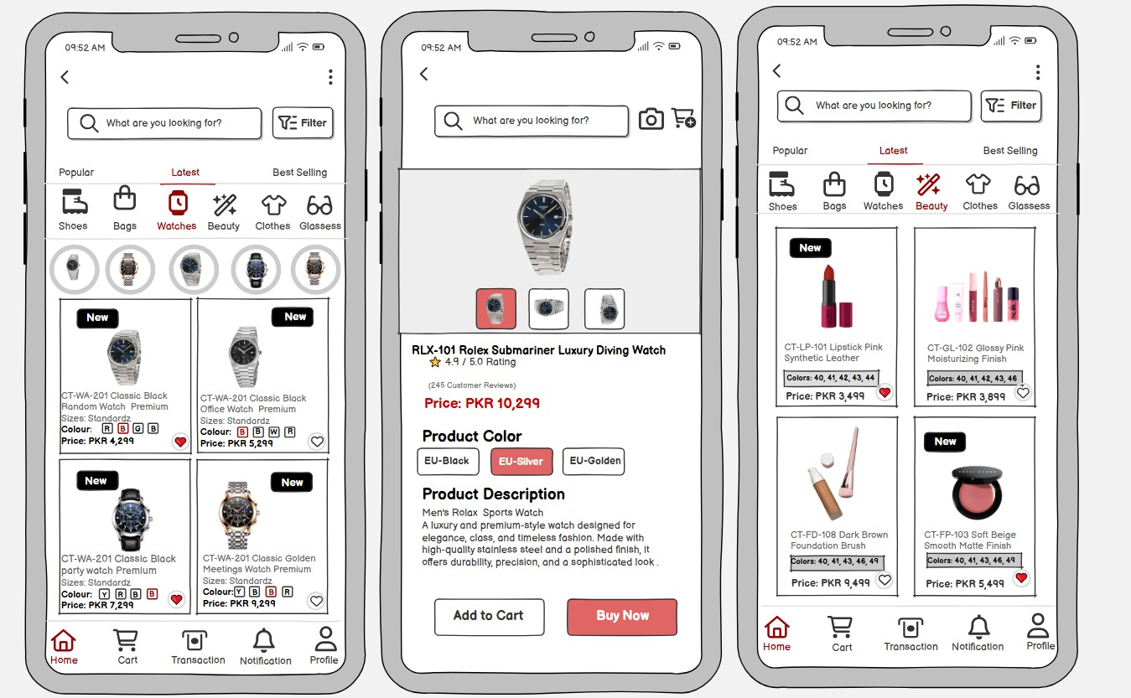
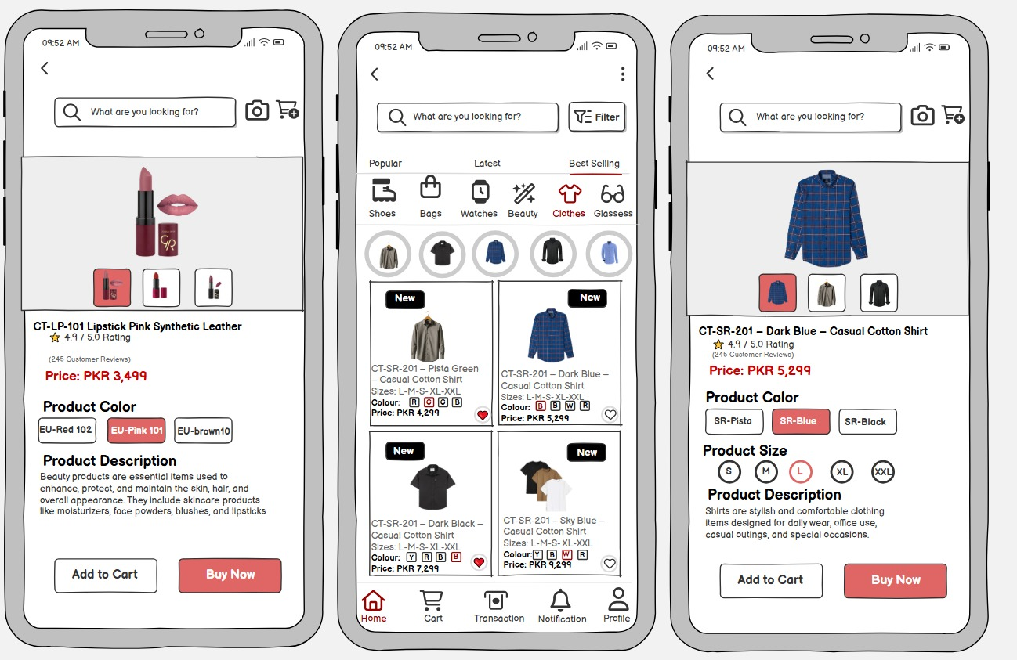
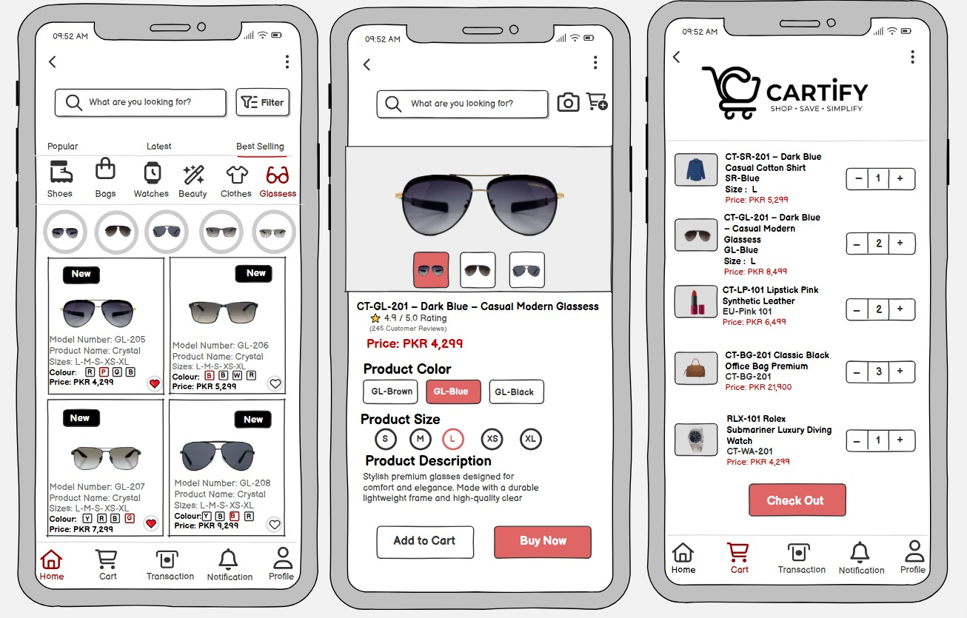
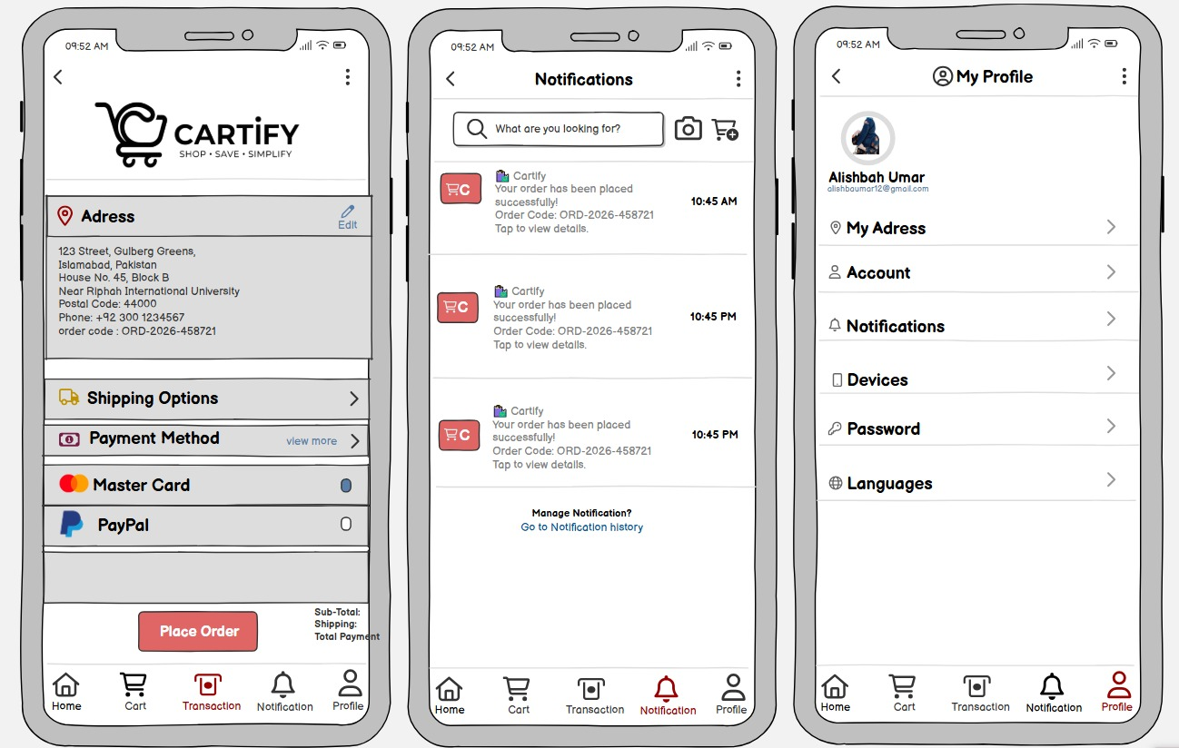
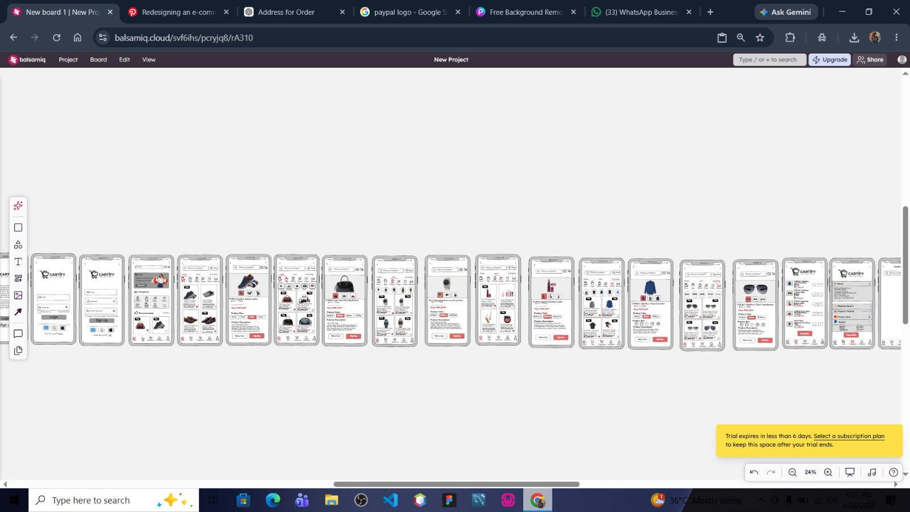
Full Figma design file:
https://www.figma.com/design/kYLoV9StrTIThrTVvDp1wZ/Internship-Task?node-id=0-1&t=c4h4pqlpivLzGAar-1

