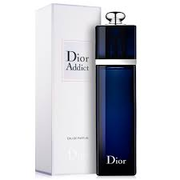EAU SAUVAGE:

34,000

Dior Addict Eau de Parfum unleashes fresh and captivating top notes that blend Mandarin Leaf with Tunisian Orange Blossom.