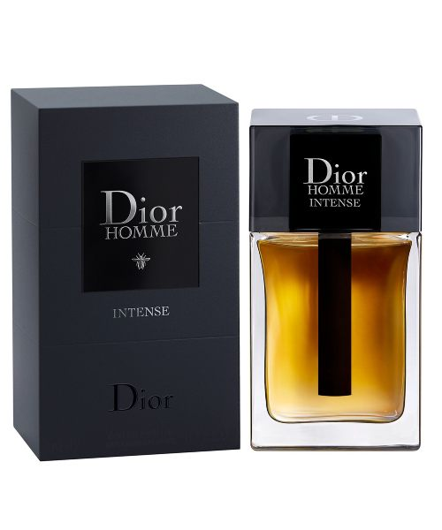INTENSE:

24,500

Dior Homme is worn the way you wear an elegantly sharp, modern suit. Dior Homme Intense Eau de Parfum reveals the extreme grandeur and sophistication of a generous and powerful eau de parfum. The olfactory intensity of Iris is enhanced by a sensual Ambery facet and precious Wood base. A scented, sensual script whose trail calls to you.