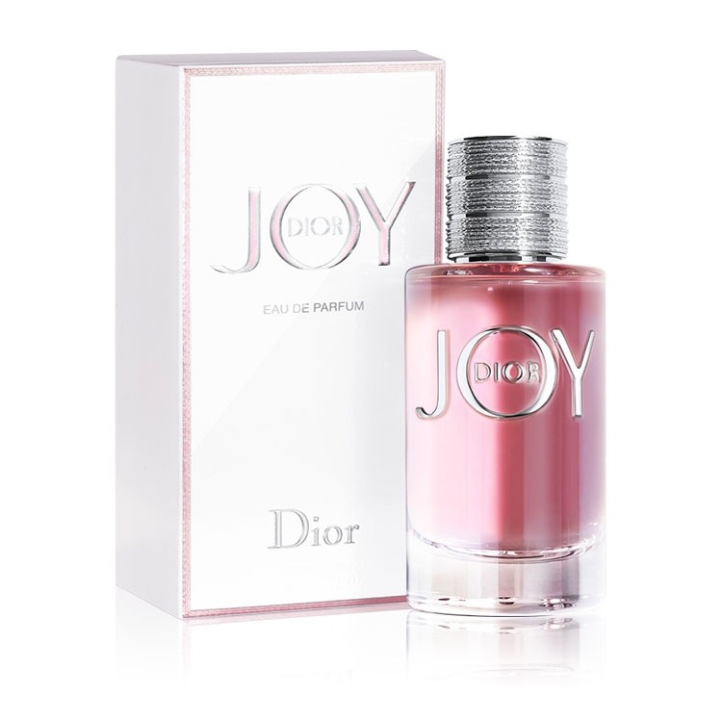JOY BY DIOR:

28,700

JOY by Dior Eau de Parfum Intense is a new olfactory burst, a scent of joy wherein flowers celebrate, exploding with all their faceted beauty. The dazzling light of juicy Citrus blends with the colorful shine of Rose and Grasse Jasmine, heightened by an enveloping woody echo of Sandalwood tinged with Vanilla. A fragrance like floral fireworks.