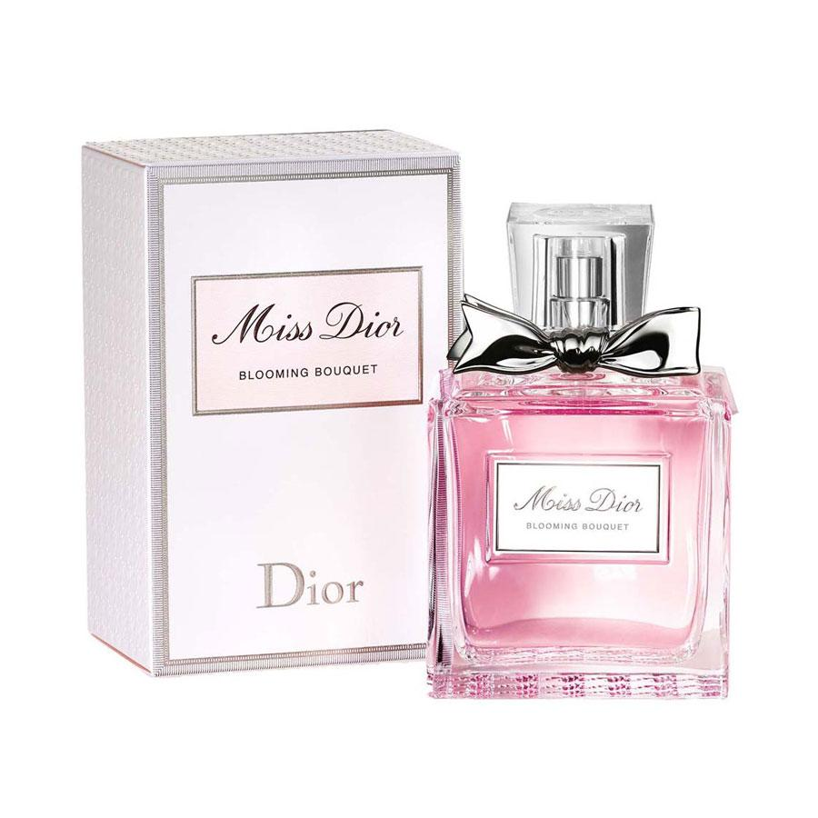MISS DIOR:

34,000

Miss Dior Rose Essence is the first Miss Dior fragrance vintage, the fruit of the 2021 May Rose harvest from the Domaine de Manon in Grasse.