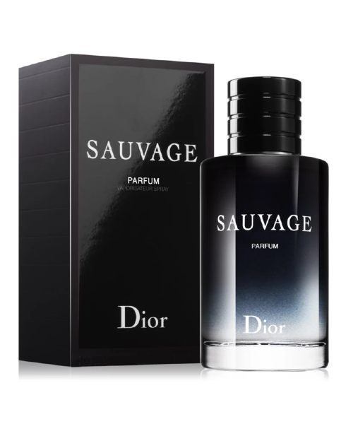SAUVAGE ELIXIR:

30,500

Sauvage Elixir is an extraordinarily\* concentrated fragrance steeped in the emblematic freshness of Sauvage with an intoxicating heart of spices, a "tailor-made" lavender essence and a blend of rich woods forming the signature of its powerful, lavish and captivating trail.