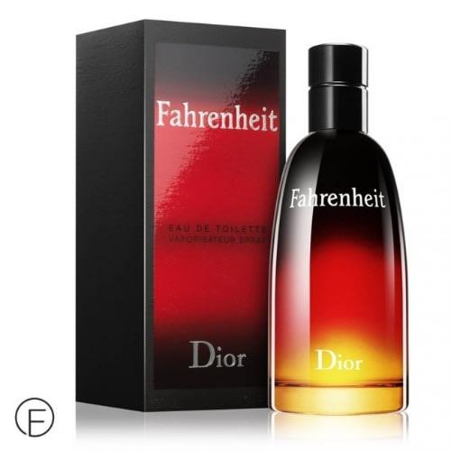FAHRENHEIT:

20,000

Alone in the face of the majestic elements, the Fahrenheit man incarnates a thirst for the absolute. Timeless and universal, Fahrenheit is a fragrance that transcends time and trends to forge its own territory. A unique,\* contrasting olfactory signature with a powerful, lingering trail. The fragrance is structured around fresh notes of Sicilian Mandarin, a surprising blend of masculine Wood and Leather notes, and a unique\* Violet accord