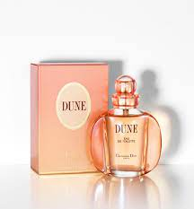DUNE:

22,000

An oceanic fragrance, created in harmony with nature, this radiant, fresh and subtle accord captures the landscape where the sky meets the sea in a warm, oceanic floral bouquet. Enveloping, serene and sensual.