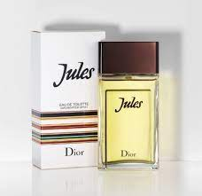JULES:

20,000

A strong men’s fragrance composed with woody green notes and spicy pepper accents.