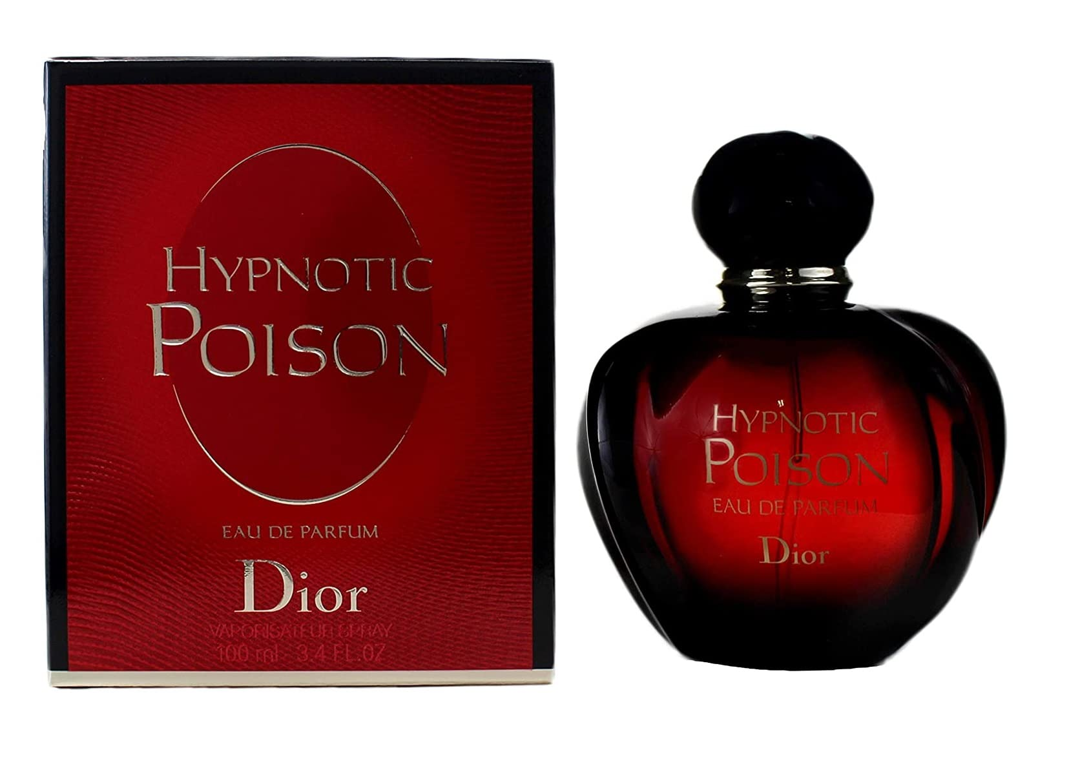POISON BY DIOR:

4,000

The legendary and intoxicating oriental eau de toilette from the House of Dior, dressed in a vibrant, resolutely modern shade of red.