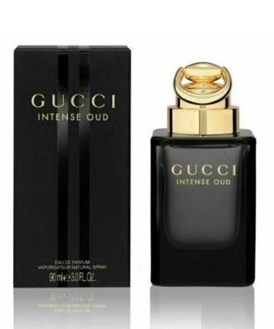

Dreamer:

19,250

Gucci Intense Oud by Gucci, Launched in 2016. Gucci Intense Oud is **a potent fragrance featuring incense and woody notes layered over a leathery base with the subtle sweetness of ambergris**. An inimitable accord of precious oud and olibanum is the prevailing characteristic of this powerful scent.