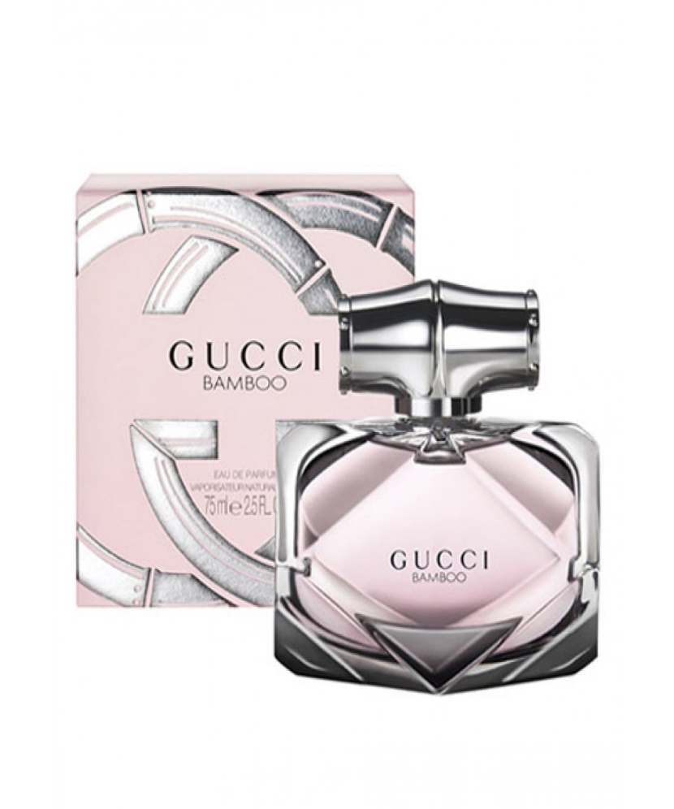BAMBOO:

35,000

Fragrance Description: **Blooming with notes of exotic Casablanca lily and Tahitian vanilla, Gucci Bamboo Eau de Parfum's femininity is balanced by a resonating, woody, contrasting note of grey amber**. Both soft and intense, the fragrance is a statement on the strong, graceful, and feminine woman it's destined for.